- Compute the reflectivity and transmissivity of a layer of optical depth 4 and $μ$0 = -0.7 (Θ=134.43) using an increasing number of photons (100, 500, 1000, 5000, 10000, etc). Derive an estimate of the rate of convergence (that is, at which number of photons the mean and standard deviation do not change significantly).
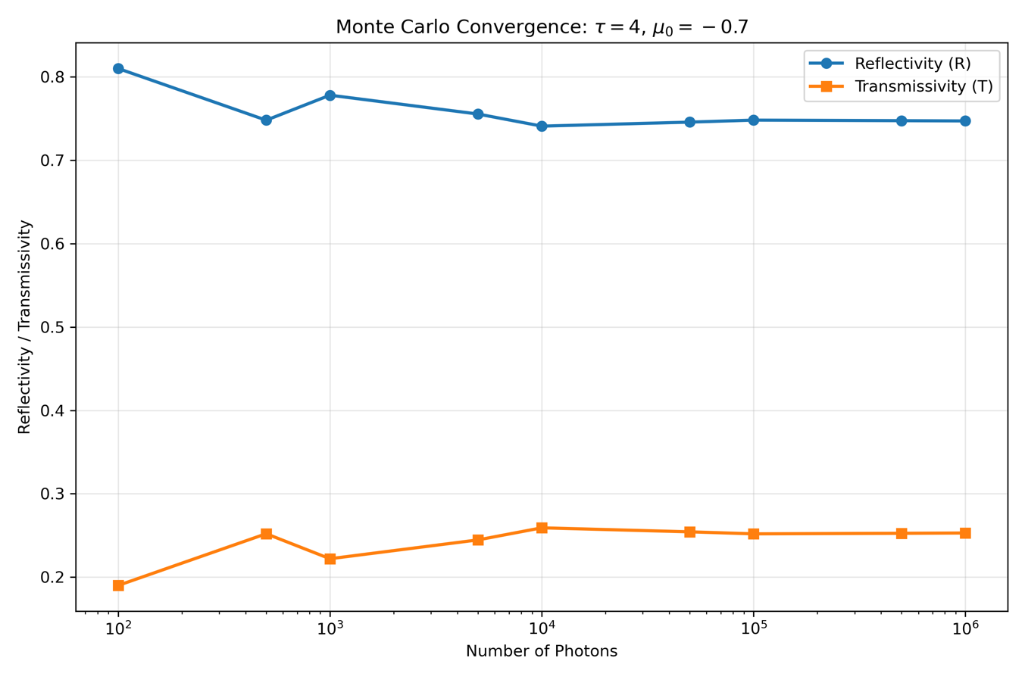
Fig 1. Monte Carlo estimates of cloud reflectivity (R) and transmissivity (T) as a function of the number of simulated photons

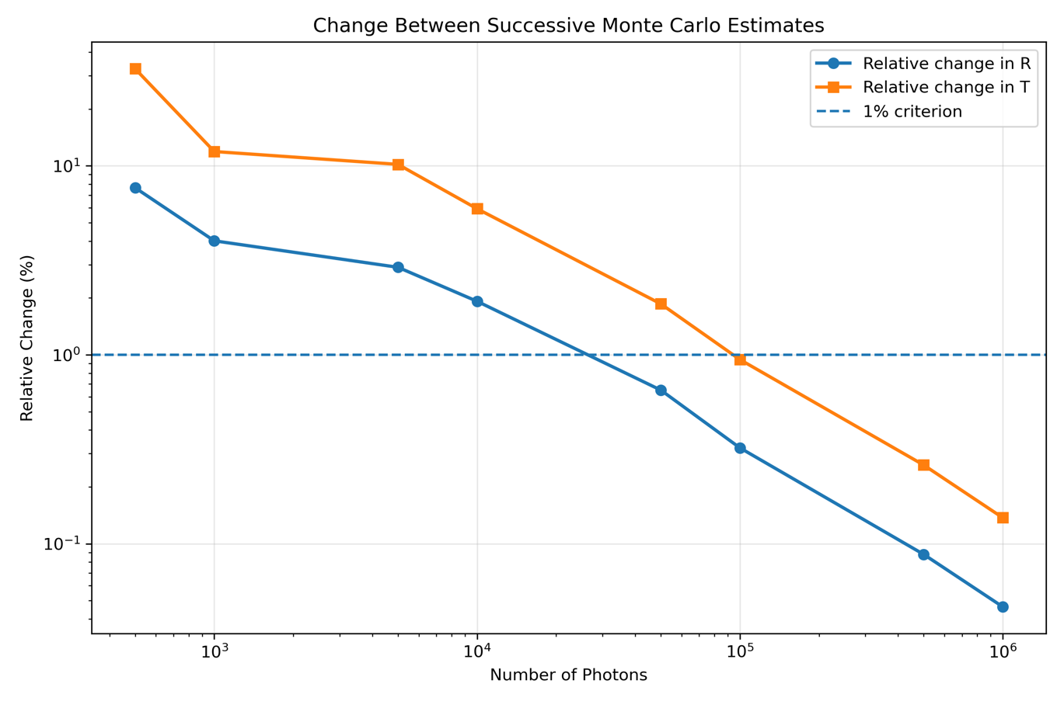
Fig 2. Relative changes in the estimated reflectivity and transmissivity between successive Monte Carlo simulations with increasing photon number. The dashed line represents the adopted 1% convergence criterion.

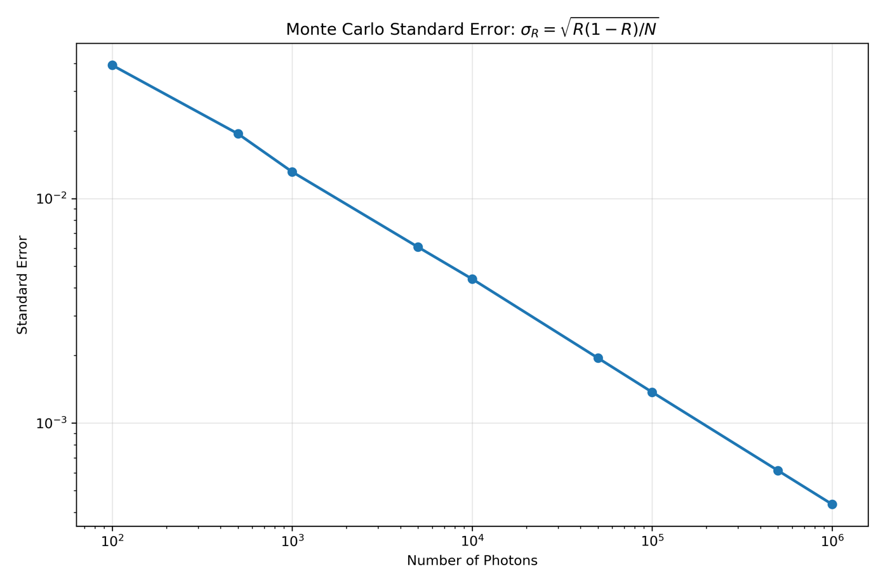
Fig 3. Estimated Monte Carlo standard error of reflectivity as a function of the number of simulated photons.
The results demonstrate the expected convergence behavior of the Monte Carlo photon-transport simulation. At small photon numbers, the calculated R and T fluctuate a lot because the estimates are based on a relatively small random sample of photons. For example, with only 100 photons, the simulation gives approximately $R=0.81$ and $T=0.19$ (see Fig. 1). As the number of photons increases, these random fluctuations become progressively smaller, and the estimates stabilize near $R≈0.747$and $T≈0.253$.
The reduction in Monte Carlo uncertainty is particularly clear in Figure 3. The estimated standard error follows
$$σ_{R}=\sqrt{\frac{R\left(1-R\right)}{N}}$$
and therefore, decreases approximately in proportion to N^{-1/2}. Consequently, reducing the statistical uncertainty by a factor of two requires approximately four times as many photons. To select enough photons for the subsequent experiments, a 1% relative-change criterion was adopted. The relative changes in both R and T first fall below 1% at N = 100,000 is selected as a practical sample size for the subsequent simulations.
- When you think that you have reached an adequate number of photons, run several iterations (5 to 10) of that number and calculate the standard deviation of your results. Remember to start your random number generator from a different kernel for each run (i.e. using different initial parameters).
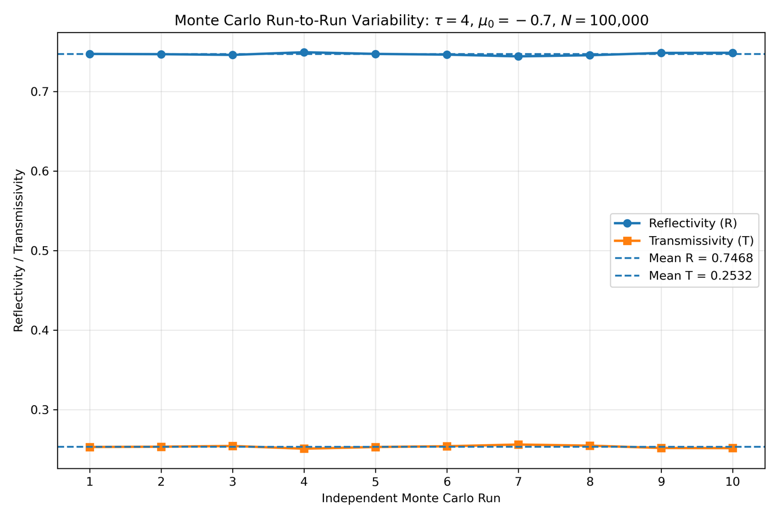
Figure 4. Reflectivity and transmissivity from ten independent Monte Carlo simulations using N=100000 photons. Each simulation used a different random-number seed.
Using the photon number determined in Question 1 ($N=100,000$), ten independent Monte Carlo simulations were performed using different random-number seeds. The sample standard deviations were 0.001559 for both quantities. The small run-to-run variability indicates that $100,000$photons provide a stable estimate of the radiative properties of the layer. The observed standard deviation of reflectivity (0.001559) is also reasonably close to the theoretical Monte Carlo standard error of 0.001375 estimated from $\sqrt{R\left(1-R\right)/N}$.
- Compute (using the number of photons determined in 1.) the reflectivity and transmissivity of a layer of optical depth 4 for 0 values of -0.1 to -0.9.
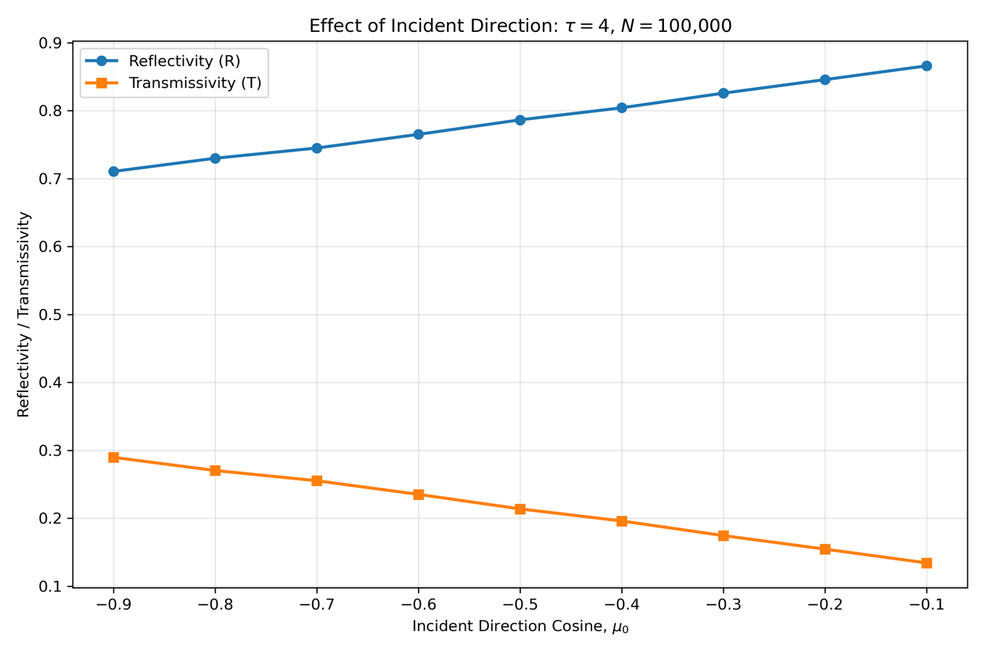
Figure 5. Monte Carlo simulated $R$ and $T$ as a function of the incident direction cosine $μ_{0}$for a nonabsorbing, isotropically scattering layer with optical depth $τ=4$. Each simulation used $N=100,000$ photons. As the incident radiation becomes more oblique ($μ_{0}→0$), reflectivity increases and transmissivity decreases.
The results show a clear dependence of reflectivity and transmissivity on the incident direction. As $μ_{0}$ increases from $-0.9$to $-0.1$, reflectivity increases from approximately $0.710$ to $0.866$, while transmissivity decreases from approximately $0.290$to $0.134$.
This behavior is caused by the geometry of the photon path. Since the vertical displacement of a photon is
$$Δz=μ_{0}l,$$
a photon with $μ_{0}=-0.9$ travels downward much more rapidly than one with $μ_{0}=-0.1$. At $μ_{0}=-0.1$, the incident beam is nearly horizontal and therefore follows a much longer slant path through the layer. This increases the likelihood of scattering before the photon penetrates deeply into the cloud. Because scattering is isotropic in this problem ($g=0$), some of these photons are redirected upward and leave through the top boundary, increasing reflectivity.
In contrast, when $∣μ_{0}∣$ is large, the photons enter more nearly vertically and can penetrate farther into the layer before scattering, increasing their probability of eventually leaving through the bottom boundary. Therefore, transmissivity increases as $μ_{0}$becomes more negative.
- Compute (using the same number of photons, and 0= -0.7) the reflectivity and transmissivity of a layer with optical depths of 1 to 8. How does the computer time increase with increasing optical depth?
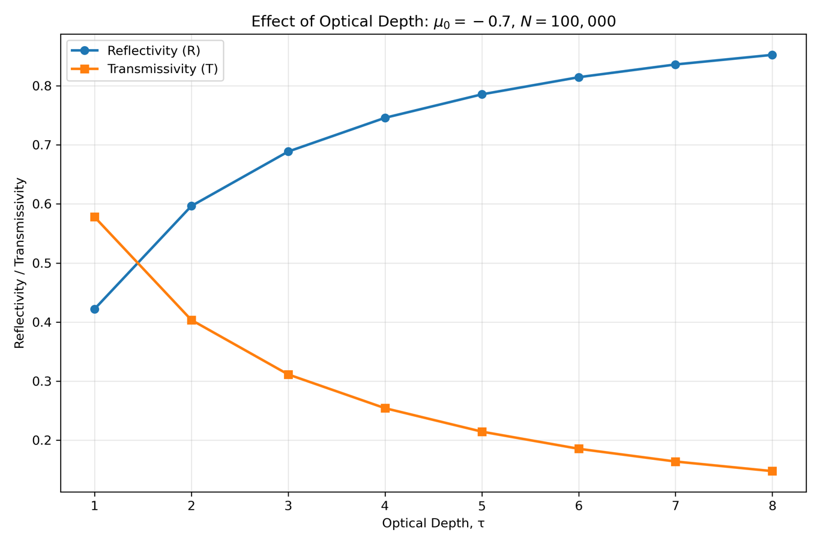
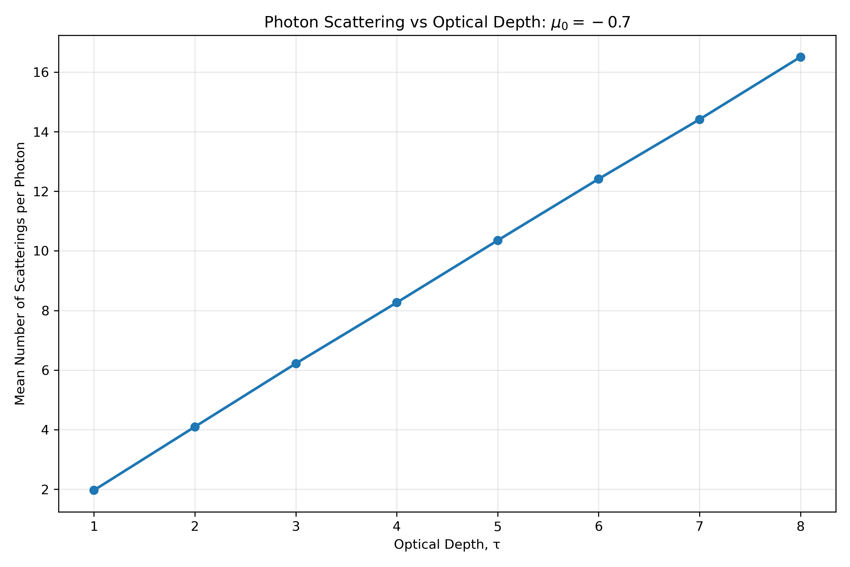
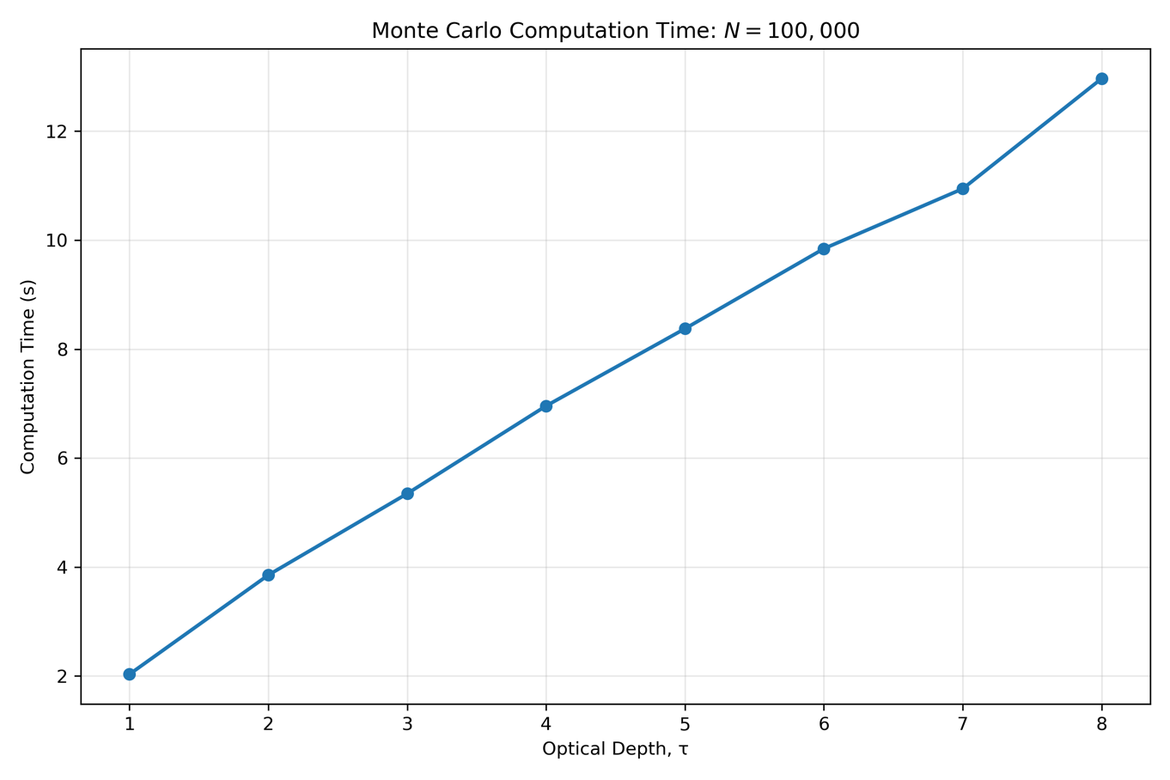
Fig 5. Effect of cloud optical depth on Monte Carlo photon transport for $N=100,000$ photons and an incident direction cosine of $μ_{0}=-0.7$. As optical depth increases from 1 to 8, reflectivity increases while transmissivity decreases because photons undergo more multiple scattering before escaping the layer. The mean number of scattering events per photon increases with optical depth, resulting in a corresponding increase in computational time.

Increasing the optical depth substantially changes the photon transport through the layer. Reflectivity increased from 0.422 at $τ=1$ to 0.852 at $τ=8$, while transmissivity decreased from 0.578 to 0.148. Because absorption was not included in the simulation, $R+T=1$ for all optical depths. As optical depth increased, photons experienced more scattering events before escaping the layer. The mean number of scattering events increased from approximately 1.96 to 16.51 over the tested range. Consequently, the computation time also increased, from approximately 2.03 s at $τ=1$ to 12.97 s at $τ=8$. Thus, over the range examined here, computational time increases approximately linearly with optical depth because optically thicker layers require the Monte Carlo model to simulate more scattering events per photon.

