NOVASCOPE DIAGNOSTICS

The BioSemiconductor Company

We Don't Make Tests. We Make the Semiconductor Platform
That Makes Tests Possible.

Powering Next-Generation Diagnostics for Alzheimer's Disease & Sepsis

BCR: BioChips Reaction

CONFIDENTIAL INVESTOR DOCUMENT

I. The Thesis: Why Semiconductors Will Transform Diagnostics
In 1971, Intel put 2,300 transistors on a single chip and launched the microprocessor revolution. Within three decades, the semiconductor transformed computing, communications, transportation, and finance. The mechanism was always the same: take something bulky, expensive, and confined to specialists, miniaturize it onto silicon, mass-produce it in a foundry, and make it cheap enough for the world.
One of the last great holdouts is medical diagnostics.
Today, the global in-vitro diagnostics (IVD) industry is worth over $80 billion, yet it still runs on the same fundamental physics it used forty years ago: optics. PCR uses fluorescence. ELISA uses colorimetry. Sequencing uses light detection. Every major platform requires optical components that are inherently bulky and expensive. A BioFire FilmArray costs $150–180 per test. A Quanterix SIMOA instrument costs $300,000–400,000. An Illumina sequencer costs $100,000–500,000. These are not tools for primary care clinics or the developing world.
Novascope was founded on a different premise: the right physics for diagnostics is not light — it is electricity.
Every biomolecule carries an electric charge. A field-effect transistor (FET) detects changes in charge with extraordinary precision. FETs are the most manufactured, most reliable, most scalable objects in human history. The insight is not that FETs can detect biomolecules — that has been known for decades. The insight is that nobody has built the complete semiconductor-grade system required to turn this principle into a clinical-grade diagnostic platform.
That is what Novascope has built. Not a test. Not an instrument. A BioSemiconductor platform — the foundational technology layer upon which an unlimited number of diagnostic applications can be deployed.

II. What We Are: A BioIC Design House
Novascope is not an IVD company that happens to use chips. We are an IC design house that has chosen diagnostics as its first — but not its only — vertical.
An IVD company develops assays, licenses instrument platforms, and sells kits. Its value is the sum of its approved products. A BioSemiconductor company designs the foundational chip technology, owns the complete IP stack, and builds application-specific systems on a reusable platform. Its value is the platform itself — the accumulated know-how that enables any new application to be built in months, not years.

The Foundry Partnership
Our manufacturing partner is UMC (United Microelectronics Corporation) — Taiwan’s premier semiconductor foundry. We are a direct customer, ordering production lots of 25 eight-inch wafers (approximately 50,000 chips per lot). These are dedicated production runs with full wafer acceptance testing, not shuttle prototypes.
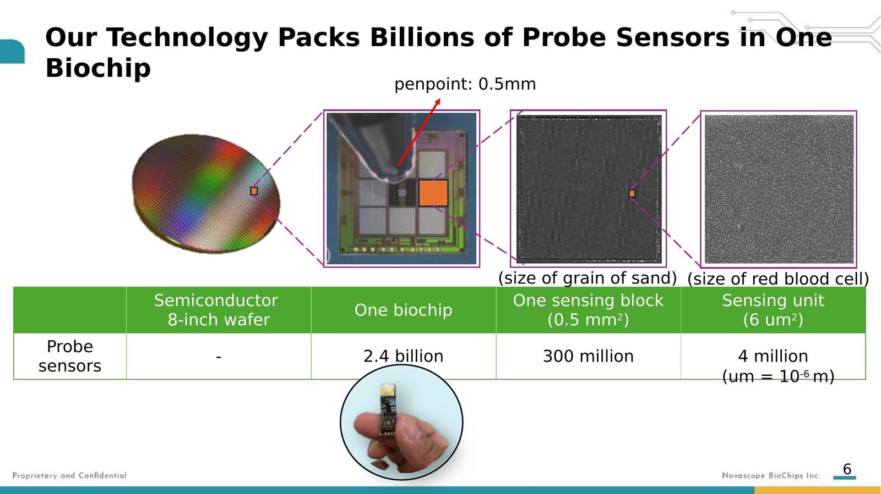
Figure 1. From 8-inch semiconductor wafer to individual biochip — each containing 2.4 billion probe sensor sites.

The Chip Portfolio
We have successfully designed and wafer-out (not merely tape-out) three chip families across six design iterations:
NS01 — The Precision BioFET. A single-FET sensor integrated with control circuitry and signal processing on a 3×3 mm die. Each chip contains approximately 2.4 billion probe sensor sites. This is a fully programmable, multiplexing, self-contained IC — reconfigurable for different assays through software and surface chemistry.
NS02 — The BioFET Array. Multi-sensor array enabling spatial multiplexing — multiple distinct assays running in parallel on a single die.
NS03 — The Optoelectric BioChip. System-on-chip integrating FET sensors with photodiode elements, combining electrical and optical sensing on a single die.
Additionally, three specialized design variants have been produced: optimized sensor layouts for different biological applications and two versions designed for microfluidic integration.

The IP Fortress
We design every circuit. We draw every mask. We do not use external silicon IP. We do not pay royalties. In a semiconductor industry where IP licensing fees typically consume 5–15% of revenue, Novascope’s clean, wholly-owned portfolio means every dollar of margin stays in the company.
Component | Ownership | Royalty
ASIC chip design (6 generations) | 100% Novascope | Zero
Reader electronics (200+ components) | 100% Novascope | Zero
Firmware & protocols | 100% Novascope | Zero
Surface chemistry (NovaLINK) | Trade secret | Zero
Monoclonal antibodies (77 clones) | 100% Novascope | Zero
ZNA nucleic acid probes | 100% Novascope | Zero
VHH nanobodies | 100% Novascope | Zero
AI signal processing algorithms | 100% Novascope | Zero
Software, cartridge, 40+ patents | 100% Novascope | Zero
Table 1. Complete IP ownership across all platform components — zero royalty obligations.

III. The Six Pillars of a BioSemiconductor Company
A chip that detects charge changes is a physics experiment. A chip that diagnoses disease requires six interlocking capabilities — each independently difficult, collectively near-impossible to replicate.
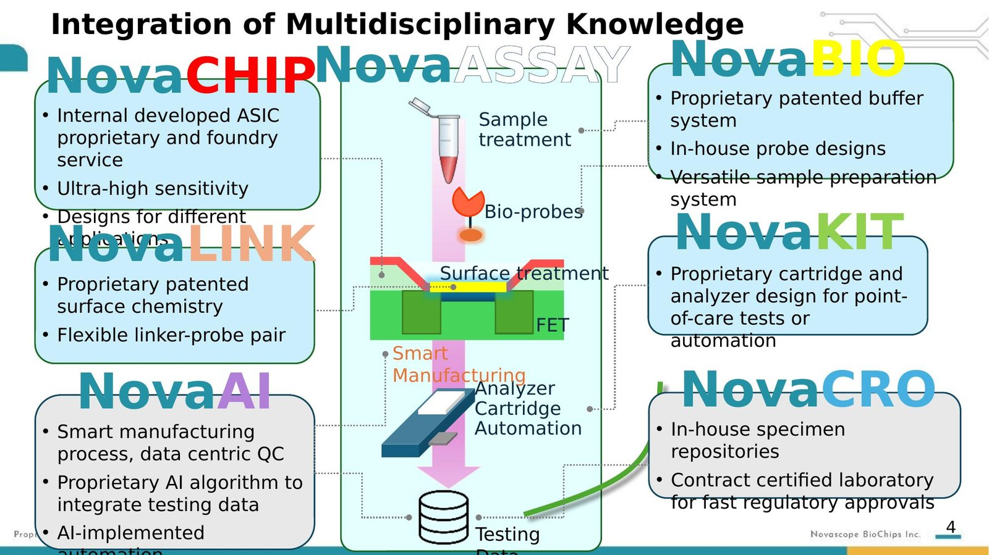
Figure 2. Novascope’s six integrated technology pillars: NovaChip, NovaBIO, NovaLINK, NovaKit, NovaAI, NovaCRO.

Pillar 1: NovaChip — The Semiconductor Platform
The NovaReader is a 200+ component electronic system designed entirely in-house, built around an ARM Cortex-M3 32-bit MCU with a custom front-end amplifier for femtoampere-level current measurement. The reader integrates touch panel control, barcode scanner, Ethernet/USB interfaces, motion control for automated cartridge handling, and complete process orchestration — from sample input to clinical result.
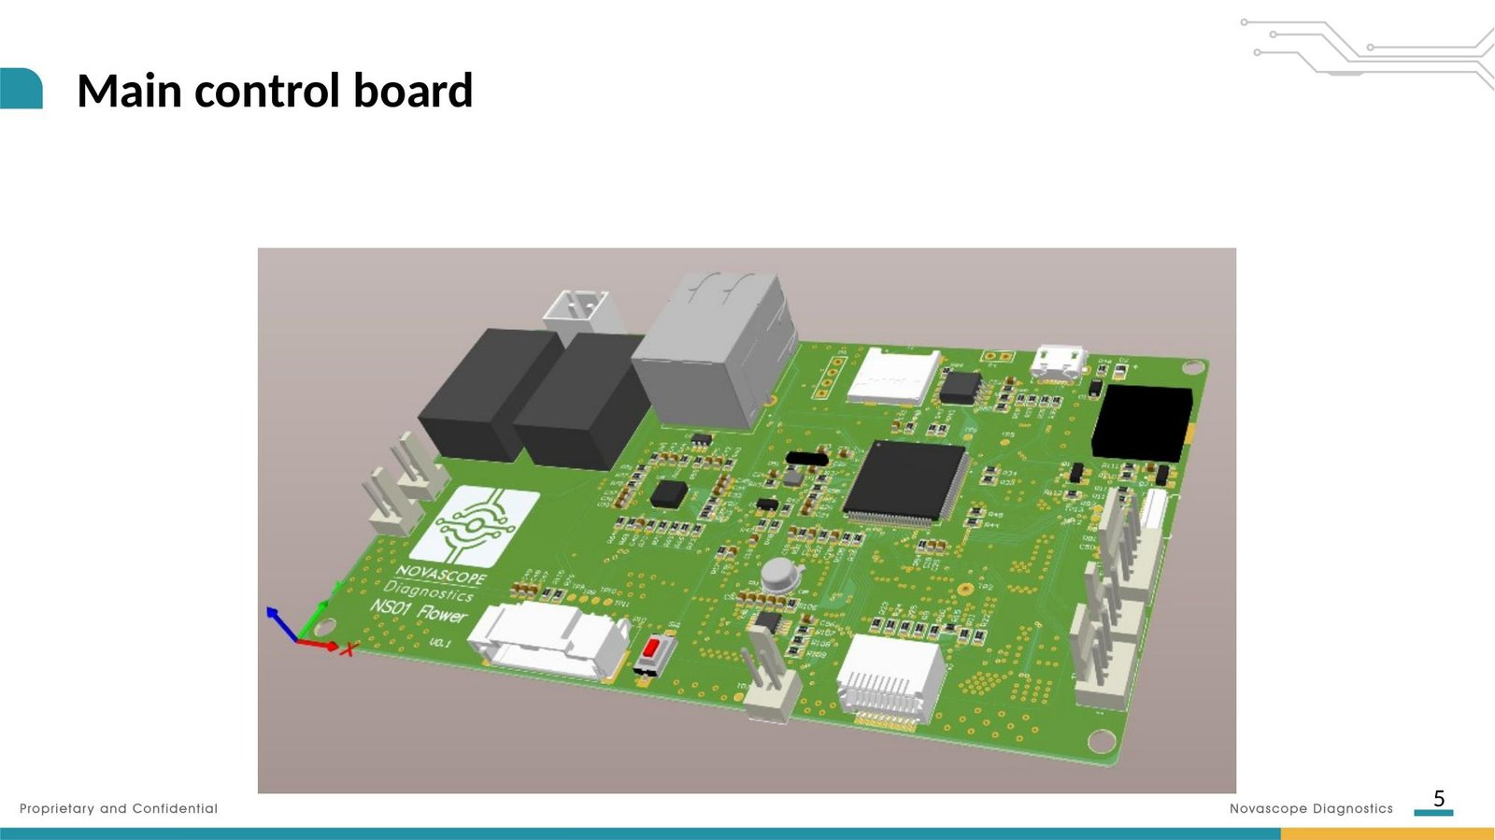
Figure 3. The NovaReader NS01 Flower main control board — designed entirely in-house by Novascope.
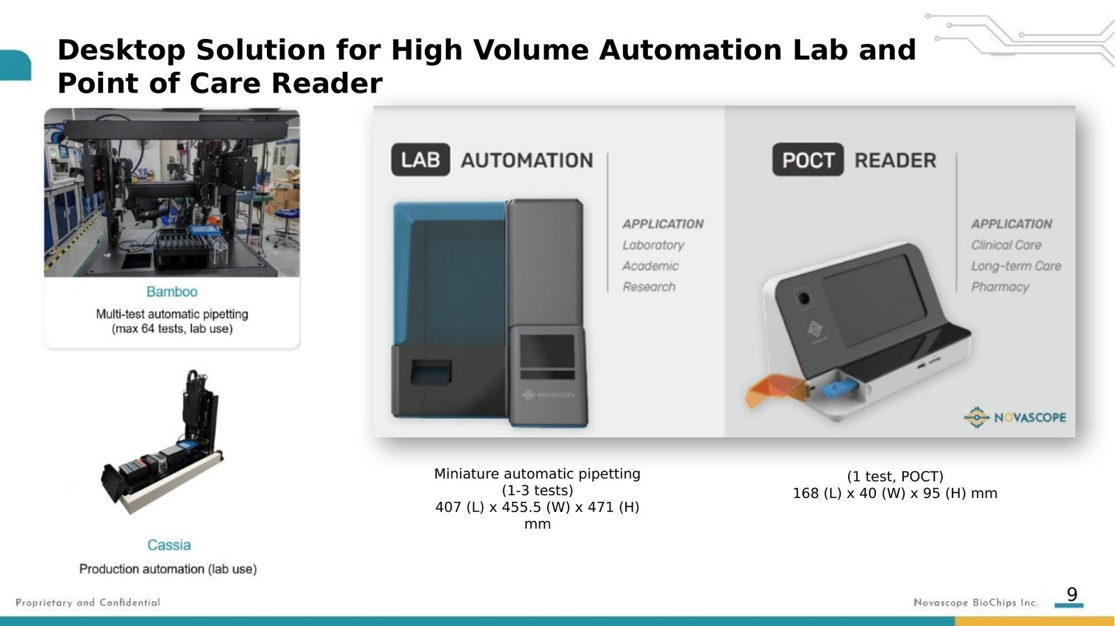
Figure 4. Three instrument form factors: Bamboo (high-throughput, 64 tests), Lab Automation (1–3 tests), and POCT Reader (single test, portable).

Pillar 2: NovaBIO — The Biological Toolkit
We develop monoclonal antibodies entirely in-house — from animal immunization through hybridoma screening, gene sequencing, recombinant expression, and purification to pharmaceutical-grade specifications (HPLC-SEC purity >97%, SDS-PAGE >95%, endotoxin 0–1 EU/mg).
Current portfolio: 77 antibody clones across 15+ target families, including p-Tau 181/217/231, NfL, GFAP, Amyloid Beta 42/40, TDP-43, Alpha-Synuclein, S100B, UCH-L1, and a VHH nanobody against p-Tau 217. Six products are currently for sale, validated through ELISA, Western blot, IHC, immunofluorescence, immunoprecipitation, and SPR kinetics.
The ultimate specificity validation: we test neurological antibodies against human brain tissue from Alzheimer’s disease patients using immunohistochemistry — the gold standard. Independent researchers have confirmed staining patterns match published references.
For pathogen detection, we use ZNA (Zip Nucleic Acids) — charge-neutral nucleic acid probes that minimize electrical background noise on the FET chip. Our next-generation probe platform uses VHH nanobodies (~15 kDa vs. ~150 kDa for conventional antibodies), positioning the binding site closer to the sensing surface for stronger signals.

Pillar 3: NovaLINK — The Surface Chemistry
Our surface chemistry simultaneously achieves probe attachment, antifouling (rejecting the ~7,000 proteins and billions of cells in human blood), and signal optimization. On our direct electrical detection platform, every nonspecifically bound molecule generates a real signal — the antifouling must be essentially perfect. This is protected as a trade secret.

Pillar 4: NovaKit — The Complete Diagnostic System
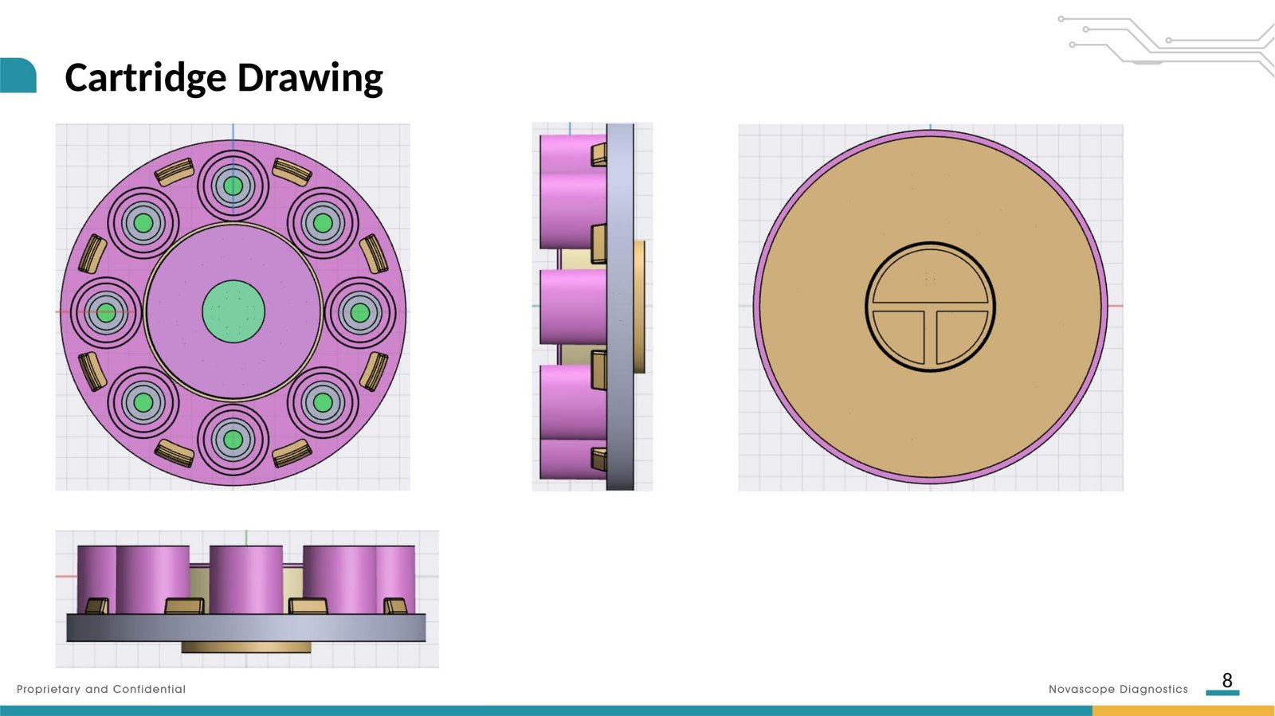
Figure 5. Multi-chip cartridge design supporting 1-chip and 8-chip configurations with integrated sample wells.
To prove the platform works, we built the entire IVD ourselves: microfluidic cartridge design, automated liquid handling, sensor PCB integration, and complete assay protocols for both nucleic acid (bacteria) and protein (neurodegeneration) detection.
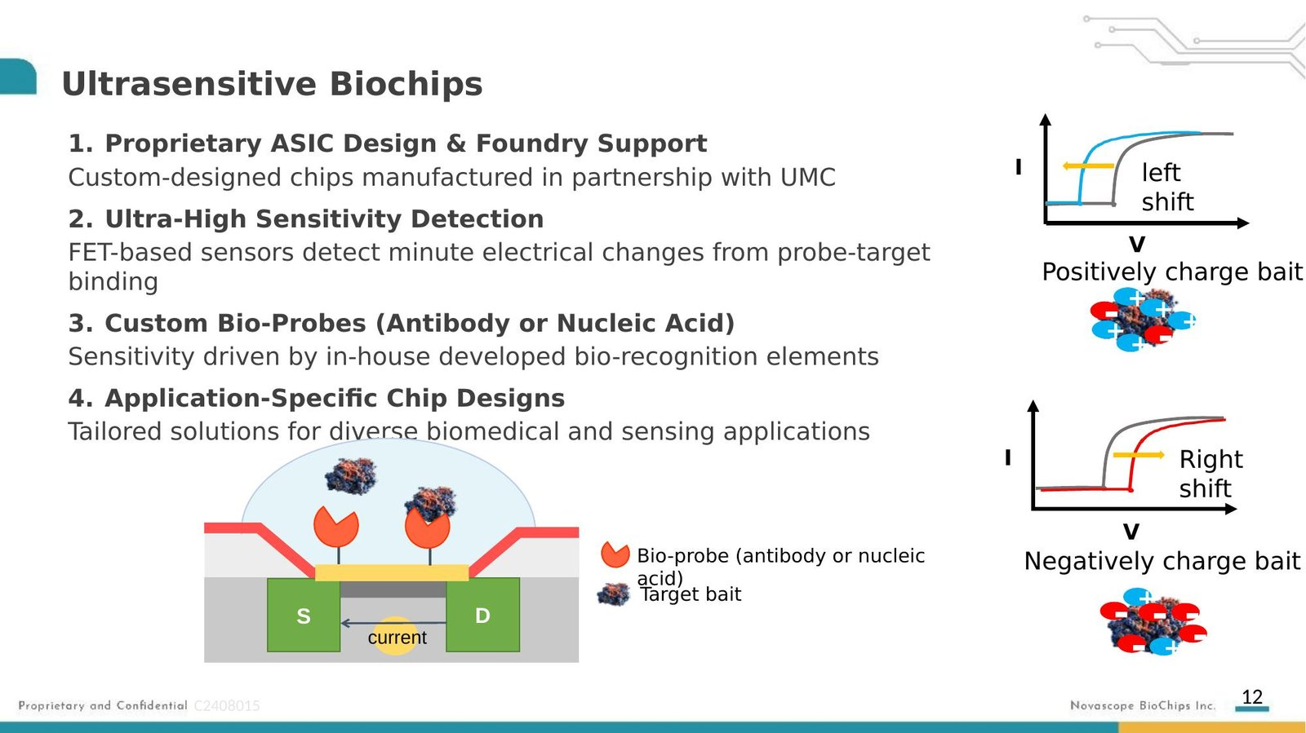
Figure 6. FET-based biosensing: probe-target binding induces threshold voltage shifts detected by the semiconductor chip.

Pillar 5: NovaAI — Signal Intelligence
At femtogram-per-milliliter sensitivity, raw signals are noisy. Our proprietary AI algorithms analyze binding curve dynamics, subtract systematic noise, compensate for chip-to-chip variation, and classify results with confidence scores. Because we design the chip, electronics, and algorithms together, we co-optimize across the entire signal chain.

Pillar 6: NovaCRO — The Clinical Data Engine
The most underappreciated asset: our proprietary biorepository. We transferred clinical isolates from Chang Gung Memorial Hospital spanning 291 bacterial species across 108 genera, linked to original clinical data. We performed whole genome sequencing on selected isolates in-house — our nucleic acid probes are designed from real clinical genomic data, not reference databases. We also maintain PET-validated, clinically characterized Alzheimer’s disease samples. This is a multi-year, multi-million-dollar data asset that competitors cannot replicate.

IV. The Proof: Clinical Validation Data

Sepsis: Direct-from-Blood Bacterial Detection
In third-party clinical validation at Chang Gung Memorial Hospital, the NS01 platform achieved breakthrough performance on the hardest clinical challenge — detecting pathogens directly from uncultured whole blood:
Sample Type | n | Sensitivity | Specificity | Accuracy
Spiked blood (10² CFU/mL) | 52 | 93% | 100% | 94%
Spiked blood (10⁸ CFU/mL) | 52 | 95% | 90% | 93%
Cultured blood culture | 44 | 97% | 90% | 96%
Non-cultured whole blood | 44 | 97% | 100% | 98%
Table 2. Third-party clinical validation results at Chang Gung Memorial Hospital.
The last row is the breakthrough: 97% sensitivity and 100% specificity from non-cultured whole blood — direct from the patient’s arm, no culture step, result in under one hour. BioFire FilmArray requires 12–24 hours of culture and showed a detection limit of 5×10⁵ CFU/mL versus our 10² CFU/mL — a 1,000-fold sensitivity advantage.

Alzheimer’s: Head-to-Head Against SIMOA Gold Standard
Across three independent batches testing NfL in clinical samples, Novascope achieved R² values of 0.96–0.97 against the Quanterix SIMOA platform (SIMOA self-correlation: 0.98–0.99). We are matching the $300,000 gold standard on a desktop platform at a fraction of the cost.

V. The Economics: Why Semiconductors Win
The semiconductor industry has spent 60 years perfecting one principle: every time you double production volume, unit cost drops 25–30%. No optical IVD platform has access to this cost curve.
Monthly Volume | COGS/Chip | At $70 ASP | Gross Margin
2,000 | $31 | $70 | 56%
5,000 | $26 | $70 | 63%
10,000 | $21 | $70 | 70%
50,000 | $10 | $70 | 86%
Table 3. Semiconductor economics: COGS trajectory at increasing production volumes.
Competitor Cost Comparison
Platform | COGS/Test | Test Price | Instrument Cost
BioFire FilmArray | $40–60 | $150–180 | $40,000–60,000
Quanterix SIMOA | $150–200 | $500 | $300,000–400,000
C2N PrecivityAD | N/A | $1,250 | $300,000–400,000
Novascope (at scale) | $10 | <$100 | Competitive
Table 4. Novascope’s structural cost advantage: 4–20× lower COGS than every competing platform.

VI. The Platform Opportunity: Beyond IVD
This is why the “BioSemiconductor” framing matters: the chip doesn’t care what molecule it detects. Any electrically charged molecule captured by a surface-bound probe generates a detectable signal. Every new application requires only new probes and assay protocol development. The chip, reader, software, and manufacturing infrastructure are reusable.
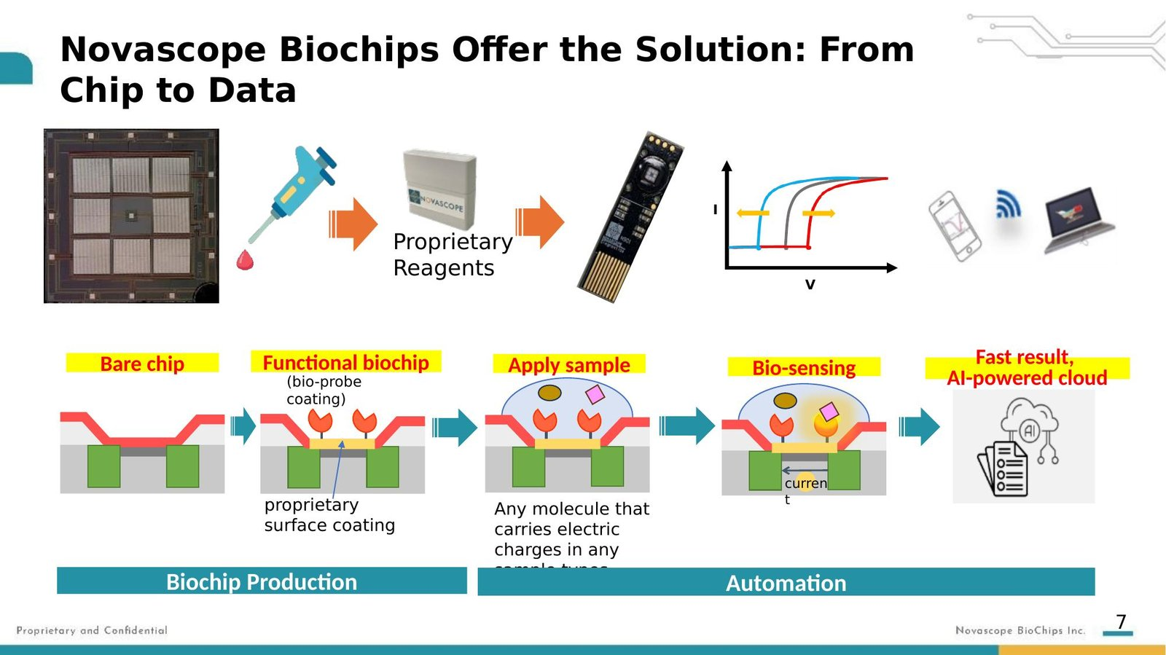
Figure 7. The Novascope workflow: from bare chip to functional biochip to clinical result — applicable to any charged biomolecule.
Current Applications
- Sepsis: 7 bacterial pathogens + AMR resistance genes — clinical validation complete
- Alzheimer’s disease: NfL, pTau 181/217/231, GFAP, Aβ42/40 — head-to-head vs. SIMOA complete
- Neurodegeneration panel: TDP-43, α-synuclein, S100B, UCH-L1 — antibodies in development
Near-Term Pipeline
- Extended sepsis panel: 60+ bacteria + resistance genes ($25B+ blood culture market)
- Oncology liquid biopsy: EGFR 168 actionable mutations ($8B+ market)
- Respiratory panel, HCV genotyping, veterinary diagnostics, food safety testing

The Market Catalyst: Alzheimer’s Companion Diagnostics
The FDA approval of lecanemab (Leqembi, $26,500/year) and donanemab has created a mandatory screening bottleneck. Every patient considered for anti-amyloid therapy requires biomarker confirmation. Current testing costs $500–$1,250 per test and is confined to reference laboratories. With an estimated 6+ million Americans with Alzheimer’s and tens of millions at risk, the screening infrastructure does not exist at current price points. Novascope’s platform — $200/test at a local clinic — fills this gap.

VII. The Team
Novascope was born where medicine meets the foundry — and our team reflects that dual DNA.
Dorothy Yen, MD PhD — Chairwoman & GM. 25+ years in microbiology and diagnostics. Former director of Taiwan’s largest clinical laboratory (>$100M annual revenue).
Chang-Fu Kuo, MD PhD — CSO & Board Director. Professor of Rheumatology, Chang Gung University. Stanford Top 2% Scientist. Former R&D Director, AI Medical Center, CGMH.
Keith Chan, PhD — VP & Board Director. Former Division Director, FDA Office of Generic Drugs. Co-founder of GloboMax.
James Wu, PhD — VP. Former Deputy Director General, ERSO/ITRI. Microelectronics, MEMS, and medical devices.
Emily Liu, CFA, CAIA — Head of Capital Markets. Deep-tech equity research and corporate finance.
US Advisory Board
Gabriel Wardi, MD (UC San Diego), Nathan Shapiro, MD (Harvard/Beth Israel), Michael McCurdy, MD (University of Maryland) — leading sepsis key opinion leaders.
US Operations
San Diego validation laboratory, CRO appointed for US clinical trials, US FDA Class I product listing established.

VIII. The Investment Opportunity
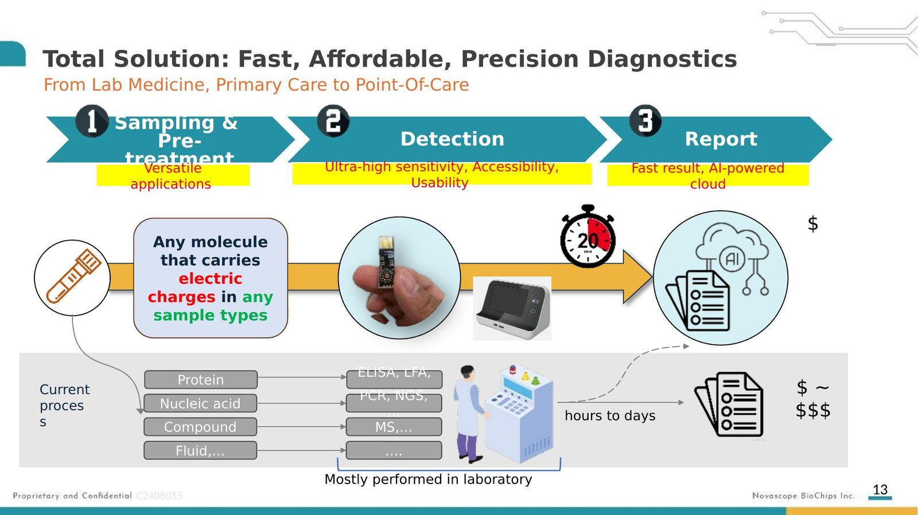
Figure 8. The total solution: fast, affordable, precision diagnostics from lab medicine to point-of-care.

Company Snapshot
Positioning | BioSemiconductor platform company
Stage | Clinical validation complete; regulatory preparation
Total Raised | ~$23.5M
Employees | ~50
Chip Generations | 6 successful wafer-outs at UMC
Antibody Portfolio | 77 clones, 15+ targets, 6 commercial products
Clinical Biobank | 291 bacterial species (108 genera) + PET-validated AD samples
Patents Filed | 40+
Production Capacity | 5,000 units/month (ISO 13485 pilot line)
Comparable | Paragraf (graphene FET) — $60M Series C at ~$300M

The De-Risking Story
Risk | How De-Risked
Does the chip work? | 6 chip generations manufactured at UMC ✔
Does it detect disease? | 98% accuracy in sepsis; R²=0.97 vs. SIMOA ✔
Can you manufacture? | ISO 13485 pilot line, 5K/month capacity ✔
Do you own the IP? | 100% ownership, 40+ patents, zero royalties ✔
Is there a market? | Anti-amyloid therapy creating mandatory screening demand ✔
Can you navigate FDA? | Former FDA Division Director on board ✔
US presence? | San Diego lab, advisory board, CRO appointed ✔

The Semiconductor Transformation of Diagnostics
The semiconductor did not improve the telephone — it replaced it with a device that is also a camera, a computer, a GPS, and a window to all human knowledge. The semiconductor did not improve the calculator — it absorbed it into a chip costing less than the paper to print its manual.
Novascope has built the platform. Six chip generations. 77 antibody clones. 291 bacterial species in a proprietary biobank. 200+ component reader designed from scratch. Clinical data matching the gold standard. The technology risk is behind us. Now it is about scaling — and the semiconductor industry has been scaling for sixty years.

NOVASCOPE: The BioSemiconductor Company

Contact: Emily Liu, CFA, CAIA — Head of Capital Markets
emily.liu@novascopedx.com

Novascope Diagnostics — BCR: BioChips Reaction
Powering Next-Generation Diagnostics for Alzheimer’s & Sepsis

