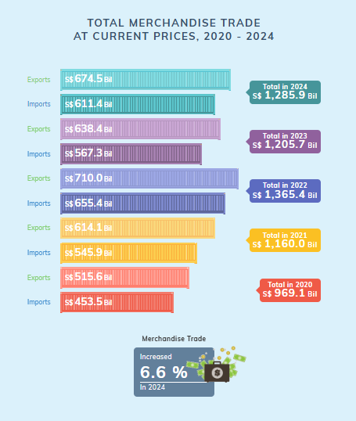

Pros
- Distinct colours chosen to separate data by year. Lighter shades are also consistently given to the Exports bar charts, making it easy to distinguish visually.
- Exact values are clearly indicated in the chart, allowing readers to get an idea of the chart’s scale and know the exact values.

Cons
- Difficult to compare between imports and exports between the years. The bar charts are stacked alternately by year. Imports should be compared with the other years’ imports, with the same applying to exports as well.
- Colour choice and differentiating data by years might not be useful. Distinct colours can be limited and might not make sense if the dataset consisted of more years. White fonts against lighter colours might also prove difficult to see. Differentiating the data by years (by colours) does not hold any functionality as well and defeats the purpose of colour usage in this chart.
- Increased percentage of merchandise trade is not intuitive. As the chart consists of data from 2020 to 2024, there should be an indication of the year that is chosen to be compared with such that there was a 6.6% increase relative to 2024.

Potential Improvement
- A line chart should be used for clear visualisation of the change over the years, as well as a rough grasp of the change between the years. The absolute value should be made available when hovered over.
- Colours should be constant individually for imports, exports, and the total per year respectively.
- Labels will be individual for each line chart rather than via a legend.


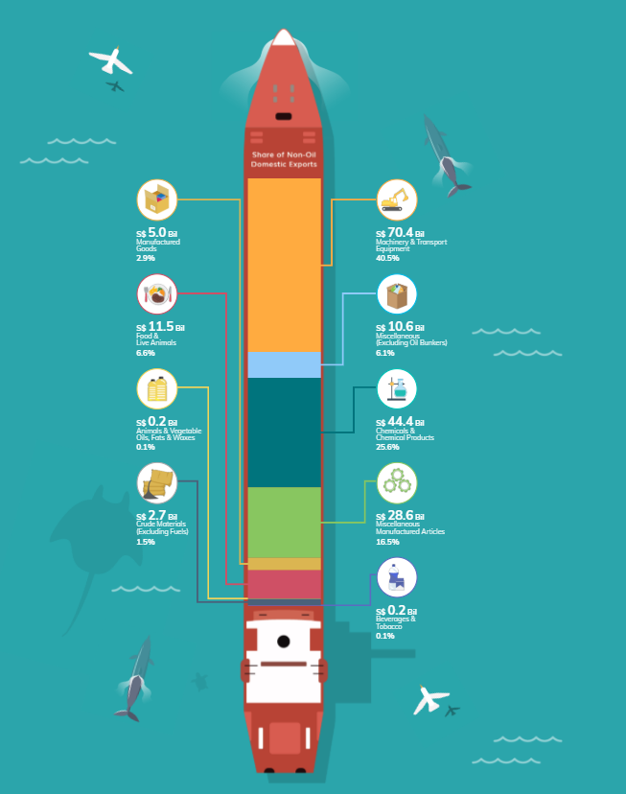
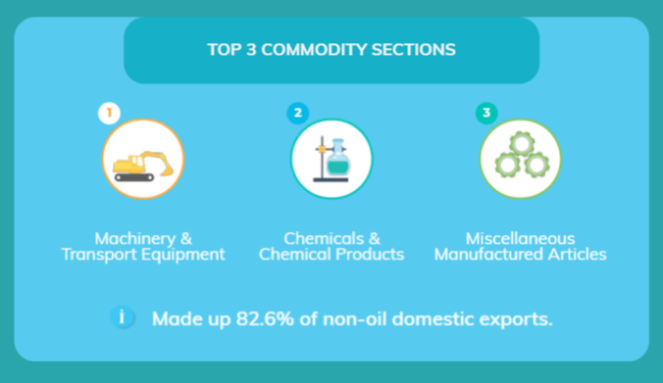

Pros
- A stacked bar chart is used to give an impression of proportionality. These are further amplified by using different colours to separate the different commodity sections.
- Animated icons are used to quickly capture the readers’ attention and give an idea of the section that is labelled without them having to read the words that are in smaller fonts.
- Clear and neat labels are used, giving readers information in a manner that is easy to process and understand quickly.

Cons
- Unsorted data display. The commodity section that has the largest proportion should be shown as the most obvious section, followed by the next. The lack of sorting thus required an additional segment at the bottom to indicate the top 3 commodity sections, which will be unnecessary if the chart could display that information.
- Unnecessary animations may be distracting. The chart included some bird and dolphin animations that do not hold value in information dissemination but yet are placed quite closely to the data that is meant to be absorbed by readers. Despite the effort for this visualisation to be attention-catching, these redundant animations might prove to be counter-productive instead.
Improvement
- Use a treemap graph. Proportions can be seen more clearly and give some form of ranking to the data. Although areas can be difficult to process comparatively, a treemap is easier to visualize than a pie chart. The most contributing commodity section can also be highlighted immediately. The intensity of the colour can further bring out this point.

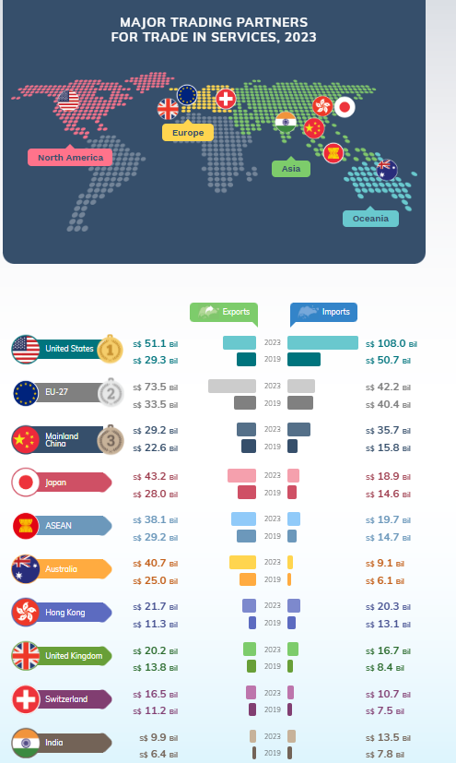

Pros
- Exact values are indicated in the chart as the proportion of the bar chart can be difficult to visualize due to the small space that the bars are plotted.
- The top 3 countries are clearly labelled. Clear identification of the top countries can be easily identified.
Cons
- Chart does not show rate of change between the two years that are being compared. The rate of change between the countries thus cannot be compared easily.
- It is not clearly stated how the countries are ranked. As the countries show imports and exports of 2019 and 2023, they could be ranked by either variable of either year, or even by the rate of change.
- It is difficult to compare the differences between the countries. They are not placed side by side for easy visual comparison and the differences could be more clearly portrayed.
Improvements
- Use a slopegraph instead. A slopegraph can clearly show the rate of change between 2019 and 2023. The data points of the different countries are also plotted on the same graph, showing their position relative to the others. This will improve on the ease of comparison between different countries for the data points as well as the rate of change of this period.
- Make the plot interactive. There might be plenty of lines on the plot which can be overwhelming. Highlight the countries that are being filtered so that comparison can be easily made between those of interest.

