Final Project: Computation Progress Report
BINF6310
Group 2
Zane Deso
Carson Hunter
Ildiko Polyak

This reproducibility project aims to reconstruct and evaluate the computational RNA-seq analysis workflow described in “Bulk RNA-seq of skeletal muscle reveals the role of ZBED6 in sepsis-induced muscle atrophy in minipigs” (Liu et al., 2025). The goal of the project is to reproduce the differential gene expression analysis associated with ZBED6 knockout and wild type skeletal muscle samples and to assess the reproducibility of the reported analytical pipeline. The pipeline begins with raw RNA-seq reads obtained from the publicly available dataset and proceeds through quality control, alignment to the reference genome, gene level quantification, and differential expression analysis, followed by downstream visualization and interpretation.
The computational workflow, as currently implemented by the group, is illustrated in Figure 1. The initial states of the pipeline involve retrieval of the raw sequencing data form the Gene Expression Omnibus (GEO) and the Sequence Read Archive using the SRA Toolkit. Metadata for the study has been extracted and organized to reflect the experimental conditions described in the paper. A script has been developed to automate retrieval of the sequencing data and to manage sample downloads in a reproducible manner. Because the full dataset contains fifty-two samples and totals approximately 308 GB of raw sequencing data, downloading the dataset requires significant processing time and storage considerations. To address this challenge, the data retrieval script includes a parameter that allows samples to be downloaded in smaller batches, allowing the workflow to be executed incrementally while minimizing storage limitations. Further considerations will be made to minimize computational processing time overhead by leveraging the explorer HPC environment. Attempts will be made to integrate the pipeline onto explorer, since doing so will speed up the time it takes to map reads to the reference genome.
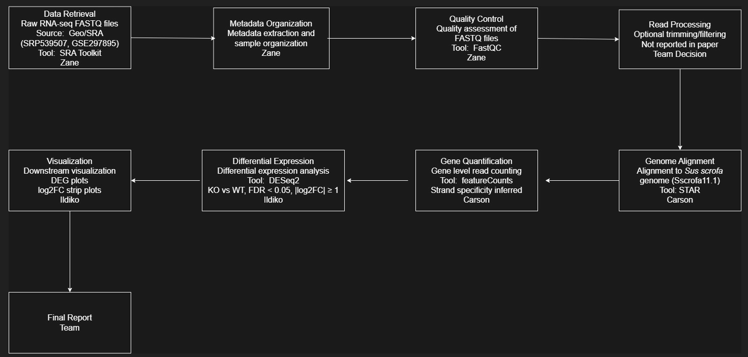
Figure 1. Computational Workflow

Following data retrieval, raw reads undergo quality assessment using the software package FastQC. This setup generates quality reports that evaluate base level sequence quality, adapter contamination, duplication levels, and other metrics relevant to RNA-seq preprocessing. Initial tests using a subset of samples indicate that the quality control scripts function as expected and produce standardized QC outputs. Full quality assessment across the entire dataset is currently in progress, and preliminary testing suggests that the workflow can be successfully executed for individual samples. These early tests also serve as proof of concept for the broader pipeline before the full dataset is processed.
After quality control, sequencing reads are aligned to the Sus scrofa reference genome (Sscrofa11.1) using the RNA-seq aligner STAR. Alignment produces binary alignment files that represent the genomic positions of sequenced reads and form the basis for downstream quantification. Because the methods section of the original paper does not fully specify certain preprocessing parameters, some alignment settings may require empirical adjustment during execution of the workflow. Additionally, while the study does not report library strandedness outright, it was discovered to be tracked within the studies meta-data link.
Gene level quantification will be performed using featureCounts from the Subread software package. This tool generates a count matrix representing the number of reads assigned to each gene for each sample. The resulting count matrix forms the input for downstream statistical analysis. Differential expression testing will be conducted using DESeq2 within the R statistical environment. Consistent with the methods reported by Liu et al. (2025), comparisons will be made between ZBED6 knockout and wild type samples within each muscle region. Differentially expressed genes will be identified using a false discovery rate threshold below 0.05 and an absolute log2 fold change of at least one. Although transcript level normalization metrics such as transcripts per million (TPM) were initially considered for normalization, further review of DESeq2’s methodology indicates that its internal normalization procedures are sufficient for count based analysis, making additional normalization unnecessary.
The group has also conducted a review of the primary tools used in the pipeline to ensure that their implementation is appropriate for reproducing the original study. STAR is a widely used RNA-seq aligner designed for high throughput transcriptomic datasets and is known for its speed and accuracy in mapping spliced reads to reference genomes. FastQC provides standardized quality assessment metrics for raw sequencing reads and is commonly used as an initial diagnostic step in RNA-seq workflows. featureCounts is an efficient read counting tool capable of assigning reads to genomic features with minimal computational overhead, making it well suited for gene level quantification. Finally, DESeq2 implements a model based on the negative binomial distribution to detect differential gene expression while accounting for sequencing depth and biological variability. These tools collectively represent a standard RNA-seq analysis pipeline consistent with the approach described in the original study.
Several potential pitfalls previously identified in the project remain relevant as the computational workflow progresses. One major challenge involves incomplete reporting of parameters within the published methods, including read preprocessing settings, and alignment configuration. While these uncertainties do not prevent execution of the pipeline, they introduce variation between the reproduced analysis and the published results. Another important consideration is the computational cost associated with the alignment step. The software STAR requires significant memory and processing time, particularly when processing dozens of samples simultaneously. Given the dataset size approximately 308 GB, computational resource management is an important aspect of the project. This is the reason attempts will be made to incorporate the pipeline onto the explorer HPC environment to leverage the superior concurrency, memory and processing speed.
There are additional logistical challenges during implementation of the workflow. The size of the raw sequencing dataset exceeds the practical limits of the repository hosting platform GitHub, meaning the data can’t be stored directly alongside the pipeline code. Instead, the project repository contains scripts that automate retrieval of the data through the SRA Toolkit. This approach ensures that the pipeline remains reproducible while avoiding the storage limitations of version-controlled repositories. At present, raw data are stored locally during processing, with the expectation that intermediate files will be removed once alignment and downstream analysis are complete to conserve storage capacity.
Despite these challenges, the project is currently progressing as planned. Scripts for downloading sequencing data and performing quality control have been successfully implemented and tested on a subset of samples. These preliminary tests indicate that the pipeline can be executed, although full dataset processing remains ongoing due to the time required to download and process the raw sequencing files. Coordination of the workflow through a shared GitHub repository ensues, allowing team members to maintain version control and run the pipeline independently within their own computing environments or on explorer.
The remaining phases of the project will involve completion of data retrieval, execution of genome alignment, generation of gene level count matrices, and differential expression analysis. Once these analyses are complete, the resulting gene expression patterns will be compared with those reported in the original publication. Visualization of differentially expressed genes across tissue types will also be generated to evaluate whether the reproduced analysis yields results consistent with the reported biological findings. An updated projected timeline is outlined in Figure 2, with alignment and quantification expected to represent the most computationally intensive stage of the workflow.
Overall, the current progress indicates that the reconstructed pipeline is feasible and that the primary obstacles relate to computational resource management and incomplete reporting of methodological parameters rather than fundamental flaws in the workflow. Continued testing and parameter evaluation during the alignment and quantification stages will help ensure that the reproduced analysis remains as true as possible to the original study while maintaining computational efficiency and reproducibility.
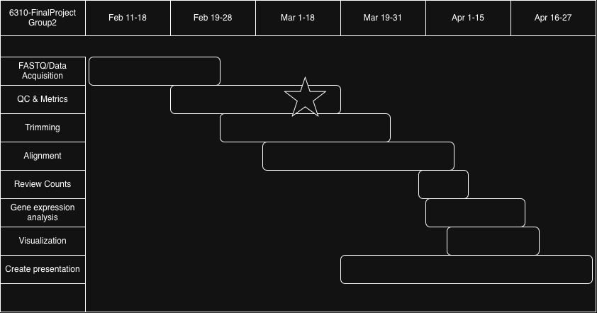
Figure 2. Timeline

References
Liu, H., Shi, W., Zheng, Y., Yang, S., Wang, Y., Yang, M., Yang, Z., Mao, E., Shang, H., Chen, E., & Chen, Y. (2025). Bulk RNA-seq of skeletal muscle reveals the role of ZBED6 in sepsis-induced muscle atrophy in minipigs. Scientific data, 12(1), 1312. https://doi.org/10.1038/s41597-025-05620-6
FastQC
Andrews, S. (2010). FastQC: A quality control tool for high throughput sequence data (Version 0.11.9) [Computer software]. Babraham Bioinformatics. https://www.bioinformatics.babraham.ac.uk/projects/fastqc/
The FastQC tool allows for rapid quality assessment and metric computation of raw fastq sequencing data prior to trimming or alignment. The tool outputs two files after a fastq file are input, a human-readable html file and a machine-readable file .zip directory with raw metric files. The html files show GC content, duplication levels, overrepresented sequences, and per base & sequence content and quality scores. This tool is being leveraged for the ease of use in generating immediately interpretable quality score metrics avoiding having to manually implement quality assessment procedures programmatically. The main params to be concerned with this tool include -t for setting thread count to allow multiple files processing simultaneously, and -outdir which specifies where to output the resultant files.
STAR
Alexander Dobin, Carrie A. Davis, Felix Schlesinger, Jorg Drenkow, Chris Zaleski, Sonali Jha, Philipp Batut, Mark Chaisson, & Thomas R. Gingeras. (2013). STAR: Ultrafast universal RNA-seq aligner. Bioinformatics, 29(1), 15-21. https://doi.org/10.1093/bioinformatics/bts635
The STAR (Spliced Transcripts Alignment to a Reference) tool allows for alignment of RNA-seq data. The tool takes FASTQ reads and a genome index file as inputs and outputs log files, and either BAM/SAM files depending on parameter options. The output files are either machine or human readable and include aligned and unmapped sequence data to the given reference genome. This is important in the pipeline since the alignment files are a central to conducting differential gene expression analysis and effectively completing the reproducibility study of Liu et al. Important parameters for the STAR alignment tool in the reproducibility study include –runThreadN to set the number of threads used in mapping, --genomeDir to specify where the reference genome file is located, --readFilesIn to specify the directory of the fastq files to be read in, and --outSAMtype to specify BAM file output.

featureCounts
Yang Liao, Gordon K. Smyth, & Wei Shi. (2014). featureCounts: An efficient general-purpose program for assigning sequence reads to genomic features. Bioinformatics, 30(7), 923-930. https://doi.org/10.1093/bioinformatics/btt656
The featureCounts tool is used to quantify gene expression levels by counting reads from BAM or SAM files. The featureCounts tool accounts for indels, splice junctions and structural variants in the reads. It also automatically detects the BAM/SAM input file type, and reorders reads to place reads next to each other if they contain location-sorted paired-end reads, which is highly convenient. This tool is essential in the reproducibility study since it relies on gene expression levels to be quantified to determine up and down regulated genes. Important parameters for this tool include -a to provide the name of the annotation file, the tool defaults to meta-feature counts, -F specifies the format of the annotation file being used, -o is used to pass in the name of the output file, -p tells the tool to use paired end reads, --countReadPairs ensures the pairs are counted together, --ignoreDup is used to ignore any marked duplicates in the BAM/SAM file(s), and --tmpDir will assign a dir to have temp files stored in during processing.
DESeq2
Michael I. Love, Wolfgang Huber, & Simon Anders. (2014). Moderated estimation of fold change and dispersion for RNA-seq data with DESeq2. Genome Biology, 15(12), 550. https://doi.org/10.1186/s13059-014-0550-8
Deseq2 is an R package that enables analysis of counts from high-throughput sequencing data. This tool allows for the determination of differential gene expression levels between conditions. This is necessary in the reproducibility study to compare expression levels between KO and WT genes in the model organism. Without such a tool, the statistical workload to complete this task would be much larger. Important parameters include object, which a DESeq class instance, test tells DESeq to use either the Wald or LRT method for significance testing, and parallel to tell the software to do parallel execution. It should be noted that DEQeq is called via functions in R, rather than fun from CLI like previous tools.

