1. Go to <http://edw.washington.edu/reports/> and log in with UW NetID

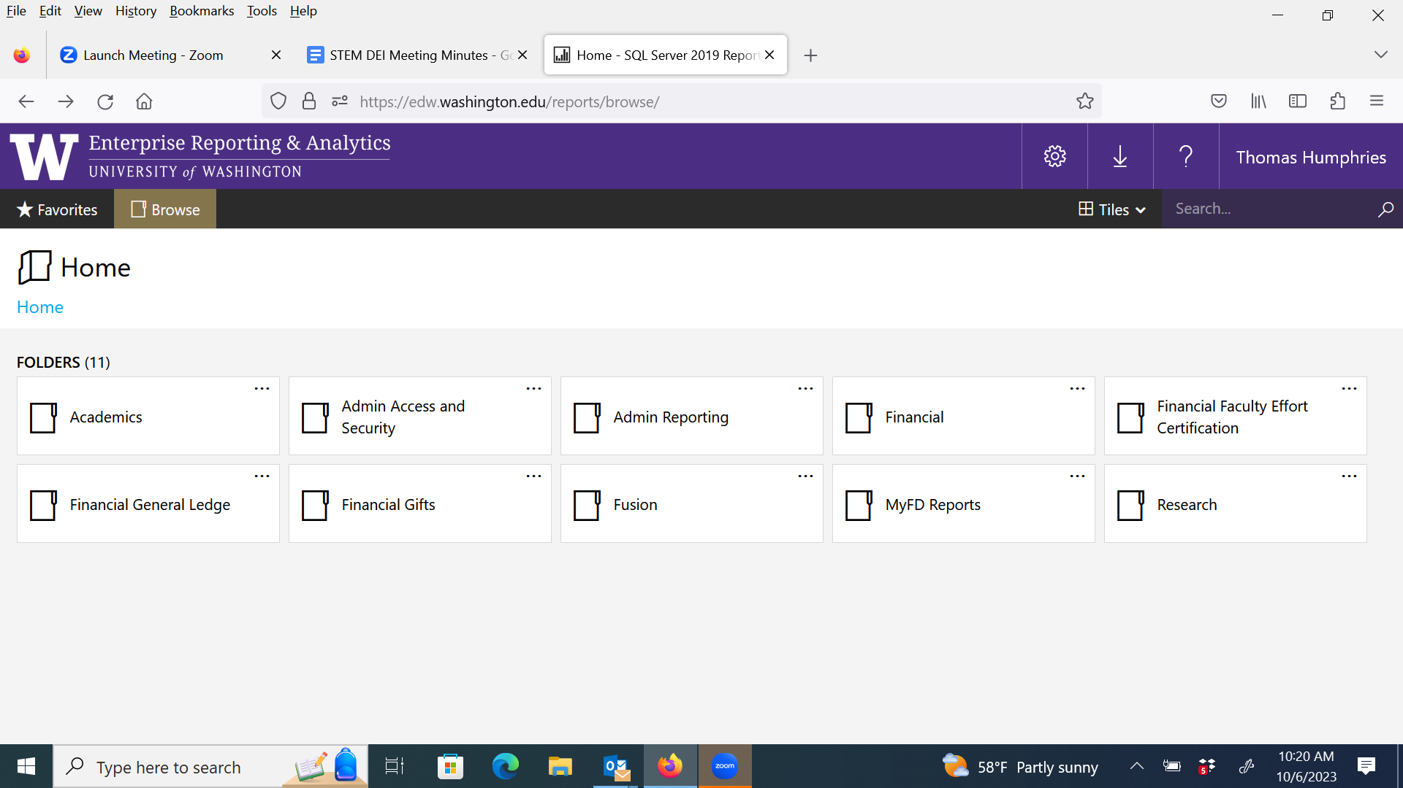

1. Click Academics -> Current Student Information

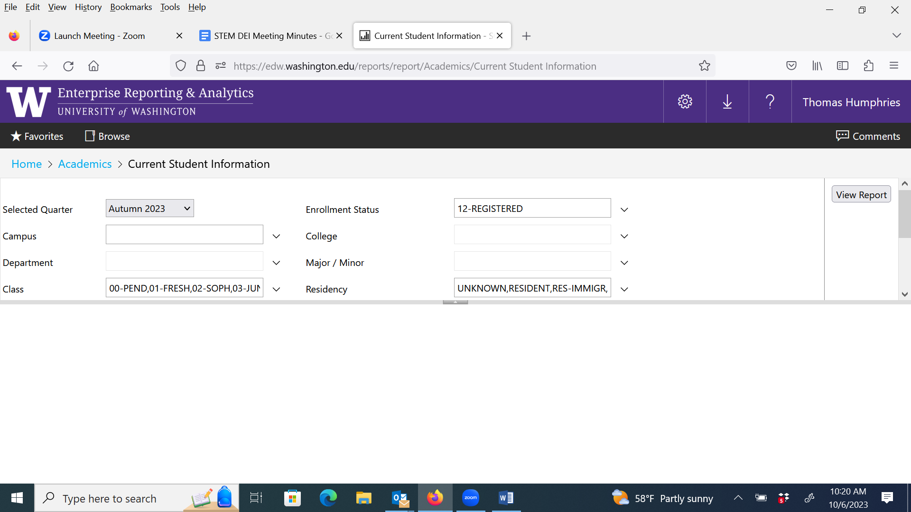

1. Enter   
   * Campus: Bothell  
   * College: UW Bothell  
   * Department: Select All

Then: View Report. Wait for report to finish generating, then click Disk icon to save as .csv or .xls file.

Other information

* Here’s the [Major_Codes metadata](https://edw.washington.edu/reports/report/Academics/Major_Codes)