Standard Operating Procedure for Ethidium Bromide

Ethidium Bromide

# Section 1 – Lab-Specific Information

**Building/Room(s) covered by this SOP: BB274/275**

**Unit or department: Biology**

**Principal Investigator Name: Jesse Zaneveld**

**Principal Investigator Signature/Date:** 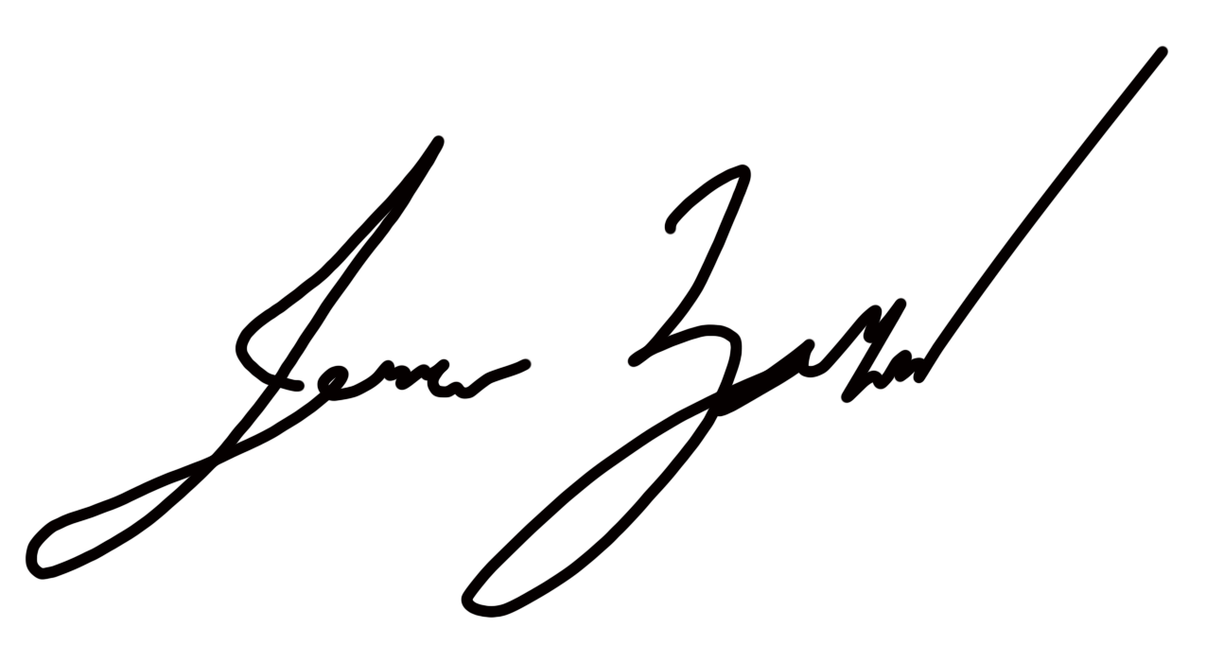

**6/16/23**

**This SOP was created by (if not PI): Tanya Brown/Research Associate**

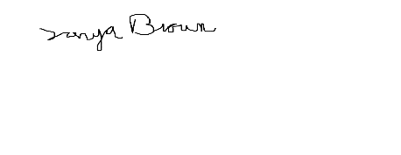

**Name/Title/Date/Signature 6/13/2023**

# Section 2 – Hazards

Ethidium bromide is classified by OSHA as highly toxic by inhalation, harmful by ingestion, and a mutagen. Avoid breathing dust, fumes, gas, vapor, mist, or spray. Toxic if inhaled. Ethidium bromide is suspected of causing genetic defects.

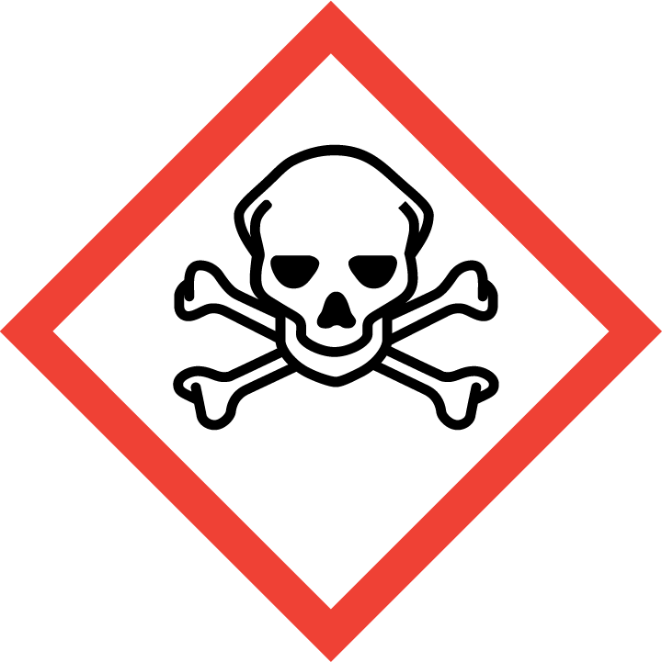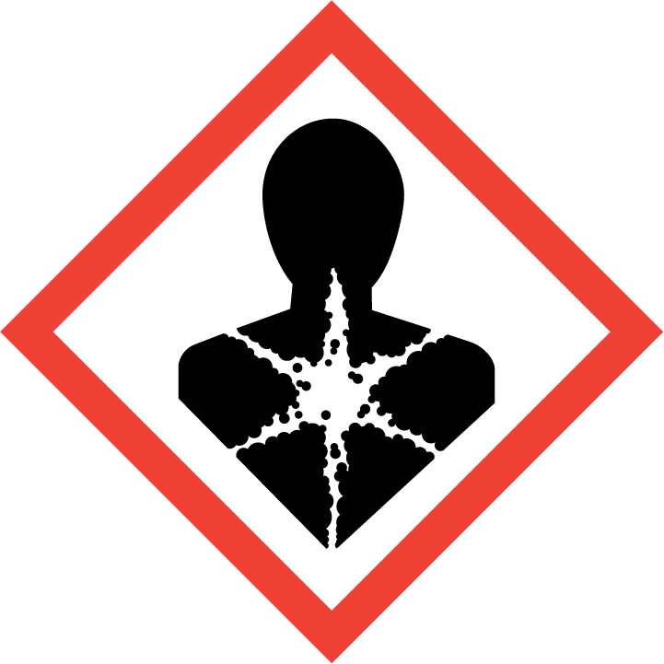

# Section 3 – Engineering Controls and Personal Protective Equipment (PPE)

## Engineering controls

Under normal working conditions where ethidium bromide is in very low concentrations in agarose gel or in an aqueous solution, use in chemical fume hood is not required, but recommended. However, all ethidium bromide powder (pure product) must be handled in a properly functioning chemical fume hood.

Any chemical fume hood used must be tested and passed by EH&S and have a velocity between 80-125 feet per minute.

## Hygiene measures

Avoid contact with skin, eyes, and clothing. Wash hands after removing PPE (gloves, lab coat), before breaks, and immediately after handling the chemical. If Ethidium Bromide come(s) into contact with any PPE, the PPE shall be immediately removed and discarded properly. Any potentially exposed body parts should be washed immediately.

## Skin and body protection

Chemically compatible laboratory coats that fully extend to the wrist must be worn and be appropriately sized for the individual and buttoned to their full length. Personnel must also wear full-length pants, or equivalent, and close-toe shoes. The area of skin between the shoe and ankle must not be exposed.

## Hand protection

Hand protection is required for the activities described in this SOP.Nitrile gloves are recommended. Wearing two pairs of nitrile gloves is also recommended.

**NOTE: Consult with your preferred glove manufacturer to ensure that the gloves you plan to use are compatible with the specific chemical being used.**

Gloves must be inspected prior to use, including a check for pinholes.

Use proper glove removal technique (without touching glove’s outer surface) to avoid skin contact with this product. Dispose of contaminated gloves after use in accordance with applicable laws and good laboratory practices. Wash and dry hands immediately after glove removal.

## Eye protection

ANSI Z87.1-compliant eye protection is required for all work with ethidium bromide. Ordinary prescription glasses will NOT provide adequate protection unless they also meet the Z87.1 standard and have compliant side shields.

ANSI approved properly fitting safety glasses or chemical splash goggles are required. A face shield may also be appropriate depending on the specific application.

## Respiratory protection

Respiratory protection is not required for the activities described in this SOP.

Under normal working conditions where ethidium bromide is in very low concentrations in agarose gel or in an aqueous solution, respiratory protection is not required. However, all ethidium bromide powder (pure product) must be handled in a properly functioning chemical fume hood.

# Section 4 – Special handling and storage requirements

* 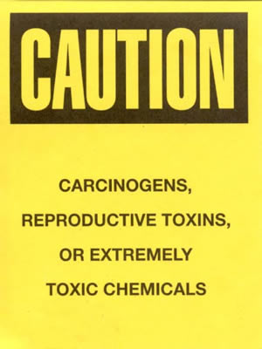Designate an area where ethidium bromide work is going to occur and only handle it in this area (i.e. chemical fume hood, bench top). The area for use is sectioned off with a diaper with a tip and gel disposal area.
* A current copy of the SDS for the specific ethidium bromide powder or solution and concentration must be made available to all personnel working in the laboratory at all times.
* It is recommended that the surfaces of the designated area be covered with an appropriate liner (i.e. plastic, chemical resistant liner). If the liner becomes contaminated, it can be replaced and disposed of as ethidium bromide contaminated debris.
* If a liner cannot be used, then the surfaces of the work area should be decontaminated routinely. All spills or evidence of contamination should be cleaned immediately.
* Avoid contact with skin and eyes and inhalation.
* Keep containers tightly closed.
* Store in a cool, dry and well-ventilated area.
* Containers which are opened must be carefully resealed and kept upright to prevent leakage.
* Routinely decontaminate the area where ethidium bromide is used. Decontamination procedures are detailed below:

**Decontamination Procedures:**

* Prepare the following decontamination solution:
  + 4.2 grams of sodium nitrite (NaNO2)
  + 20 milliliters of 50% hypophosphorous acid solution (H3PO2)
  + 300 milliliters of water
* Soak a paper towel in the decontamination solution and thoroughly wash the contaminated area.
* Once the contaminated area has been thoroughly washed with the decontamination solution, rinse the area 5 times with tap water using a clean paper towel for each rinse.
* Soak all spent paper towels in the decontamination solution for one hour. Gently wring out excess solution and dispose of as hazardous waste with contaminated gloves, pipette tips or any other solid ethidium bromide debris.
* Using a UV light, check to ensure all ethidium bromide has been removed.
* The decontamination solution should be collected in an appropriate container and labeled as hazardous waste (i.e. Water 95%, hypophosphorus acid 3%, Sodium Nitrite 1%, ethidium Bromide 1%).

**Note:** Hypophosphorous acid is a DEA List chemical. When purchasing this product, you and your PI will have to fill out and sign an “Authorized Purchaser” form. This is simply a company’s method of ensuring you will not misuse the material.

Click here to enter text.

# Section 5 – Spill and accident procedures

Chemical spills must be cleaned up as soon as possible by properly protected and trained personnel. All other persons should leave the area. See decontamination procedure in Section 4.

If lab personnel feel comfortable cleaning up the spill, then they can do so as long as proper training has been provided. The spilled material should be absorbed and/or collected and put in an appropriate container (e.g., bucket and/or bag) for proper disposal by EH&S. The decontamination procedures detailed in Section 4 of this SOP should be followed for decontaminating surfaces.

Clean up spills using contents of the laboratory spill kit.

Do **not** attempt to clean up any spill if **not** trained or comfortable. Evacuate the area and call 9-1-1 on campus phone for help. If the spill is out of control, call 9-1-1. If a person is injured, exposed or suspected of being exposed, call 9-1-1 and follow the EXPOSURE PROCEDURES (below).

Spill area must be cleaned up in the following manner: Cleaning must be conducted using absorbent pads and placed in a sealed bag labeled with “Hazardous Waste.” After absorption, the area must be cleaned using a detergent solution

Spill cleanup materials must be disposed of in the following manner: Bag absorbent pads into a biohazard bag and contact EH&S for pickup.

For questions on spill cleanup, contact EH&S spill consultants at 206‐543‐0467 during normal business hours (Monday-Friday, 8 a.m. to 5 p.m.).

Any spill, exposure or near miss incident requires the involved person or supervisor to complete and submit the [Online Accident Reporting System (OARS)](https://www.ehs.washington.edu/workplace/accident-and-injury-reporting) form on the EH&S website within 24 hours ([certain types of incidents](https://ehs.washington.edu/workplace/accident-and-injury-reporting) require immediate notification) at oars.ehs.washington.edu.

**Exposures:** If a person is injured, exposed, or suspected of being exposed to ethidium bromide, follow procedures listed here:

**Perform first aid immediately.**

* **Inhalation exposure**: Move out of contaminated area; get medical help.
* **Sharps injury** (needle stick or subcutaneous exposure): Scrub exposed area thoroughly for 15 minutes using warm water and sudsing soap.
* **Skin exposure:** Use the nearest safety shower for 15 minutes; stay under the shower and remove clothing; use a clean lab coat or spare clothing for cover‐up.
* **Eye exposure:** Use the eye wash for 15 minutes while holding eyelids open.

**Get Help.**

* **Call** 9-1-1 or go to nearest Emergency Department (ED); provide details of exposure:
  + - Agent
    - Dose
    - Route of exposure
    - Time since exposure
* **Bring** **the SDS and this SOP** to the Emergency Department
* **Notify your supervisor** as soon as possible for assistance
* **Secure the area** before leaving; lock doors and indicate spill if needed

**Report the incident to Environmental Health & Safety**.

* **Notify** **EH&S immediately** after providing first aid and/or getting help.
  + During business hours (M‐F/8‐5), call 206‐543‐7262.
  + Outside of business hours, call 206‐685‐UWPD (8973) to be routed to EH&S Staff On Call.
* The involved person or supervisor submits the UW Online Accident Reporting System (OARS) form on the EH&S website within 24 hours ([certain types of incidents](https://ehs.washington.edu/workplace/accident-and-injury-reporting) require immediate notification) at oars.ehs.washington.edu.

# Section 6 – Waste accumulation and disposal procedures

Waste generated from ethidium bromide containing gels and running buffer are collected in BB274. Gels are collected in a sturdy bin with a biohazard bag. Liquid is collected in sturdy screw cap glass bottles.

Once liquid running buffer has been used three times, a neutralizing tea bag with carbon in it is placed into the contaminated buffer for 24 hours. The carbon neutralizes the ethidium bromide and it is then safe to pour down the drain. Clean bottles well with soap and water.

**All chemical waste containers must be labeled** with a [UW Hazardous Waste Label](https://www.ehs.washington.edu/chemical/hazardous-chemical-waste-disposal). Refer to [How to Label Chemical Waste Containers](https://www.ehs.washington.edu/system/files/resources/how-to-label-chemical-waste-containers.pdf).

To request a collection of chemical waste, submit a form on the [Chemical Waste Disposal](https://www.ehs.washington.edu/chemical/hazardous-chemical-waste-disposal) webpage on the EH&S website or directly in [MyChem](https://www.ehs.washington.edu/chemical/mychem) inventory. Contact EH&S at 206.616.5835 or [chmwaste@uw.edu](mailto:chmwaste@uw.edu) with questions.

Work area decontamination procedures as appropriate for the chemical in use should be followed.

Any ethidium bromide contaminated gloves or gels need to be disposed of in the sturdy container with a biohazard bag in it found by the gel rig in BB274. Once the bag is full EH&S is contacted for disposal of contaminated waste.

# Section 7 – Protocol

Ethidium Bromide is used in low concentrations in gels. It is used to visualize DNA and RNA under a transilluminator found in BB245. Ethidium Bromide is added to cooled (baby bottle warm) agarose gel in BB274. It is added in the fume hood using a designated pipette. We add 3ul of Ethidium Bromide to 30ml of liquid agarose and swirled. The gel is then immediately poured into the gel mold and well combs are inserted. After solidification TAE buffer is added to over the gel in the gel rig. Samples are loaded and run. Images are captured on the gel imager in BB275. Gels and contaminated gloves are disposed of in the gel waste container in BB274. Used buffer is poured into a glass bottle with screw top lid and can be reused up to 3 times. Once the buffer is used three times it is decontaminated using a carbon tea bag.

**NOTE:** Any deviation from this SOP requires approval from Principal Investigator.

# Section 8 – Special Precautions for animal use (No)

NA

# Section 9 – Approvals required

All staff working with Ethidium Bromide must be trained on this SOP prior to starting work. They must also review the Ethidium Bromide SDS, and it must be readily available in the laboratory. All training must be documented and maintained by the PI or their designee.

* Staff must undergo training with the PI or lab manager for proper use and disposal of contaminated material.

# Section 10 – Decontamination

The work area around the gel rigs is protected using disposable dippers. When the dipper becomes contaminated with spilled buffer containing ethidium bromide, it is disposed of in a biohazard bag. Ethidium bromide is added to gels under the fume hood and the area is frequently cleaned with bleach.

Waste generated from ethidium bromide containing gels and running buffer are collected in BB274. Gels are collected in a sturdy bin with a biohazard bag. Liquid is collected in sturdy screw cap glass bottles.

Once liquid running buffer has been used three times, a neutralizing tea bag with carbon in it is placed into the contaminated buffer for 24 hours. The carbon neutralizes the ethidium bromide and it is then safe to pour down the drain. Clean bottles well with soap and water.

# Section 11 – Designated area

# Ethidium bromide is used to make gels in UWBB-274 and gels containing ethidium bromide are imaged in UWBB-275. The gel running area next to the fume hood facing away from the windows is the only location ethidium bromide is used in UWBB-274. The fume hood adjacent to the gel rig set up is used to add the ethidium bromide to the gel using a designated contaminated pipette. The gel imaging station in UWBB-275 is the only location where ethidium bromide contaminated material touches a surface.

# Section 12 – Documentation of training

* Prior to using substances included in this SOP, laboratory personnel must be trained on the hazards described in this SOP, how to protect themselves from the hazards, and emergency procedures.
* Ready access to this SOP and to a Safety Data Sheet for each hazardous material described in the SOP must be made available in the lab space(s) where these substances are used.
* The Principal Investigator (PI), or Responsible Party, if the activity does not involve a PI, must ensure that their laboratory personnel have attended appropriate laboratory safety training (and refresher training where applicable).
* Training must be repeated following **any** revision to the content of this SOP.
* Training must be documented. This training sheet is provided as one option; other forms of training documentation (including electronic) are acceptable but records must be accessible and immediately available upon request.

**I have read and understand the content of this SOP:**

| **Name** | **Signature** | **Date** |
| --- | --- | --- |
| **Tanya Brown** | tb signature | **6/13/23** |
|  |  |  |
|  |  |  |
|  |  |  |
|  |  |  |
|  |  |  |
|  |  |  |
|  |  |  |
|  |  |  |
|  |  |  |
|  |  |  |
|  |  |  |