**INSTRUCTIONS: This is an SOP template; it is complete when**

**1) All form fields have been completed to reflect chemical/lab-specific information,** including adding relevant procedure information, or deleted inapplicable information; and

**2) SOP has been signed and dated by the PI and relevant lab personnel.**

Use safety data sheets (SDSs) as a resource for chemical-specific information. Text highlighted in gray indicates where information should be added or edited. Delete all instructions in red text and “Draft” watermark after the SOP is approved by PI.

Standard Operating Procedure

Flammable Liquids

Print a copy and insert into your *Lab-Specific Chemical Hygiene Plan*.

**Section 1 – Lab-Specific Information**

**Building/Room(s) covered by this SOP: INV-231**

**Unit or department: Biological Sciences**

**Principal Investigator Name: Jesse Zaneveld**

**Principal Investigator Signature/Date:** 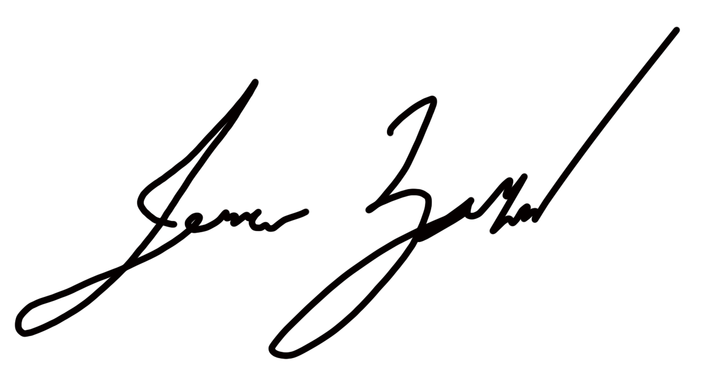

**This SOP was created by (if not PI): PI**

**Name/Title/Date/Signature: NA**

# **Section 2 – Definitions and Hazards**

* **Flammable Liquid:** Liquids having a flash point below 38oC (100oF).
* **Combustible Liquid:** Liquids having a flash point at or above 38oC (100oF) and no greater than 93oC (200oF).
* 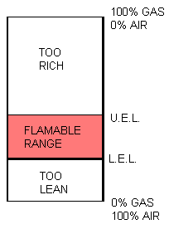**Flash Point:** The minimum temperature at which vapors are formed on the surface of a substance in sufficient quantity to ignite when exposed to an ignition source.
* **Fire Point:** The minimum temperature at which self-sustained combustion of a substance will occur upon or after exposure to an ignition source.
* **Boiling Point:** The temperature at which the vapor pressure of a liquid equals the atmospheric pressure and the liquid changes into a vapor.
* **Auto Ignition Temperature:** The minimum temperature at which self-sustained combustion will occur in the absence of an ignition source.
* **Lower Explosive Limit** **(LEL):** The lowest concentration (percentage) of a gas or a vapor in air capable of producing a flash of fire in presence of an ignition source (arc, flame, heat).
* **Upper Explosive Limit** **(UEL):** Highest concentration (percentage) of a gas or a vapor in air capable of producing a flash of fire in presence of an ignition source (arc, flame, heat).

Keep flammable or combustible liquid away from heat, sparks, open flames, and hot surfaces. Flammable and combustible liquids often have other hazards associated with them such as toxicity and the ability to form explosive organic peroxides. Make sure that all of the potential hazards are understood before handling any chemical.

GHS Flammable Hazard Pictogram


**Section 3 – Engineering and Personal Protective Equipment (PPE)**

**Engineering Controls:** The use of flammable and combustible liquids should be conducted in a properly functioning chemical fume hood whenever possible. The chemical fume hood must be approved and certified by EH&S.

**Hygiene Measures:** Avoid contact with skin, eyes, and clothing. Wash hands before breaks and immediately after handling the chemical.

**Hand Protection:** Chemical-resistant gloves must be worn, nitrile gloves are recommended for low volume applications. Wearing two pairs of nitrile gloves is recommended. If handling a high volume (> 1 liters) of flammable or combustible liquid, then disposable gloves are likely not suitable; a more heavy duty glove such as a butyl rubber is required. **NOTE:** Consult with your preferred glove manufacturer to ensure that the gloves you plan on using are compatible with the specific chemical being used.

**Eye Protection:** ANSI-approved properly fitting safety glasses or chemical splash goggles are required. A face shield may also be appropriate depending on the specific application.

**Skin and Body Protection:** Laboratory coats must be worn and be appropriately sized for the individual and buttoned to their full length. Flame resistant lab coats must be worn when handling volumes greater than 1 liter. Personnel must also wear full length pants, or equivalent, and close-toed shoes. Full length pants and close-toed shoes must be worn at all times by all individuals that are occupying the laboratory area. The area of skin between the shoe and ankle must not be exposed.

**Respiratory Protection:** If flammable and/or combustible liquids are being used outside of a chemical fume hood, respiratory protection may be required. If this activity is necessary, contact EH&S at 206.543.7388 so a respiratory protection analysis can be performed.

# **Section 4 – Special Handling and Storage Requirements**

* Flammable Storage Cabinet
  Designate a storage area for flammable and combustible liquids such as a flammable storage cabinet (as shown to the right).
* No more than 37 liters (10 gallons) of flammable liquid is permitted to be stored outside of a flammable storage cabinet.
* Make a current copy of the SDS for the specific flammable/combustible liquids being used available to all personnel working in the laboratory at all times.
* Do not over purchase; only purchase what can be safely stored in the laboratory.
* Avoid contact with skin, eyes, and inhalation.
* Keep away from sources of ignition.
* Keep containers tightly closed. Store in a cool, dry, and well-ventilated area away from incompatible substances such as oxidizers.
* Follow laboratory supervisor’s instructions for PPE, which may differ depending on the type and/or quantity of flammable/combustible liquid being used.
* Use in the smallest practical quantities for the experiment being performed.
* Conduct work in a chemical fume hood if air concentrations above 10% of the PEL could be created, if the chemical is irritating to the eyes or respiratory system, and/or is toxic by inhalation.
* Keep containers closed when not in use. This is to preventing accumulation of flammable vapor concentrations and accidental ignition.
* Label containers appropriately. Label should indicate the name of the chemical(s) in the container. Avoid using chemical abbreviations and formulae.
* When not in use, store in flammable storage cabinets if possible.
* Figure 5.2 – Flammable Safety Can

  Containers must be in good condition and compatible with the material; store in safety cans (spring closing lid, as illustrated to the right) if possible.
* Avoid using ignition sources (flame burners or any open flame source, hot plates, electrical equipment with frayed or cracked wiring, etc.) and/or creating static electricity in areas where flammable/combustible chemicals are being used.
* Ground and bond containers when transferring more than 4 liters of flammable/combustible liquids.
* Transport all flammable/combustible liquids in secondary containment, such as polyethylene or other non-reactive acid/solvent bottle carrier.
* Segregate flammable/combustible liquids from incompatible materials such as oxidizers (e.g., hydrogen peroxide, nitric acid). Incompatibilities will be noted in Section 10 of the SDS, “Stability and Reactivity”.
* If flammable liquids will be stored in refrigerators or freezers, these will be specially modified or purpose-made “flammable-safe” refrigerators and freezers which have no internal sources of ignition posed by an internal light or thermostat circuit.

# **Section 5 – Spill and Accident Procedures**

If skin is exposed, remove contaminated clothing, wash with soap and water. If eye is exposed, call 911 as soon as possible and flush eyes for 15 minutes in the eye wash.

Immediately evacuate area if fumes present a serious health risk and ensure others are aware of the spill. During normal business hours (Monday – Friday, 8 AM – 5 PM), call EH&S at 206.543.0467 for further assistance. If it is after hours, call 911 for further assistance. If there is an imminent threat of a fire, pull the nearest fire alarm station to evacuate the building and **dial 911.** If it is safe to clean up the spill, wear PPE listed above. Double bag and securely fasten spill materials. Label as hazardous waste. Label bags as hazardous waste.

Report the spill via the EH&S Online Accident Reporting System (OARS).

# **Section 6 – Waste Disposal Procedures**

Store hazardous waste in closed containers that are properly labeled, and in a designated area (flammable cabinet is recommended). Flammable and combustible liquid waste should be segregated from all incompatibles such as oxidizers. No flammable or combustible liquids (including alcohols) are permitted to be poured down the drain. Request chemical waste collection via the EH&S website.

# **Section 7 – Protocol**

Click here to enter text.

**NOTE:** Any deviation from this SOP requires approval from Principal Investigator.

# **Section 8 – Documentation of Training (signature of all users is required)**

Prior to conducting any work with flammable liquids, the Principal Investigator must ensure that all laboratory personnel receive training on the content of this SOP.

**I have read and understand the content of this SOP:**

| **Name** | **Signature** | **Date** |
| --- | --- | --- |
| **Jesse Zaneveld** |  | **12/19/24** |
|  |  |  |
|  |  |  |
|  |  |  |
|  |  |  |
|  |  |  |
|  |  |  |
|  |  |  |
|  |  |  |
|  |  |  |