Laboratory Risk Assessment Tool (Lab R.A.T.)

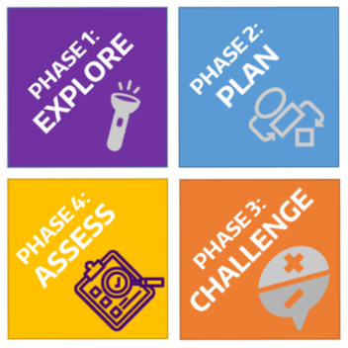The Laboratory Risk Assessment Tool (Lab RAT) provides a framework for risk assessment complimenting the process researchers already use to answer scientific questions.

This tool provides a format for researchers to systematically identify and control hazards to reduce risk of injuries and incidents. Conduct a risk assessment prior to conducting an experiment for the first time and review the [**Lab R.A.T. Guidelines**](https://www.ehs.washington.edu/system/files/resources/laboratory-risk-assessment-tool-guidelines.pdf) document for further details.

The risk assessment process involves rating the risk of the experiment from “low” to “unacceptable” risk. Consult with your PI/supervisor and EH&S if your risk rating is “high” or “unacceptable” to redesign the experiment and/or implement additional controls to reduce risk.

|  |  |  |
| --- | --- | --- |
| **Procedure:** | | |
| **PI / Lab Group:** | | |
| **Department:** | **Building / Location:** | |
| **Form Completed By:** | | **Start Date:** |

# Phase 1: Explore

**Identify your research question and approach.** What question are you trying to answer? What are you trying to measure or learn? What is your hypothesis? What approach or method will you use to answer your question? Are there alternative approaches?

|  |
| --- |
| **Research Question(s)** |
|  |
| **Approach(s) or Method** |
|  |

**Identify the general hazards (check all that apply).** Perform background research to identify known risks of the reagents, reactions, or processes. Review protocols, Safety Data Sheets (SDSs), and safety information for hazardous chemicals, agents, or processes. Review accident histories within your laboratory/department.

|  |
| --- |
| **Hazardous Agents** |

**Physical Hazards of Chemicals**

☐ Compressed gases

☐ Cryogens

☐ Explosives

☐ Flammables

☐ Organic peroxides

☐ Oxidizers

☐ Peroxide formers

☐ Pyrophorics

☐ Self-heating substances

☐ Self-reactive substances

☐ Substances which, in contact with water, emit flammable or toxic gases

**Health Hazards of Chemicals**

☐ Acute toxicity

☐ Carcinogens

☐ Eye damage/ irritation

☐ Germ cell mutagens

☐ Nanomaterials

☐ Reproductive toxins

☐ Respiratory or skin sensitization

☐ Simple asphyxiant

☐ Skin corrosion/ irritation

☐ Specific target organ toxicity

☐ Hazards not otherwise classified

**Ionizing Radiation**

☐ Irradiator

☐ Radionuclide

☐ Radionuclide sealed source

☐ X-ray machine

**Non-Ionizing Radiation**

☐ Lasers, Class 3 or 4

☐ Lasers, Class 2

☐ Magnetic fields (e.g., NMR, MRI)

☐ RF/microwaves

☐ UV lamps

**Biohazards**

☐ BSL-2 Biological agents

☐ BSL-3 Biological agents

☐ Human cells/blood/ BBP

☐ NHPs/cells/blood

☐ Non-exempt rDNA

☐ Animal work

☐ High risk animals (RC1)

☐ Other (list):

|  |
| --- |
| **Hazardous Conditions or Processes** |

**Reaction Hazards**

☐ Explosive

☐ Exothermic, with potential for fire, excessive heat, or runaway reaction

☐ Endothermic, with potential for freezing solvents decreased solubility or heterogeneous mixtures

☐ Gases produced

☐ Hazardous reaction intermediates/products

☐ Hazardous side reactions

**Hazardous Processes**

☐ Generation of air contaminants (gases, aerosols, or particulates)

☐ Heating chemicals

☐ Large mass or volume

☐ Pressure > atmospheric

☐ Pressure < atmospheric

☐ Scale-up of reaction

**Other Hazards**

☐ Hand/power tools

☐ Moving equipment/parts

☐ Electrical

☐ Noise > 80 dBA

☐ Heat/hot surfaces

☐ Ergonomic hazards

☐ Needles/sharps

☐ Other (list):

# Phase 2: Plan

**Outline the Procedure.** List the steps or tasks for your procedure and the hazard/potential consequences of each. Include set-up and clean-up steps or tasks. Define the hazard controls to minimize the risk of each step using the hierarchy of controls starting with the most effective (i.e., elimination, substitution, engineering controls, administrative controls, and personal protective equipment). List the hazard control measure you would use for each step or task (e.g., run at a micro scale, work in a fume hood, wear face shield and goggles).

|  |  |  |
| --- | --- | --- |
| **Steps or Tasks** | **Hazard** | **Hazard Control Measure(s)** |
|  |  |  |
|  |  |  |
|  |  |  |
|  |  |  |
|  |  |  |
|  |  |  |
|  |  |  |
|  |  |  |
|  |  |  |
|  |  |  |

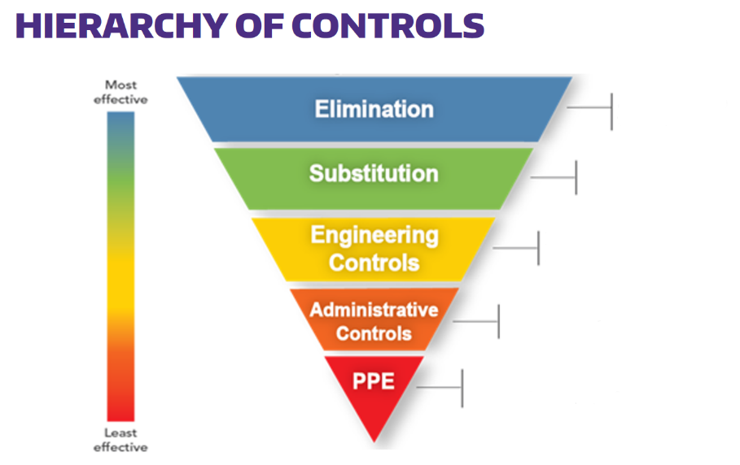

**Eliminate use of chemical or hazard**

**Use a less hazardous chemical, concentration, or process**

**Isolate people from hazard (e.g. ventilation, barriers)**

**Change the way people work (e.g. training, work policies, SOPs)**

**Personal protective equipment**

**(e.g. lab coat, appropriate gloves, goggles)**

*1 For guidance on selection of Personal Protective Equipment (PPE), use EH&S PPE Hazard Assessment Tool.*

*2 For guidance on selection of chemical-resistant gloves, see EH&S Website.*

A hierarchy of controls should be applied starting with the most effective controls (i.e., elimination and substitution) at the top of the graphic and moving down. While personal protective equipment (PPE) should always be used, it should be considered the last line of defense from potential hazards.

**Select the appropriate PPE and safety supplies for the procedure (check all that apply).**

|  |
| --- |
| **Laboratory PPE/Safety Supplies** |

☒ Appropriate street clothing

(long pants, closed shoes)

☐ Gloves; indicate type: ________________________

☐ Safety glasses

☐ Safety goggles

☐ Face shield and googles

☐ Lab coat

☐ Flame-resistant lab coat

☐ Fire extinguisher

☐ Eyewash/safety shower

☐ First aid kit

☐ Spill kit

☐ Specialized medical supplies (e.g. calcium gluconate for hydrofluoric acid and amyl nitrite for cyanides

☐ Other (list):

**Identify the appropriate training (check all that apply).** Identify the general safety and procedure based/specific training appropriate for your procedure.

|  |
| --- |
| **General Safety Training** |

**General/Chemical Safety**

☐ Lab Safety Compliance & Practices

☒ Managing Lab Chemicals

☐ Compressed Gas Safety

☐ Fume Hood Training

☐ Hydrofluoric Acid Safety

☐ Formaldehyde Safety

**Biosafety**

☐ Biosafety Training

☐ Bloodborne Pathogens

**Radiation Safety**

☐ Radiation Safety

☐ Laser Safety

**Field Safety**

☐ First Aid & CPR

☐ SCUBA certification/diving safety

☐ Driving safety

☐ Other (list):

|  |
| --- |
| **Job Specific Training** |

☒ Lab/job-specific training

☐ Lab SOP(s) to review (list):

☐ Emergency plans or field evacuation plans

☐ Equipment SOP(s) to review (list):

☐ Other (list):

# Phase 3: Challenge

**Question your methods.** What have you missed and who can advise you? Challenge your hazard control measures by asking “What if…?” questions. “What if” questions should challenge you to find the gaps in your knowledge or logic. Include possible accident scenarios. Factors to consider are human error, equipment failures, and deviations from the planned/expected parameters (e.g., temperature, pressure, time, flow rate, and scale/concentration). Update your plan to include any new controls required to address these possibilities.

|  |
| --- |
| **What If Analysis** |
| **What if…?** Examples: there is a loss of cooling? …valves/stopcocks are left open/closed? …there is unexpected over-pressurization? …a spill occurs? …the laser is misaligned? …weather conditions change? |
| **Then…** there may be a runaway reaction. …there may be an unexpected splash potential. …the reaction vessel may fail. …there may be a dermal exposure. …there may be an eye injury. …routes may be inaccessible. |
| **What if…?** |
| **Then…** |
| **What if…?** |
| **Then…** |
| **What if…?** |
| **Then…** |
| **What if…?** |
| **Then…** |
| **What if…?** |
| **Then…** |
| **What if…?** |
| **Then…** |
| **What if…?** |
| **Then…** |

**Assign a risk rating to the experiment.** Based on your procedure outline and the what if analysis, determine the risk rating for the experiment or procedure.

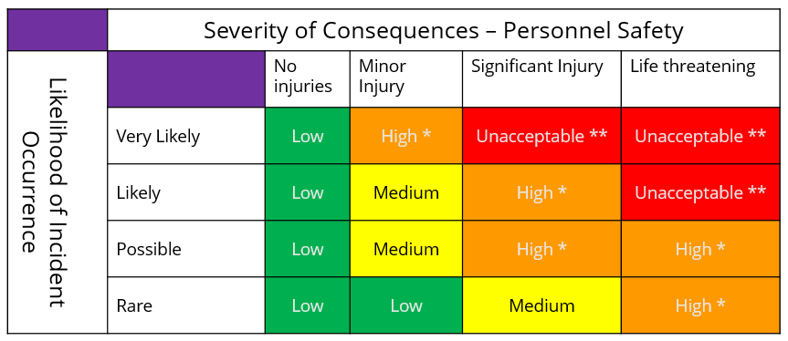

**Risk Rating:** ____________________

*1The Risk Rating is subjective. The primary goal is for researchers to think about risk, and differentiate unacceptable and high-level risk steps from those with a lower level risk. This will help drive additional consultation and control measures where needed.*

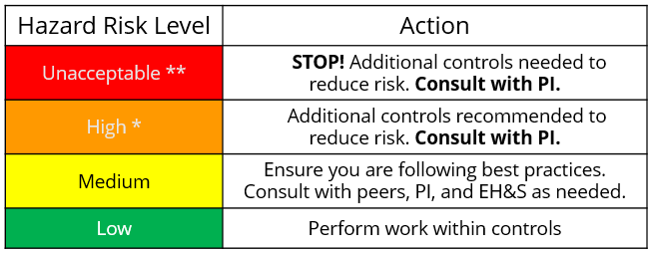**Revise plan if the risk rating is too high.** Are these risks acceptable? Use this table to determine the action to take based on the risk rating. What are the highest risk steps? What more can you do to control the risks? Return to planning and use the hierarchy of controls to design a safer experiment.

**PI/Supervisor Approval:**

__________________________________ ______________________

**\***Signature for **High** risk ratings.If needed, contact EH&S (206.221.2339) for recommendations.

**NOTE:** **\*\*Unacceptable** risk-rated experiments **should not proceed**. Introduce further controls to reduce risk. Contact EH&S (206.221.2339) for recommendations and best practices.

# Phase 4: Assess

**Perform a trial run.** How you can test your experimental design? Can you do a dry run of the procedure without hazardous chemicals/reagents/gases to familiarize yourself with equipment and demonstrate your ability to manipulate the experimental apparatus? Can you run the procedure with a less hazardous material? Can you test your experimental design at a smaller scale? If your procedure requires multiple people, would a table top exercise be useful?

|  |
| --- |
| **Trial Run** |
| **Trial Run Procedure / Date:** |
| **Did the trial go as expected? Yes ☐ No ☐** |
| **Experimental design changes needed (if any):** |

**Perform and evaluate.** Run your procedure using the appropriate controls you’ve identified. Evaluate controls and hazards as you work. Critique the controls and process you used by answering the following questions. If changes to controls are needed, update your risk assessment tool and re-evaluate any time you revise your process (e.g. changes in scale, reagent, equipment, or conditions that might increase the hazard/risk). Share your assessment with your PI/colleagues for the next iteration of the experiment.

|  |
| --- |
| **Evaluate Your Procedure** |
| **What went well?** |
| **Did the controls perform as expected?** |
| **Did anything unexpected occur?** |
| **Did a hazard manifest itself that was not previously identified?** |
| **Were there any close-calls or near misses that indicate areas of needed improvement?** |
| **Did something go exceptionally well that others could learn from?** |
| **I plan to evolve my procedure by...** |

|  |  |
| --- | --- |
| **Procedure Risk Assessment is Complete** | |
| **Form Completed By:** | |
| **Signature:** | **Date:** |
| **PI / Supervisor Signature:** | |