ZYNTH
Lights, Bites, Together
Food & Beverage / FMCG · Myanmar · Thadingyut seasonal retail activation + family gifting campaign
Prepared 2026-08-20 · Proposed timing: 16–27 October · Thadingyut gifting and reunion planning · Validity: 14 days for planning assumptions.
Concept proposal — subject to client, legal, platform, venue, supplier, talent and regulatory validation. Prices and ROI are indicative until current quotations and client data are confirmed.

Executive summary
Festival promotions can collapse into discount noise and overlook the family rituals that make a gift feel considered. Lights, Bites, Together changes one behaviour: the audience will build a small gift bundle, write a permissioned care note and redeem in-store with a family code. The commercial mechanism is festival bundle purchase and loyalty-member acquisition..
Decision | Recommendation | Commercial outcome
Recommended package | MMK 88,000,000 indicative | Proof + conversion + follow-up
Timing | 16–27 October · Thadingyut gifting and reunion planning | Thadingyut full-moon day and holiday window are listed for 26–27 October 2026 [3]; exact retail trading hours to be confirmed.
Approval ask | Approve working direction within 5 business days | Release RFQ and creative gate

Business context
The World Bank reports weak demand, rising logistics costs and inflation pressure in Myanmar’s current operating environment [1]. For F&B, this increases the importance of a credible product proof and a short path to value, rather than broad reach alone.
Audience insight
A food gift matters when it signals care across generations without creating extra work for the giver. DataReportal’s late-2025 planning indicators show 39.8 million internet users and 21.0 million social-media user identities in Myanmar [2]. These are contextual indicators, not unique-reach promises.
Segment | Decision trigger | Exclusion / context
Family shoppers, young adults buying for parents and household decision-makers. | A sensory proof, relevant offer and low-friction action | No unsupported product, health, origin or price claim
Retail / trade partner | Measurable footfall, basket or lead pathway | Partner terms and data rules TBC
Creator / KOL | Useful authentic sensory story | Disclosure, suitability and usage rights required

Strategic objective
Objective: make the promise “Bring a little more care to the table.” commercially useful by moving the audience from sensory attention to a source-coded action. Single behaviour: Build a small gift bundle, write a permissioned care note and redeem in-store with a family code..
Big idea
**Lights, Bites, Together** — Bring a little more care to the table. Visual world: Soft lantern light, table textures, handwritten Myanmar note motifs, premium but not religiously appropriative.
Signature moment | Audience behaviour | Client result
Light a Table: modular lantern product display. | Recognises relevance, participates and consents to a next step | More useful intent signal
Care-Note Counter: bilingual handwritten card. | Recognises relevance, participates and consents to a next step | More useful intent signal
Family Taste Pairing: small guided sampling. | Recognises relevance, participates and consents to a next step | More useful intent signal
Gifting Receipt: referral offer for the next visit. | Recognises relevance, participates and consents to a next step | More useful intent signal

Campaign architecture
Trigger → anticipation → arrival/discovery → sensory proof → conversion → immediate follow-up → nurture → referral → measurement. Event/campaign form: Thadingyut seasonal retail activation + family gifting campaign. Seasonal/sponsorship rationale: Thadingyut full-moon day and holiday window are listed for 26–27 October 2026 [3]; exact retail trading hours to be confirmed. Mall, retail chain or family-entertainment sponsorship package proposed; TBC.
Stage | Sees | Does | Receives | Owner
Trigger | Sensory hook | Stops/saves | Relevant proof | ZYNTH/social
Proof | Tasting, sound, maker or product demo | Tries/asks/compares | Product truth | Host/creator
Conversion | Clear code or appointment | Redeems / books / buys | Confirmation | Client CRM/sales
Nurture | Useful follow-up | Returns/refers | Value reminder | Client CRM

Marketing plan
Workstream | Plan | Measure
Brand | Distinctive title, platform and bilingual visual/copy system | Recognition and approval
PR / partner | Retail, lifestyle or trade angle; sponsor pitch if relevant | Qualified partner coverage
Social / content | Hero, ASMR/sensory cutdowns, creator assets, proof cards | Watch-through, saves, creator-code traffic
Paid digital | Meta/TikTok/Google testing where permitted | CPM/CPC/CPL/CPA
CRM / reactivation | Consent-based message, code and response owner | Repeat/referral/response time
Retail / sales enablement | Staff cue card, QR/source code, handoff process | Basket/lead attribution
Post-campaign | Review, referral and case-study loop | Advocacy and learning

Experience and production
Production direction: Soft lantern light, table textures, handwritten Myanmar note motifs, premium but not religiously appropriative. Proposed footprint: 14m W × 10m D × 4m H. Requirements include venue/site approval, accessible circulation, clear allergen/hygiene information where sampling is involved, security, transport/logistics, photography/video, source-code registration and a weather/technical contingency. No permit or supplier availability is assumed.
Part A — SKETCH DESIGN: labelled concept plan covering entry/exit, registration, tasting/proof, content/demo, conversion, staff control, circulation, accessibility and emergency-egress assumption. This is not a construction drawing.
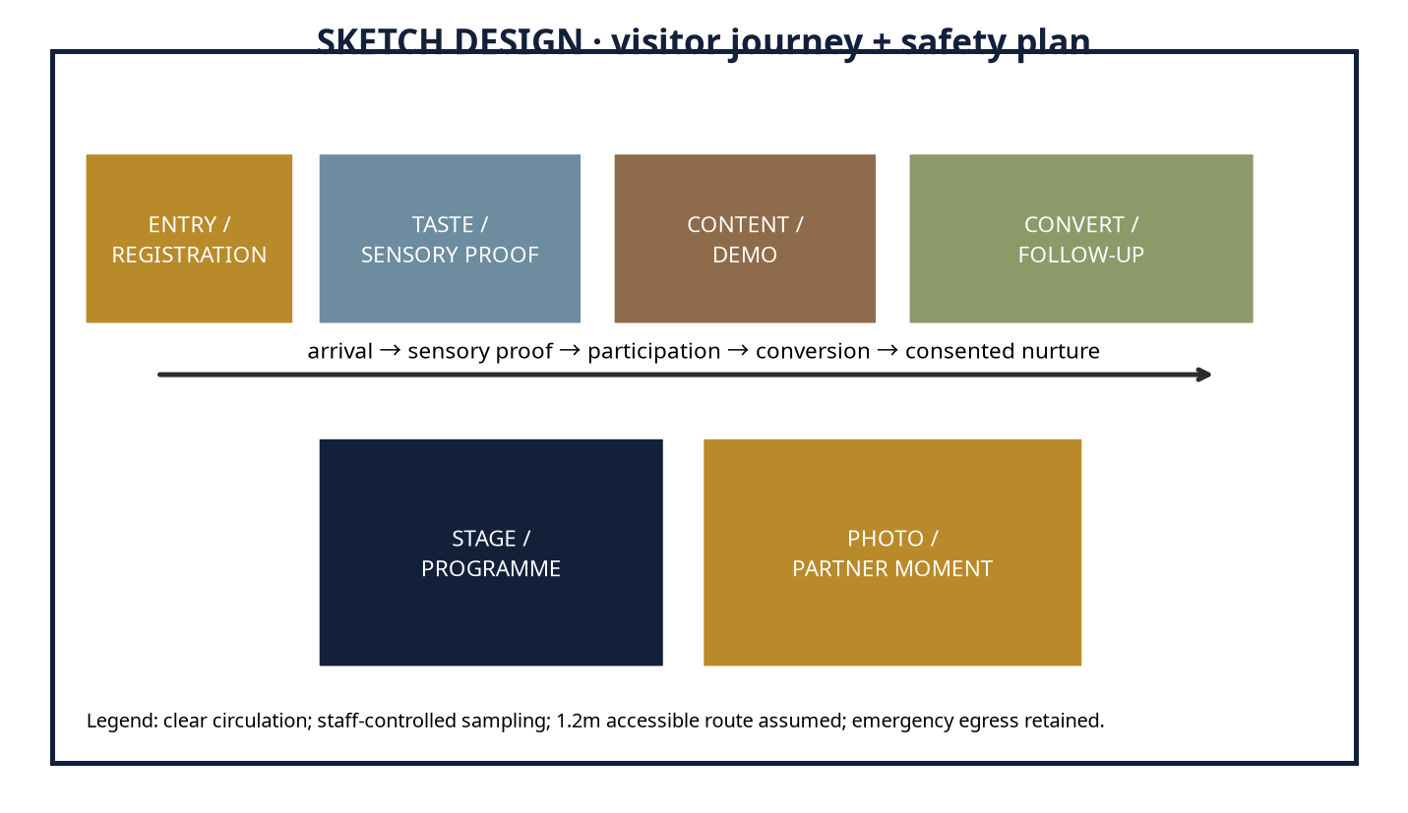
Part B — 3D DESIGN: client-viewable four-view package with hero perspective, front elevation, top/plan and branded-touchpoint detail. It is a concept render package, not an editable Blender, FBX, GLB, OBJ or CAD scene.
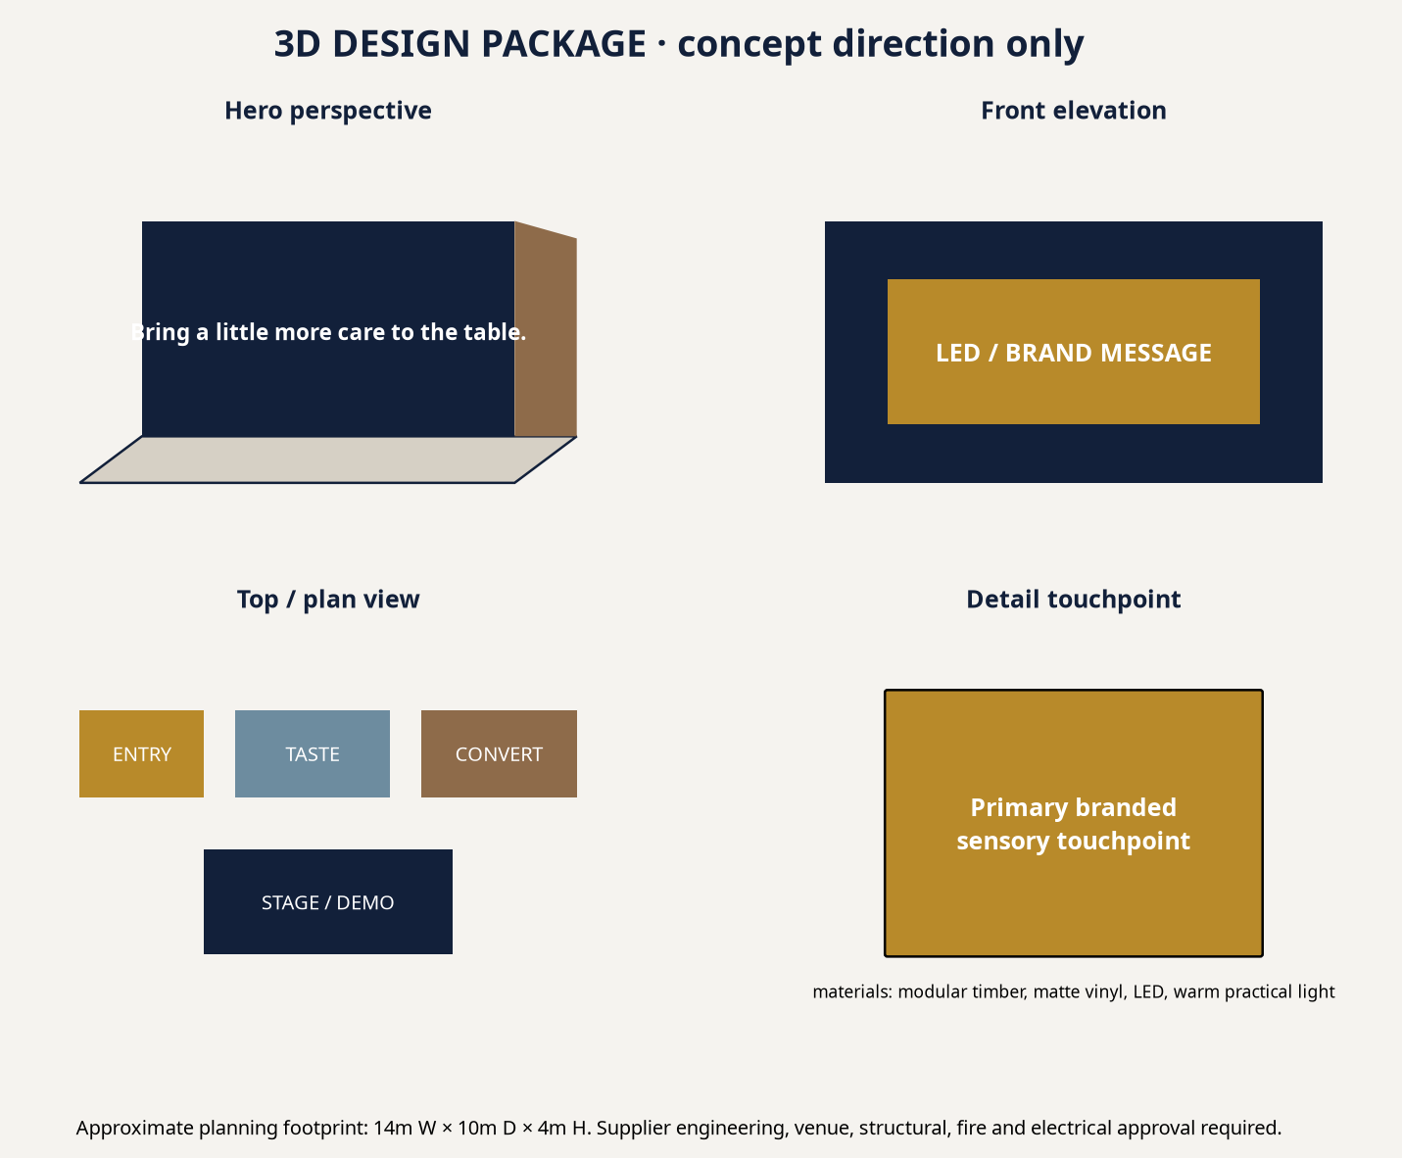
Design-to-production bridge | Status / next gate
Buildable concept | Modular zones, lighting, signage and AV direction are conceptually buildable.
Supplier engineering | Structural, fire, electrical, food hygiene and venue approval required.
Lead time | Indicative 3–8 weeks after scope, RFQ and design lock.
Budget impact | Imported equipment, venue availability, fuel, talent and fabrication complexity can materially change cost.

Talent and programme
Proposed/TBC: host or MC where physical, 3–5 carefully selected food/lifestyle creators, food stylist/chef or product demonstrator, sampling crew, photographer/videographer and technical crew. Talent is selected for audience and proof value; availability, fee, conflict, disclosure and usage rights require written confirmation.
Content calendar
Timing | Content / media | Commercial action
T−28 to T−21 | Tease sensory tension; partner/sponsor pitch; creator shortlist | UTM/source-code and retail forecast
T−20 to T−7 | Hero/ASMR assets, RSVP or sampling CTA, PR outreach | Lead/stock and staff routing
T−6 to T−1 | FAQ, access, creator proof, retargeting | Confirmation and rehearsal
Live / launch | Short clips, moderation, source-code handoff | Incident log and response SLA
T+1 to T+30 | Recap, reward, review/referral, learning cutdown | Nurture and ROI closeout

Workflow and roles
Gate | ZYNTH | Client / vendor
Discovery | Research, tension, baseline, risk scan | Product truth, sales/CRM owner, legal input
Concept | Creative system, calendar, budgets | Approve conversion and working scope
Production | RFQ, design, content, run sheet | Venue, supplier, permits and stock sign-off
Launch | Operate, distribute, optimise | Sales response and escalation
Closeout | KPI/ROI report and learning archive | Revenue/margin confirmation

Budget proposition
All figures are date-stamped, indicative MMK planning ranges. They separate client-paid pass-through spend from ZYNTH fees. USD planning equivalent, where needed, is MMK 3,658/USD on 2026-08-18 [8]. Rates vary with venue, season, availability, imported equipment, fuel, exchange rate, talent and production complexity.
Line item | Basis / quantity | Lean / Pilot | Recommended | Impact / Flagship | Type | Confidence
Strategy / account service | Research, governance, approvals | 3,750,000 | 6,600,000 | 10,875,000 | ZYNTH fee | Medium
Creative / copy / transcreation | Platform, scripts, English–Myanmar hybrid | 3,750,000 | 6,600,000 | 10,875,000 | ZYNTH fee | Medium
Design / 3D / spatial | Sketch, 3D package or digital storyboard | 3,500,000 | 6,160,000 | 10,150,000 | ZYNTH fee | Medium
Venue / permits | Site hire, permissions, basic insurance | 4,500,000 | 7,920,000 | 13,050,000 | Pass-through | Low
Fabrication / AV / lighting | Modular build, LED, sound, technical labour | 8,000,000 | 14,080,000 | 23,200,000 | Pass-through | Low
Staff / registration / security | Hosts, queue, security, medical basic cover | 3,500,000 | 6,160,000 | 10,150,000 | Pass-through | Medium
Talent / creators | TBC, usage and exclusivity not included until quoted | 4,500,000 | 7,920,000 | 13,050,000 | Pass-through | Low
Photography / video / livestream | Capture, cutdowns, deliverables | 3,250,000 | 5,720,000 | 9,425,000 | Pass-through | Medium
Transport / logistics / catering | Fuel, delivery, stock movement, staff meals | 2,750,000 | 4,840,000 | 7,975,000 | Pass-through | Low
Media spend | Platform distribution / retail media | 5,500,000 | 9,680,000 | 15,950,000 | Pass-through | Medium
CRM / measurement | Consent, routing, dashboard, closeout | 2,250,000 | 3,960,000 | 6,525,000 | ZYNTH fee | Medium
Agency fee | Integrated delivery oversight | 3,000,000 | 5,280,000 | 8,700,000 | ZYNTH fee | Medium
Taxes / levies | Depends on invoices/entity | TBC | TBC | TBC | Client / pass-through | Low
Contingency | Scope, price, fuel and availability buffer | 3,250,000 | 5,720,000 | 9,425,000 | Pass-through reserve | Medium
TOTAL PLANNING RANGE | Indicative MMK; not supplier quote | 50,000,000 | 88,000,000 | 145,000,000 | Mixed | Medium

Assumptions and procurement
Assumption | Basis / required validation
Seasonal date | Public holiday planning source [3]; confirm operating days and local client calendar.
Sponsorship / expo | Only a proposal until organiser quote, rights inventory, venue and audience terms are confirmed [6].
Media | Public benchmarks partly proxy-based; run live platform test [7].
FX | MMK 3,658/USD dated reference [8]; recheck at PO.
Taxes / levies | TBC based on supplier invoices, client entity and tax advice.
Payment | Planning convention: 50% approval / 40% pre-live / 10% closeout, subject to contract.
Exclusions | Legal fees, insurance extensions, imported equipment, talent usage extensions and changes outside signed scope.

ROI and KPI scorecard
Primary conversion: Festival bundle purchase and loyalty-member acquisition.. Placeholder average value: MMK 90,000; placeholder contribution margin: 34%. Contribution = conversions × value × margin. Projected ROI = (contribution − investment) ÷ investment. These are scenarios, not guarantees; replace with client revenue, margin, baseline conversion and sales-cycle data.
Scenario | Conversions | Contribution | ROI vs Recommended
Conservative / break-even | 2876 | MMK 88,005,600 | 0%
Base | 4602 | MMK 140,821,200 | 60%
Upside | 5752 | MMK 176,011,200 | 100%

KPI area | Scorecard
Awareness | Reach, frequency, video completion, branded search proxy
Engagement | Saves, replies, sound/story completion, participation
Attendance / reach | Booked, attended, sampling/experience completion
Lead quality | Qualified rate, source code, response time
Conversion / revenue | Basket, voucher, booking, B2B meeting or repeat purchase
Retention / advocacy | Repeat, review, referral, creator-code reuse
Media / operations | CPM/CPL/CPA, on-time delivery, incident-free, accessibility and hygiene compliance

Timeline, risk and approval ask
Implementation sequence: Days 1–7 discovery/RFQ; Days 8–21 concept/design/partner lock; Days 22–45 production and media launch; Days 46–60 live/optimisation; Days 61–90 nurture, referral and closeout. Primary risks: product/health/origin claims, sampling hygiene, food-allergen handling, alcohol/age gating where applicable, venue/permit availability, weather, talent rights, fuel/logistics, platform shifts and data consent. Mitigate through written approval, an evidence file, alternative supplier/venue paths, a contingency reserve, consented capture and named escalation owners.
Approval ask: approve the Recommended package as a working ceiling, nominate the client decision and CRM/sales owners, release product/revenue baseline data, and schedule a 60-minute discovery plus quotation-validation workshop within five business days.
ASMR-ready pitch-outreach candidates
“ASMR-ready” is interpreted here as sensory-product brands and retailers that may benefit from responsibly produced crunch, pour, sizzle, unwrap or texture content. This is a pitch-outreach list based on public catalog/source visibility—not a claim that the organisations have commissioned ASMR work or that contacts are available.
Publicly visible candidate | Pitch angle | Proposed role
City Selection | Sensory product proof, seasonal retail or creator-led conversion | Brand Director / Shopper Marketing Lead / Modern Trade Lead
Feel | Sensory product proof, seasonal retail or creator-led conversion | Brand Director / Shopper Marketing Lead / Modern Trade Lead
Penguin | Sensory product proof, seasonal retail or creator-led conversion | Brand Director / Shopper Marketing Lead / Modern Trade Lead
Coca-Cola Pinya Beverages Myanmar | Sensory product proof, seasonal retail or creator-led conversion | Brand Director / Shopper Marketing Lead / Modern Trade Lead

Sources and references
[1] Myanmar Economic Monitor, June 2026: Shock Amid Fragility — https://reliefweb.int/report/myanmar/myanmar-economic-monitor-june-2026-shock-amid-fragility-enmy (published/accessed 2026-06-16). Supports: 2026 macro pressure: weak demand, fuel/logistics costs, inflation and operating uncertainty.
[2] Digital 2026: Myanmar — https://datareportal.com/reports/digital-2026-myanmar (published/accessed 2025-11-08). Supports: Late-2025 digital planning indicators: 39.8m internet users, 62.5m mobile connections and 21.0m social identities.
[3] Holiday List of 2026 — Consulate General of Myanmar, Los Angeles — https://myanmarcgla.org/index.php/holiday-list-of-2026 (published/accessed 2025-12-29). Supports: Public dates used in this planning calendar: 26–27 Oct Thadingyut, 23–24 Nov Tazaungdaing, 4 Dec National Day; client must confirm local operating calendars.
[4] Local delicacies take centre stage at Taste of the Golden Land 2026 — https://www.gnlm.com.mm/local-delicacies-take-centre-stage-at-taste-of-the-golden-land-2026-this-july/ (published/accessed 2026-07-15). Supports: Evidence of a Yangon food festival format that combines regional cuisines, brand participation, activity programmes and photo moments.
[5] City Mall Myanmar — Food category catalogue — https://www.citymall.com.mm/citymall/my/%E1%80%95%E1%80%85%E1%80%B9%E1%80%85%E1%80%8A%E1%80%BA%E1%80%B8%E1%80%A1%E1%80%99%E1%80%BB%E1%80%AD%E1%80%AF%E1%80%B8%E1%80%A1%E1%80%85%E1%80%AC%E1%80%B8%E1%80%99%E1%80%BB%E1%80%AC%E1%80%B8/%E1%80%85%E1%80%AC%E1%80%B8%E1%80%9E%E1%80%B1%E1%80%AC%E1%80%80%E1%80%BA%E1%80%80%E1%80%AF%E1%80%94%E1%80%BA%E1%80%95%E1%80%85%E1%80%B9%E1%80%85%E1%80%8A%E1%80%BA%E1%80%B8%E1%80%99%E1%80%BB%E1%80%AC%E1%80%B8/c/id01?q=%3Abestselling&page=169 (published/accessed accessed 2026-08-20). Supports: Myanmar-language retail context and publicly visible food brands/products, including City Selection, Yummy, Popy, Pa Pa, Feel and Penguin.
[6] 2026 Agriculture Related Trade Shows and Conferences — USDA FAS — https://apps.fas.usda.gov/newgainapi/api/Report/DownloadReportByFileName?fileName=2026%20Agriculture%20Related%20Trade%20Shows%20and%20Conferences_Rangoon_Burma%20-%20Union%20of_BM2026-0003.pdf (published/accessed 2026-01-22). Supports: Publicly indexed 2026 food-and-beverage/retail-show opportunity; exact venue, dates and sponsorship inventory require organiser confirmation.
[7] Myanmar Advertising Costs 2026: Facebook, Google, TikTok Rate Card — https://marketingmyanmar.com/myanmar-advertising-costs-2026-facebook-google-tiktok-rate-card/ (published/accessed 2026-03-20). Supports: Indicative platform planning ranges that are expressly proxy-based where Myanmar platform data is unavailable.
[8] Yoma Bank — Currency Exchange Rates — https://www.yomabank.com/en/rates/ (published/accessed 2026-08-18). Supports: Dated planning USD/MMK reference: MMK 3,658 per USD for trade-related transactions; not a binding supplier or settlement rate.
Disclaimer: This proposal is a planning document, not a supplier quotation, financial guarantee, legal opinion or permit approval. Prices, dates, sponsorship availability and ROI scenarios require validation through current local quotations, client data and relevant approvals.

