ZYNTH
First Light, First Bite
Food & Beverage / FMCG · Myanmar · Cultural night-market activation + community food programme
Prepared 2026-08-20 · Proposed timing: 20–24 November · Tazaungdaing cultural-market planning · Validity: 14 days for planning assumptions.
Concept proposal — subject to client, legal, platform, venue, supplier, talent and regulatory validation. Prices and ROI are indicative until current quotations and client data are confirmed.

Executive summary
Cultural-season campaigns can feel extractive when brands use the occasion as decoration instead of creating a useful shared experience. First Light, First Bite changes one behaviour: the audience will visit a maker stall, complete a taste trail, choose a community contribution and share a permitted recommendation. The commercial mechanism is taste-trail completion, retailer referral and opt-in community/loyalty lead..
Decision | Recommendation | Commercial outcome
Recommended package | MMK 98,000,000 indicative | Proof + conversion + follow-up
Timing | 20–24 November · Tazaungdaing cultural-market planning | Tazaungdaing holiday and full-moon day are listed for 23–24 November 2026 [3]; local permissions and cultural guidance are mandatory.
Approval ask | Approve working direction within 5 business days | Release RFQ and creative gate

Business context
The World Bank reports weak demand, rising logistics costs and inflation pressure in Myanmar’s current operating environment [1]. For F&B, this increases the importance of a credible product proof and a short path to value, rather than broad reach alone.
Audience insight
Respect is visible when a brand makes room for local makers, family time and clear community benefit. DataReportal’s late-2025 planning indicators show 39.8 million internet users and 21.0 million social-media user identities in Myanmar [2]. These are contextual indicators, not unique-reach promises.
Segment | Decision trigger | Exclusion / context
Families, local food explorers, community makers and urban cultural-weekend visitors. | A sensory proof, relevant offer and low-friction action | No unsupported product, health, origin or price claim
Retail / trade partner | Measurable footfall, basket or lead pathway | Partner terms and data rules TBC
Creator / KOL | Useful authentic sensory story | Disclosure, suitability and usage rights required

Strategic objective
Objective: make the promise “Share the first light with something worth tasting.” commercially useful by moving the audience from sensory attention to a source-coded action. Single behaviour: Visit a maker stall, complete a taste trail, choose a community contribution and share a permitted recommendation..
Big idea
**First Light, First Bite** — Share the first light with something worth tasting. Visual world: Warm light, natural material, locally legible signs, maker credit and low-volume acoustic ambience.
Signature moment | Audience behaviour | Client result
First Light Taste Trail. | Recognises relevance, participates and consents to a next step | More useful intent signal
Maker Microphone: short origin stories. | Recognises relevance, participates and consents to a next step | More useful intent signal
Community Bowl: transparent contribution counter. | Recognises relevance, participates and consents to a next step | More useful intent signal
Family Exit Card: retailer and referral cue. | Recognises relevance, participates and consents to a next step | More useful intent signal

Campaign architecture
Trigger → anticipation → arrival/discovery → sensory proof → conversion → immediate follow-up → nurture → referral → measurement. Event/campaign form: Cultural night-market activation + community food programme. Seasonal/sponsorship rationale: Tazaungdaing holiday and full-moon day are listed for 23–24 November 2026 [3]; local permissions and cultural guidance are mandatory. Community-market, local-media or township-partner sponsorship proposed; permits and cultural review required.
Stage | Sees | Does | Receives | Owner
Trigger | Sensory hook | Stops/saves | Relevant proof | ZYNTH/social
Proof | Tasting, sound, maker or product demo | Tries/asks/compares | Product truth | Host/creator
Conversion | Clear code or appointment | Redeems / books / buys | Confirmation | Client CRM/sales
Nurture | Useful follow-up | Returns/refers | Value reminder | Client CRM

Marketing plan
Workstream | Plan | Measure
Brand | Distinctive title, platform and bilingual visual/copy system | Recognition and approval
PR / partner | Retail, lifestyle or trade angle; sponsor pitch if relevant | Qualified partner coverage
Social / content | Hero, ASMR/sensory cutdowns, creator assets, proof cards | Watch-through, saves, creator-code traffic
Paid digital | Meta/TikTok/Google testing where permitted | CPM/CPC/CPL/CPA
CRM / reactivation | Consent-based message, code and response owner | Repeat/referral/response time
Retail / sales enablement | Staff cue card, QR/source code, handoff process | Basket/lead attribution
Post-campaign | Review, referral and case-study loop | Advocacy and learning

Experience and production
Production direction: Warm light, natural material, locally legible signs, maker credit and low-volume acoustic ambience. Proposed footprint: 20m W × 15m D × 4m H. Requirements include venue/site approval, accessible circulation, clear allergen/hygiene information where sampling is involved, security, transport/logistics, photography/video, source-code registration and a weather/technical contingency. No permit or supplier availability is assumed.
Part A — SKETCH DESIGN: labelled concept plan covering entry/exit, registration, tasting/proof, content/demo, conversion, staff control, circulation, accessibility and emergency-egress assumption. This is not a construction drawing.
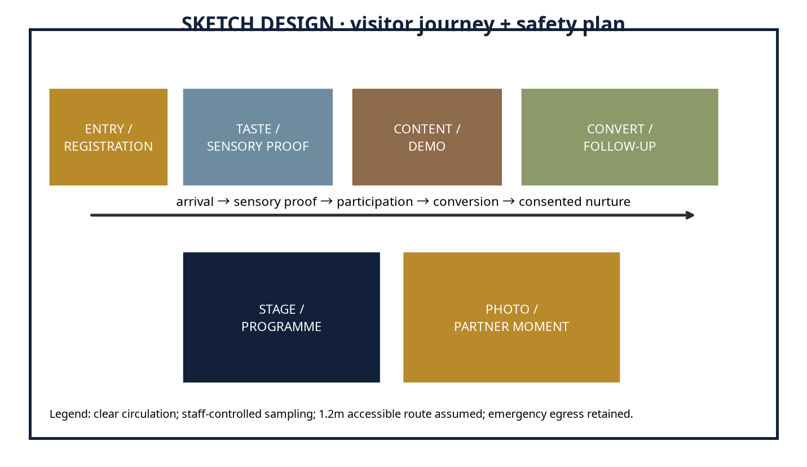
Part B — 3D DESIGN: client-viewable four-view package with hero perspective, front elevation, top/plan and branded-touchpoint detail. It is a concept render package, not an editable Blender, FBX, GLB, OBJ or CAD scene.
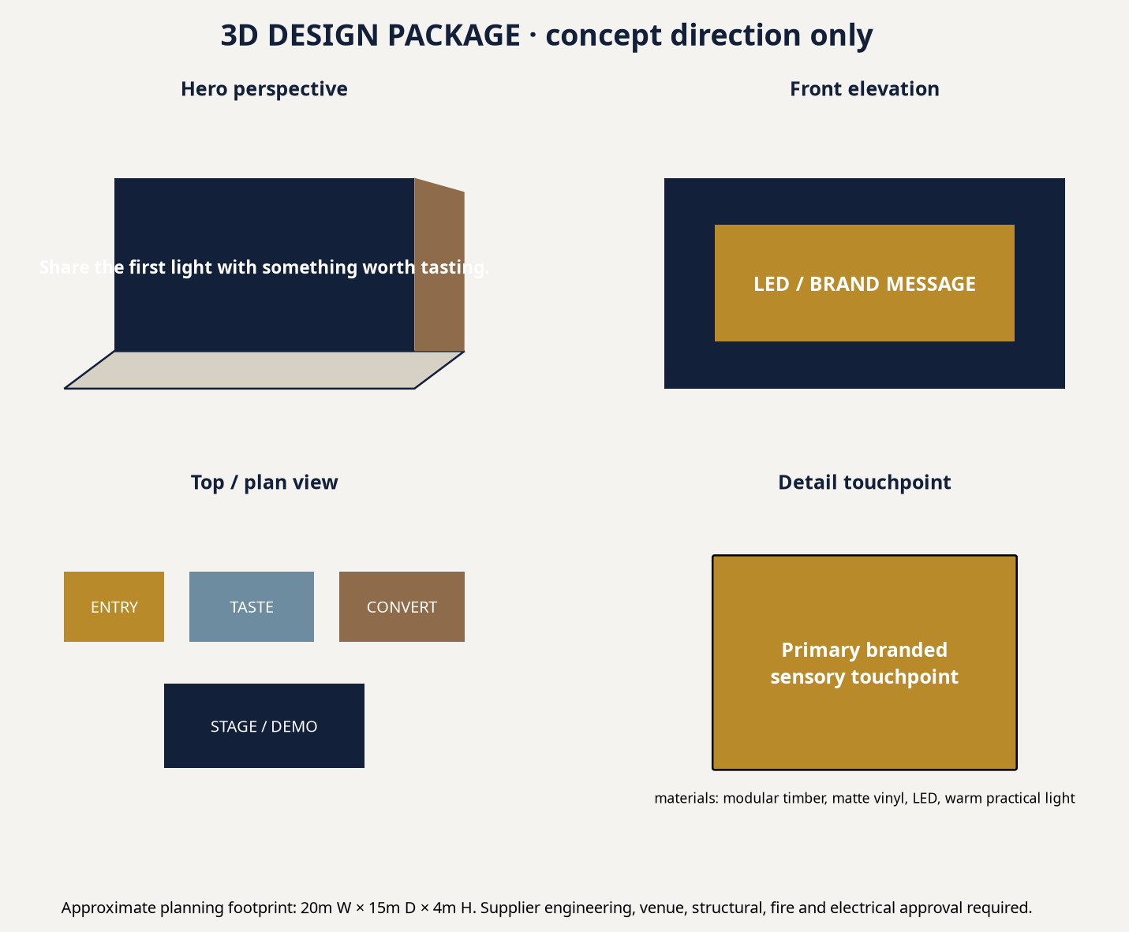
Design-to-production bridge | Status / next gate
Buildable concept | Modular zones, lighting, signage and AV direction are conceptually buildable.
Supplier engineering | Structural, fire, electrical, food hygiene and venue approval required.
Lead time | Indicative 3–8 weeks after scope, RFQ and design lock.
Budget impact | Imported equipment, venue availability, fuel, talent and fabrication complexity can materially change cost.

Talent and programme
Proposed/TBC: host or MC where physical, 3–5 carefully selected food/lifestyle creators, food stylist/chef or product demonstrator, sampling crew, photographer/videographer and technical crew. Talent is selected for audience and proof value; availability, fee, conflict, disclosure and usage rights require written confirmation.
Content calendar
Timing | Content / media | Commercial action
T−28 to T−21 | Tease sensory tension; partner/sponsor pitch; creator shortlist | UTM/source-code and retail forecast
T−20 to T−7 | Hero/ASMR assets, RSVP or sampling CTA, PR outreach | Lead/stock and staff routing
T−6 to T−1 | FAQ, access, creator proof, retargeting | Confirmation and rehearsal
Live / launch | Short clips, moderation, source-code handoff | Incident log and response SLA
T+1 to T+30 | Recap, reward, review/referral, learning cutdown | Nurture and ROI closeout

Workflow and roles
Gate | ZYNTH | Client / vendor
Discovery | Research, tension, baseline, risk scan | Product truth, sales/CRM owner, legal input
Concept | Creative system, calendar, budgets | Approve conversion and working scope
Production | RFQ, design, content, run sheet | Venue, supplier, permits and stock sign-off
Launch | Operate, distribute, optimise | Sales response and escalation
Closeout | KPI/ROI report and learning archive | Revenue/margin confirmation

Budget proposition
All figures are date-stamped, indicative MMK planning ranges. They separate client-paid pass-through spend from ZYNTH fees. USD planning equivalent, where needed, is MMK 3,658/USD on 2026-08-18 [8]. Rates vary with venue, season, availability, imported equipment, fuel, exchange rate, talent and production complexity.
Line item | Basis / quantity | Lean / Pilot | Recommended | Impact / Flagship | Type | Confidence
Strategy / account service | Research, governance, approvals | 4,125,000 | 7,350,000 | 12,000,000 | ZYNTH fee | Medium
Creative / copy / transcreation | Platform, scripts, English–Myanmar hybrid | 4,125,000 | 7,350,000 | 12,000,000 | ZYNTH fee | Medium
Design / 3D / spatial | Sketch, 3D package or digital storyboard | 3,850,000 | 6,860,000 | 11,200,000 | ZYNTH fee | Medium
Venue / permits | Site hire, permissions, basic insurance | 4,950,000 | 8,820,000 | 14,400,000 | Pass-through | Low
Fabrication / AV / lighting | Modular build, LED, sound, technical labour | 8,800,000 | 15,680,000 | 25,600,000 | Pass-through | Low
Staff / registration / security | Hosts, queue, security, medical basic cover | 3,850,000 | 6,860,000 | 11,200,000 | Pass-through | Medium
Talent / creators | TBC, usage and exclusivity not included until quoted | 4,950,000 | 8,820,000 | 14,400,000 | Pass-through | Low
Photography / video / livestream | Capture, cutdowns, deliverables | 3,575,000 | 6,370,000 | 10,400,000 | Pass-through | Medium
Transport / logistics / catering | Fuel, delivery, stock movement, staff meals | 3,025,000 | 5,390,000 | 8,800,000 | Pass-through | Low
Media spend | Platform distribution / retail media | 6,050,000 | 10,780,000 | 17,600,000 | Pass-through | Medium
CRM / measurement | Consent, routing, dashboard, closeout | 2,475,000 | 4,410,000 | 7,200,000 | ZYNTH fee | Medium
Agency fee | Integrated delivery oversight | 3,300,000 | 5,880,000 | 9,600,000 | ZYNTH fee | Medium
Taxes / levies | Depends on invoices/entity | TBC | TBC | TBC | Client / pass-through | Low
Contingency | Scope, price, fuel and availability buffer | 3,575,000 | 6,370,000 | 10,400,000 | Pass-through reserve | Medium
TOTAL PLANNING RANGE | Indicative MMK; not supplier quote | 55,000,000 | 98,000,000 | 160,000,000 | Mixed | Medium

Assumptions and procurement
Assumption | Basis / required validation
Seasonal date | Public holiday planning source [3]; confirm operating days and local client calendar.
Sponsorship / expo | Only a proposal until organiser quote, rights inventory, venue and audience terms are confirmed [6].
Media | Public benchmarks partly proxy-based; run live platform test [7].
FX | MMK 3,658/USD dated reference [8]; recheck at PO.
Taxes / levies | TBC based on supplier invoices, client entity and tax advice.
Payment | Planning convention: 50% approval / 40% pre-live / 10% closeout, subject to contract.
Exclusions | Legal fees, insurance extensions, imported equipment, talent usage extensions and changes outside signed scope.

ROI and KPI scorecard
Primary conversion: Taste-trail completion, retailer referral and opt-in community/loyalty lead.. Placeholder average value: MMK 65,000; placeholder contribution margin: 35%. Contribution = conversions × value × margin. Projected ROI = (contribution − investment) ÷ investment. These are scenarios, not guarantees; replace with client revenue, margin, baseline conversion and sales-cycle data.
Scenario | Conversions | Contribution | ROI vs Recommended
Conservative / break-even | 4308 | MMK 98,007,000 | 0%
Base | 6893 | MMK 156,815,750 | 60%
Upside | 8616 | MMK 196,014,000 | 100%

KPI area | Scorecard
Awareness | Reach, frequency, video completion, branded search proxy
Engagement | Saves, replies, sound/story completion, participation
Attendance / reach | Booked, attended, sampling/experience completion
Lead quality | Qualified rate, source code, response time
Conversion / revenue | Basket, voucher, booking, B2B meeting or repeat purchase
Retention / advocacy | Repeat, review, referral, creator-code reuse
Media / operations | CPM/CPL/CPA, on-time delivery, incident-free, accessibility and hygiene compliance

Timeline, risk and approval ask
Implementation sequence: Days 1–7 discovery/RFQ; Days 8–21 concept/design/partner lock; Days 22–45 production and media launch; Days 46–60 live/optimisation; Days 61–90 nurture, referral and closeout. Primary risks: product/health/origin claims, sampling hygiene, food-allergen handling, alcohol/age gating where applicable, venue/permit availability, weather, talent rights, fuel/logistics, platform shifts and data consent. Mitigate through written approval, an evidence file, alternative supplier/venue paths, a contingency reserve, consented capture and named escalation owners.
Approval ask: approve the Recommended package as a working ceiling, nominate the client decision and CRM/sales owners, release product/revenue baseline data, and schedule a 60-minute discovery plus quotation-validation workshop within five business days.
ASMR-ready pitch-outreach candidates
“ASMR-ready” is interpreted here as sensory-product brands and retailers that may benefit from responsibly produced crunch, pour, sizzle, unwrap or texture content. This is a pitch-outreach list based on public catalog/source visibility—not a claim that the organisations have commissioned ASMR work or that contacts are available.
Publicly visible candidate | Pitch angle | Proposed role
Feel | Sensory product proof, seasonal retail or creator-led conversion | Marketing Director / CSR Lead / Community Partnerships Manager
Yummy | Sensory product proof, seasonal retail or creator-led conversion | Marketing Director / CSR Lead / Community Partnerships Manager
Pa Pa | Sensory product proof, seasonal retail or creator-led conversion | Marketing Director / CSR Lead / Community Partnerships Manager
Shwe Kyee | Sensory product proof, seasonal retail or creator-led conversion | Marketing Director / CSR Lead / Community Partnerships Manager

Sources and references
[1] Myanmar Economic Monitor, June 2026: Shock Amid Fragility — https://reliefweb.int/report/myanmar/myanmar-economic-monitor-june-2026-shock-amid-fragility-enmy (published/accessed 2026-06-16). Supports: 2026 macro pressure: weak demand, fuel/logistics costs, inflation and operating uncertainty.
[2] Digital 2026: Myanmar — https://datareportal.com/reports/digital-2026-myanmar (published/accessed 2025-11-08). Supports: Late-2025 digital planning indicators: 39.8m internet users, 62.5m mobile connections and 21.0m social identities.
[3] Holiday List of 2026 — Consulate General of Myanmar, Los Angeles — https://myanmarcgla.org/index.php/holiday-list-of-2026 (published/accessed 2025-12-29). Supports: Public dates used in this planning calendar: 26–27 Oct Thadingyut, 23–24 Nov Tazaungdaing, 4 Dec National Day; client must confirm local operating calendars.
[4] Local delicacies take centre stage at Taste of the Golden Land 2026 — https://www.gnlm.com.mm/local-delicacies-take-centre-stage-at-taste-of-the-golden-land-2026-this-july/ (published/accessed 2026-07-15). Supports: Evidence of a Yangon food festival format that combines regional cuisines, brand participation, activity programmes and photo moments.
[5] City Mall Myanmar — Food category catalogue — https://www.citymall.com.mm/citymall/my/%E1%80%95%E1%80%85%E1%80%B9%E1%80%85%E1%80%8A%E1%80%BA%E1%80%B8%E1%80%A1%E1%80%99%E1%80%BB%E1%80%AD%E1%80%AF%E1%80%B8%E1%80%A1%E1%80%85%E1%80%AC%E1%80%B8%E1%80%99%E1%80%BB%E1%80%AC%E1%80%B8/%E1%80%85%E1%80%AC%E1%80%B8%E1%80%9E%E1%80%B1%E1%80%AC%E1%80%80%E1%80%BA%E1%80%80%E1%80%AF%E1%80%94%E1%80%BA%E1%80%95%E1%80%85%E1%80%B9%E1%80%85%E1%80%8A%E1%80%BA%E1%80%B8%E1%80%99%E1%80%BB%E1%80%AC%E1%80%B8/c/id01?q=%3Abestselling&page=169 (published/accessed accessed 2026-08-20). Supports: Myanmar-language retail context and publicly visible food brands/products, including City Selection, Yummy, Popy, Pa Pa, Feel and Penguin.
[6] 2026 Agriculture Related Trade Shows and Conferences — USDA FAS — https://apps.fas.usda.gov/newgainapi/api/Report/DownloadReportByFileName?fileName=2026%20Agriculture%20Related%20Trade%20Shows%20and%20Conferences_Rangoon_Burma%20-%20Union%20of_BM2026-0003.pdf (published/accessed 2026-01-22). Supports: Publicly indexed 2026 food-and-beverage/retail-show opportunity; exact venue, dates and sponsorship inventory require organiser confirmation.
[7] Myanmar Advertising Costs 2026: Facebook, Google, TikTok Rate Card — https://marketingmyanmar.com/myanmar-advertising-costs-2026-facebook-google-tiktok-rate-card/ (published/accessed 2026-03-20). Supports: Indicative platform planning ranges that are expressly proxy-based where Myanmar platform data is unavailable.
[8] Yoma Bank — Currency Exchange Rates — https://www.yomabank.com/en/rates/ (published/accessed 2026-08-18). Supports: Dated planning USD/MMK reference: MMK 3,658 per USD for trade-related transactions; not a binding supplier or settlement rate.
Disclaimer: This proposal is a planning document, not a supplier quotation, financial guarantee, legal opinion or permit approval. Prices, dates, sponsorship availability and ROI scenarios require validation through current local quotations, client data and relevant approvals.

