ZYNTH
Sip the Year Brighter
နှစ်သစ်ကို ပိုလင်းလက်စွာ သောက်စို့
Food & Beverage / FMCG · Myanmar · Beverage sponsorship + micro-festival + responsible enjoyment campaign
အစားအသောက်နှင့် အဖျော်ယမကာ / FMCG · မြန်မာဈေးကွက် · Beverage sponsorship + micro-festival + responsible enjoyment campaign
Prepared 2026-08-20 · Proposed timing: 10–25 December · year-end celebration and Christmas planning · Validity: 14 days for planning assumptions.
Concept proposal — subject to client, legal, platform, venue, supplier, talent and regulatory validation. Prices and ROI are indicative until current quotations and client data are confirmed.
ဤအဆိုပြုချက်သည် concept planning အတွက်သာ ဖြစ်ပြီး client၊ legal၊ platform၊ venue၊ supplier နှင့် regulatory approval များအပေါ် မူတည်ပါသည်။ ဈေးနှုန်းနှင့် ROI သည် quotation နှင့် client data အတည်ပြုပြီးမှသာ အတည်ဖြစ်ပါမည်။

Executive summary | အနှစ်ချုပ်
Year-end beverage activity can privilege spectacle over safety, repeat purchase and accessible inclusion. Sip the Year Brighter changes one behaviour: the audience will choose a drink ritual, use a refill/return or purchase code, and join a safe transport or next-day offer. The commercial mechanism is event-to-retail purchase, responsible-service opt-in and post-event crm retention..
နှစ်သစ်ကို ပိုလင်းလက်စွာ သောက်စို့ က audience ကို “Choose a drink ritual, use a refill/return or purchase code, and join a safe transport or next-day offer.” ဟူသော အပြုအမူသို့ ရွှေ့ပေးရန် ရည်ရွယ်ပါသည်။ စီးပွားရေးရလဒ်မှာ Event-to-retail purchase, responsible-service opt-in and post-event CRM retention. ဖြစ်ပါသည်။
Decision | Recommendation | Commercial outcome
Recommended package | MMK 128,000,000 indicative | Proof + conversion + follow-up
Timing | 10–25 December · year-end celebration and Christmas planning | Christmas Day is listed for 25 December 2026 [3]; any alcohol activity requires separate legal, age-gating and responsible-service review.
Approval ask | Approve working direction within 5 business days | Release RFQ and creative gate

Business context | စီးပွားရေးအခြေအနေ
The World Bank reports weak demand, rising logistics costs and inflation pressure in Myanmar’s current operating environment [1]. For F&B, this increases the importance of a credible product proof and a short path to value, rather than broad reach alone.
World Bank ၏ 2026 Myanmar Economic Monitor အရ demand အားနည်းခြင်း၊ logistics cost နှင့် inflation pressure များရှိနေပါသည် [1]။ ထို့ကြောင့် F&B brand များအတွက် product proof နှင့် purchase သို့ ရောက်စေမည့် ရှင်းလင်းသော customer journey လိုအပ်ပါသည်။
Audience insight | ပရိသတ်အမြင်
Celebration works harder for the brand when everyone has a visible, enjoyable and responsible way to participate. DataReportal’s late-2025 planning indicators show 39.8 million internet users and 21.0 million social-media user identities in Myanmar [2]. These are contextual indicators, not unique-reach promises.
Audience insight — Celebration works harder for the brand when everyone has a visible, enjoyable and responsible way to participate. Digital planning ကို mobile-first အဖြစ် လုပ်ဆောင်မည်ဖြစ်သော်လည်း content မှာသာ ရပ်မနေဘဲ retail၊ sampling နှင့် CRM follow-up တို့နှင့် ချိတ်ဆက်ရမည်။
Segment | Decision trigger | Exclusion / context
Urban professionals, friend groups, hospitality guests and music/event audiences aged 18+ where applicable. | A sensory proof, relevant offer and low-friction action | No unsupported product, health, origin or price claim
Retail / trade partner | Measurable footfall, basket or lead pathway | Partner terms and data rules TBC
Creator / KOL | Useful authentic sensory story | Disclosure, suitability and usage rights required

Strategic objective | မဟာဗျူဟာရည်မှန်းချက်
Objective: make the promise “Make the year-end toast feel brighter for everyone.” commercially useful by moving the audience from sensory attention to a source-coded action. Single behaviour: Choose a drink ritual, use a refill/return or purchase code, and join a safe transport or next-day offer..
Strategic objective — “Make the year-end toast feel brighter for everyone.” ဟူသော promise ကို sales action နှင့် ချိတ်ဆက်ရန်ဖြစ်ပါသည်။ Single behaviour: Choose a drink ritual, use a refill/return or purchase code, and join a safe transport or next-day offer.
Big idea | အဓိက အကြံဉာဏ်
**Sip the Year Brighter** — Make the year-end toast feel brighter for everyone. Visual world: Citrus light, clean glass sounds, inclusive zero-proof visual language and no excessive-consumption messaging.
**နှစ်သစ်ကို ပိုလင်းလက်စွာ သောက်စို့** — Make the year-end toast feel brighter for everyone. Visual direction: Citrus light, clean glass sounds, inclusive zero-proof visual language and no excessive-consumption messaging.
Signature moment | Audience behaviour | Client result
Pour Bar: sensory but responsible. | Recognises relevance, participates and consents to a next step | More useful intent signal
Zero-Proof Hero Counter. | Recognises relevance, participates and consents to a next step | More useful intent signal
Soundcheck Stage: artist content, TBC. | Recognises relevance, participates and consents to a next step | More useful intent signal
Safe Ride Exit: transport referral. | Recognises relevance, participates and consents to a next step | More useful intent signal

Campaign architecture | ကမ်ပိန်း ဖွဲ့စည်းပုံ
Trigger → anticipation → arrival/discovery → sensory proof → conversion → immediate follow-up → nurture → referral → measurement. Event/campaign form: Beverage sponsorship + micro-festival + responsible enjoyment campaign. Seasonal/sponsorship rationale: Christmas Day is listed for 25 December 2026 [3]; any alcohol activity requires separate legal, age-gating and responsible-service review. Venue, music, food-court or transport-partner sponsorship proposed; all rights and permits TBC.
Journey: Trigger → Anticipation → Arrival/Discovery → Sensory Proof → Conversion → Follow-up → Nurture → Referral → Measurement. Seasonal/sponsorship rationale: Christmas Day is listed for 25 December 2026 [3]; any alcohol activity requires separate legal, age-gating and responsible-service review.
Stage | Sees | Does | Receives | Owner
Trigger | Sensory hook | Stops/saves | Relevant proof | ZYNTH/social
Proof | Tasting, sound, maker or product demo | Tries/asks/compares | Product truth | Host/creator
Conversion | Clear code or appointment | Redeems / books / buys | Confirmation | Client CRM/sales
Nurture | Useful follow-up | Returns/refers | Value reminder | Client CRM

Marketing plan | မားကက်တင်း အစီအစဉ်
Workstream | Plan | Measure
Brand | Distinctive title, platform and bilingual visual/copy system | Recognition and approval
PR / partner | Retail, lifestyle or trade angle; sponsor pitch if relevant | Qualified partner coverage
Social / content | Hero, ASMR/sensory cutdowns, creator assets, proof cards | Watch-through, saves, creator-code traffic
Paid digital | Meta/TikTok/Google testing where permitted | CPM/CPC/CPL/CPA
CRM / reactivation | Consent-based message, code and response owner | Repeat/referral/response time
Retail / sales enablement | Staff cue card, QR/source code, handoff process | Basket/lead attribution
Post-campaign | Review, referral and case-study loop | Advocacy and learning

Hybrid copy rule: customer-facing Myanmar should use natural Unicode Burmese; English remains for brand names, product terms, technical specifications, KPI labels and legal wording where appropriate.
Experience and production | အတွေ့အကြုံနှင့် ထုတ်လုပ်ရေး
Production direction: Citrus light, clean glass sounds, inclusive zero-proof visual language and no excessive-consumption messaging. Proposed footprint: 22m W × 14m D × 5m H. Requirements include venue/site approval, accessible circulation, clear allergen/hygiene information where sampling is involved, security, transport/logistics, photography/video, source-code registration and a weather/technical contingency. No permit or supplier availability is assumed.
Production requirements တွင် venue/site approval၊ accessible circulation၊ sampling ဖြစ်ပါက allergen နှင့် hygiene information၊ security၊ transport/logistics၊ photography/video၊ source-code registration နှင့် weather/technical contingency တို့ပါဝင်သည်။
Part A — SKETCH DESIGN: labelled concept plan covering entry/exit, registration, tasting/proof, content/demo, conversion, staff control, circulation, accessibility and emergency-egress assumption. This is not a construction drawing.
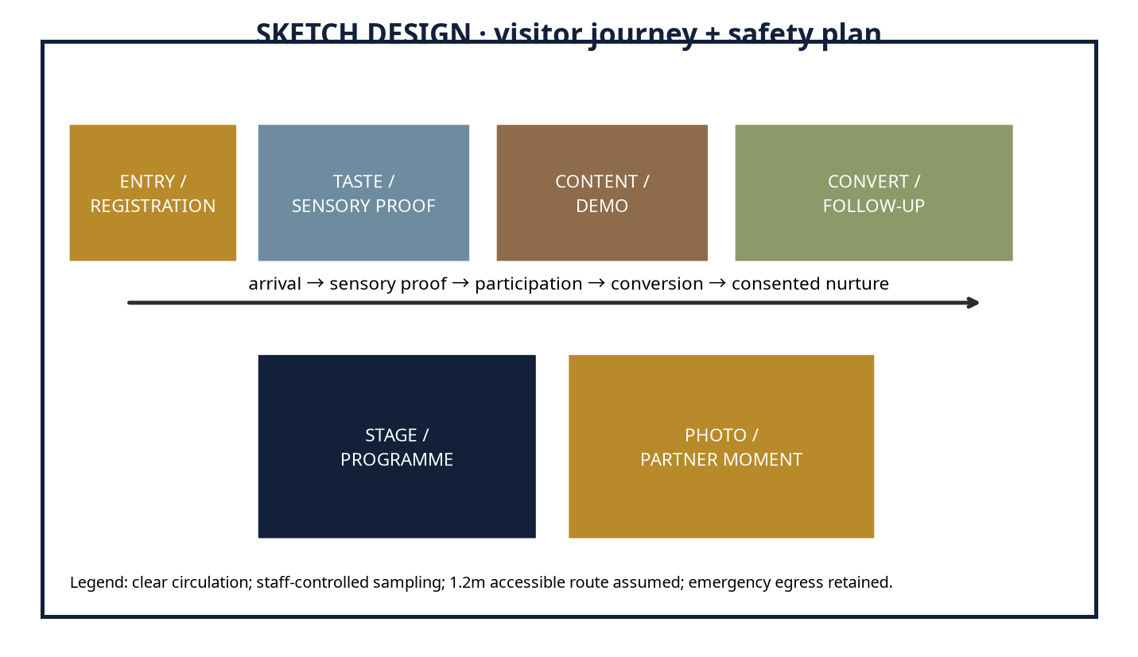
Part B — 3D DESIGN: client-viewable four-view package with hero perspective, front elevation, top/plan and branded-touchpoint detail. It is a concept render package, not an editable Blender, FBX, GLB, OBJ or CAD scene.
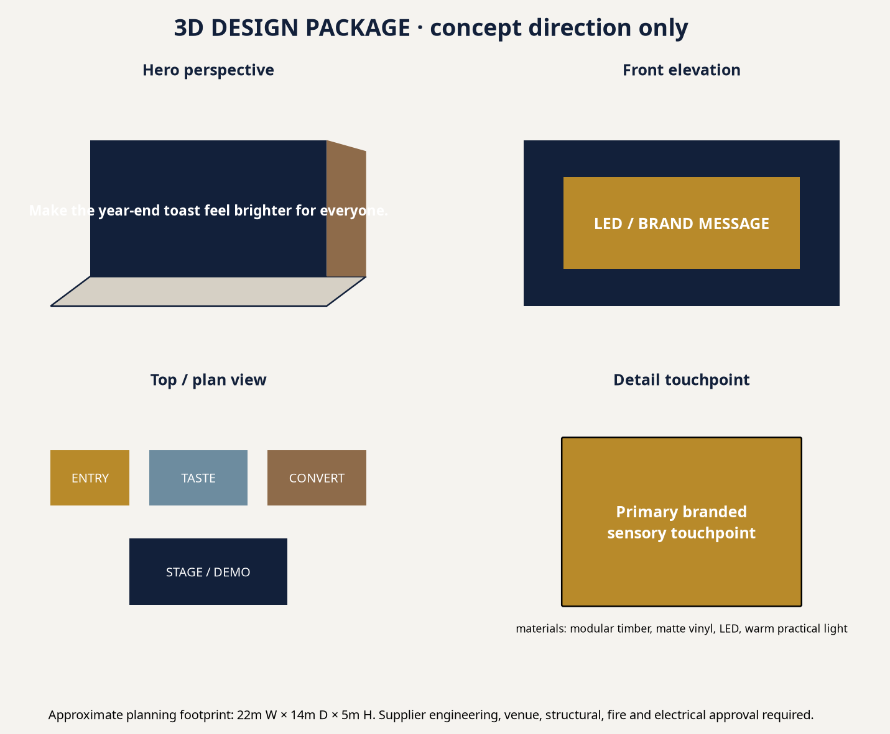
Design-to-production bridge | Status / next gate
Buildable concept | Modular zones, lighting, signage and AV direction are conceptually buildable.
Supplier engineering | Structural, fire, electrical, food hygiene and venue approval required.
Lead time | Indicative 3–8 weeks after scope, RFQ and design lock.
Budget impact | Imported equipment, venue availability, fuel, talent and fabrication complexity can materially change cost.

Talent and programme | Talents နှင့် Programme
Proposed/TBC: host or MC where physical, 3–5 carefully selected food/lifestyle creators, food stylist/chef or product demonstrator, sampling crew, photographer/videographer and technical crew. Talent is selected for audience and proof value; availability, fee, conflict, disclosure and usage rights require written confirmation.
Talent များသည် proposed/TBC ဖြစ်ပါသည်။ Creator၊ host/MC၊ food stylist/chef၊ sampling crew၊ photographer/videographer နှင့် technical crew တို့၏ availability၊ fee၊ conflict၊ disclosure နှင့် usage rights များကို written confirmation ဖြင့် အတည်ပြုရမည်။
Content calendar | Content နှင့် Media Calendar
Timing | Content / media | Commercial action
T−28 to T−21 | Tease sensory tension; partner/sponsor pitch; creator shortlist | UTM/source-code and retail forecast
T−20 to T−7 | Hero/ASMR assets, RSVP or sampling CTA, PR outreach | Lead/stock and staff routing
T−6 to T−1 | FAQ, access, creator proof, retargeting | Confirmation and rehearsal
Live / launch | Short clips, moderation, source-code handoff | Incident log and response SLA
T+1 to T+30 | Recap, reward, review/referral, learning cutdown | Nurture and ROI closeout

Workflow and roles | လုပ်ငန်းစဉ်နှင့် တာဝန်များ
Gate | ZYNTH | Client / vendor
Discovery | Research, tension, baseline, risk scan | Product truth, sales/CRM owner, legal input
Concept | Creative system, calendar, budgets | Approve conversion and working scope
Production | RFQ, design, content, run sheet | Venue, supplier, permits and stock sign-off
Launch | Operate, distribute, optimise | Sales response and escalation
Closeout | KPI/ROI report and learning archive | Revenue/margin confirmation

Budget proposition | ဘတ်ဂျက် အဆိုပြုချက်
All figures are date-stamped, indicative MMK planning ranges. They separate client-paid pass-through spend from ZYNTH fees. USD planning equivalent, where needed, is MMK 3,658/USD on 2026-08-18 [8]. Rates vary with venue, season, availability, imported equipment, fuel, exchange rate, talent and production complexity.
Line item | Basis / quantity | Lean / Pilot | Recommended | Impact / Flagship | Type | Confidence
Strategy / account service | Research, governance, approvals | 5,400,000 | 9,600,000 | 15,375,000 | ZYNTH fee | Medium
Creative / copy / transcreation | Platform, scripts, English–Myanmar hybrid | 5,400,000 | 9,600,000 | 15,375,000 | ZYNTH fee | Medium
Design / 3D / spatial | Sketch, 3D package or digital storyboard | 5,040,000 | 8,960,000 | 14,350,000 | ZYNTH fee | Medium
Venue / permits | Site hire, permissions, basic insurance | 6,480,000 | 11,520,000 | 18,450,000 | Pass-through | Low
Fabrication / AV / lighting | Modular build, LED, sound, technical labour | 11,520,000 | 20,480,000 | 32,800,000 | Pass-through | Low
Staff / registration / security | Hosts, queue, security, medical basic cover | 5,040,000 | 8,960,000 | 14,350,000 | Pass-through | Medium
Talent / creators | TBC, usage and exclusivity not included until quoted | 6,480,000 | 11,520,000 | 18,450,000 | Pass-through | Low
Photography / video / livestream | Capture, cutdowns, deliverables | 4,680,000 | 8,320,000 | 13,325,000 | Pass-through | Medium
Transport / logistics / catering | Fuel, delivery, stock movement, staff meals | 3,960,000 | 7,040,000 | 11,275,000 | Pass-through | Low
Media spend | Platform distribution / retail media | 7,920,000 | 14,080,000 | 22,550,000 | Pass-through | Medium
CRM / measurement | Consent, routing, dashboard, closeout | 3,240,000 | 5,760,000 | 9,225,000 | ZYNTH fee | Medium
Agency fee | Integrated delivery oversight | 4,320,000 | 7,680,000 | 12,300,000 | ZYNTH fee | Medium
Taxes / levies | Depends on invoices/entity | TBC | TBC | TBC | Client / pass-through | Low
Contingency | Scope, price, fuel and availability buffer | 4,680,000 | 8,320,000 | 13,325,000 | Pass-through reserve | Medium
TOTAL PLANNING RANGE | Indicative MMK; not supplier quote | 72,000,000 | 128,000,000 | 205,000,000 | Mixed | Medium

Assumptions and procurement | ယူဆချက်နှင့် Procurement
Assumption | Basis / required validation
Seasonal date | Public holiday planning source [3]; confirm operating days and local client calendar.
Sponsorship / expo | Only a proposal until organiser quote, rights inventory, venue and audience terms are confirmed [6].
Media | Public benchmarks partly proxy-based; run live platform test [7].
FX | MMK 3,658/USD dated reference [8]; recheck at PO.
Taxes / levies | TBC based on supplier invoices, client entity and tax advice.
Payment | Planning convention: 50% approval / 40% pre-live / 10% closeout, subject to contract.
Exclusions | Legal fees, insurance extensions, imported equipment, talent usage extensions and changes outside signed scope.

ROI and KPI scorecard | ROI နှင့် KPI Scorecard
Primary conversion: Event-to-retail purchase, responsible-service opt-in and post-event CRM retention.. Placeholder average value: MMK 75,000; placeholder contribution margin: 30%. Contribution = conversions × value × margin. Projected ROI = (contribution − investment) ÷ investment. These are scenarios, not guarantees; replace with client revenue, margin, baseline conversion and sales-cycle data.
Scenario | Conversions | Contribution | ROI vs Recommended
Conservative / break-even | 5689 | MMK 128,002,500 | 0%
Base | 9103 | MMK 204,817,500 | 60%
Upside | 11378 | MMK 256,005,000 | 100%

KPI area | Scorecard
Awareness | Reach, frequency, video completion, branded search proxy
Engagement | Saves, replies, sound/story completion, participation
Attendance / reach | Booked, attended, sampling/experience completion
Lead quality | Qualified rate, source code, response time
Conversion / revenue | Basket, voucher, booking, B2B meeting or repeat purchase
Retention / advocacy | Repeat, review, referral, creator-code reuse
Media / operations | CPM/CPL/CPA, on-time delivery, incident-free, accessibility and hygiene compliance

Timeline, risk and approval ask | Timeline၊ Risk နှင့် Approval Ask
Implementation sequence: Days 1–7 discovery/RFQ; Days 8–21 concept/design/partner lock; Days 22–45 production and media launch; Days 46–60 live/optimisation; Days 61–90 nurture, referral and closeout. Primary risks: product/health/origin claims, sampling hygiene, food-allergen handling, alcohol/age gating where applicable, venue/permit availability, weather, talent rights, fuel/logistics, platform shifts and data consent. Mitigate through written approval, an evidence file, alternative supplier/venue paths, a contingency reserve, consented capture and named escalation owners.
Approval ask — Recommended package ကို working ceiling အဖြစ် အတည်ပြုပေးရန်၊ client decision owner နှင့် CRM/sales owner ကို သတ်မှတ်ရန်၊ product truth/price/revenue baseline ပေးရန်၊ 5 business days အတွင်း 60-minute discovery + quotation-validation workshop ကို စီစဉ်ရန် တောင်းဆိုပါသည်။
ASMR-ready pitch-outreach candidates | ASMR-ready pitch-outreach candidates
“ASMR-ready” is interpreted here as sensory-product brands and retailers that may benefit from responsibly produced crunch, pour, sizzle, unwrap or texture content. This is a pitch-outreach list based on public catalog/source visibility—not a claim that the organisations have commissioned ASMR work or that contacts are available.
Publicly visible candidate | Pitch angle | Proposed role
Coca-Cola Pinya Beverages Myanmar | Sensory product proof, seasonal retail or creator-led conversion | Marketing Director / Experiential Lead / Corporate Affairs
Penguin | Sensory product proof, seasonal retail or creator-led conversion | Marketing Director / Experiential Lead / Corporate Affairs
City Selection | Sensory product proof, seasonal retail or creator-led conversion | Marketing Director / Experiential Lead / Corporate Affairs
Burbrit | Sensory product proof, seasonal retail or creator-led conversion | Marketing Director / Experiential Lead / Corporate Affairs

Sources and references | အရင်းအမြစ်များ
[1] Myanmar Economic Monitor, June 2026: Shock Amid Fragility — https://reliefweb.int/report/myanmar/myanmar-economic-monitor-june-2026-shock-amid-fragility-enmy (published/accessed 2026-06-16). Supports: 2026 macro pressure: weak demand, fuel/logistics costs, inflation and operating uncertainty.
[2] Digital 2026: Myanmar — https://datareportal.com/reports/digital-2026-myanmar (published/accessed 2025-11-08). Supports: Late-2025 digital planning indicators: 39.8m internet users, 62.5m mobile connections and 21.0m social identities.
[3] Holiday List of 2026 — Consulate General of Myanmar, Los Angeles — https://myanmarcgla.org/index.php/holiday-list-of-2026 (published/accessed 2025-12-29). Supports: Public dates used in this planning calendar: 26–27 Oct Thadingyut, 23–24 Nov Tazaungdaing, 4 Dec National Day; client must confirm local operating calendars.
[4] Local delicacies take centre stage at Taste of the Golden Land 2026 — https://www.gnlm.com.mm/local-delicacies-take-centre-stage-at-taste-of-the-golden-land-2026-this-july/ (published/accessed 2026-07-15). Supports: Evidence of a Yangon food festival format that combines regional cuisines, brand participation, activity programmes and photo moments.
[5] City Mall Myanmar — Food category catalogue — https://www.citymall.com.mm/citymall/my/%E1%80%95%E1%80%85%E1%80%B9%E1%80%85%E1%80%8A%E1%80%BA%E1%80%B8%E1%80%A1%E1%80%99%E1%80%BB%E1%80%AD%E1%80%AF%E1%80%B8%E1%80%A1%E1%80%85%E1%80%AC%E1%80%B8%E1%80%99%E1%80%BB%E1%80%AC%E1%80%B8/%E1%80%85%E1%80%AC%E1%80%B8%E1%80%9E%E1%80%B1%E1%80%AC%E1%80%80%E1%80%BA%E1%80%80%E1%80%AF%E1%80%94%E1%80%BA%E1%80%95%E1%80%85%E1%80%B9%E1%80%85%E1%80%8A%E1%80%BA%E1%80%B8%E1%80%99%E1%80%BB%E1%80%AC%E1%80%B8/c/id01?q=%3Abestselling&page=169 (published/accessed accessed 2026-08-20). Supports: Myanmar-language retail context and publicly visible food brands/products, including City Selection, Yummy, Popy, Pa Pa, Feel and Penguin.
[6] 2026 Agriculture Related Trade Shows and Conferences — USDA FAS — https://apps.fas.usda.gov/newgainapi/api/Report/DownloadReportByFileName?fileName=2026%20Agriculture%20Related%20Trade%20Shows%20and%20Conferences_Rangoon_Burma%20-%20Union%20of_BM2026-0003.pdf (published/accessed 2026-01-22). Supports: Publicly indexed 2026 food-and-beverage/retail-show opportunity; exact venue, dates and sponsorship inventory require organiser confirmation.
[7] Myanmar Advertising Costs 2026: Facebook, Google, TikTok Rate Card — https://marketingmyanmar.com/myanmar-advertising-costs-2026-facebook-google-tiktok-rate-card/ (published/accessed 2026-03-20). Supports: Indicative platform planning ranges that are expressly proxy-based where Myanmar platform data is unavailable.
[8] Yoma Bank — Currency Exchange Rates — https://www.yomabank.com/en/rates/ (published/accessed 2026-08-18). Supports: Dated planning USD/MMK reference: MMK 3,658 per USD for trade-related transactions; not a binding supplier or settlement rate.
Disclaimer: This proposal is a planning document, not a supplier quotation, financial guarantee, legal opinion or permit approval. Prices, dates, sponsorship availability and ROI scenarios require validation through current local quotations, client data and relevant approvals.

