ZYNTH
Charge the Weekend
Automotive / EV · Myanmar commercial context · EV roadshow + dealer event + test-drive lead funnel
Prepared 2026-08-20 · Validity window: 14 days for planning assumptions · Confidential — prepared for client discussion only.
Concept proposal — subject to client, legal, platform, venue, supplier, talent and regulatory validation. Prices and ROI are indicative until validated through current local quotations and client data.

1. Executive summary
EV distributor or mobility brand entering Yangon faces a specific commercial tension: EV curiosity is high, but purchase hesitation is practical: range, charging, serviceability and resale confidence. The opportunity is to change one behaviour — visitors compare a real weekend route, estimate charge needs, and book a supervised test drive with a dealer follow-up slot. — so that the audience moves from passive interest to a measurable qualified test drive, dealer appointment, fleet enquiry or deposit conversation..
The proposed platform is **Charge the Weekend**. Its promise is: “See how far your real life can go.” The architecture combines ev roadshow + dealer event + test-drive lead funnel because the event or experience creates proof, the content system scales that proof, and CRM/sales follow-up converts the moment while intent is still warm.
Decision | Recommendation | Commercial logic
Recommended package | Recommended · MMK 165,000,000 indicative | Balances proof, reach, production control and measurable follow-up.
Primary conversion | Qualified test drive, dealer appointment, fleet enquiry or deposit conversation. | One conversion definition keeps reporting accountable.
Approval ask | Approve concept, working budget and discovery access within 5 business days. | Enables venue/vendor RFQ and first creative gate.

2. Business context and opportunity
Myanmar’s current operating context is not a reason to become generic. The World Bank reports tentative stabilisation alongside weak demand, fuel/logistics pressure and a 24.6% year-on-year inflation reading in April 2026 [1]. That makes relevance, proof and operational discipline more valuable than spectacle alone.
For automotive / ev, the commercial opportunity is to reduce one form of hesitation: ev curiosity is high, but purchase hesitation is practical: range, charging, serviceability and resale confidence.. The proposal therefore treats the audience journey as a connected system rather than an isolated event.
3. Myanmar industry and audience insight
Digital planning should be mobile-first but not digital-only. DataReportal’s Digital 2026 Myanmar page reports 39.8 million internet users at the end of 2025, 62.5 million cellular connections and 21.0 million social-media user identities [2]. These are planning indicators, not deduplicated reach guarantees. The media plan therefore uses platform-native short video and CRM/relationship follow-up, with offline proof where the category requires trust.
Audience insight: People cross the consideration gap when they can see the vehicle inside their actual weekend, not inside a glossy showroom claim. The cultural/context implication is to use Burmese-first transcreation where the audience is mass-market, preserve respectful representation, and avoid claims that cannot be substantiated locally. Exclusions include minors or vulnerable audiences where consent, safeguarding or category rules are not cleared.
4. Strategic objective and measurable goals
The strategic objective is to make EV distributor or mobility brand entering Yangon the easiest credible next step for the audience’s current need. The single behaviour change is: Visitors compare a real weekend route, estimate charge needs, and book a supervised test drive with a dealer follow-up slot..
Goal | 90-day target | Measurement
Attention | Reach 150,000–600,000 qualified impressions depending on package | Platform delivery + deduplicated reporting where available
Engagement | 3–8% meaningful interaction or content completion benchmark | Saves, replies, watch-through, diagnostic starts
Commercial | Qualified conversion volume sufficient to replace client baseline | CRM status, consented source code, sales disposition
Experience quality | ≥90% of booked/attended journey steps completed | Registration, queue, handoff and incident log

5. Target audience, triggers, context and exclusions
Segment | Trigger | What they need to see | Exclusion / caution
Urban professionals, family buyers, fleet managers, tech-forward early adopters and ride-hailing operators. | A real-life friction or aspiration | Proof in their language, a next step, and a reason to act now | No unsupported performance or price claim
Influencers / partners | A useful story with permissioned access | Clear brief, disclosure, usage rights | No hidden sponsorship
Sales / relationship team | A signal of intent | A short handoff card and owner | No unconsented data sharing

6. Big idea and creative platform
**Charge the Weekend** turns the category’s abstract promise into a tangible proof moment. Promise: “See how far your real life can go.” Visual world: editorial Myanmar realism, restrained navy and off-white foundations, one gold signal for the next action, and real people shown in context rather than stock-photo aspiration.
The platform can generate a hero film, short-form cutdowns, creator prompts, proof cards, CRM messages, sales handoff tools, event signage and a closeout case study without changing the core idea.
Signature moment | Audience behaviour created | Client result
Weekend Route Simulator: map your real trip and see charge logic. | Stop, recognise relevance, and complete the next step | Higher-quality intent signal
Battery Myth Court: transparent questions answered. | Stop, recognise relevance, and complete the next step | Higher-quality intent signal
Quiet Drive: supervised test-drive slots. | Stop, recognise relevance, and complete the next step | Higher-quality intent signal
Dealer handoff pack with personalised follow-up. | Stop, recognise relevance, and complete the next step | Higher-quality intent signal

7. Event / campaign architecture
Architecture: trigger → anticipation → arrival/discovery → proof → conversion → immediate follow-up → nurture → referral → measurement. The event layer is Seven-day mobile roadshow with two anchor dealer weekends.; the distribution layer is Facebook, TikTok, YouTube, Google Search, automotive media, dealer CRM, fleet ABM.; the conversion layer is Qualified test drive, dealer appointment, fleet enquiry or deposit conversation..
Journey stage | Prospect sees | Prospect does | Receives | Who responds next
Trigger | A culturally relevant tension | Stops or saves | Short proof asset | ZYNTH/social team
Arrival / discovery | A clear choice architecture | Completes diagnostic or experience | Personalised card / result | Host or facilitator
Proof | Real demonstration or case | Asks, compares, tests | Evidence and next step | Specialist / sales
Conversion | Consent-based CTA | Books, applies, enquires or refers | Confirmation and owner | Client CRM / sales
Nurture | Useful follow-up | Returns or shares | Reminder, proof, review/referral | Client retention team

8. Full marketing plan
Workstream | Plan | Output / KPI
Brand | Platform, visual system, Burmese/English transcreation | Recognition, consistency, approval gate
PR | Local trade/lifestyle pitch, founder or specialist angle | Qualified mentions and referral traffic
Media | Reach + retargeting across Meta/Google/TikTok where permitted | CPM, CPC, CPL, frequency
Social/content | Hero, cutdowns, creator prompts, proof cards, recap | Watch-through, saves, comments, shares
Performance | Lead or booking objective with source codes | CPL/CPA, conversion rate
CRM/reactivation | Consent-based reminder and sales routing | Response time, booked follow-up
KOL/creator | Proposed/TBC creators selected for audience fit, not vanity reach | Qualified traffic, disclosed content
Partner/community | Venue, distributor, clinic, school, employer or community partner | Partner leads and trust transfer
Sales enablement | One-page handoff card, FAQ, objection handling | Lead disposition and time-to-contact
Post-campaign | Review request, referral prompt, case study | Advocacy, repeat, referral rate

9. Experience and production design
Venue/site direction: Mall forecourt / dealer network, Yangon and Mandalay; approvals TBC. Production direction: 20m x 15m forecourt, vehicle plinth, route simulator LED, cones/barriers, weatherproof signage, charging demo safety.. The experience is designed to create the audience behaviour that supports the conversion, not to add decoration. All dimensions are planning assumptions; supplier engineering, fire/electrical review, venue approval and local permits remain open gates.
Part A — SKETCH DESIGN. The plan view shows entry/exit, registration, discovery/proof, demo, conversion, content capture, circulation and safety assumptions. It is a concept-board and spatial-planning aid, not a construction drawing.
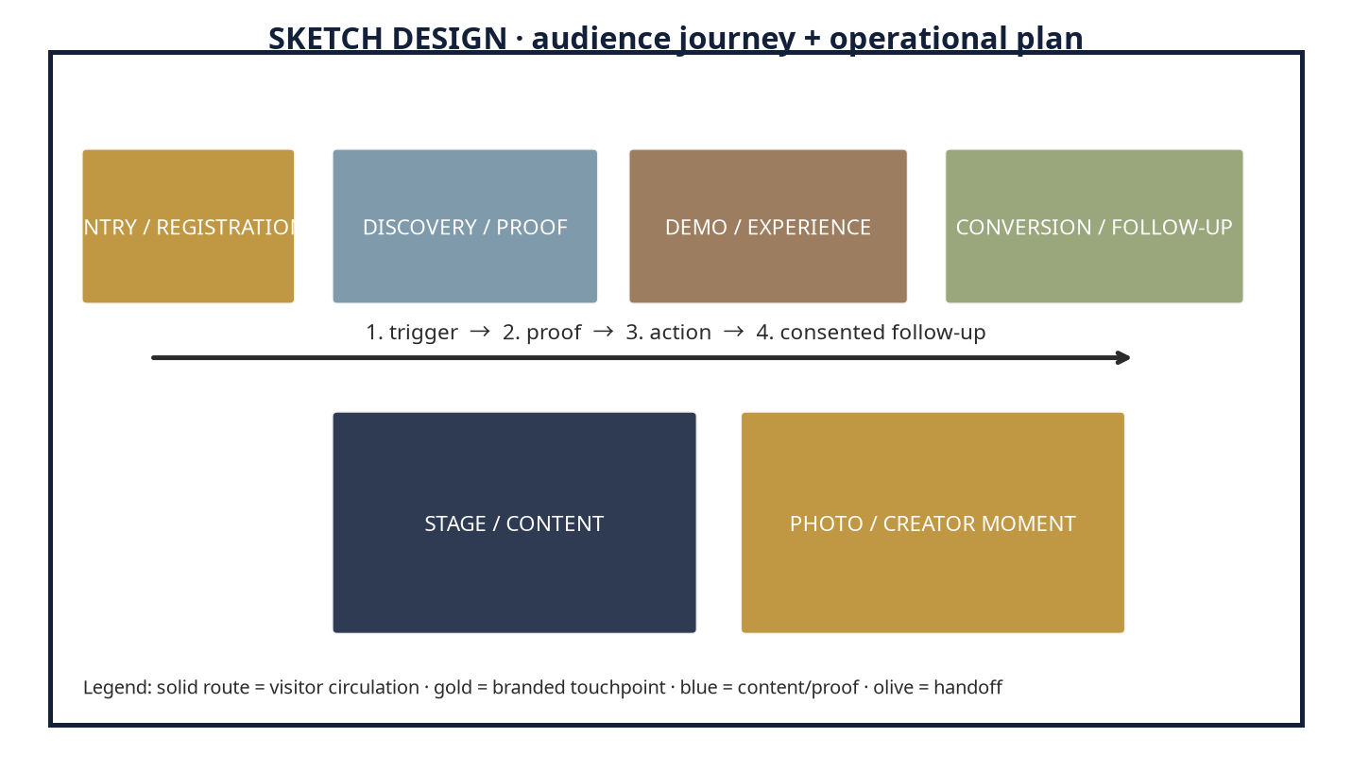
Part B — 3D DESIGN. The hero perspective is a client-viewable render-style direction. It is not an editable Blender, FBX, GLB or CAD file. Dimensions, materials, LED/video surfaces, lighting and sightlines must be validated by the appointed supplier and venue.
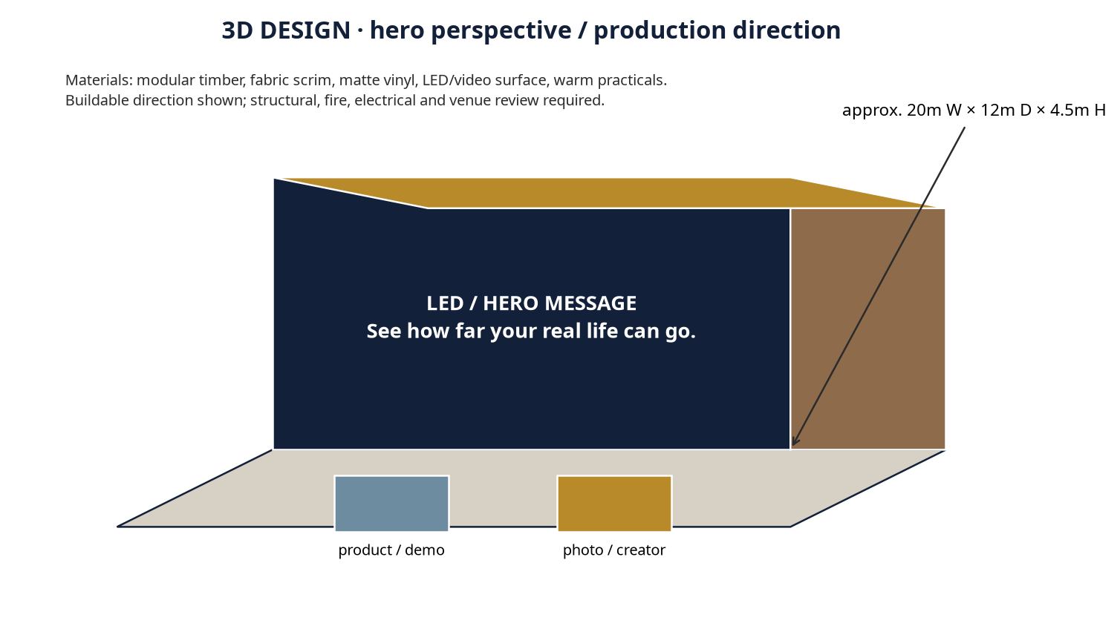
Design-to-production bridge | Current status | Next validation
Conceptual | Mood, zone logic, hero message, material intent | Client concept approval
Buildable as shown in principle | Modular zones, signage, simple LED/AV, staff positions | Supplier RFQ and venue walk-through
Requires engineering | Structural loading, hanging points, electrical, fire egress | Venue and structural/fire review
Lead time / budget impact | Indicative 3–8 weeks depending on imported equipment and fabrication | Lock scope before deposit

10. Talent and programme plan
Required talent: Automotive moderator, engineer spokesperson TBC, 3 creators, trained brand ambassadors. All names, rates, availability and usage rights are proposed/TBC until brief, conflict check and quotation. Technical crew should be sized to the selected AV and capture scope. Specialist or regulated speakers require client and legal approval.
11. Channel-by-channel content and media calendar
Timing | Facebook / Instagram | TikTok / video | PR / partner / CRM | Sales / measurement
T−28 to T−21 | Reveal tension and saveable proof card | Creator hook tests | Partner save-the-date | CRM audience and UTM/source-code setup
T−20 to T−7 | Benefit-led explainers and RSVP/lead CTA | Native creator proof | Trade/lifestyle pitch | Lead routing rehearsal
T−6 to T−1 | FAQ, access, reminder, retargeting | Countdown / behind-the-scenes | Reminder and partner reposts | Attendance / booking confirmation
Live / launch | Stories, live updates, moderation | Short live cuts / creator capture | Real-time issue log | Handoff desk and response SLA
T+1 to T+30 | Recap, proof, review/referral | Cutdowns and testimonials | Case-study pitch | Nurture, attribution and closeout

12. Project workflow and gates
Gate | Work | Approval / evidence
1 Discovery | Brief, data, business baseline, compliance scan | Client access and decision owner
2 Research | Myanmar sources, audience, competitor/category contrast | Research/source register
3 Concept | Platform, journey, creative routes, budget packages | Concept approval
4 Design | Key visual, content system, sketch/3D or storyboard | Design sign-off
5 Production | RFQ, supplier lock, talent, permits, rehearsals | Production readiness review
6 Launch / live | Publish, operate, moderate, route leads | Live log and incident plan
7 Optimisation | Daily/weekly readouts and creative/media changes | Change log
8 Report / closeout | ROI/KPI, assets, learnings, next action | Final report within 7 days

13. Roles and responsibilities
Party | Responsibility
ZYNTH | Strategy, creative platform, project management, production oversight, content, media/CRM coordination, measurement and closeout.
Client | Business baseline, brand/legal approval, product truth, CRM/sales owner, venue access, payment and final claims approval.
Vendors | RFQ, engineering, fabrication, AV, staffing, safety documentation, delivery and insurance as applicable.
Partners | Audience access, venue/channel support, co-promotion and handoff.
Talent | Approved performance/content deliverables, disclosure, usage rights and call times.

14. Detailed budget proposition (MMK)
All amounts below are date-stamped planning ranges for 2026-08-20. Pass-through costs are separated from ZYNTH fees. USD equivalents use MMK 3,658/USD from Yoma Bank’s 2026-08-18 reference and are for planning only [6]. Rates vary materially with venue, season, availability, imported equipment, fuel, exchange-rate movement, talent profile and production complexity.
Line item | Basis / quantity | Lean / Pilot | Recommended | Impact / Flagship | Cost type | Confidence
Strategy / account service | Discovery, research, planning, weekly governance | 7,600,000 | 13,200,000 | 18,200,000 | ZYNTH fee | Medium
Creative / copy | Platform, key message, scripts, transcreation | 6,650,000 | 11,550,000 | 16,900,000 | ZYNTH fee | Medium
Design / content system | Key visual, templates, channel adaptations | 5,700,000 | 9,900,000 | 15,600,000 | ZYNTH fee | Medium
3D / spatial / CGI | Conceptual spatial direction and renders | 4,750,000 | 8,250,000 | 14,300,000 | ZYNTH fee / design pass | Low–Medium
Venue / site / permits | Venue or site hire; permits TBC | 7,600,000 | 13,200,000 | 19,500,000 | Pass-through | Low
Production / fabrication | Zones, print, furniture, signage, build | 11,400,000 | 19,800,000 | 33,800,000 | Pass-through | Low
Stage / AV / lighting / sound | AV, power, screens, technical crew | 7,600,000 | 14,850,000 | 26,000,000 | Pass-through | Low
Staffing / registration / security | Hosts, queue, registration, basic security | 4,750,000 | 8,250,000 | 14,300,000 | Pass-through | Medium
Talent / KOL / creator | Proposed/TBC; usage rights excluded until quoted | 6,650,000 | 14,850,000 | 26,000,000 | Pass-through | Low
Photo / video / livestream | Capture, edits, live or hybrid requirements | 5,700,000 | 11,550,000 | 19,500,000 | Pass-through | Medium
Transport / logistics / catering | Route, meals, delivery, fuel allowance | 4,750,000 | 8,250,000 | 15,600,000 | Pass-through | Low
Media spend / paid digital | Paid distribution; platform billable spend | 8,550,000 | 14,850,000 | 20,800,000 | Pass-through | Medium
CRM / automation / measurement | Lead routing, dashboard, report, closeout | 4,750,000 | 8,250,000 | 11,700,000 | ZYNTH fee | Medium
Agency fee | Blended management and production oversight | 5,700,000 | 9,900,000 | 16,900,000 | ZYNTH fee | Medium
Taxes / levies | Not included; confirm applicable local tax treatment | TBC | TBC | TBC | Client / pass-through | Low
Contingency | Planning reserve for price, fuel, availability | 5,700,000 | 9,900,000 | 16,900,000 | Pass-through reserve | Medium
TOTAL PLANNING RANGE | Indicative, not a supplier quotation | 95,000,000 | 165,000,000 | 260,000,000 | MMK | Medium

15. Assumptions, exclusions, procurement and payment
Assumption | Planning basis | Confidence / validation
Venue | TBC; official venue page supports capacity existence but not a live quote [4] | Low — obtain 2 written quotes
Media | Myanmar-specific ranges are indicative and partly proxy-based [5] | Medium — platform plan and live test
Talent / creators | Proposed/TBC; usage rights, exclusivity and travel are separate until quoted | Low — shortlist and RFQ
FX | MMK 3,658/USD dated 2026-08-18 reference; not binding [6] | Medium — recheck at PO
Taxes / levies | Not included until client entity and supplier invoices are known | Low — finance validation
Payment | 50% deposit at approval, 40% before live/launch, 10% on closeout; subject to contract | Medium — client procurement review
Exclusions | Major travel, imported equipment, paid talent usage extensions, structural/fire certification, legal fees and post-scope changes | High — confirm in SOW

Quotation-validation checklist: obtain two venue quotes; two production/fabrication quotes; current AV/lighting quote; talent availability and usage rights; platform media plan; transport/fuel estimate; permits/insurance; tax treatment; final client margin/revenue inputs; and a signed scope before procurement.
16. ROI model and break-even logic
Primary commercial conversion: Qualified test drive, dealer appointment, fleet enquiry or deposit conversation.. Planning value per conversion: MMK 8,500,000; assumed contribution margin: 18%. These are placeholders to be replaced by client data. Formula: contribution value = conversions × average value × contribution margin; projected ROI = (contribution value − total investment) ÷ total investment. No result is guaranteed.
Scenario | Conversions | Contribution value | Projected ROI vs Recommended | Interpretation
Conservative | 108 | MMK 165,240,000 | 0% | Break-even planning case
Base | 184 | MMK 281,520,000 | 71% | Replace with client baseline
Upside | 216 | MMK 330,480,000 | 100% | Requires strong reach and sales follow-up

Break-even conversion volume at the Recommended package is approximately 108 conversions under the placeholder value/margin. Client inputs requested: average order/contract value, contribution margin, baseline conversion rate, sales-cycle length, repeat/referral value and CRM disposition rules.
17. KPI scorecard
Dimension | Target / measure | Source
Awareness | Reach, frequency, video completion, branded search proxy | Platform and search data
Engagement | Saves, replies, diagnostic starts, content completion | Platform / form analytics
Attendance / reach | Booked, attended, journey-step completion | Registration / event log
Lead quality | Qualified rate, source code, response time | CRM / sales
Conversion / revenue | Booked, applied, reserved, purchased, attributed contribution | Client CRM / finance
Retention / advocacy | Repeat, review, referral, recurring contribution | CRM / review platform
Media efficiency | CPM, CPC, CPL/CPA, frequency | Platform exports
Operational quality | On-time, incident-free, accessibility and safety compliance | Run sheet / incident log

18. Expected client benefits and why ZYNTH
The expected benefit is not merely attention. The system gives EV distributor or mobility brand entering Yangon a clearer proof asset, a consented signal of intent, a routed next action and a measurable learning loop. ZYNTH is the right partner when the client needs strategy, creative, production, distribution and measurement connected in one operating rhythm: “The Intelligence of Creativity.”
19. Implementation schedule
Period | Milestone
Days 1–7 | Discovery, source validation, client baseline, venue/supplier RFQ
Days 8–21 | Concept approval, design route, content plan, CRM and measurement setup
Days 22–45 | Production, talent lock, media launch, rehearsal / QA
Days 46–60 | Live execution or campaign optimisation, daily/weekly readouts
Days 61–90 | Nurture, referral/review, case study, ROI/KPI closeout and next-quarter recommendation

20. Risks, mitigations, compliance and decision requests
Risk / compliance | Mitigation
Road permissions, insurance, weather, vehicle availability, fuel/transport volatility. | Named owner, written approval, backup route and contingency reserve.
Platform / data privacy | Consent-based capture, source-code governance, access limits and no private-profile collection.
Venue / safety | Venue walk-through, egress preserved, fire/electrical/structural review and incident plan.
Claims / talent | Client legal approval, evidence file, disclosure and usage-rights schedule.
Decision requested | Approve Recommended package, nominate client decision owner and CRM/sales owner, release baseline data, and schedule a 60-minute kickoff within 5 business days.

21. Why this wins
This proposal wins on a category contrast: instead of asking the audience to believe a generic claim, it gives them a small, relevant proof moment and a clear next action. The opportunity map is: tension → proof → consent → handoff → nurture. The creative territory is distinctive because weekend route simulator: map your real trip and see charge logic. and battery myth court: transparent questions answered. are designed around the category’s real friction rather than a generic event theme.
22. Sources and references
[1] Myanmar Economic Monitor, June 2026: Shock Amid Fragility — https://reliefweb.int/report/myanmar/myanmar-economic-monitor-june-2026-shock-amid-fragility-enmy (published/accessed 2026-06-16). Supports: Macro conditions, fuel shock, inflation, weak demand, operating uncertainty.
[2] Digital 2026: Myanmar — https://datareportal.com/reports/digital-2026-myanmar (published/accessed 2025-11-08). Supports: Internet, mobile and social-media planning context; late-2025 data used for 2026 planning.
[5] Myanmar Advertising Costs 2026: Facebook, Google, TikTok Rate Card — https://marketingmyanmar.com/myanmar-advertising-costs-2026-facebook-google-tiktok-rate-card/ (published/accessed 2026-03-20). Supports: Indicative Myanmar digital media ranges, explicitly proxy-based where platform data is unavailable.
[6] Yoma Bank — Currency Exchange Rates — https://www.yomabank.com/en/rates/ (published/accessed 2026-08-18). Supports: Dated indicative USD/MMK assumption: MMK 3,658 trade-related average selling price; rates are not binding.
[8] ZYNTH internal planning knowledge — Myanmar event landscape — https://github.com/zanezynthbrain/zynth-brain/blob/main/backend/knowledge/22_myanmar_event_landscape.md (published/accessed accessed 2026-08-20). Supports: Internal planning ranges and venue/vendor starting points; all require RFQ validation.
[9] ZYNTH internal planning knowledge — pricing and standards — https://github.com/zanezynthbrain/zynth-brain/blob/main/backend/knowledge/09_pricing_and_standards.md (published/accessed accessed 2026-08-20). Supports: Agency fee models, deposit convention, contingency and service standards; not supplier quotes.

Final action page
Recommended decision: approve the Recommended package as a working ceiling, subject to RFQ. First milestone: discovery and quotation-validation workshop. Information needed from client: revenue/margin baseline, CRM fields, target geography, product truth, legal constraints, venue/site access and decision owners. Next meeting objective: lock the single conversion, proof moment and procurement timetable.
Disclaimer: This is a planning document, not a supplier quotation, financial guarantee, legal opinion, permit approval or promise of outcome. All pricing and ROI are indicative until current local quotations, client data, platform availability and relevant approvals are validated.

