1. Select Novice

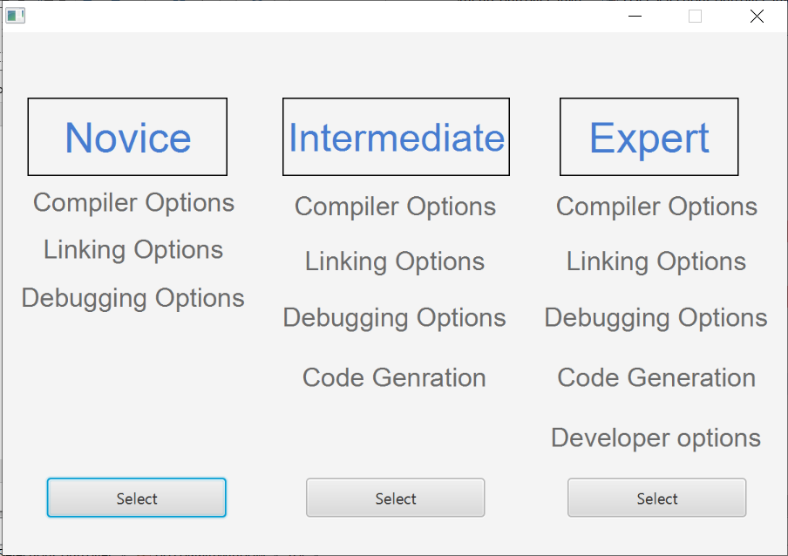

1. Select New project

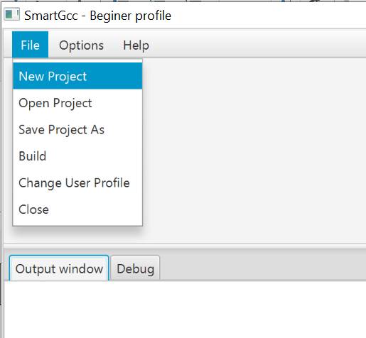

1. It will open the windows browser to select a cpp file (create a helloworld.cpp) for your test
2. Select you .cpp file

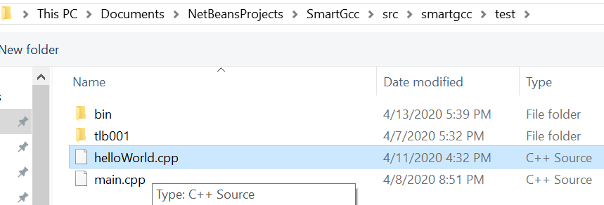

1. Another browser opens immediately, but this one is to save a project ( maybe not the most efficient) but this is how it works as of today.

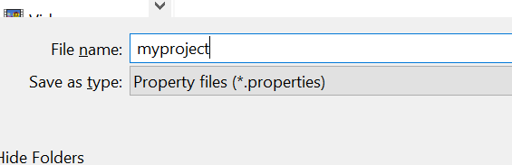

1. Notice the main window changes. The reason is that there is a cpp file loaded and a project name. It also shows the current g++ command by default.

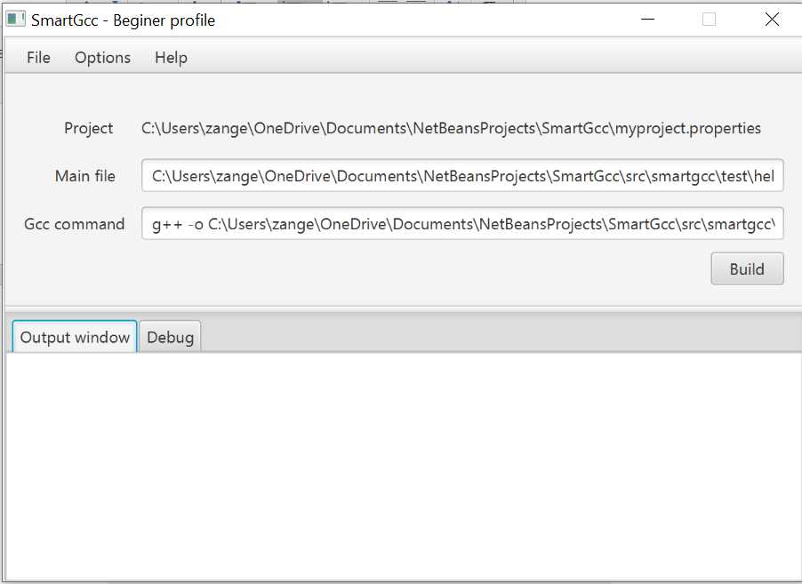

1. If you click buil the it will show you in the output window.
2. Click in User options to see what is available

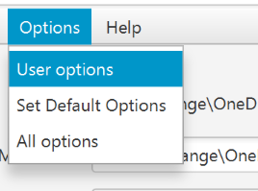

1. Notice all the possibilities are shown on the tabs, enven for Beginer. But if you click on Developer for instance you will see next

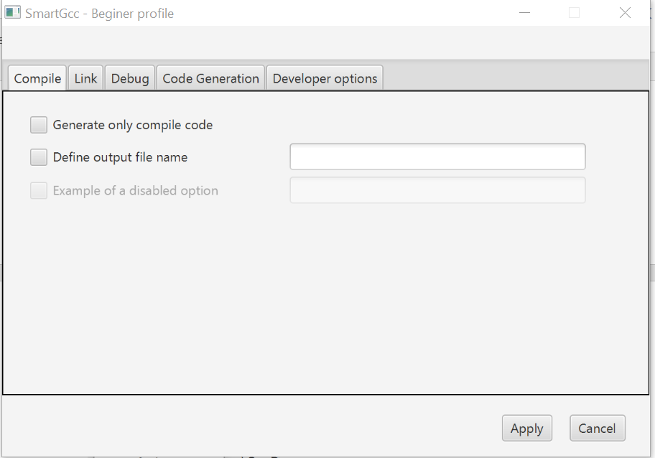

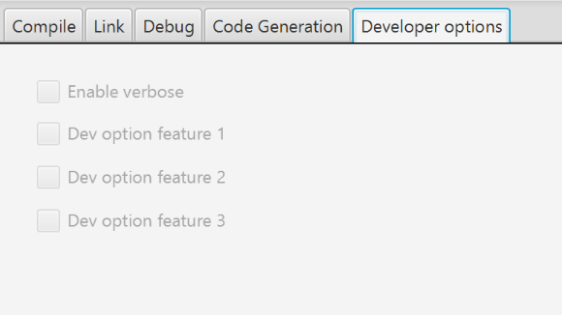

1. In order to active the option, you have to click cancel and go to All options

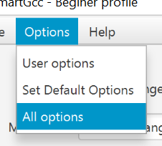

1. Go to the developer tab and click on the feature you are interested on, I clicked in the first one.

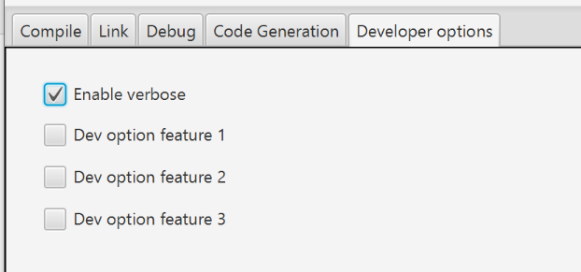

1. Cliclk on apply and go back to the user options, Developer tab. Notice it is the only one available.

