Project Report
name:- Mayank Gobind
College :- Manipal Institute of Technology

ACKNOWLEDGEMENT

It has indeed been a great privilege for me to have Rammohan Bethi , Machine Learning & Python Trainer , SmartBridge, as my mentor for this project. I take this opportunity to express my utmost gratitude to him. I am indebted to him for his timely and valuable advice throughout the internship.

Mayank Gobind

Background Theory
Types of Machine Learning
The types of machine learning algorithms differ in their approach, the type of data they input and output, and the type of task or problem that they are intended to solve. Broadly Machine Learning can be categorized into four categories.
- I. Supervised Learning
- II. Unsupervised Learning
- III. Reinforcement Learning
- IV. Semi-supervised Learning

Supervised Learning
Supervised Learning is a type of learning in which we are given a data set and we already know what are correct output should look like, having the idea that there is a relationship between the input and output. Basically, it is learning task of learning a function that maps an input to an output based on example input-output pairs. It infers a function from labeled training data consisting of a set of training examples.
Supervised learning problems are categorized.

Unsupervised Learning
Unsupervised Learning is a type of learning that allows us to approach problems with little or no idea what our problem should look like. We can derive the structure by clustering the data based on a relationship among the variables in data. With unsupervised learning there is no feedback based on prediction result. Basically, it is a type of self-organized learning that helps in finding previously unknown patterns in data set without pre-existing label.

Reinforcement Learning
Reinforcement learning is a learning method that interacts with its environment by producing actions and discovers errors or rewards. Trial and error search and delayed reward are the most relevant characteristics of reinforcement learning. This method allows machines and software agents to automatically determine the ideal behavior within a specific context in order to maximize its performance. Simple reward feedback is required for the agent to learn which action is best.

Semi-Supervised Learning
Semi-supervised learning fall somewhere in between supervised and unsupervised learning, since they use both labeled and unlabeled data for training – typically a small amount of labeled data and a large amount of unlabeled data. The systems that use this method are able to considerably improve learning accuracy. Usually, semi-supervised learning is chosen when the acquired labeled data requires skilled and relevant resources in order to train it / learn from it. Otherwise, acquiring unlabeled data generally doesn’t require additional resources.

Machine Learning Algorithms
There are many types of Machine Learning Algorithms specific to different use cases. As we work with datasets, a machine learning algorithm works in two stages. We usually split the data around 20%-80% between testing and training stages. Under supervised learning, we split a dataset into a training data and test data in Python ML. Followings are the Algorithms of Python Machine Learning –

1. Linear Regression-
Linear regression is one of the supervised Machine learning algorithms in Python that observes continuous features and predicts an outcome. Depending on whether it runs on a single variable or on many features, we can call it simple linear regression or multiple linear regression.
This is one of the most popular Python ML algorithms and often under-appreciated. It assigns optimal weights to variables to create a line ax+b to predict the output. We often use linear regression to estimate real values like a number of calls and costs of houses based on continuous variables. The regression line is the best line that fits Y=a*X+b to denote a relationship between independent and dependent variables.
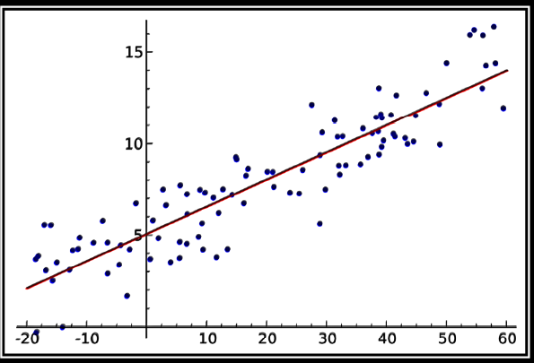
2. Logistic Regression -
Logistic regression is a supervised classification is unique Machine Learning algorithms in Python that finds its use in estimating discrete values like 0/1, yes/no, and true/false. This is based on a given set of independent variables. We use a logistic function to predict the probability of an event and this gives us an output between 0 and 1. Although it says ‘regression’, this is actually a classification algorithm. Logistic regression fits data into a logit function and is also called logit regression.
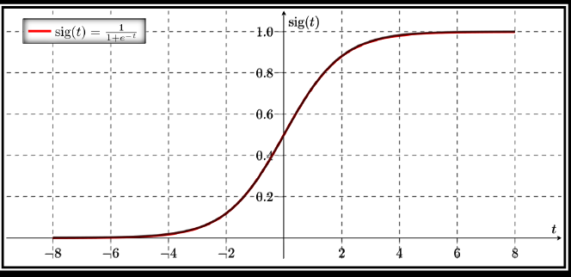
3. Decision Tree -
A decision tree falls under supervised Machine Learning Algorithms in Python and comes of use for both classification and regression- although mostly for classification. This model takes an instance, traverses the tree, and compares important features with a determined conditional statement. Whether it descends to the left child branch or the right depends on the result. Usually, more important features are closer to the root.
Decision Tree, a Machine Learning algorithm in Python can work on both categorical and continuous dependent variables. Here, we split a population into two or more homogeneous sets. Tree models where the target variable can take a discrete set of values are called classification trees; in these tree structures, leaves represent class labels and branches represent conjunctions of features that lead to those class labels. Decision trees where the target variable can take continuous values (typically real numbers) are called regression trees.

4. Support Vector Machine (SVM)-
SVM is a supervised classification is one of the most important Machines Learning algorithms in Python, that plots a line that divides different categories of your data. In this ML algorithm, we calculate the vector to optimize the line. This is to ensure that the closest point in each group lies farthest from each other. While you will almost always find this to be a linear vector, it can be other than that. An SVM model is a representation of the examples as points in space, mapped so that the examples of the separate categories are divided by a clear gap that is as wide as possible. In addition to performing linear classification, SVMs can efficiently perform a non-linear classification using what is called the kernel trick, implicitly mapping their inputs into high-dimensional feature spaces. When data are unlabeled, supervised learning is not possible, and an unsupervised learning approach is required, which attempts to find natural clustering of the data to groups, and then map new data to these formed groups.
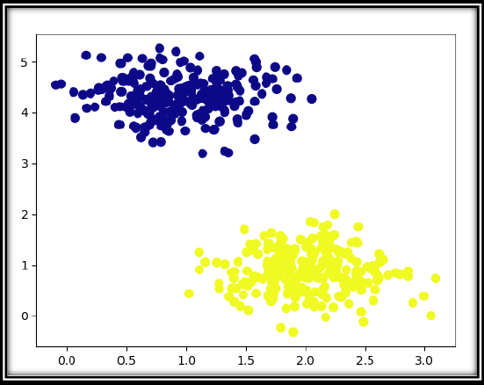5. Naïve Bayes Algorithm -
Naive Bayes is a classification method which is based on Bayes’ theorem. This assumes independence between predictors. A Naive Bayes classifier will assume that a feature in a class is unrelated to any other. Consider a fruit. This is an apple if it is round, red, and 2.5 inches in diameter. A Naive Bayes classifier will say these characteristics independently contribute to the probability of the fruit being an apple. This is even if features depend on each other. For very large data sets, it is easy to build a Naive Bayesian model. Not only is this model very simple, it performs better than many highly sophisticated classification methods. Naïve Bayes classifiers are highly scalable, requiring a number of parameters linear in the number of variables (features/predictors) in a learning problem. Maximum-likelihood training can be done by evaluating a closed-form expression, which takes linear time, rather than by expensive iterative approximation as used for many other types of classifiers. 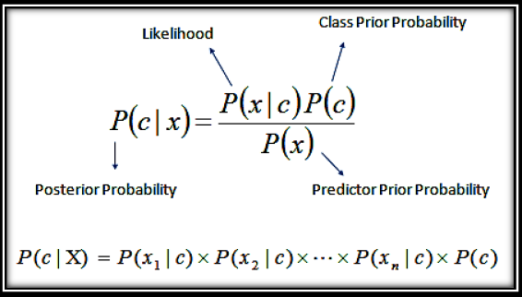
6. kNN Algorithm -
This is a Python Machine Learning algorithm for classification and regression- mostly for classification. This is a supervised learning algorithm that considers different centroids and uses a usually Euclidean function to compare distance. Then, it analyzes the results and classifies each point to the group to optimize it to place with all closest points to it. It classifies new cases using a majority vote of k of its neighbors. The case it assigns to a class is the one most common among its K nearest neighbors. For this, it uses a distance function. k-NN is a type of instance-based learning, or lazy learning, where the function is only approximated locally and all computation is deferred until classification. k-NN is a special case of a variable-bandwidth, kernel density "balloon" estimator with a uniform kernel. 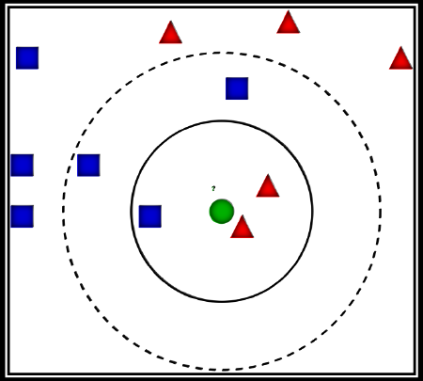
7. K-Means Algorithm -
k-Means is an unsupervised algorithm that solves the problem of clustering. It classifies data using a number of clusters. The data points inside a class are homogeneous and heterogeneous to peer groups. k-means clustering is a method of vector quantization, originally from signal processing, that is popular for cluster analysis in data mining. k-means clustering aims to partition n observations into k clusters in which each observation belongs to the cluster with the nearest mean, serving as a prototype of the cluster. k-means clustering is rather easy to apply to even large data sets, particularly when using heuristics such as Lloyd's algorithm. It often is used as a preprocessing step for other algorithms, for example to find a starting configuration. The problem is computationally difficult (NP-hard). k-means originates from signal processing, and still finds use in this domain. In cluster analysis, the k-means algorithm can be used to partition the input data set into k partitions (clusters). k-means clustering has been used as a feature learning (or dictionary learning) step, in either (semi-)supervised learning or unsupervised learning. 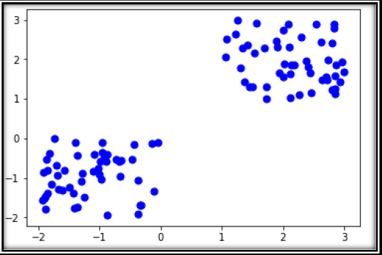
8. Random Forest -
A random forest is an ensemble of decision trees. In order to classify every new object based on its attributes, trees vote for class- each tree provides a classification. The classification with the most votes wins in the forest. Random forests or random decision forests are an ensemble learning method for classification, regression and other tasks that operates by constructing a multitude of decision trees at training time and outputting the class that is the mode of the classes (classification) or mean prediction (regression) of the individual trees.
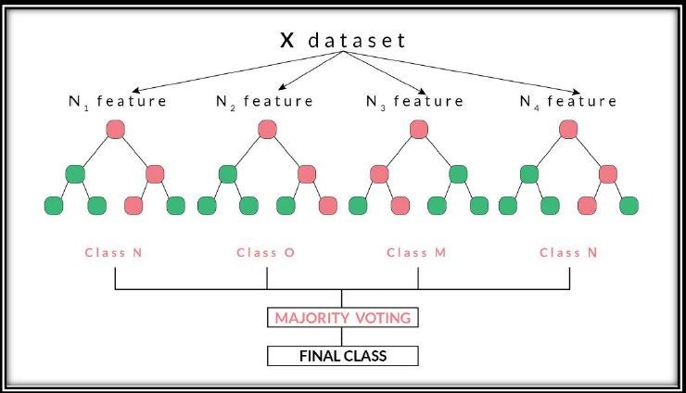

Libraries used:-
Numpy
NumPy is the fundamental package for scientific computing with Python. It contains among other things:
- a powerful N-dimensional array object
- sophisticated (broadcasting) functions
- tools for integrating C/C++ and Fortran code
- useful linear algebra, Fourier transform, and random number capabilities

Besides its obvious scientific uses, NumPy can also be used as an efficient multi-dimensional container of generic data. Arbitrary data-types can be defined. This allows NumPy to seamlessly and speedily integrate with a wide variety of databases.
NumPy is licensed under the BSD license, enabling reuse with few restrictions. The core functionality of NumPy is its "ND array", for n-dimensional array, data structure. These arrays are stride views on memory. In contrast to Python's built-in list data structure (which, despite the name, is a dynamic array), these arrays are homogeneously typed: all elements of a single array must be of the same type. NumPy has built-in support for memory-mappedarrays.
Here is some function that are defined in this NumPy Library.
1. zeros (shape [, dtype, order]) - Return a new array of given shape and type, filled with zeros.
2. array (object [, dtype, copy, order, lubok, ndim]) - Create an array
3. as array (a [, dtype, order]) - Convert the input to an array.
4. As an array (a [, dtype, order]) - Convert the input to an ND array, but pass ND array subclasses through.

5. arange([start,] stop [, step,] [, dtype]) - Return evenly spaced values within a given interval.
6. linspace (start, stop [, num, endpoint, ...]) - Return evenly spaced numbers over a specified interval.

etc. there many functions which are used to perform specified operation on the given input values
Pandas
Pandas is an open-source, BSD-licensed Python library providing high-performance, easy-to-use data structures and data analysis tools for the Python programming language. Python with Pandas is used in a wide range of fields including academic and commercial domains including finance, economics, Statistics, analytics, etc. In this tutorial, we will learn the various features of Python Pandas and how to use them in practice.
The name Pandas is derived from the word Panel Data – an Econometrics from Multidimensional data.
In 2008, developer Wes McKinney started developing pandas when in need of high performance, flexible tool for analysis of data.
Prior to Pandas, Python was majorly used for data munging and preparation. It had very little contribution towards data analysis. Pandas solved this problem. Using Pandas, we can accomplish five typical steps in the processing and analysis of data, regardless of the origin of data — load, prepare, manipulate, model, and analyze.
Python with Pandas is used in a wide range of fields including academic and commercial domains including finance, economics, Statistics, analytics, etc.
Key Features of Pandas
- Fast and efficient DataFrame object with default and customized indexing.
- Tools for loading data into in-memory data objects from different file formats.
- Data alignment and integrated handling of missing data.
- Reshaping and pivoting of date sets.
- Label-based slicing, indexing and subsetting of large data sets.
- Columns from a data structure can be deleted or inserted.
- Group by data for aggregation and transformations.
- High performance merging and joining of data.
- Time Series functionality.
Matplotlib
Matplotlib is a Python 2D plotting library which produces publication quality figures in a variety of hardcopy formats and interactive environments across platforms. Matplotlib can be used in Python scripts, the Python and IPython shells, the Jupyter notebook, web application servers, and four graphical user interface toolkit.
Matplotlib tries to make easy things easy and hard things possible. You can generate plots, histograms, power spectra, bar charts, errorcharts, scatterplots, etc., with just a few lines of code. For examples, see the sample plots and thumbnail gallery.
For simple plotting the pyplot module provides a MATLAB-like interface, particularly when combined with IPython. For the power user, you have full control of line styles, font properties, axes properties, etc, via an object-oriented interface or via a set of functions familiar to MATLAB users.
Scikit-Learn
Scikit-learn (formerly scikits. learn) is a free software machine learning library for the Python programming language. It features various classification, regression and clustering algorithms including support vector machines, random forests, gradient boosting, k-means and DBSCAN, and is designed to interoperate with the Python numerical and scientific libraries NumPy
SciPy
The scikit-learn project started as scikits.learn, a Google Summer of Code project by David Cournapeau. Its name stems from the notion that it is a "SciKit" (SciPy Toolkit), a separately-developed and distributed third-party extension to SciPy. The original codebase was later rewritten by other developers. In 2010 Fabian Pedregosa, Gael Varoquaux, Alexandre Gramfort and Vincent Michel, all from INRIA took leadership of the project and made the first public release on February the 1st 2010. Of the various scikits, scikit-learn as well as scikit-image were described as "well-maintained and popular" in November 2012.
As of 2018, scikit-learn is under active development.
Scikit-learn is largely written in Python, with some core algorithms written in Cython to achieve performance. Support vector machines are implemented by a Cython wrapper around LIBSVM; logistic regression and linear support vector machines by a similar wrapper around LIBLINEAR. [10]
Advantages of using Scikit-Learn:
- Scikit-learn provides a clean and consistent interface to tons of different models.
- It provides you with many options for each model, but also chooses sensible defaults.
- Its documentation is exceptional, and it helps you to understand the models as well as how to use them properly.
- It is also actively being developed.

Project:-
In my project i use the ML algorithm logistic regression to train our model using a given dataset Iand make predictions wether the given person has diabeties or not . I used Bootstrap to create the UI and and the use flask to connect it with the algorithm .We take the user data as input and try to predict the output
The user can send the input in 2 different ways
1) user will fill data after that prediction will be displayed over UI
2)user can upload csv file with required features and then get downloadable predicted csv file
My model contains the following folders
app.py : Front and back end portion of the web application
downloads : contains predicted csv file
models : contains model for prediction
static : contains static files
templates : contains templates for UI
uploads : uploaded csv will be stored here
CODE :-
import pandas as pd
import numpy as np
import warnings
warnings.filterwarnings('ignore')
import pickle
print('import successfull')
FILE = 'diabetes.csv'
df = pd.read_csv(f'./src/{FILE}')
X = df.iloc[:,[0,1,2,3,4, 5, 7]].values
y = df.iloc[:,8].values
from sklearn.model_selection import train_test_split
X_train, X_test, y_train, y_test = train_test_split(X, y, test_size = 0.25, random_state = 0)
from sklearn.preprocessing import StandardScaler
sc = StandardScaler()
X_train = sc.fit_transform(X_train)
X_test = sc.transform(X_test)
from sklearn.linear_model import LogisticRegression
classifier = LogisticRegression(random_state = 0)
classifier.fit(X_train, y_train)
y_pred = classifier.predict(X_test)
from sklearn.metrics import confusion_matrix
cm = confusion_matrix(y_test, y_pred)
print(cm)
MODEL= 'my_model.pkl'
SCALAR = 'transformer.pkl'
pickle.dump(sc, open(f'./models/{SCALAR}','wb'))
pickle.dump(classifier, open(f'./models/{MODEL}','wb'))

Conclusion
During the course of project I learnt how to implement various technologies like ml and html and how to integrate them using bootstrap. The project aims at finding wether the user has diabetes or not based on the input given, using logistic regression the model is trained and using this model we can predict if the patient has diabetes or not

References
[1] Analytics Vidhya. 2020. Analytics Vidhya - Learn Machine Learning, Artificial Intelligence, Business Analytics, Data Science, Big Data, Data Visualizations Tools And Techniques. | Analytics Vidhya. [online] Available at: <https://www.analyticsvidhya.com/> [Accessed 1 December 2020].
[2] Medium. 2020. Medium – Where Good Ideas Find You.. [online] Available at: <https://medium.com/> [Accessed 1 December 2020].
[3] Pandas.pydata.org. 2020. Pandas - Python Data Analysis Library. [online] Available at: <https://pandas.pydata.org/> [Accessed 1 December 2020].
[4] Scikit-learn.org. 2020. Scikit-Learn: Machine Learning In Python — Scikit-Learn 0.16.1 Documentation. [online] Available at: <https://scikit-learn.org/> [Accessed 1 December 2020].
[5] Towards Data Science. 2020. Towards Data Science. [online] Available at: <https://towardsdatascience.com/> [Accessed 1 December 2020].

