**Software Design Document**

**for**

**EduInsight**

**Student Performance Analysis & Learning Strategies Recommendation System**

**Prepared by**

**Aysha Sanam Ummer**

**Bettina Mariam Biju**

**Fathima Zanha K**

**Safuan P Anvar**

**Batch 2 / Team 2**

**Guide : Dr. Cerene Mariam Abraham**

**04.03.2023**

**Table of Contents**

**1. Introduction**

1.1 Purpose

1.2 Scope

1.3 References

1.4 Constraints

**2. System Overview**

**3. System Architecture**

3.1 Architectural Description

3.2 Component Decomposition Description

**4. Data Design**

4.1 Database Description

**5. Detailed System Design**

5.1 DFDs

5.2 Modules

**6. Requirements Matrix**

**7. Resource Estimates**

**1.Introduction**

**1.1 Purpose**

The purpose of our software is to revolutionize the way student performance is analyzed and improved. By leveraging advanced data analytics and machine learning techniques, our platform aims to provide personalized recommendations tailored to each student's unique learning style and needs.Through comprehensive performance analysis, our software will identify patterns and trends in students' academic progress. With this information, our platform will generate targeted recommendations for optimizing study schedules, and employing effective study techniques.

By empowering students with actionable insights and personalized guidance, our software aims to enhance academic performance, increase motivation, and foster a culture of continuous improvement in learning outcomes. Ultimately, our goal is to support students in their mission to success and achievement.

**1.2 Product Scope**

The product scope for our software, designed to enhance student performance through personalized recommendations and analysis, encompasses the following features and functionalities:

1. Performance Tracking and Analysis: The software will enable students to track their academic performance across various subjects and assessments. It will analyze performance data to identify trends, strengths, and areas for improvement.
2. Personalized Recommendations: Based on the analysis of performance data, the software will generate personalized recommendations for students. These recommendations may include suggested study techniques and time management strategies tailored to each student's learning style and needs.
3. Machine Learning Algorithms: The core functionality of the software will leverage machine learning algorithms to analyze the collected performance data. These algorithms will identify patterns, correlations, and trends in students' academic performance.
4. Predictive Analytics: Using machine learning models, the software will provide predictive analytics to forecast future academic performance based on historical data. This will enable early intervention and personalized support for students at risk of falling behind
5. User-Friendly Interface: The software will feature a user-friendly interface designed for easy navigation and accessibility. Students can easily input data, view recommendations, and track their progress without requiring extensive technical knowledge.

Overall, the product scope aims to empower students with personalized recommendations and insights to optimize their learning experience, improve academic performance, and achieve their educational goals.

**1.3 References**

1. Amrieh, E. A., Hamtini, T., & Aljarah, I. (2016). Mining educational data to predict student’s academic performance using ensemble methods. *International journal of database theory and application*, *9*(8)
2. Pashler, H., McDaniel, M., Rohrer, D., & Bjork, R. (2008). Learning styles: Concepts and evidence. *Psychological science in the public interest*,
3. van Sluijs, M., & Matzat, U. (2023). Predicting time‐management skills from learning analytics. *Journal of Computer Assisted Learning*.

**1.4 Constraints**

● **Design Constraint :** The interface should be intuitive, easy to navigate, and user-friendly to accommodate users with varying levels of technical proficiency and educational backgrounds. The predictive models should achieve satisfactory performance metrics such as accuracy, precision, recall, and F1-score to provide reliable predictions and recommendations.

● **Implementation constraints :** The effectiveness of the system relies on the availability and quality of student performance data. Inconsistent data collection methods, incomplete records, and data silos can hinder the accuracy of predictions and recommendations. As the number of users and data volume grows, the system should be able to scale efficiently to handle increased loads without sacrificing performance.Ensuring user acceptance and adoption of the system among students. user-friendly interfaces, clear documentation, and training sessions can facilitate the adoption process.

**2.System Overview**

**2.1 The system context and design**

EduInsight addresses the challenge of personalizing learning experiences for enhanced academic performance and engagement. Traditional educational approaches often overlook individual students' unique needs, preferences, and challenges. By utilizing machine learning and data analytics, EduInsight introduces a nuanced, data-driven approach to education, aiming to bridge this gap and create a more tailored and effective learning environment.

* Individual Learning Insights: By analyzing data specific to each student, EduInsight is able to understand their unique learning patterns. This includes how external factors like attendance and participation correlate with their academic performance.
* Machine Learning and Data Analytics:These technologies enable the system to process and analyze large volumes of data efficiently, uncovering insights that would be impossible to identify manually.
* Logistic Regression for Prediction: This tool is particularly useful for identifying students who might be at risk of underperforming, allowing for timely intervention. It's a practical application of machine learning in predicting future outcomes based on historical data.
* Flask and Django for Web Development: Flask is used to create the API, serving as the backend that processes requests and delivers data. Django offers a robust framework for developing the dynamic web interface, facilitating user interaction with the system. Together, they provide a seamless, user-friendly platform that can be accessed by students.
* Regulatory Requirements: The system should comply with relevant laws and regulations, including privacy laws and accessibility standards. The system should provide secure access controls, ensure the privacy of user data, and be designed to be accessible to all patrons, regardless of ability.

**2.2 The background to the project**

EduInsight is an innovative, machine learning-powered platform designed to revolutionize the educational landscape by providing personalized insights and recommendations to enhance student academic performance. Leveraging a combination of advanced data analytics and machine learning algorithms, the system analyzes a myriad of data points such as academic grades, attendance records, and participation levels to build detailed student profiles. Through its dynamic web interface, EduInsight offers tailored advice on study techniques and time management strategies.

In classrooms with varied learning needs, the platform identifies and bridges knowledge gaps, recommends alternative study materials to enhance engagement, optimizes study techniques based on individual preferences, and supports teachers with actionable insights for tailored instruction. Additionally, EduInsight enables early identification of at-risk students and facilitates personalized time management strategies, fostering a culture of success by adapting to the unique needs and circumstances of each learner. This capability ensures that every student receives a customized learning experience that aligns with their individual needs and learning styles, setting a new standard for personalized education. By doing so, EduInsight not only aims to improve academic outcomes but also to empower students with the tools and knowledge they need to succeed in their educational journeys.

**3.System Architecture**

**3.1 Architectural Description**

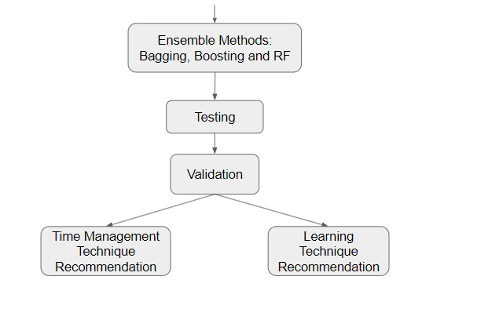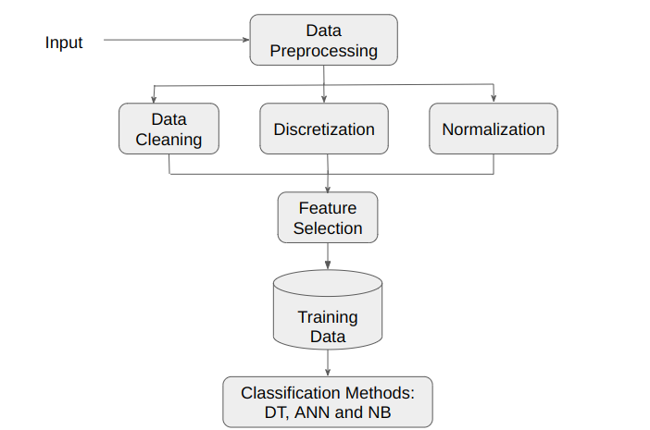

**Figure 1 : System Architecture**

**3.2 Component Decomposition Description**

**User Interface Component:**

* Dashboard Interface: Allows users (students) to log in, view their performance metrics, and access recommendations.
* Performance Overview: Graphical representation of academic performance, including grades and attendance.
* Recommendation Section: Displays personalized learning and time management recommendations based on the analysis of performance data

**Data Collection and Processing Component:**

* Data Collection Module: Reads input data that the user provides.
* Data Preprocessing Module: Cleans and preprocesses the collected data for analysis, handling missing values and outliers.
* Performance Analysis Module: Utilizes statistical methods and machine learning algorithms to analyze student performance data and identify patterns.

**Recommendation Engine:**

* Learning Style Recommendation Algorithm: Suggests learning techniques tailored to individual student needs based on their performance analysis and learning preferences.
* Time Optimization Algorithm: Provides suggestions of time management techniques to optimize time use.

**Reporting and Visualization Component:**

* Performance Reports: Generates detailed reports on academic performance trends, learning progress, and time management metrics.
* Visualizations: Presents data insights through charts, graphs, and visual representations for better understanding and decision-making.
* Feedback Mechanism: Allows students to provide feedback on the effectiveness of recommendations and suggestions provided by the system.

**4.Data Design**

**4.1 Dataset Design**

The dataset for the Student Performance Analysis & Learning Strategies Recommendation Systemincludes the features : Age, Gender, CGPA, Course, StudyTime, SleepTime, AbsentDays, AttentionSpan, RaisedHands, TimeManagement, LearningStrategy, InformationPresentation, MentalActivity..

Age : To know how old a student is based on their date of birth, helping in understanding their educational stage and providing age-specific insights or recommendations.

Gender : To know the student's gender, providing additional information that might be relevant for tailoring personalized insights or recommendations.

CGPA: Specifies their current score which will be relevant for classifying students into different levels.

Course : To specify the academic program or course of study that the student is enrolled in, providing information about their major or field of study.

StudyTime : Tracks how much time a student spends studying, helping tailor recommendations for effective time management.

SleepTime : Records how much a student sleeps, offering insights for well-being and study effectiveness considerations.

AbsentDays : Tracks the number of days a student is absent, aiding in monitoring attendance and providing insights for personalized recommendations.

AttentionSpan : Measures how long a student can focus without distraction, helping tailor recommendations for effective study habits.

RaisedHands : Indicates how often a student participates by raising hands, offering insights for tailored recommendations on active engagement strategies.

TimeManagement : Assesses a student's ability to manage time effectively, offering insights for personalized recommendations on improving time management skills.

LearningStrategy : Identifies how a student prefers to study, guiding personalized recommendations for effective learning approaches.

InformationPresentation : Identifies how the student learns best, making it easier for them to understand and remember.

MentalActivity : Assesses a student's activities that make students think and stay interested in learning.

Satisfaction : Measures how well the current system meets students' needs for an enhanced learning experience.

Overall, the dataset for EduInsight efficiently captures crucial student information and academic details,

facilitating personalized insights and recommendations to enhance academic performance.

**5.Detailed System Design**

**5.1 Data Flow Diagrams**

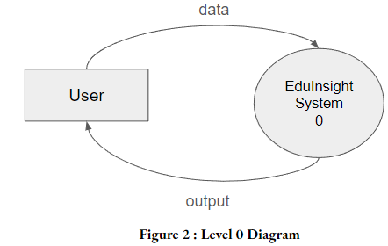

**Figure 2 : Level 0 Diagram**

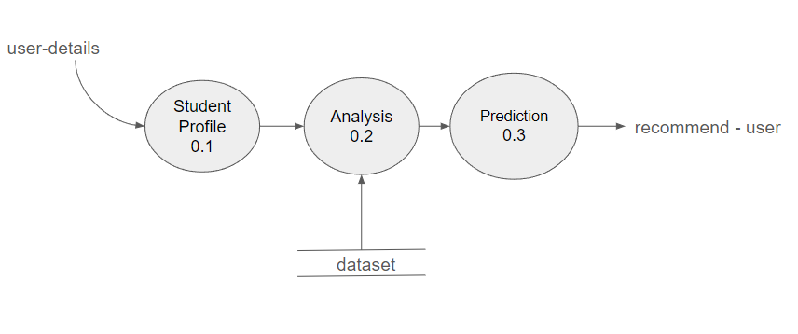

**Figure 3 : Level 1 Diagram**

**5.2 Modules**

**Analysis:**

● This feature analyzes the diverse historic data and finds patterns , correlations and trends.

**Profile Creation:**

● The system constructs comprehensive profiles for each student based on the processed data.

**Prediction:**

**●** The recommendation engine translates the analysis into actionable steps, offering tailored suggestions for study techniques and time management strategies

**Was it Useful:**

**●** The system enquiries if the suggested strategies were helpful or not.

**6.Requirements Matrix**

| **Requirement** | **Description** |
| --- | --- |
| **Functional requirements** | |
| FR1 | EduInsight will meticulously process academic grades, attendance records, and participation levels to construct comprehensive profiles for each student. |
| FR2 | Leveraging advanced data analytics, machine learning algorithms will identify patterns, correlations, and trends within the data, providing profound insights into individual learning behaviors. |
| FR3 | A prediction engine will translate the analysis into actionable steps by forecasting individual student performance and tailoring suggestions. |
| **Non-functional requirements** | |
| NFR1 | EduInsight should efficiently handle substantial volumes of data and deliver quick responses to user requests, ensuring scalability with a growing user base. |
| NFR2 | The system must maintain acceptable response times for database queries, page loads, and other operations, ensuring a seamless user experience. |
| NFR3 | EduInsight should prioritize robust security features to safeguard the confidentiality, integrity, and availability of student data, ensuring compliance with privacy regulations. |
| NFR4 | The software should provide an intuitive, easy-to-use interface with clear instructions for users, promoting accessibility and enhancing the overall user experience. |

**7.Resource Estimates**

Resource estimates for the proposed system will depend on various factors such as personnel, hardware, software, time, budget, and testing/evaluation/maintenance resources. . Here are some of the resource estimates that can be considered:

**Personnel:**

* Data Scientists/Engineers: 2-3 experts for developing and fine-tuning machine learning algorithms.
* Software Developers: 2-3 developers for implementing the web interface, recommendation engine, and API.
* Front-end Developers: 1-2 developers for creating and maintaining the dynamic web interface.

**Hardware:**

* Processor : Ryzen 5
* Memory (RAM) : 8 GB
* Ethernet connection (LAN) OR a wireless adapter (Wi-Fi)
* Hard Drive: Minimum 32 GB; Recommended 64 GB or more

### Software:

* Machine Learning Frameworks: Depending on the chosen framework (e.g., TensorFlow, PyTorch), ensure compatibility and updates.
* Flask (for API development)
* Django (for web interface)
* HTML, CSS, JavaScript libraries
* Data Analysis Tools: Pandas, NumPy, Jupyter Notebooks.

### Time:

The development time for the proposed system will take 3 to 4 months depending on several factors like the complexity of the features, amount of historical data, project approach and resources available.

**Budget:**

### The cost of the system would depend on the software which can be estimated to be about Rs. 50,000. The actual cost may vary depending on the specific requirements of the system.

### Testing, Evaluation and Maintenance:

This includes the resources required for testing and maintenance, including software testing tools, system documentation and the resources required for the ongoing maintenance of the system.