Datasets:
There are 3 type of Dataset, as it mentioned in the main manuscript. First dataset contain 5 features as follows:
- T
- PH
- EC
- PO4
- NH4
for Second dataset the NH4 column drops and for the third EC and NH4 doesn’t being used.

Outliers:
the data contains many outliers as it can calculated by the IQR method. The IQR method calculates the interval between quarter 2 and quarter 3 of each column.
IQR=Q3-Q2
any data greater than (1.5 * IQR +Q3) counts as outlier. In the same way, any data lower than (1.5* IQR – Q2) is a outlier and it should be deleted. This method implemented on both train and test data.

Scaling:
In the manuscript it mentioned Z Score scaling. It can be calculated by the following formula:
z = ( x - μ ) / σ
Models:
The models that are used in this research are as follows:
- Decision Tree
- Random Forest
- Gradient Boost Regressor
- Support Vector Regressor
- Multi Layer Perceptron
- K nearest neighbors regressor

Results:
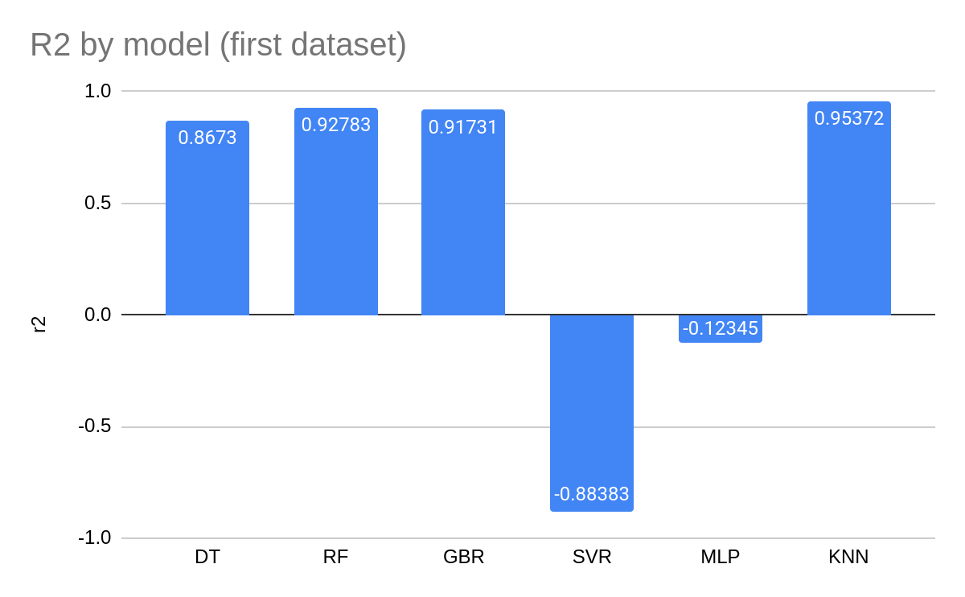
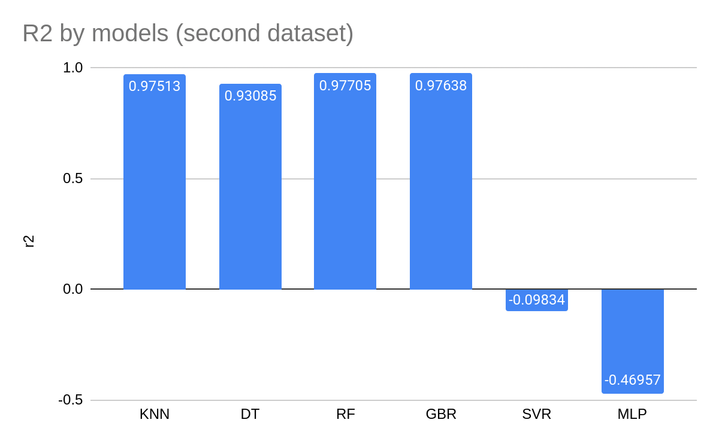
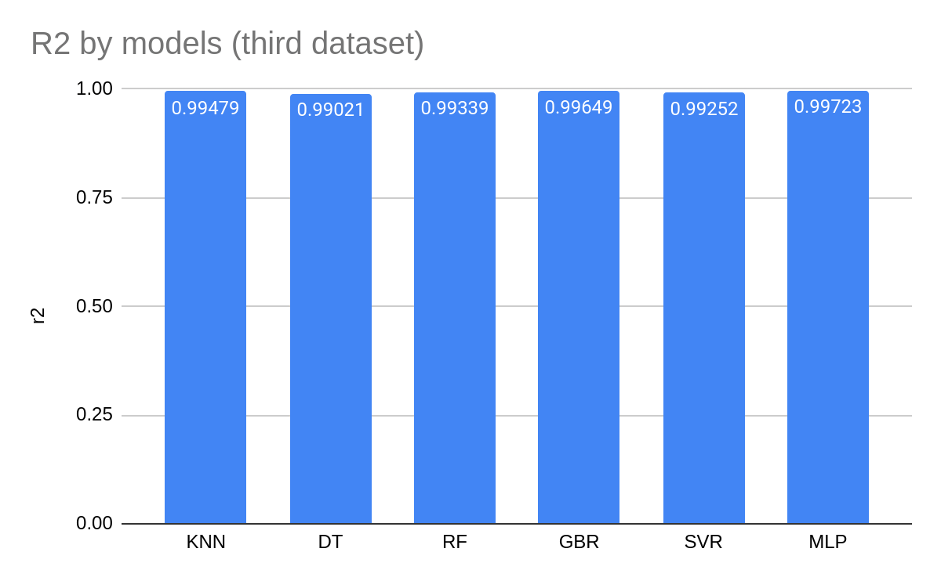

The Best Model:
As it can be concluded by the charts, the best model is KNN on every datasets. The KNN model works by the nearest data around the sample. The K=3 and the nearest samples calculated by the distance around the sample.

The metrics on KNN model is showed in the following table:

dataset | mse | rmse | Relative % | mae | corr | r2
ds1 | 0.00002 | 0.00414 | -0.00694 | 0.00297 | 0.97759 | 0.95372
ds2 | 0.00001 | 0.00313 | -0.00461 | 0.00226 | 0.98773 | 0.97513
ds3 | 0.00245 | 0.04947 | 0.01677 | 0.02382 | 0.99739 | 0.99479

