

**Project Report**

Food Ordering System



 **ONLINE FOOD ORDERING SYSTEM**

**Introduction:**

It is known very well that in today’s world, everyone wants his or her work done immediately at the very first moment. When it comes to food, People usually don’t want wasting their time standing in queues and waiting for their turn to order or buy food. Everybody wants a platform where they can place their order conveniently and enjoy their meal happily without getting their time wasted. Therefore, a need for an online ordering system arises where a customer can place his or her order according to his or her need and can get his desired meal at the first pace of time.

The ONLINE FOOD ORDERING SYSTEM is an interface between a customer and the manager or person behind the system. The Food Ordering System will provide a platform to the customer to login or create an account first and then select type of food item and place an order hence making it possible for the customer to save his or her time.

**Purpose:**

The purpose of this project is to promote a platform where a user/customer can login and select his or her desired type of food as well as his or her choice of food items by signing in to the application and finally place an order so that he can have meal delivered at the very first moment thus saving his/her time.

**Implementation:**

The project is implemented on Microsoft Visual Studio 2012.

**Project Description:**

The project is divided into four stages:

1. Login/create account
2. Food type selection (Chinese,desi etc)
3. Food item selection i.e. order placement
4. Billing

**Main Page Form:**

As the application is set to execute a main page or form is displayed to the user as shown below:

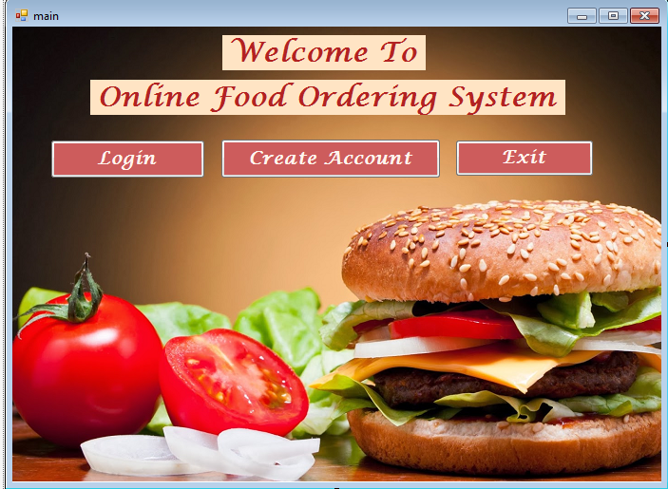

This form contains a welcome label and three buttons namely login, create account and exit which lead to the user to his/her desired page.

These buttons contain the following lines of code:

**Login Button:**

Private void button1_Click(object sender, EventArgs e)

{

this.Hide();

Login l = new Login();

l.Show();

}

**Create Account Button:**

private void button2_Click(object sender, EventArgs e)

{

this.Hide();

Create_Account ca = new Create_Account();

ca.Show();

}

**Exit Button:**

private void button3_Click(object sender, EventArgs e)

{

this.Close();

}

**Login Form:**

If the user selects login, then a login form appears as shown below:

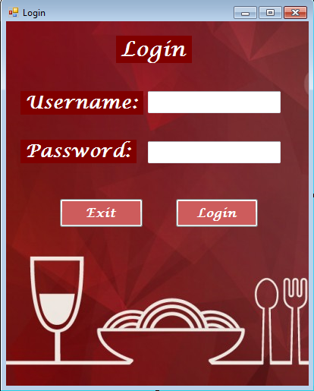

This form contains 2 labels of Username and Password, 2 textboxes and 2 buttons namely login and exit. The login button simply takes the user to the display page where he can choose the type of food he wants.

The username and password are stored in the local database table of the application project.

The login button contains following lines of code:

private void button2_Click(object sender, EventArgs e)

{

// SqlConnection con = new SqlConnection (@"Data Source=(LocalDB)\v11.0;AttachDbFilename=G:\WindowsFormsApplication1\WindowsFormsApplication1\New folder\login.mdf;Integrated Security=True;Connect Timeout=30");

SqlDataAdapter sda = new SqlDataAdapter ("Select Count (*) From FLogin where UserName = '" + textBox1.Text+"' and Password = '"+textBox2.Text + "'",con);

DataTable dt = new DataTable();

sda.Fill (dt);

if (dt.Rows[0][0].ToString()=="1")

{

this.Hide ();

FrmFood d = new FrmFood();

d.Show ();

}

else

{

MessageBox.Show ("please enter correct details");

}

}

**Create Account Form:**

If the user chooses to create an account then a form is displayed to the user as shown:

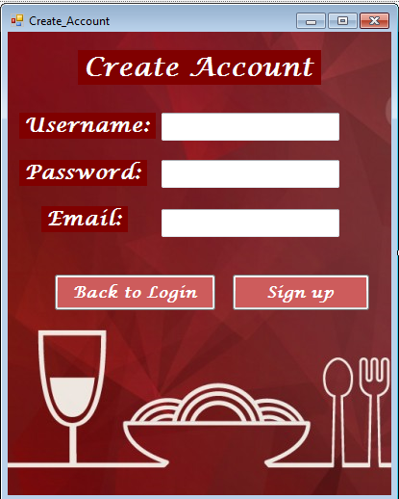

This form contains 3 labels of username, password and email and 3 textboxes and 2 buttons namely back to login and sign up.

When the user enters his data and clicks the button ‘sign up’, all of his data gets stored in the database table for login and a message dialog appears confirming his account creation. Then he has to click on the ‘back to login’ button so that he can proceed further.

The sign up button contains following line of code:

private void button2_Click(object sender, EventArgs e)

{

con.Open();

SqlCommand cmd = con.CreateCommand();

cmd.CommandType = CommandType.Text;

cmd.CommandText = "insert into FLogin values('" + textBox1.Text + "','" + textBox2.Text + "','" + textBox3.Text + "')";

cmd.ExecuteNonQuery();

con.Close();

textBox1.Clear();

textBox2.Clear();

textBox3.Clear();

MessageBox.Show("Account created successfully");

}

The ‘back to login’ button contains following lines of code:

private void button1_Click(object sender, EventArgs e)

{

this.Hide();

Login l = new Login();

l.Show();

}

**Display Form:**

After login or account creation, another page appears to the user as shown below:

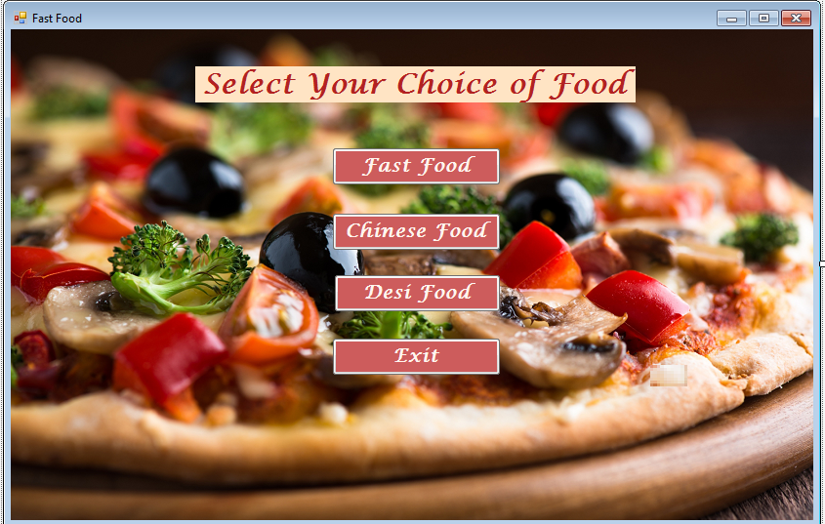

This form contains four buttons fast food, Chinese food and Desi food.

Each button takes the user to his desired type of food items.

Code behind these buttons contains nothing but the linkage of the food type forms.

private void button1_Click(object sender, EventArgs e)

{

this.Hide();

FastFood f2 = new FastFood();

f2.Show();

}

private void button2_Click(object sender, EventArgs e)

{

this.Hide();

Chinese c = new Chinese();

c.Show();

}

private void button3_Click(object sender, EventArgs e)

{

this.Hide();

Desi d = new Desi();

d.Show();

}

**Fast Food Form:**

If the user selects the fast food type, a form is displayed as shown below:

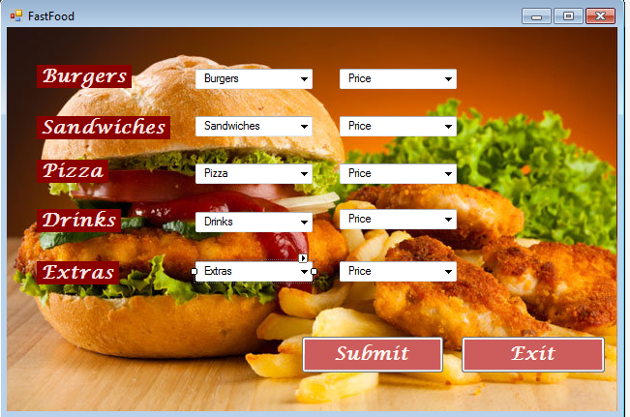

This form contains 5 labels namely burgers, sandwiches, pizza, drinks and extras and 10 comboboxes out of which 5 are for food type choices and 5 are for their price and 2 buttons of submit and exit. The submit button takes the user to the billing page where the total bill is displayed to the user.

SUBMIT button contains following lines of code:

private void button1_Click(object sender, EventArgs e)

{

con.Open();

SqlCommand cmd = con.CreateCommand();

cmd.CommandType = CommandType.Text;

cmd.CommandText = "insert into FastFood values('" + comboBox1.Text + "','" + comboBox2.Text + "','" + comboBox3.Text + "','" + comboBox4.Text + "','" + comboBox5.Text + "')";

cmd.ExecuteNonQuery();

con.Close();

SetValueForCombo1 = comboBox1.Text;

SetValueForCombo2 = comboBox2.Text;

SetValueForCombo3 = comboBox3.Text;

SetValueForCombo4 = comboBox4.Text;

SetValueForCombo5 = comboBox5.Text;

SetValueForCombo6 = comboBox6.Text;

SetValueForCombo10 = comboBox10.Text;

SetValueForCombo7 = comboBox7.Text;

SetValueForCombo8 = comboBox8.Text;

SetValueForCombo9 = comboBox9.Text;

this.Hide();

Bill b = new Bill();

b.Show();

comboBox1.Text = "";

comboBox2.Text = "";

comboBox3.Text = "";

comboBox4.Text = "";

comboBox5.Text = "";

MessageBox.Show(" Order received Successfully !!!!");

// label1.Text = comboBox1.Text;

}

**Chinese Food Form:**

Similarly if the user selects Chinese food then the following page is displayed to the user:

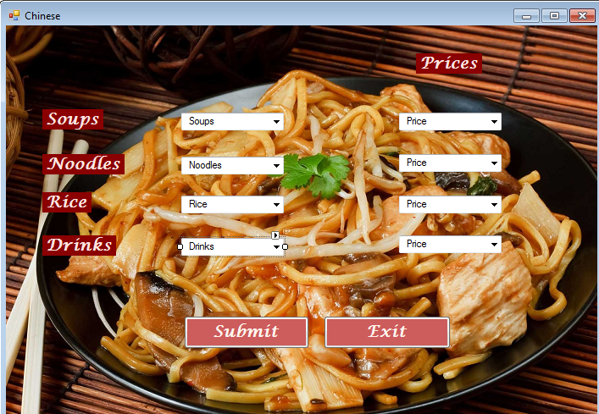

This form contains 4 labels of soups, noodles, rice and drinks, 8 comboboxes out of which 4 comboboxes contain food type choices and other 4 contain price of those items as well as there are 2 buttons of submit and exit. The submit button takes the user to the billing page where the total bill is displayed to the user.

SUBMIT button contains following lines of code:

private void button1_Click(object sender, EventArgs e)

{

con.Open();

SqlCommand cmd = con.CreateCommand();

cmd.CommandType = CommandType.Text;

cmd.CommandText = "insert into ChinesFood values('" + comboBox1.Text + "','" + comboBox2.Text + "','" + comboBox3.Text + "','" + comboBox4.Text + "')";

cmd.ExecuteNonQuery();

con.Close();

MessageBox.Show(" Order received Successfully !!!!");

SetValueForCombo1 = comboBox1.Text;

SetValueForCombo2 = comboBox2.Text;

SetValueForCombo3 = comboBox3.Text;

SetValueForCombo4 = comboBox4.Text;

SetValueForCombo6 = comboBox6.Text;

SetValueForCombo7 = comboBox7.Text;

SetValueForCombo8 = comboBox8.Text;

SetValueForCombo9 = comboBox9.Text;

this.Hide();

Bill b = new Bill();

b.Show();

comboBox1.Text = "";

comboBox2.Text = "";

comboBox3.Text = "";

comboBox4.Text = "";

}

**Desi Food Form:**

Similarly if the user selects Chinese food then the following page is displayed to the user:

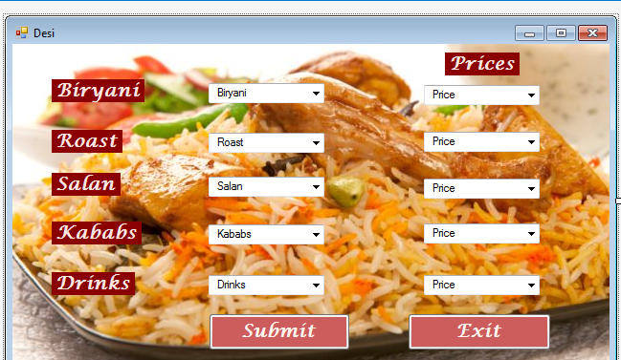

This form contains 5 labels of biryani, roast, salan, kababs and drinks, 10 comboboxes out of which 5 comboboxes contain food type choices and other 5 contain price of those items as well as there are 2 buttons of submit and exit. The submit button takes the user to the billing page where the total bill is displayed to the user.

SUBMIT button contains following lines of code:

private void button1_Click(object sender, EventArgs e)

{

con.Open();

SqlCommand cmd = con.CreateCommand();

cmd.CommandType = CommandType.Text;

cmd.CommandText = "insert into DesiFood values('" + comboBox1.Text + "','" + comboBox2.Text + "','" + comboBox3.Text + "','" + comboBox4.Text + "','" + comboBox5.Text + "')";

cmd.ExecuteNonQuery();

con.Close();

MessageBox.Show(" Order received Successfully !!!!");

SetValueForCombo1 = comboBox1.Text;

SetValueForCombo2 = comboBox2.Text;

SetValueForCombo3 = comboBox3.Text;

SetValueForCombo4 = comboBox4.Text;

SetValueForCombo5 = comboBox5.Text;

SetValueForCombo6 = comboBox6.Text;

SetValueForCombo7 = comboBox7.Text;

SetValueForCombo8 = comboBox8.Text;

SetValueForCombo9 = comboBox9.Text;

SetValueForCombo10 = comboBox10.Text;

this.Hide();

Bill b = new Bill();

b.Show();

comboBox1.Text = "";

comboBox2.Text = "";

comboBox3.Text = "";

comboBox4.Text = "";

comboBox5.Text = "";

}

**Billing Form:**

At last after the user selects his food items and clicks the submit button, a form appears that is the billing form:

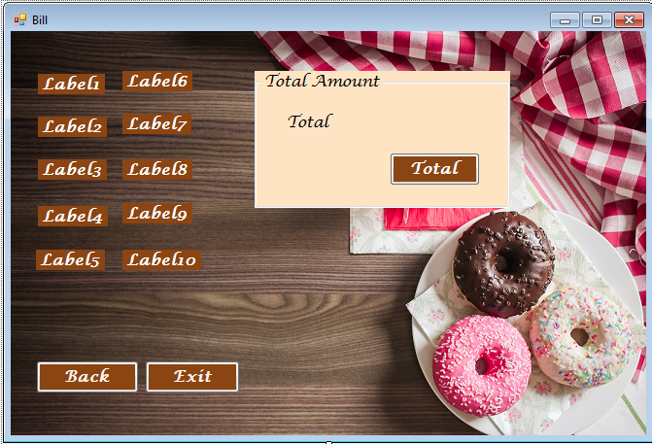

This form contains 10 labels, 3 buttons and 1 groupBox of TotalAmount.

When the user selects the food item through comboboxes they automatically get set into these labels and the price is also displayed to the user separately. The total button displays the total bill to the user.

**Code Snippet of Billing Form:**

private void Bill_Load(object sender, EventArgs e)

{

label1.Text = FastFood.SetValueForCombo1;

label2.Text = FastFood.SetValueForCombo2;

label3.Text = FastFood.SetValueForCombo3;

label4.Text = FastFood.SetValueForCombo4;

label5.Text = FastFood.SetValueForCombo5;

label6.Text = FastFood.SetValueForCombo6;

label7.Text = FastFood.SetValueForCombo7;

label8.Text = FastFood.SetValueForCombo8;

label9.Text = FastFood.SetValueForCombo9;

label10.Text = FastFood.SetValueForCombo10;

}

TOTAL button contains following lines of code:

private void button1_Click_1(object sender, EventArgs e)

{

int num1, num2, num3, num4, num5,sum;

num1 = Int32.Parse(label6.Text);

num2 = Int32.Parse(label7.Text);

num3 = Int32.Parse(label8.Text);

num4 = Int32.Parse(label9.Text);

num5 = Int32.Parse(label10.Text);

sum = num1 + num2 + num3 + num4 + num5;

label11.Text = sum.ToString();

}

The End