**首页(yachts-home)**

**关于我们**

-帆船俱乐部简介(history)

-会员章程(privacy)

-诺莱仕集团 (外链到 http://www.noahsgroup.com/)

-合作伙伴

扫描二维码

**咨询中心（新闻动态）**

-航海活动（events）

-帆船行业动态（inspiration）

-帆船赛事公告（图文加表格 貌似没有相关的页面）

-俱乐部圈层活动（blog-masonry-3-columns）

-航海文化（single-destination）

**全球联盟**

-联盟体系内容（privacy）

-星海联盟体系（single-inspiration）

-入会资格（maintenance）

-邀请函（随便哪个图文页面 内容很少）

**会员中心**

-至会员（随便找个文本页面 没图的）

-船东银行（single-destination）

-理事会员介绍（暂无内容）

-航海里程数累积（single-inspiration）

**联系我们**

[**http://www.noahsyachtclub.com/site/contact**](http://www.noahsyachtclub.com/site/contact) **类似于这样的不知道有没有**

**关于我们**

**-帆船俱乐部简介**

诺莱仕帆船俱乐部 Noahs（Shanghai）Sailing Club

2016-04-26 [诺莱仕帆船俱乐部](https://mp.weixin.qq.com/s?__biz=MjM5NzIwMzA1Mg==&mid=10013126&idx=1&sn=42245138984681316747499af5587004&scene=18&key=f23a956137bfda7fb0a4289a0166ae807c99505789dc9107461dcafc9f10384d220ceea304a6d00b1922df3afd6ba7cb8616579bee551f7f15c68246908c6113bcc6f2e6685111e9847f87beaaf7788f&ascene=1&uin=NDM0OTMxMDk1&devicetype=Windows+7&version=6204014f&pass_ticket=nJthzsbuj%2FyXkEi1uF%2F6z60kpHnmvOol3NIUiDgFWVWXBEtfE9r%2BYQRRlSsyc%2B95&winzoom=1##)

诺莱仕帆船俱乐部

——中国大帆船时代领军者

   坐落于上海陆家嘴黄金水岸的诺莱仕帆船俱乐部成立于2013年，是一家致力于打造职业帆船赛队，推动大帆船运动在中国蓬勃发展的国际化帆船俱乐部。通过参与一系列的国际帆船比赛及中外文化交流活动，诺莱仕旨在全面推广帆船文化，为社会菁英提供具有全新理念的集体育、文化与休闲为一体的高端社交平台。2015年，俱乐部将隆重推出由其倾力打造的TP52级大帆船赛队“中国梦之队”，并第一次以一支纯中国人组成的专业赛队跻身全球顶级帆船赛事。这是中国帆船运动的一大步，但只是我们的第一步。俱乐部不仅仅是要让中国的风帆竞逐在全球大洋之上，更要让风靡国际的帆船运动和生活方式真正植根在中国。不久的将来，世界顶级帆船俱乐部将不再限于地中海的岛屿和迈阿密的沙滩上，更要在中国，在上海，在诺莱仕！

Situated in the central location of Shanghai, China's biggest port city as well as a dynamic cosmopolis, Noahs Sailing Club combines a dazzling metropolitan lifestyle with serious professional sailing. As Shanghai's first professional yacht club, NSC devotes itself to China's rise in professional sailing events and also the promotion of sailing sport in China. This winter, with NSC's TP52 yacht Ark323 and the team 'Chinese Dream Team', a pure Chinese team will take part in regatta at highest international levels for the first time in history.

【俱乐部核心价值】

   地处上海核心的黄浦江畔，背靠陆家嘴金融城，正对百年外滩，在历史风云和现代风潮的交汇之地，诺莱仕帆船俱乐部汲取海派文化氤氲，紧跟国际风尚，同时呈现蓝海的帆船运动精神和都市的精致生活品位。同时，俱乐部正在全国各大沿海城市陆续建立帆船基地，充分利用各地优势的地理条件和帆船文化，为打造一支具有国际水准的帆船赛队提供专业化的硬件支持。此外，诺莱仕帆船俱乐部通过广泛的国际交流与合作，与海外知名帆船俱乐部建立了长期友好联系，共同推广帆船文化。  
In the middle of the first metropolis in the Far East, Shanghai, towards the Bund,the witness of the past surging century, the unequalled location at the intersection of history and modernity provides Noahs Sailing Club a unique cultural atmosphere. The club's offer of leisure and recreation embody the balance between dignity and nitality, tradition and modernity, challenge spirit off the shore and lifestyle in the city. Furthermore, NSC pays attention not least to serious sailing.NSC sets its yacht bases in China's important coastal cities, especially in Sanya, Hainan, where the warm tropical monsoon climate, clean water of South China Sea and good sailing atmosphere as well as facilities ensure the high quality of training.

【大帆船在中国】

700年前，郑和七下西洋，用中国宝船震动两洋，中国人的风帆第一次傲然出现在世界大洋之上；600年前，中国人错过了地理大发现的浪潮，而麦哲伦的大帆船则成就了欧洲的崛起。今天，风帆不再承载国运，但依旧是人类智慧、勇气和挑战的精神体现，以及社会地位的象征。现代帆船经过百年发展，已经成为一项公认的贵族运动，参与者不乏商业精英，王室贵族如西班牙国王便是职业赛队的船员，而挪威王室则拥有自己的赛队。帆船运动尽管相对小众，但却与足球、奥运会、F1并列为四大体育盛事，可见其在世界范围内的影响力之大。中国的崛起使国人涉足高投入、高技术含量、高人员素质的大帆船运动成为了可能，而诺莱仕帆船俱乐部也在此历史背景之下应运而生，并肩负起带领中国人走向帆船赛事的世界舞台以及将现代帆船的理念带入中国的使命。

In the 15th Century, Zheng He’s seven Expeditions into the Western Ocean astonished the whole Southeast Asia even countries around the Indian Ocean. In the 16th Century, China missed great opportunities in the Age of Discovery, while European galleons nourished the rise of Europe. Although sails relate nowadays no longer to a nation’s destiny, sailing is still a symbol of human courage and challenge spirit. As one of the four classic traditional sports, sailing is famous for its requirement for high investment and professional team building. For decades have Chinese crews been absent from world’s top sailing events. But today, social development and economic flourish have make sailing possible in China. In such a dramatic epoch focuses NSC on the revival of china’s sailing undertaking. NSC has developed initiatives for the building of high-level professional racing team and the attraction of attention to Chinese crews in world’s top races.

【传奇赛船TP52】

    诺莱仕帆船俱乐部旗下的TP52级帆船是当今世界最受欢迎和规格最高的专业竞赛帆船之一，因其外形独特美观，内在性能优越，科技含量高，比赛性能稳定等特点而受到广大专业人士的好评。该级别赛船统一规格为长15米，桅高21米，船员11人，采用全碳纤维船体和模块化设计，同时具备港内竞速和离岸远洋航行的能力。自2001年推出以来，很快被各大赛事接纳。先进的材料和设计赋予了TP52级帆船极强的适航能力和机动性，使它在顺风条件下时速高达20海里，因此在比赛中更快、更具对抗性和竞争力。

As the core element and the base of a racing team, NSC’s racing boat belongs to TP52 class. TP52 is one of the most popular and top-level racing boat classes. A TP52 boat is 15m in length, with a 21-meter-tall mast and a crew of 11 members. Because of its size, the number of crew and allowing the best of materials and building techniques this is never going to be a class for small budget campaigns. Since its advent in 2001, TP52 has been rapidly and widely accepted as a standard class in regattas at highest levels like America’s Cup and Sydney to Hobart Yacht Race. Using of advanced materials and race-oriented design philosophy provide TP52 with outstanding navigability and maneuverability. Downwind in stronger breezes they can regularly surf at well over 20kts.

【纯中国人的顶级赛队】

 诺莱仕帆船俱乐部倾力打造的“中国梦”之队是一支完全由中国人组成的赛队——从船员到船长再到运营者及股东。这样一支全是中国面孔的赛队在世界顶级赛事里还是第一次出现。俱乐部希望藉此让中国人真正成为世界顶级帆船赛的参与者，而不再仅仅是作为中国元素点缀其中。

Built and run by Noahs Sailing Club, Chinese Dream Team is a racing team consisting all of Chinese members, from skipper and crews to sponsors. By organizing such a Chinese team, NSC will make Chinese the real participators in top-level sailing events, rather than just Chinese element in the crews.

**-会员章程**

会员章程

2014-04-04 [诺莱仕帆船俱乐部](https://mp.weixin.qq.com/s?__biz=MjM5NzIwMzA1Mg==&mid=200003066&idx=1&sn=6e9c03909efb181f5a3a40aead8b0048&scene=18&key=8c3e7ded42e4df897a444c538fa84c515da932eaa82a9b7968804885b93b9ee79b7304f07c80823d7b71d2b8b2fd9227a9c9a48d31b380e496f49781a2d74b4b599e1aa2a76929780e2cafe2e7fca091&ascene=1&uin=NDM0OTMxMDk1&devicetype=Windows+7&version=6204014f&pass_ticket=nJthzsbuj%2FyXkEi1uF%2F6z60kpHnmvOol3NIUiDgFWVWXBEtfE9r%2BYQRRlSsyc%2B95&winzoom=1##)

诺莱仕帆船运动俱乐部

会员章程

Membership Charter  Noahs Sailing Club

一．总则

为了社会各界热爱帆船文化，崇尚航海精神，有集体观念和团队协作精神的人士，提供（社交、共同体育爱好、学习交流、休闲旅游、陶冶情操等）活动场所和各种帆船运动平台，发起组建会员制组织的帆船俱乐部，特制定本章程。

会所（俱乐部）名称

中文：诺莱仕帆船俱乐部

英文：Noahs Sailing Club

本俱乐部为中华人民共和国境内法人会员制组织

帆船俱乐部一切活动，遵守国家法律、法规，维护国家利益和社会公共利益，接受政府有关部门的依法监督和管理。

二．帆船俱乐部地址、规模、范围

1.  帆船俱乐部地址：

中国上海浦东滨江大道3510号外滩游艇会

2. 帆船俱乐部实行会员制，一切设施的服务均属会员专用，不对外营业。

3.  帆船俱乐部为封闭式管理，会员限定名额。

4.  帆船俱乐部活动范围。

俱乐部会员服务（学习、培训、交流）

国内外帆船航海赛事组织策划、帆船赛事品牌运营管理，帆船代理销售、租借、帆船培训、帆船养护、码头的出租出售、岛屿销售代理，海岛观光旅游、航海家包装、航海艺术展示。

三．会员资格

1.  热爱帆船文化，崇尚航海精神

2.  具有良好的信誉度，注重海洋环境卫生；

3.  能理解和认可诺莱仕帆船俱乐部会员章程；

4.  入新会员须有一名现有会员推荐。（会员为年满十八周岁以上身体健康，无不良嗜好的人员。）

5.  经我俱乐部会理事会审核，符合帆船俱乐部会员资格者。

6.  个人会员交纳年费为人民币6万元/年；公司及团体会员交纳年费为8万元/年（1张主卡，1张不记名卡）；理事会员交纳10万元/年，交纳保证金10万元。

四．会员权益

1.  享受由入门级到大帆船的全套帆船运动培训课程；

2. 参加日常训练及俱乐部组织的例行赛事，推出候鸟帆船训练班，“全球帆船目的地”城市。

详见《目的地名录》。

国内；青岛、烟台、威海、丹东、大连、日照、宁波、厦门、汕头、深圳、珠海、海口、三亚、北海......

国际；香港、澳门、台湾、泰国、新加坡、韩国、法国、意大利、瑞典、澳大利亚......

3．全年可预约享受100课时俱乐部提供的帆船运动，按驾照等级规定使用。

4．帆船使用过程中，可免费获赠人身意外伤亡保险一份。

5．可享受与本俱乐部已签订合作协议的俱乐部及组织进行交流、互访。

6．尊享上海诺莱仕高级健身会所体能训练。

7．尊享外滩游艇会举办的多元主题的社交、商务活动、奢侈品展和文化鉴赏等活动。

8．尊享外滩游艇会APP资源共享平台。

9．国际帆船运动时，可提供6种国际语言翻译业务。

10.  尊享会员本人的精致下午茶。

11.  对帆船俱乐部管理具有建议权。

12. 对俱乐部举办或者参与的帆船活动可以申请成为志愿者。

五．入会手续

1.  填写入会申请表格并附身份证或法人执照复印件、照片及其他文件。

2.  经过帆船俱乐部理事会审理。

3.  批准入会，签订入会合同，交纳入会费及保证金。

4.  发给会员卡及证书成为正式会员。

六．会员组成（不同类型的会员享有不同的会员权利）

1.  个人会员：记名会员卡及证书各一张。

2.  团体会员：记名会员卡及证书各一张，不记名附卡一张。

3.  理事会员：记名会员卡及证书各一张。

七．会员义务

1.  遵守国家法律法规及帆船俱乐部章程；

2. 有义务提供详细，真实的个人有效信息，并按时缴纳会费；

3.  会员于会员卡有效日期届满前出示其有本人签字的有效会员卡，方可享受其会员拥有的各项权益；

4.  自觉维护诺莱仕帆船俱乐部的形象和声誉，不在公共范围散播或鼓动他人散布不良言论；

5.  不允许在帆船俱乐部指定的会所，训练场馆、船艇内组织，参与或鼓动他人参与赌博，吸毒等违反国家法律法规的行为；

6.  会员卡仅限会员本人所有和使用，不得转让，会员卡如有遗失或损坏，请立即告知诺莱仕帆船俱乐部，并进行补办手续。

7.  帆船运动是一项贵族运动，讲求人、船、海、风的四位合一，请遵守航海礼仪和文化，爱护船只、帆装、索具。

8. 如您没有预约或者在预约时间未能抵达现场，造成用船不便，由会员自行承担。

9.  请遵守国家法律法规及相关文件，为保证人员及器材安全，须根据驾驶资质准驾对应船型，不可超出驾照准驾范围用船。

10.  会员及其参与者须身体健康，不得隐瞒任何不适宜参加各类运动的疾病，如有突发疾病或不适，应及时告知。如有不实，由此产生的一切后果自行承担。

11.  会员参加目的地城市的训练、比赛及关联活动时，其所在城市至目的地城市的交通食宿由会员承担（俱乐部可全程配合接待，统一安排行程，并享受超低优惠）

八．帆船俱乐部的权利

1.  拥有对会员资格的决定权；

2. 拥有按照俱乐部章程收取会费及保留在无需预先通知的情况下调整会籍费用标准的权利；

3. 拥有制止会员违反国家法律法规或俱乐部章程规定的行为，并取消其会员资格的权利；

4. 拥有保留在无需预先通知的情况下更改或修订有关会籍条款及细则的权利。

九．帆船俱乐部的义务

1. 提供会所场地和体能训练场地，设施及帆船运动相关服务；

2. 提供业界资讯信息交流平台；

3. 尊重会员个人隐私，对会员的个人信息资料提供保密工作。

十．帆船俱乐部理事会

1. 帆船俱乐部设立理事会，为俱乐部咨询、议事、监督机构。

2. 理事会设立理事长一人，秘书一人（可由总经理兼任），视情况聘请名誉董事长、名誉理事若干，理事会规模为9人。

3. 理事会每届任期3年，一年召开2次理事会议，遇特殊情况可召开特别会议。

4.  理事会职能：

（1）审查通过俱乐部的各种规章制度；

（2）审核、批准会员加入或转让的申请；

（3）任命俱乐部总经理，不同赛事代表俱乐部船队参加比赛船员资格的认定；

（4）审查俱乐部管理方案、工作报告、财务报告和收费标准；

（5）决定其他重大事项。

5.  理事会普通决议以简单多数通过，特别决议以

 2/3以上同意通过。

6.  理事会成员：

（1）首届理事会成员由俱乐部管理机构提名组成；

（2）其他各届理事会由全体成员或会员代表选举产生。

7.  俱乐部每年划拨一笔理事会工作经费。

8. 理事会闭会期间，由理事长、副理事长、秘书代表理事会行驶职权。

十一．会员卡终止与撤销

1. 帆船俱乐部会员卡约定期满后自动终止，并退还保证金，其会员不再享有任何权利；

2.  发生以下情况，帆船俱乐部有权撤消其会员

资格。

（1）严重违反帆船俱乐部章程规定或损害俱乐部内其他会员的权益者，

（2）违反国家法律法规，或发现有赌博、吸毒等行为者。

                        诺莱仕（上海）帆船俱乐部有限公司拥有最终解释权

Noahs Sailing Club

Membership Regulations

Membership Charter Noahs Sailing Club

1 . General Principle

This regulation isspecially formulated to call for establishment of membership organizationsailing club, and to provide (social interactions, shared sports hobbies,communication on learning, leisure tourism, ease minds) activity places andplatforms for various sailing sports, for those who love the culture of sailingand advocate sailing spirit, and for those with group thoughts and team workingspirit from all circles of the society.

Club Name

Chinese: 诺莱仕帆船俱乐部

English: NoahsSailing Club

This Club is acorporate membership organization in the People's Republic of China.

All activitiesheld by the Sailing Club will abide by the national laws and regulations,maintain interests of the nation and the general public, and accept the legalsupervision and management of relevant government departments.

2. Address, Size and Scope ofthe Sailing Club

1. Address of thesailing club:

Bund Yacht Club,No. 3510 Pudong Binjiang Avenue, Shanghai, China

2. Sailing Clubimplements membership system, and all the services of the facilities arededicated to members only, not open to visitors.

3. The Sailing Clubadopts closed-off management with limited number of members.

4. Activity scopeof the Sailing Club.

Club memberservices (learning, training, communication)

The organizationand planning of sailing events at home and abroad, brand operation andmanagement of sailing races, sailing agent for the sale, lease, sailingtraining, the sailing ship maintenance, lease and selling of quays, islandsales agents, island tourism, navigator packaging, sailing art show.

3. Membership

1. Love sailingculture, and advocate sailing spirit

2. Have good credibility,value the maintenance of clean Marine environment;

3. Understand andacknowledge the membership constitution of the Noahs Sailing Club;

4. New member mustbe recommended by an existing member. (Member should be over 18 years old, ingood health, and with no bad hobbies.)

5. Be eligible forthe membership of the sailing club through the examination and approval of theclub's board.

6. Individualmember pays an annual fee of 60,000 RMB; Companies and corporate members pay anannual fee of 80,000 RMB (a main card, a non-tangible card); Council memberspay 100,000 RMB/year and security deposit 100,000 yuan/year.

4. Rights and Interests of Members

1. Enjoy the fullsailing training courses from entry level to galleon level;

2. Participate inroutine training and regular competitions organized by the Club, and set upmigrant sailboat training courses, and "global sailing destinations"cities.

Refer to “List ofDestination” for details.

Domestic; Qingdao,Yantai, Weihai, Dandong, Dalian, Rizhao, Ningbo, Xiamen, Shantou, Shenzhen,Zhuhai, Haikou, Sanya, Beihai…

International; HongKong, Macao, Taiwan, Thailand, Singapore, South Korea, France, Italy, Sweden,Australia...

3. Make anappointment to enjoy 100-hour sailing provided by the Club all the year aroundaccording to the regulations of the level of driving license.

4. During the useof sailboat, every member can receive a free copy of personal accident injuryinsurance.

5. Carry outexchanges and visits with the clubs and organizations that have signed cooperationagreement with this Club.

6. Enjoy thefitness training of Shanghai Noahs Senior Fitness Club.

7. Enjoymulti-theme social activities, business activities, luxury exhibitions andcultural appreciation activities organized by the Bund Yacht Club.

8. Enjoy APPresource sharing platform of the Bund Yacht Club.

9. The translationservice of six international languages is provided in the period ofinternational sailing sports.

10. Enjoy the fineafternoon tea of your own.

11. Have the rightto make suggestions to the management of Sailing Club.

12. Apply to be avolunteer of the sailing activities held or participated in by our club.

5. To Join us

1. Fill in themembership application form with copies of ID card or business license of legalpersons, photos and other documents attached.

2. After the trialof Board of Trustees of the Sailing Club.

3. Sign theenrollment contract, and pay the admission fee and the guaranteed deposit afterthe application is approved.

4. Issue amembership card and certificate to the full member.

6. Formation of Members (different kinds of membersenjoy different membership rights)

1. Individualmembers: a registered membership card and a certificate.

2. Corporatemembership: a registered membership card, a certificate, and an unregisteredsupplementary card.

3. Council members:a registered membership card and a certificate.

7. Member Obligations

1. Comply with thenational laws and regulations and Sailing Club rules;

2. Be obligated toprovide detailed and real valid personal information, and pay membership due intime;

3. Members who showa valid membership card with his/her own signature before the expiry day of themembership card may enjoy the members’ rights and interests;

4. Conscientiouslymaintain the image and reputation of Noahs Sailing Club, and do not spread oragitate others to spread adverse remarks;

5. Behaviors suchas organizing, participating in or instigating others to be involved in actionsthat violate national laws and regulations such as gambling and drug takingetc. will be forbidden in clubhouses, training venues and yachts designated by theSailing Club;

6. The membershipcard is only limited to the member himself/herself owns and uses, and is nottransferable. If the membership card is damaged or lost, please inform theNoahs Sailing Club promptly, and then complete the reapplication formalities.

7. Sailing is anoble sport which requires the four-in-one of the sailor, the sail boat, thesea and the wind. Please observe sailing etiquette and culture, and take careof boats, rigs and riggings.

8. If you do notmake an appointment or do not arrive on the scene at appointment time, thecaused inconvenience of using sailing boats is at member's own.

9. Please complywith national laws and regulations and relevant documents. To ensure the safetyof personnel and equipment, it is necessary to choose the corresponding shiptype according to your driving qualification and never choose the one out ofyour permitted driving scope.

10. Members andits participants should be healthy and shall not withhold any disease unfit toparticipate in various sports. Any sudden illness or discomfort should be promptlyinformed to us. All results caused must be taken by oneself if there is anyfalsehood.

11. When membersparticipate in training, competition and relevant activities in the destinationcity, members undertake the transportation and accommodation fee caused by thetrip from their city to the destination city (the Club can fully cooperate withreception and make unified arrangement, and members can enjoy ultra-lowdiscount)

 8. Rights ofthe Sailing Club

1. Thedecision-making power of its membership;

2. The right ofcollecting dues according to club's regulations and the right of adjusting thestandard of dues with no previous notice;

3. The right of preventingits members from violating national laws and regulations or club's regulationsand the right of cancelling the membership;

4. The right ofaltering or revising relevant membership terms and detailed rules andregulation with no previous notice.

 9. Obligationsof the Sailing Club

1. To provideclubhouse area, physical training area, equipment and sailing-related service;

2. To providecommunication platform for industry information;

3. To respectmembers' privacy and keep members' personal information a secret.

10. The Board of Trustees of the Sailing Club

1. The Sailing Clubsets up Board of Trustees as the institution for consulting, discussing andsupervision in the Club.

2. The Board ofTrustees has one president of Board and one secretary (which can be acted by generalmanager as the additional post). Honorary chairman and several honorary boardmembers will be employed according to the situation, and there are 9 persons inthe Board of Trustees.

3. The term forevery Board of Trustees is 3 years, board meeting is convened twice a year, andextraordinary meetings can be held under special circumstances.

4. Board's functions:

(1)Review variousrules and regulations of the Club;

(2) Review andapprove applications of members' entering and transferring;

(3) Appointgeneral manager of the Club, and recognize qualification of crew as delegatesof club's sailing teams to participate in competitions of various competitionevents;

(4) Examinemanagement plan, working reports, financial reports and charging standard ofthe Club;

(5) Decide other majorevents.

5. The ordinaryresolution of the Board of Trustees can be passed with a simple majority vote,while the special resolution

with the agreementof over 2/3 members.

6. Members of theBoard:

(1) Members of theBoard for the first session are to be nominated and organized by Club'smanagement body;

(2) Board ofTrustees of other sessions should be constituted by members elected by all themembers or member representatives.

7. The Club willtransfer a sum of money for the Board of Trustees as working funds every year.

8. The presidentand vice president of the Board and the secretary exercise the authorities ofthe board when it is not in session.

11. Termination and Revocation of Membership Card

1. Membership cardof the Sailing Club terminates automatically on the expiry of the agreed term,with deposit released and rights no longer entitled;

2. If thefollowing situations occur, the Sailing Club has the right to withdraw his/her qualificationof membership.

(1) People whoseriously violate the rules and regulations of the Sailing Club or damage theinterests of other members in this club,

(2) People who violatethe laws and regulations of the State or turn out to be involved in misbehaviorssuch as gambling and drug taking.

Noahs (Shanghai) SailingClub Co., Ltd. reserves the right of final explanation.

**-诺莱仕集团**

外链到 http://www.noahsgroup.com/

**-合作伙伴**



**咨询中心（新闻动态）**

-航海活动

易企秀链接

**-帆船行业动态**

英国航海家Alan Priddy 莅临外滩游艇会

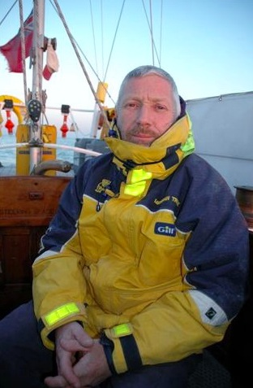

         Alan Priddy先生是英国航海领域中是极负盛名之人，他既是航海家，又是冒险家。他虽已是耳顺之年，但他仍然经理充沛，他创造过在103个小时，驾驶快艇穿越大西洋的世界纪录，直到2012年，他已经打破了37项世界纪录，12项英国国家纪录。

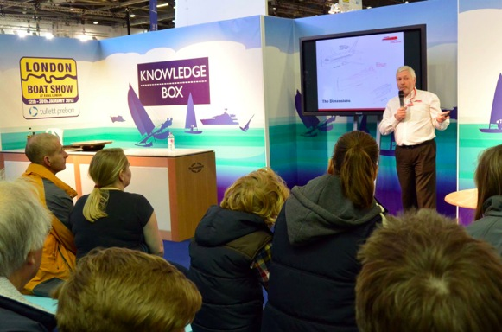

         2014 元月2日，在诺莱仕帆船俱乐部对2014年推行中国帆船国际化交流的高度展望下，我们有幸与知名的航海家Alan Priddy先生在2014年伊始共进晚餐，商讨在新的一年里的帆船合作计划，随后我们与Priddy先生在外滩游艇会共同交流了未来中国帆船业的发展与前景，并初步商讨了关于环球帆船航海游的计划。在交流中，我们对Priddy先生致力于航海事业的精力和想法，以及他个人在航海事业中打破了37次世界纪录，赢得了3次终身成就奖，斩获不计其数的国家奖杯感到万分敬佩！

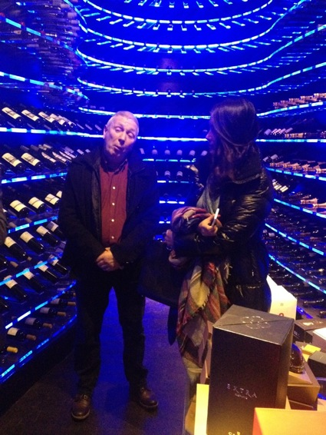

         通过友好轻松的谈话，双方均表现出强烈的合作意愿，并能展开更多层面的合作与共享，这是Priddy先生首次来到中国， 难能可贵的是Priddy先生愿意为中国推动航海事业贡献自己的一份力量，Priddy先生殷切希望诺莱仕帆船俱乐部带领更多的中国船员去踊跃报名参加英格兰国际帆船赛事考斯赛周（Cowes Week），并能加入到Priddy先生的2014年的帆船环球航行计划。

    我们诚挚地欢迎热爱航海的人士报名参加Priddy先生的帆船环球航行！

           垂询报名热线021－58779999

**-帆船赛事公告**

史上最全的大帆船赛事（不收藏是您的损失）

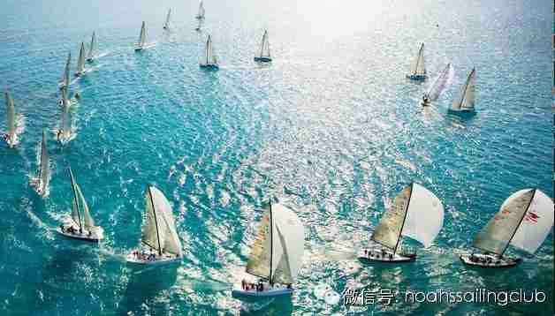

         2014年伊始，诺莱仕帆船俱乐部精心为各位帆友收集整理了2014全年的全球大帆船赛事，同时希望更多的朋友们来一起指正、完善。届时我们将持续系统的关注全球各类帆船赛事和资讯。诺莱仕帆船俱乐部有望在2014年与各位帆友们一起参加更多的国际帆船赛事，带领有志参加国际赛事的帆友们走出中国，并与广大帆友们一起创造中国水手在全球海域上的奇迹。

全球帆船赛报名热线：021－58779999

**2014年全球帆船赛最新赛事表**

|  |  |  |  |  |
| --- | --- | --- | --- | --- |
| 时间 | 赛事 | 比赛场地 | 国家 | 主办单位 |
| 2013.12.26－2014.1.1 | 劳力士悉尼－霍巴特帆船赛 |  | 澳大利亚 |  |
| 2013.12.27－2013.12.31 | 加的斯海湾－－新年帆船赛 | 加的斯 | 西班牙 | 安达鲁西亚航海联盟 |
| 2014.1.12－ | 克利伯环球帆船赛 |  |  |  |
| 2014.1.14－2014.1.18 | 新加坡海峡杯帆船赛 |  | 新加坡 | 新加坡帆船协会和One 15游艇俱乐部 |
| 2014.2.2－2014.2.8 | 海王星帆船赛 |  | 印尼 |  |
| 2014.2.11－2014.2.12 | 加州梦想赛－圣地亚哥站 | 圣地亚哥 | 美国 | 夏天 格林 |
| 2014.2.12-2014.2.16 | 攀牙甲米普吉湾帆船赛 | 攀崖甲米 | 泰国 | 奥查龙游艇俱乐部 |
| 2014.2.13－2014.2.18 | 皇家兰卡威国际帆船赛 | 兰卡威 | 马来西亚 | 英国皇家兰卡威游艇会 |
| 2014.2.14－2014.2.21 | 劳力士杯大西洋路线帆船赛 | 布宜诺斯艾利斯 | 阿根廷 | 阿根廷游艇会 |
| 2014.1.31－2014.2.14 | 奥克兰市海桥帆船赛 | 奥克兰 | 新西兰 |  |
| 2014.2.1－2014.2.8 | 马德普拉塔国际游艇周 | 马德普拉塔 | 阿根廷 |  |
| 2014.2.2－2014.2.6 | 哈迪杯 |  | 澳大利亚 | 悉尼皇家游艇会 |
| 2014.2.10－2014.2.14 | 戛纳－费恩国际帆船周 | 戛纳 | 法国 | 戛纳游艇会 |
| 2014.2.13－2014.2.16 | 兰卡威国际柏达纳帆船赛 | 兰卡威 | 马来西亚 | 英国皇家兰卡威游艇会 |
| 2014.2.18－201.2.22 | 卡塔尔国际帆船赛（海湾） | 多哈 | 卡塔尔 |  |
| 2014.2.20－2014.2.23 | 卡尔贝塔 巴塔贡 | 布宜诺斯艾利斯 | 阿根廷 | 阿根廷游艇会 |
| 2014.2.22-2014.2.23 | 城市日帆船公开赛 | 基纳巴卢 | 马来西亚 |  |
| 2014.2.23－2014.2.26 | 因佩里亚天空游艇赛 | 因佩里亚 | 意大利 | 因佩里亚业余运动员组织游艇会 |
| 2014.3.14-2014.3.16 | 斯洛文尼亚国家公开赛 | 伊左拉 | 斯洛文尼亚 |  |
| 2014.3.19－2014.3.29 | 第五届环海南岛国际大帆船赛 | 三亚 | 中国 |  |
| 2014.4.4－2014.4.6 | 国会杯帆船赛 | 长滩 | 美国 | 长滩游艇会 |
| 2014.4.16－2014.4.21 | 中国劳力士帆船赛 |  | 中国 | 皇家海洋比赛俱乐部（RORC） |
| 2014.4.18－2014.4.20 | KFC-霹雳州公开赛 | 昔加里 | 马来西亚 |  |
| 2014.4.19－2014.4.21 | 国际复活节帆船赛 | 切塞纳蒂科 | 意大利 |  |
| 2014.4.30－2014.5.6 | 布尔加斯港口帆船赛 | 布尔加斯 | 保加利亚 | 布尔加斯港口游艇会 |
| 2014.5.1－2014.5.5 | 加冕杯海湾帆船赛 |  | 泰国 | 海洋游艇俱乐部 |
| 2014.5.2－2014.5.4 | 马伊奥离岸帆船赛 |  | 德国 |  |
| 2014.5.15-2014.5.25 | 诺曼底航道帆船赛 | 卡恩 | 法国 |  |
| 2014.5.24－2014.5.31 | 苏梅岛帆船赛 | 苏梅岛 | 泰国 |  |
| 2014.5.30－2014.6.1 | 大型卡利什杯国际帆板赛 | 卡利什 | 波兰 |  |
| 2014.5.31－2014.6.1 | 丰收节帆船公开赛 | 沙巴 | 马来西亚 | 基纳巴卢游艇会 |
| 2014.6.9－2014.6.13 | 黄金航海帆船赛 | 韦茅斯／波兰 | GBR |  |
| 2014.6.11－2014.6.13 | 布林迪西－－科孚岛国际帆船赛 | 布林迪西 | 意大利 |  |
| 2014.6.14－2014.6.21 | 热阿古里亚劳力士杯帆船赛 | 圣特罗佩 | 法国 |  |
| 2014.6.14－2014.6.15 | 六月圣地亚哥游艇俱乐部赛 | 圣地亚哥 | 美国 | 圣地亚哥游艇俱乐部 |
| 2014.6.20－2014.6.22 | 图尔戈亚克杯帆船赛 | 米阿斯市／雅宾斯克洲 | 俄罗斯 |  |
| 2014.6.30－2014.7.7 | 史坦纳杯瑞典帆船赛 |  | 瑞典 | 皇家哥德堡游艇会 |
| 2014.7－ | 无锡太湖杯帆船赛 | 无锡 | 中国 | 太湖山水游艇会 |
| 2014.7.19－2014.7.26 | 印度尼西亚帆船赛 |  | 印度尼西亚 |  |
| 2014.8－ | 青岛帆船周 | 青岛 | 中国 |  |
| 2014.8.13－2014.8.15 | 芝加哥大满贯 |  | 美国 |  |
| 2014.8.21－2014.8.26 | 蒙特卡洛帆船航海赛 |  | 蒙特卡洛 |  |
| 2014.8.28－2014.8.31 | 利普诺帆船赛 | 利普诺湖 | 捷克 |  |
| 2014.9－ | 美洲杯帆船赛 |  |  |  |
| 2014.9.8－2014.9.14 | 劳力士天鹅杯帆船赛 | 波多切沃 | 意大利 |  |
| 2014.9.22－2014.9.27 | 皇家帆船赛 | 戛纳 | 法国 |  |
| 2014.10－ | 香港-三亚帆船拉力赛 | 香港－三亚 | 中国 |  |
| 2014.10－ | 中国俱乐部杯帆船赛 | 厦门 | 中国 |  |
| 2014.10－ | 中国杯帆船赛 | 深圳 | 中国 |  |
| 2014.10.4 | 沃尔沃环球帆船赛 | 阿里坎特 | 西班牙 |  |
| 2014.10.11 | 沃尔沃环球帆船赛 | 阿里坎特往开普敦 | 英国 |  |
| 2014.1024.－2014.10.27 | 科威特国际帆船赛 | 萨法特 | 科威特 |  |
| 2014.11.1－2014.11.6 | 阿尔及尔国际帆船赛 | 阿尔及尔 | 阿尔及利亚 |  |
| 2014.11.9－ | 法国旺底帆船赛 | 旺底 | 法国 |  |
| 2014.11.19 | 沃尔沃环球帆船赛 | 开普敦往阿布扎比 | 阿联酋 |  |
| 2014.12.4－2014.12.7 | 因佩里亚冬季帆船赛 | 因佩里亚 | 意大利 |  |
| 2014.12.27-2014.12.31 | 新年帆船赛－－加的斯海湾 | 加的斯 | 西班牙 |  |
| 2013.12.26－2014.1.1 | 劳力士悉尼－霍巴特帆船赛 |  | 澳大利亚 |  |
| 2013.12.27－2013.12.31 | 加的斯海湾－－新年帆船赛 | 加的斯 | 西班牙 | 安达鲁西亚航海联盟 |
| 2014.1.12－ | 克利伯环球帆船赛 |  |  |  |

*更多帆友活动，请关注*

*“ noahssailingclub”*公众账号！

**-俱乐部圈层活动**

2013上海帆友年会

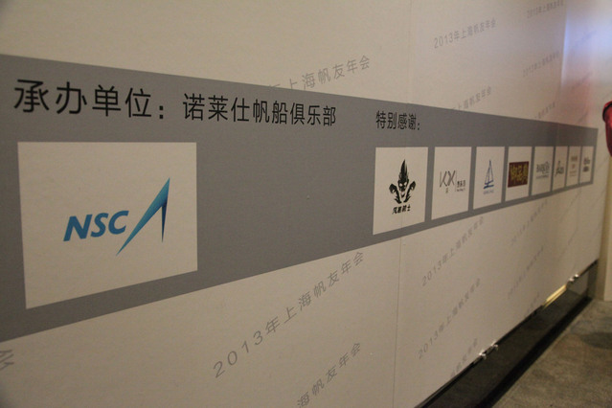

2013年12月14日，上海水手年会在“360度”黄浦江景的上海国际会议中心落下帷幕，在年会的首个环节里，在场的各位来宾分享了2013年亚洲帆船盛事——“泰王杯”的赛事分享。为其五天的赛事，有来自世界五十多个国家的百余只参赛队伍汇聚泰国普吉岛附近海域，展开了激烈的角逐。通过赛事的现场视频、照片资料，来宾们欣赏到了世界级帆船赛手们的英姿，而对惊险与激烈的比赛过程也无不发出惊呼与赞叹。据悉，“泰王杯”帆船赛开始于1987年，距今已有26年，每年12月份的第一周在普吉岛举行，是亚洲最受欢迎的帆船比赛之一。目前，“诺莱仕帆船俱乐部”正积极与各大国际赛事友好洽谈中；而在未来不久的时间里，上海的帆船友人们即能通过“诺莱仕帆船俱乐部”的平台，有机会参与各类国际赛事。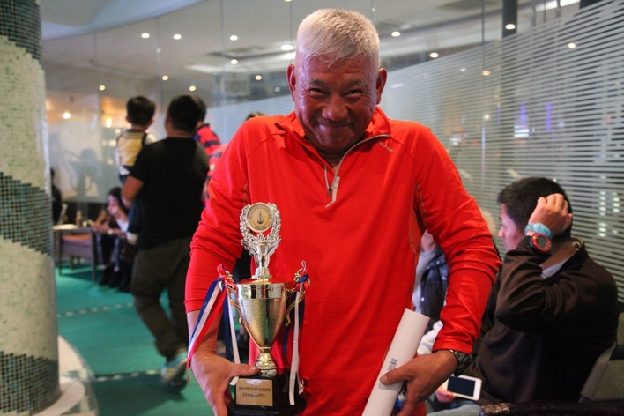

在接下来的年会环节中，主办方“诺莱仕帆船俱乐部”现场为上海“淀山湖杯”迎新帆船赛事进行了揭晓与颁奖。来自13只国内帆船领域的参赛队伍冒着料峭寒意、顶着瞬时20米每秒的强风，充分表现了作为一名出色帆船手勇敢无畏、坚韧探索和团结与共的精神。

此次的颁奖仪式，不但是为了表彰航海人士们的杰出表现，更是对上海帆船赛事权威性与专业性的高度认可；这也给予“诺莱仕帆船俱乐部”足够的信心，在未来去开拓更多具有意义的赛事合作。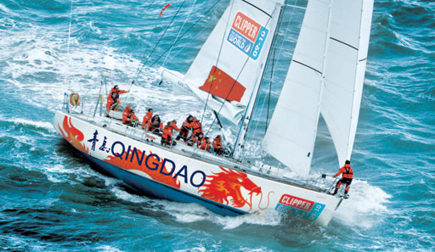

随后，“诺莱仕帆船俱乐部”还邀请到了资深帆友王文滔进行克利伯站航海分享，与来宾交流心得也拓展视野。这些资深航海人士活跃在各个帆船活动、赛事上，热衷于投入帆船实践领域、分享帆船体验与感悟，用自身的经验所得为来宾们提供借鉴与参考。这番温馨与真诚的交流，使得在场来宾思想碰撞火花不断，交流活跃，每位来宾对于帆船的认识都收获颇丰。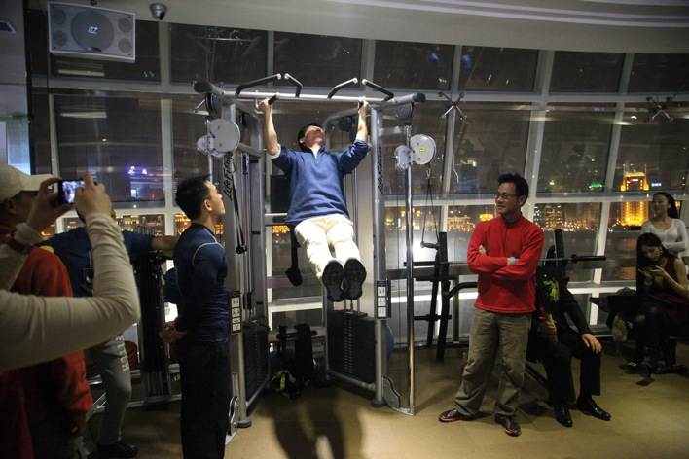

        在游戏与抽奖环节中，来宾们早已是打成一片，现场笑声连连。这些资深帆船友人们通过“2013帆友年会”的平台相遇相识，每一位来宾。都秉持着对于帆船运动共同的信念与爱好。值得一提的是，帆友均来自于各大行业的精英人士，懂得创造新的生活乐趣，更懂得品位帆船这项绿色、环保、充满奋斗与协作精神的高贵运动。从稳向板和手推舵到固定龙骨和双轮舵，从每周末家门口的比赛到每年一届的亚洲顶级帆船比赛——“泰王杯”，从横跨台湾海峡的拉力较量到环球海南全岛的不间断航程，上海帆船军团所到之处无不令人称赞。

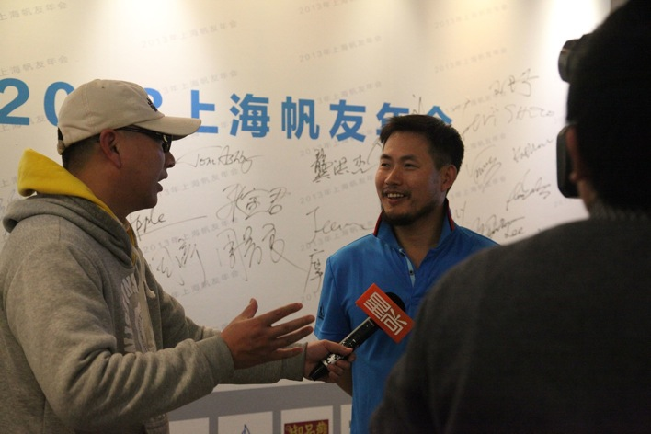

总之，未来的诺莱仕帆船俱乐部，一定为在场每一位热爱航海的人士，提供好一个良好的学习交流环境和专业的航海配套服务，争取做一个合格的水手“管家”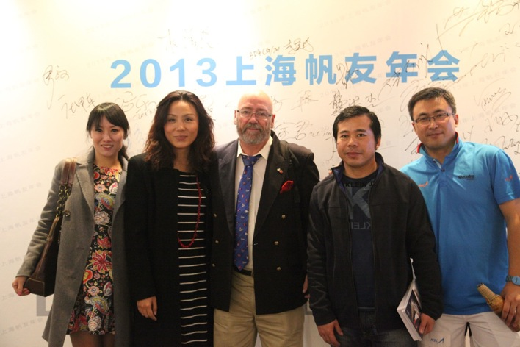

“2013上海帆友年会”的顺利举办，为诺莱仕帆船俱乐部的向前开拓和创新打下可扎实基础。帆船这项高贵又普及的运动，也会随着生活方式的提升而迅速普及。我们期待船员的热情加入，并为每位会员提供行业规范、互助、共享的专业服务，带领会员们一同来推动帆船事业的健康可持续发展。美女签到 百媚添娇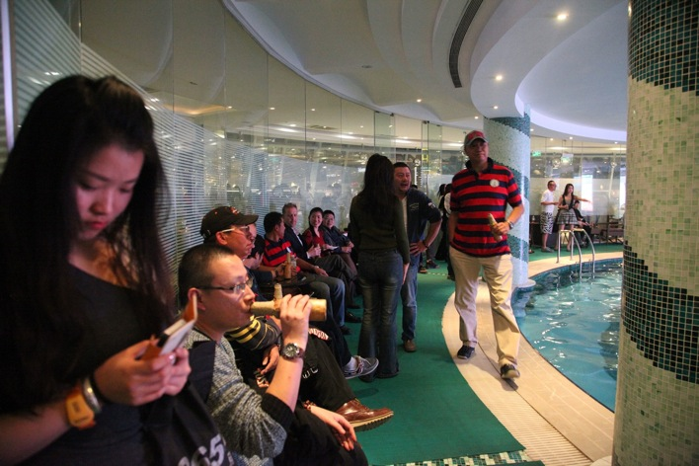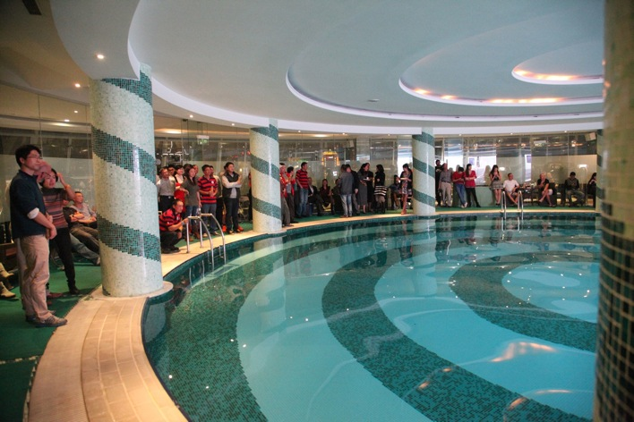各路英豪 泳池环绕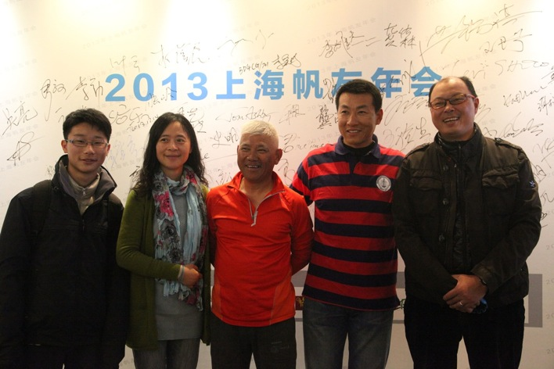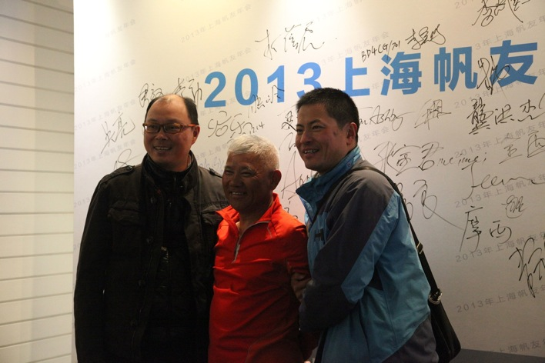

 新老水手  欢聚一堂



 美女主持 活力四射

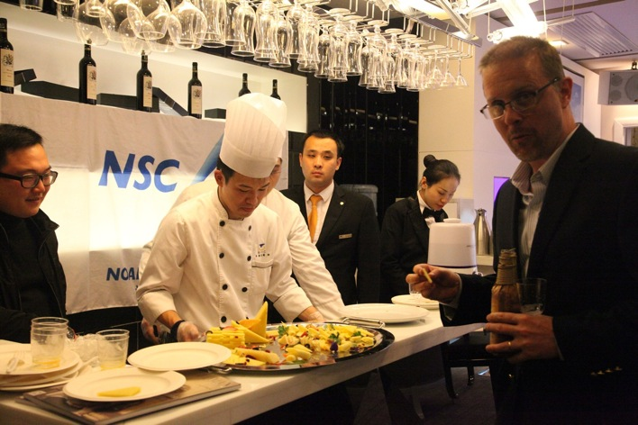

外滩游艇会的厨师团队

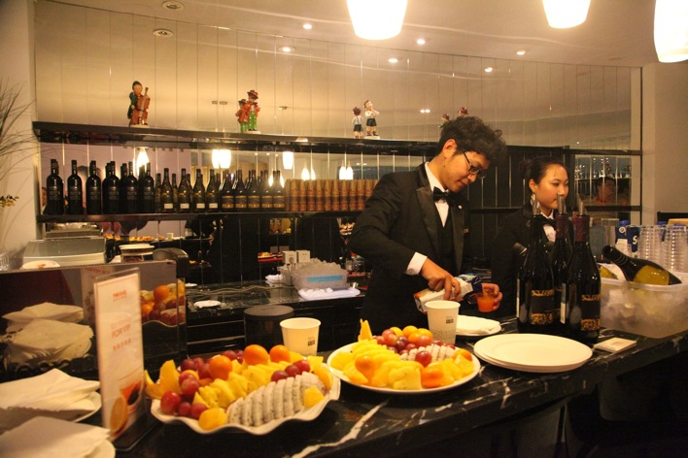

**外滩游艇会的英伦管家团队**

**-航海文化**

重塑中国人的海洋自信

2014-01-24 [诺莱仕帆船俱乐部](https://mp.weixin.qq.com/s?__biz=MjM5NzIwMzA1Mg==&mid=200003176&idx=1&sn=e55d466d1b97d17534c35ea9d1a92479&scene=18&key=750dd8c5ddc8f1129a2582894ee94676b5ea68adcd6f6529031910873a0782edb9b6f9295bad0e3d67914a1bf52d3fb6e81c3259e02a94b2b66ed60dd7d18f9079d7f3861f7f0059c8fb8e1c4ff3b552&ascene=1&uin=NDM0OTMxMDk1&devicetype=Windows+7&version=6204014f&pass_ticket=9HGf5rCcMKmvVmFBME2FOmoZjYf9LCFDLWmluKOkqcf4b1O2dIKDh%2BOkOWvWrzCx&winzoom=1##)

**重塑中国人的海洋自信**

**To Remold the Chinese Confidence on the Sea**

    中国自古以来“负陆面海”，不仅有960万平方千米的陆地国土，还有300万平方千米的蔚蓝色国土和漫长的海岸线。曾经，我们的祖先深得“渔盐之利”与“舟楫之便”，海洋，古往今来就是世界各国的战略制高点。中世纪时期，水城威尼斯凭藉其得天独厚的海上贸易，成为了远近闻名的富裕之都。15世纪初，明代官员郑和率200多艘船舶七次远航西洋，途径30多个国家和地区，为世界航海史添上了辉煌而又浓墨重彩的一笔。之后，意大利航海家哥伦布发现美洲“新大陆”，从此打开了美欧国家间互通往来的海上贸易渠道，全球商业发展也由此繁荣早期的航海者们，就能运用帆布合力制造船舶，通过辨别风向与潮汐来操纵航线以便顺利航；而这恰恰就是现代帆船领域的雏形。

As a country with advantages both in land and sea since the acient times, China not only has the land about 9.6 million square kilometers, but also the blue ocean area of 3 millions square kilometers and the long coastline. Our ancestors had been well-placed with respect to the advantages on “fishery & salt” and “shipping”. Each ocean, through the ages, is alway deemed as a strategic commanding ground for countries throughout the world. In the Middle Ages, Venice has rated as the Affluent City for its unique maritime trade. In the early stage of the 15th Century, Zheng He (a official in the Ming Dynasty) made seven voyages to the West with more than 200 vessels and visited over 30 countries and regions, which undoubtedly adds a brilliant and splendid touch to the world’s marine history. And then, the Italian navigator Christopher Columbus discoveried the "New World" in America, thus exploring a marine channel for business transactions between the United States & Europe and driving the prosperity of the global business development. Pioneering navigators used canvas to manufacture ship, controlled the route and successfully navigated by identifying the wind direction and tides; precisely, this is the prototype of the modern sailboats.

 海洋主权对于中国来说，则有着非同一般的意义。早在秦代，秦始皇就派遣数千民东渡日本，传去了雕刻、园林、绘画、艺术和丝织等文化技巧；唐宋年间，中国海船携织物、瓷器远航到印度以换取当地的宝石、珍珠，实现了海上丝绸之路的贸易昌盛；明代郑和下西洋的划时代事件，则更是将中国对海洋史的探寻推至巅峰。

For China, the maritime sovereignty has its unusual significance. As early as the Qin Dynasty, Qin Shi Huang (the First Emperor of Qin) dispatched thousands of people to go to Japan and spread the sculpture, gardening, painting, art, silk and other cultural techniques to Japan; in the period between the Tang and Song Dynasties, a Chinese ship voyaged to India with fabric and porcelain in exchange for local gemstones and pearls, which realized the trade prosperity of the Maritime Silk Road; as an epoch-making event, Zheng He's travellingtothewest (in Ming Dynasty) even pushed the Chinese contributions on exploration of the world’s marine history to the climax .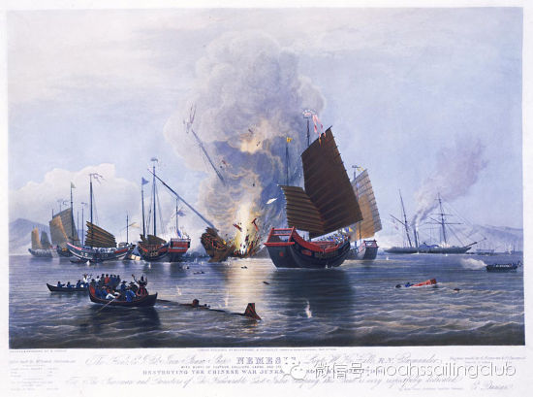

  然而，近代甲午战争和鸦片战争的爆发，使得中国一度失守领海，八国联军由海上入侵，顿时哀鸿遍野，民不聊生，人民饱受战火的蹂躏和摧残，各种珍贵文物被掠夺和破坏。中国彻底丧失了对海洋领土的主权控制，并忍受了长达100年的痛苦和屈辱，时至今日在中国人民心中仍留下了刻骨的伤疤。

However, the outbreaks of the Sino-Japanese War and the Opium War in the Chinese modern history had caused the Chinese for short-time loss of the territorial waters, following the Eight-Power Allied Forces’ invasion by the sea. At that time, China was devastated; the Chinese lived in the dire poverty and suffered from the ravages and devastations of the wars;a variety of precious relics were robbed and destroyed; China had completely lost the control of marine territorial sovereignty and endured the pain and humiliation for up to 100 years. There is a deep-seated scars still left in the hearts of the Chinese people today.

近日，中国领海的“钓鱼岛事件”“南海问题”波澜不断，在国际社会中掀起轩然大波。尽管此次事件的结果悬而未落，但中国对于维护海洋权益、领土主权的决心空前强硬，成为了各方舆论关注的焦点。

Recently, the "Diaoyu Island Incident” and “the Issue of the South China Sea” related with China’s territorial waters，which had caused a great stir in the international community, seems to be transquil. Although these issue have not yet settled, China takes a unprecedentedly-tough stand with respect to safeguard ing its maritime rights and interests as well as territorial sovereignty; thus, these issues have become the focus for discussions from the parties.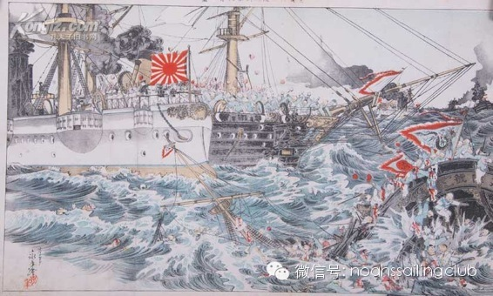

重塑海洋自信，复兴海洋主权，恢复海洋繁荣，成为了中国乃至每个国民责无旁贷的使命。几十年来，我国不断扩大海洋经济规模，保护海洋生态环境，在海洋公益服务和科研调查成果也取得了显著成果。十八大报告更是指出，要将“建设海洋强国”提升至国家发展战略高度，令国人为之振奋。这也宣示着中国将着重提高海洋资源开发能力，坚决维护国家海洋权益，给予了每个中国人复兴海洋文化繁荣的强大民族信心。

It has become the indispensable mission for China and its people to remold China’s confidence on the sea, revive its maritime sovereignty, restore its marine prosperity. For decades, China has been expanding its marine economic scale, protecting its marine ecological environment and also making remarkable achievements in the marine public service and scientific investigation results. It was also pointed out in the Report to the Eighteenth National Congress of the Communist Party of China  that to build maritime powers shall be raised to be one of the national development strategies so that the people are eletrified. It also declares that China will focus on improving the ability to explore the marine resources, resolutely safeguarding the national maritime rights & interests and giving its people a strong national confidence in the revival of the prosperity of the marine culture.

上海作为全国最大的沿海城市，尽占我国黄金海岸线中部和长江出海口通江达海的区位优势，海洋经济具备健康快速发展的良好基础。据著名未来学家格雷厄姆·莫利托曾预计，到2015 年左右，发达国家将进入“休闲时代”，发展中国家也将紧随其后，休闲将成为人类生活的重要组成部分。天时地利，上海将引领海上休闲运动新风尚。

Shanghai, as China's the largest coastal city, does occupy  the middle part of the golden coastline and the favorable position as a port for the Yangtze River into the sea. Its marine economy has been provided with a good foundation for the sound and rapid development. According to the estmiation of the famous Futurist Graham Molitor, By 2015, the developed countries will enter a "leisure era", closely following the developing countries. Leisure will become an important part of human life. With the right time and the right position, Shanhai will lead a new trend of the marine leisure sports.

纵观现今海上休闲市场，游艇行业日益成熟，而帆船如朝阳冉冉升起，代表了未来的一种发展方向和生活态度。提起游艇，人们感受更多的是高端、张扬，而帆船则是一种绿色、健康的运动。怎样通过更加意义非凡的海洋运动来演绎海洋乐趣，来重塑国人的海洋自信；帆船运动则是被认为最行之有效和最被推崇的普及方式。船员们可以通过海上驰骋不断挑战与锻炼自我，树立自信；并且在团队协作中树立广阔的视野、博大的胸怀。

Throughout today's marine leisure market, the yachting industry has been increasinglymature; meanwhile, the sailing industry, like the rising sun, represents a development direction and attitude towards life. When talking about the yachting, the words of high-end and show-off may appear in the mind; however, the sailing is a kind of green and healthy sport. How to interpret the marine fun through more significant marine sports in order to remold the people's self-confidence: it’s sailing. The sailing is the most effective and the most recommended & populized method. The sailors can ride over the waves in the sea to constantly self-challenge and self-exercise so as to build their self-confidence; besides, they can also form a broad vision and a broad mind through teamwork in the sailing.

     作为国内帆船领域的开拓者， 上海首家真正意义的大帆船俱乐部——诺莱仕帆船俱乐部，矢志以建设中国大帆船事业总部为使命。“俱乐部倡导的帆船不仅是专业赛事竞技的体育运动，更是一种低碳、环保、时尚的休闲运动。帆船俱乐部能满足国人对帆船进阶学习、日常训练以及国际赛事的所有需求。这里将有国际赛事滚动举办，全球海域帆船集会纷呈上演，资深船长的陪伴指导，以及专属服务特殊定制。帆船俱乐部践行海洋精神、热衷帆船事业作为价值准则，而俱乐部招募的船员则都必须兼具宽广博大的胸怀、团队共赢的目标、协调合作的理念。诺莱仕帆船俱乐部将号召更多的帆船爱好者以不同的形式参与其中，享受扬帆起航的乐趣，感受海洋的博大与激情，再现中国航海事业的辉煌。”

As a pioneer in the domestic sailing field, Noahs (Shanghai) Sailing Club is really the first sailing club in Shanghai. It is noted by its director, "We advocate the sailing shall be not only one of professional tournament competitive sports，but also a low-carbon, environmentally-friendly and fashionable lesuire sport. We will meet all the needs of the people regarding advanced learning, daily trainning and international competitions of the sailing by our efforts in all aspects, e.g., the international competitions will be regularly staged and brilliant sailboat shows will be delivered, professional coaches will be arragned for giving guaidance and exclusive specially-tailored services will be provided. Noahs (Shanghai) Sailing Club will insist on the fulfillments of the marine spirit and the contributions on the sailing career as the value criteria; furthermore, the club crew must have armed with a broad mind, win-win goal through teamwork, coordination and cooperation concept. We will call on more sailing enthusiasts to participate in the sport in different forms, enjoy the pleasure of sailing, feel the breadth and passion of the ocean and reproduce the glories of the marine cause. "

帆船，堪称是风、水、人、船四者的完美融合。国人将在帆船运动中寻到征服海洋的无限乐趣，感受海面疾驰的拼搏体验；帆船更能使得国人在劈波斩浪、勇往直前、挑战自我中领悟海洋文化与精髓的深意。而国人重振海洋地位的道路也将愈发坚实，复兴之时指日可待！

The sailing is rated as the perfect integration of wind, water, people and boat. The people will, through the sailing, find the endless fun to conquer the ocean and obtain the fighting experience by riding over the waves; the sailing could help the people to comprehend the meanings of the marine culture and essence when they are against the wind and wave or self- challenged. The road to revive the marine status will also thus become more solid and the rejuvenation will be well in sight!

**全球联盟**

**-联盟体系内容WHAT MSA PROMOTE**

## 全球顶级游艇会联盟体系

###### Union of Elite Yacht Clubs

**1. Organization of top-level sailing events**

a) Initiating and organizing top sailing events annually.Cooperating with the Yacht Clubs, the Alliance will develop independent IP sailing event brands;

ｂ)MSA will introduce international top-level sailing events in Shanghai, China, including inshore and offshore events.

**2. Establishment of business tourism platform**

During the annual Summit, MSA will hold exhibition to realize the promotion of the regional, economical and trading exchanges.

**3. Set up “Boat Owner’s Bank”**

The “Boat Owner’s Bank” is built up for the purpose of rationally allocating sailing boats and efficiently reducing the duration of sailing. The "Boat Owners Banking "system Yacht Club in the League, advocating boat share scheme, aims at increasing boat usage. For example,

Boat owner A deposits its sailing duration berthing at its home harbor into a ship-owner bank. Hence, Boat owner A can freely exchange it into the duration of Boat owner B’s sailing ship berthing at another port, with a premise that Boat owner B has signed a Boat owner Bank Agreement. Except for the exchange mode, there are also multiple deposit and exchange modes, such as dependence on lease instead of maintenance.

**4. Club member visits**

Establishment of Yacht Club member and fleet visits.

Members can access 50-League club destinations worldwide and enjoy local club membership benefits & services.

**一、共同举办顶级帆船赛事，联盟体系联合各家游艇会，自主研发独立IP的帆船赛事品牌；**

1)由联盟体系发起，每年举办顶级的大帆船赛事。

2)同时联盟体系将引入国际顶级大帆船赛事落户中国上海，其中包括场地赛事、一级离岸赛事。

**二、建立商贸旅游的平台**

每年高峰论坛期间，同步举办展览，邀请游艇会所在国家或地区展出航海相关主题的博览会，促进联通体系内各个国家地区的航海与经济贸易的交流。

**三、船艇共享经济 成立“船东银行”**

为合理配置帆船资源，高效利用船只时间。发起“船东银行”在联盟体系游艇会，倡导船艇共享计划，以全球50个游艇码头间建立使用时间互换系统，提高船艇使用率和扩大船东玩船地点。

船东通过自己船只的航行时间存入船东银行，即可兑换联盟体系中的其他港口的船只航行时间，同时也提供以租代养的多种兑换模式。

**四、 俱乐部间会员互访**

建立游艇会间的会员互访与船队互访。

会员可到达全球50个联盟俱乐部目的地，接受当地俱乐部的会员身份待遇与服务。

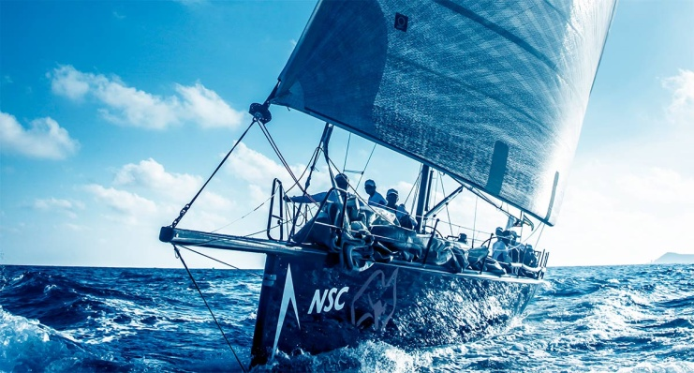

**-星海联盟体系MORNING STAR ALLIANCE**

## 星海联盟体系

###### Morning Star Alliance (Abbreviated as MSA)

影响有影响力的俱乐部   Change the world together with the strongest.



**LOGO的寓意**    **Design of Logo**

Graphics: the entire logo features on the stars arising from the horizon as the motif, meaning positiveness and development bring infinite possibilities.

Color: Orange: stands for prosperity, strength, wisdom, positiveness and vitality

Color: Orange: stands for prosperity, strength, wisdom, positiveness and vitality

Blue: stands for the eternal theme of Sea and Sky.

**图形构成**：整个logo以星辰浮出海面为主旋律，寓意为朝气向上，蓬勃发展，带来无限可能的构思。

**颜色搭配**：

橙色的含义：繁荣、力量、智慧、阳光、活力

蓝色的含义：大海 天空 永恒的主题

**OUR VISION**

1. MSA will ally with more than 50 world well-known yacht clubs.

2. The Noahs Yacht Club which belongs to MSA is a multifunctional platform for finding business opportunities and holding promotional events.

Morning Star Alliance’s destinations include France, Italy, Spain, Sweden, Switzerland, the United Kingdom, Germany, Portugal, Australia, New Zealand, Korea, Dubai, the United States, Brazil, Hong Kong, Macau and Taiwan．

**联盟发展远景**

1、联合超过50家全球知名游艇会成为星海联盟成员

2、游艇会会所功能强化商贸、旅游；金融等多种友谊纽

目的地包括：　法国、意大利、西班牙、瑞典、瑞士、英国、德国、葡萄牙、澳大利亚、新西兰、韩国、迪拜、美国、巴西、香港、澳门、台湾

**世界地图**

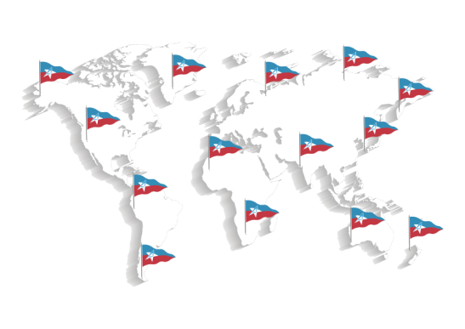

**-入会资格MEMBERSHIP QUALIFICATIONS**

## 入会资格

###### MSA Membership qualifications

1. Advocating the nautical spirit and boat culture;

2. With good reputation, focusing on marine environment;

3. Understanding and recognition of the Alliance member articles;

4. With club premises/venue/ training bases/boats;

Approved by the Council and qualified for the Yacht Club of Alliance membership.

1、热爱帆船文化，崇尚航海精神;

2、具有良好的信誉度，关注海洋环境;

3、所在国家或者区域有一定影响力，能理解和认可联盟体系会员章程;

4、有自己的会所经营场地／或训练基地／或船只;

经理事会审核，符合游艇俱乐部联盟会员资格者。

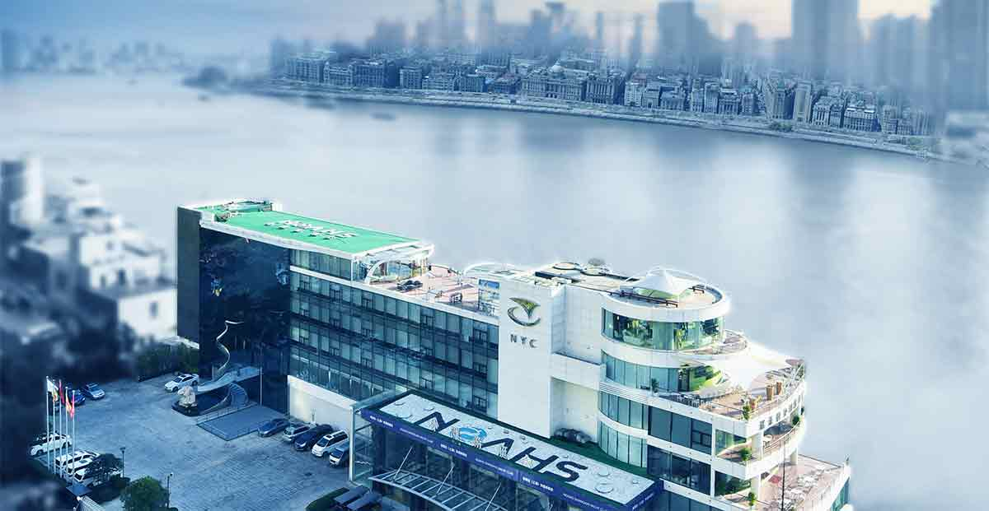

Members of affiliated clubs, upon showing the membership cards of their clubs, are entitled to use ＮYC club facilities. Their reciprocal rights entitle them to:

Access to the club’s cellar/lounge;

Access to the club’s meeting room on weekdays;

Access to the car park or the marina.

The service and facilities may be available through prior reservations. The Booking line is 4006060111.

联盟成员权益

联盟俱乐部的会员，可以使用诺莱仕游艇会的场地设施，互惠的权利包括：

可使用游艇会酒窖和雪茄吧;

可使用游艇会的会议室;

联盟体系之间的互惠条款需要通过诺莱仕游艇会提前预定，预定热线 4006060111。

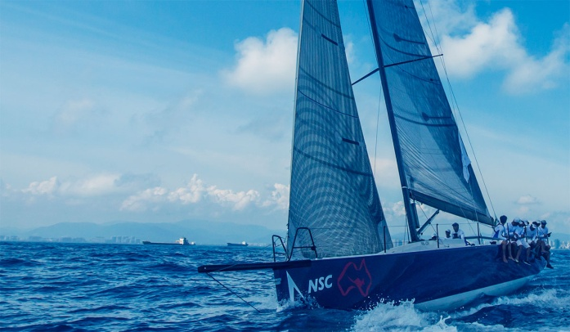

**-邀请函INVITATION LETTER**

邀请公开信

INVITATION LETTER

To whom it may concern,

In recognition of our club’s wonderful long history and sailing traditions,we are pleased to invite you to join the Morning Star Alliance.

We are a non-profit organization cooperating with the Leading Yacht Clubs by sharing their experiences,learning from their successes.and reviewing the unforgettable challenges,Morning Star Alliance is a new platform for all leading clubs around the world for organizing sailing races,seminars and summits.Morning Star Alliance aims at elevating the level of sailing events in Asia-Pacific region to international scale.

We sincerely hope you will join us and work with Morning Star Alliance.

对于俱乐部悠久历史和航海传统的认同感，我们诚挚的邀请贵方加入星海联盟体系。

星海联盟是一家非营利性组织与全球范围顶级游艇俱乐部共同合作，通过经验分享、学习成功案例、回顾共同的挑战。星海联盟也是一个崭新的平台。顶级俱乐部通过联盟可以共同举办赛事、高峰论坛、行业研讨会。星海联盟致力于将亚太地区以及全球的帆船赛事带到一个新高度。

我们诚挚的希望贵方与我们一起搭建联盟体系。

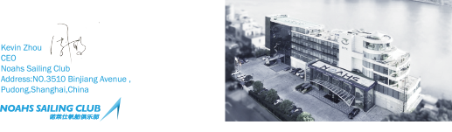

**会员中心**

**-至会员**

## 诺莱仕帆船俱乐部欢迎您

尊贵的会员（船员）：

从这一刻起，我们因彼此而熠熠生辉

您的渴求，我们将倾力呈现；

您的夙愿，我们总牢记心间。

这里是您托付信任的一隅良田，

我们为您精耕细作，和您心手相连；这里将是您环球航海的后勤保障基地，

我们一起撑起中国航海梦，这里是您实现大帆船运动的价值平台，

我们为您在全球帆船目的地联盟资源搭建桥梁，以期荣辱共赢。

作为您不二的俱乐部选择，我们钦佩您独到的智慧，定会不负您的胜望；

作为您风雨同舟的伙伴，我们将用国际最成熟的俱乐部管理经验和商业模式

来回馈您的倾情加入！

诺莱仕（上海）帆船俱乐部，诚挚欢迎您荣耀加入！

此致，祝好！

**-船东银行**

## 造船过河 不如借船过河

                                   当今中国的每一位市长都在为城市交通焦头烂额，汽车拥堵成了今后几年的焦点问题，“拥堵”每一个人都可以说上几句，似乎每一个人又都没有更好的解决办法。拓宽公路、增设停车场、北京市有限号、上海市有高价沪牌等行政措施，但这些只能是扬汤止沸，治标不治本。我想这一定不是最初发明汽车者卡尔·茨(KARLBENZ)的本意，德国奔驰公司自2009年已率先在北美推出Car 2 go汽车共享计划，该计划提出未来的交通出行，倡导你不再是汽车的拥有者，而是汽车的使用者，注册会员可通过网络或电话了解附近“car2go” smart车辆位置，并可提前24小时完成车辆预订，奔驰公司进行云计算，通过物联网自由调配，你可以通过刷卡开启车门，确认你的预定信息后开走这辆车，随着Car 2 go模式的全球渗透，也就是说未来的汽车出行卡势必成为主流，就像现在的电卡一样，你预计用多少量，你可事先充值多少

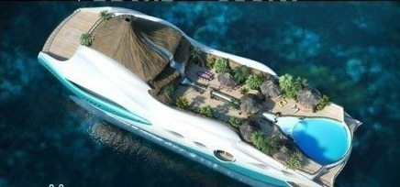

              交通拥堵的核心问题其实是价值观念的问题。中国人“好面子”，才造成私家车持有量在中国畸形疯长，而汽车实际每天的平均使用率不到二小时，高额的养护成本，并造成大量闲置和资源浪费。我们习惯理解是拥有德系车车主可以看不上日系车主、大排量车主比小排量车主自信。今天当几万的车和几百万的车一起被傻堵在路中央的时候，我们才去审视个人利益是否应该让位于公共利益，社会公民的责任不会因为谁车好就可以免于自责。当优势不在，个性被共性掩盖，价值评判标准不再以你有没有车或者开什么车来衡量时，甚至大排量汽车有点自私、不环保、炫富的嫌疑时。去掉附加在汽车身上其它意义作为一种交通工具将回归到初始功能，就像现在没有人关心有钱人家用什么牌子煤气、装什么牌子自来水一样。

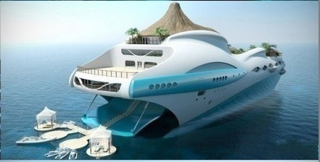

        诺莱仕帆船俱乐部致力打造成中国帆船的事业总部，设立之前曾做过大量的市场调研，走访了国内外的游艇俱乐部。就中国目前泊在各大俱乐部码头边的游艇，船东自主平均使用一年也不超过5次，且已形成常态。为了避免中国帆船业重蹈覆辙，借鉴汽车业的心路历程，防患过度开发和盲目兴建。我们推出＜全球目的地联盟＞体系建设和＜船东银行＞的概念，会员卡即是用船时间的储值卡，按个人需求在全国签订＜全球目的地联盟＞体系内港口自由支出。同时为了合理配置船只资源，提高帆船的使用率。船东A通过停在母港帆船的航行时间存入船东银行，即可自由兑换在已签定《船东银行协议》体系中其他港口的船东B帆船的航行时间，也可以提供以租代养等多种存兑模式。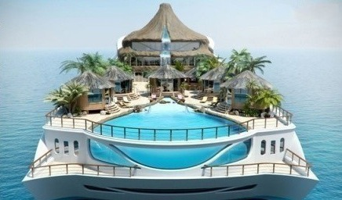

        大数据迅猛发展的今天，“造船过河不如借船过河”，轻资产，重软实力，强化船员服务和资源整合是诺帆船的主体运行思路

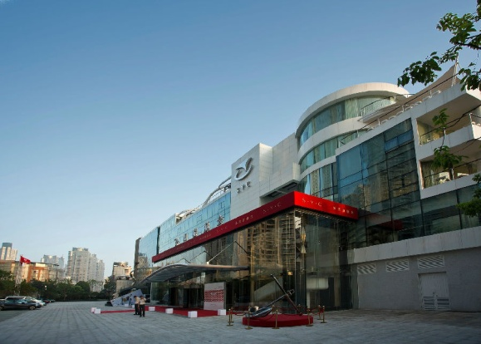

**-理事会员介绍**

**暂无内容**

**-航海里程数累积**

## 喜欢帆船的N种理由

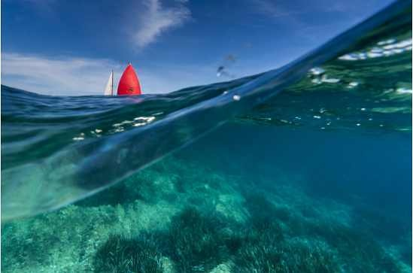

 “点燃中国人的航海梦”！

                          ——喜欢帆船的N种理由

   当前世界四大顶级体育盛事；足球赛、奥运会、F1赛车、帆船赛。前三者早已进入中国，并被国人熟知，唯独帆船赛尚处于萌芽状态，2008北京奥运会、2010上海世博会后、因各种政策利好因素推动，引发了我国众多景观水系旅游地产的开发热潮。2012中国18大过后 国家更是提出发展海洋强国，随着陆地资源趋于匮乏和海洋文化的兴起，南海热、东海热、在中国农耕文明向海洋文明自然演变的进程中，中国人开始热血沸腾，无数的社会活动开始指向海洋，人们的触角已伸向海洋。

    “衡量一个国家的经济实力就看这个国家港口城市桅杆数量的多少”前奥委会主席罗格的这句话从一个侧面诠释了一种全新的价值的理念和生活方式，同时帆船运动体现着环保、低炭和时尚的概念，代表了未来的一种发展方向和生活态度。重要的是，帆船运动不同于其它运动赛事，参与者不是纯粹的专业运动员，多为企业家或名人，如微软副总栽、甲骨文的老板、万科的王石等，都是帆船比赛的常客。这种示范效应使这项运动成为一个名人和名牌产品展示的舞台，因此被称为一项“小众带动大众”的运动

               “中国人的航海梦已被点燃”！

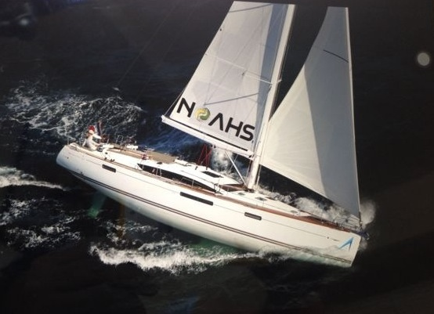

熏染贵族气质

始于16世纪的贵族运动，在这里成为你至高无上的无二选择。自古王室成员都钟意帆船，希腊国王、挪威王子都是帆船领域的巅峰人物。帆船即航海，航海即勇士；而如今投身于古老、环保帆船运动的人士，毫无疑问将会被称为全球贵族冒险精神的典范！

极致素质拓展

这是一项挑战与荣誉并存，智慧与技能兼具的时尚运动。在团队运动合作驾驶中，建立信任增进沟通、使彼此距离更加紧密。在激烈紧张的帆船竞赛中，体会挫折互相鼓励、懂得人生起伏感悟真谛。

时尚娱乐方式

今天的高尔夫多少显得有点过气，这一刻，放下所有羁绊，扬帆出海。与海邀约，与风厮磨，与水嬉戏，自由与激情的碰撞。朋友圈中有着时尚和品位著称的您岂能错过一次远航，像风一样自由吧，呼啸的海风，汹涌的海浪，也许玩得就是心跳

无限社交平台

这是一处蕴藏了无限商机的宝贵平台，当你真心投入到这项航海运动中时，更巨大的商机价值应运而生。我们努力搭建船员平台，通过帆船学习交流、创意碰撞互动、资源构建分享，成为精英船员们所亲自构筑的桥梁。

超越自我

      作为一名真正的海洋勇士，就让赛事来证明你的魅力吧！全年不间断国际级赛事及活动，满足你一试身手、一决高下的任何需要。每一次赛事活动，船员们必当为了共同目标，一起克服困难、齐心协力与自然抗争，这正反映了“自强不息”、“厚德载物”的精神。

抢占商机，把握时代脉搏

 岛屿经济，特别是民间资本主导的岛屿经济，在中国尚处于起步阶段。在地理资源充沛，政策资源和市场经济资源基本到位并得到不断补充增强的条件下，可操作的空间十分广阔，若能控制好发展节奏和产业布局，半私有化的岛屿经济必将成为活力四射的经济热点。

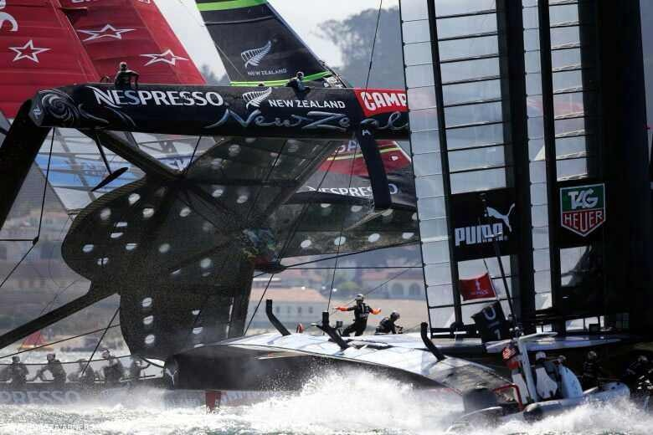

加入帆船事业吧，做时代的弄潮儿、做航海的先行者！

**联系我们**

### 联系我们

* 

##### 企业名称

诺莱仕游艇会

* 

##### 电话

400-606-0111 / 021-5877-9888

* 

##### 邮箱

info@noahsyachtclub.com

* 

##### 地址

上海市浦东新区滨江大道3510号

* 

##### 邮编

200081

加一个百度地图