assignment2_solution

z5136463

The flow of the program is showed as below:

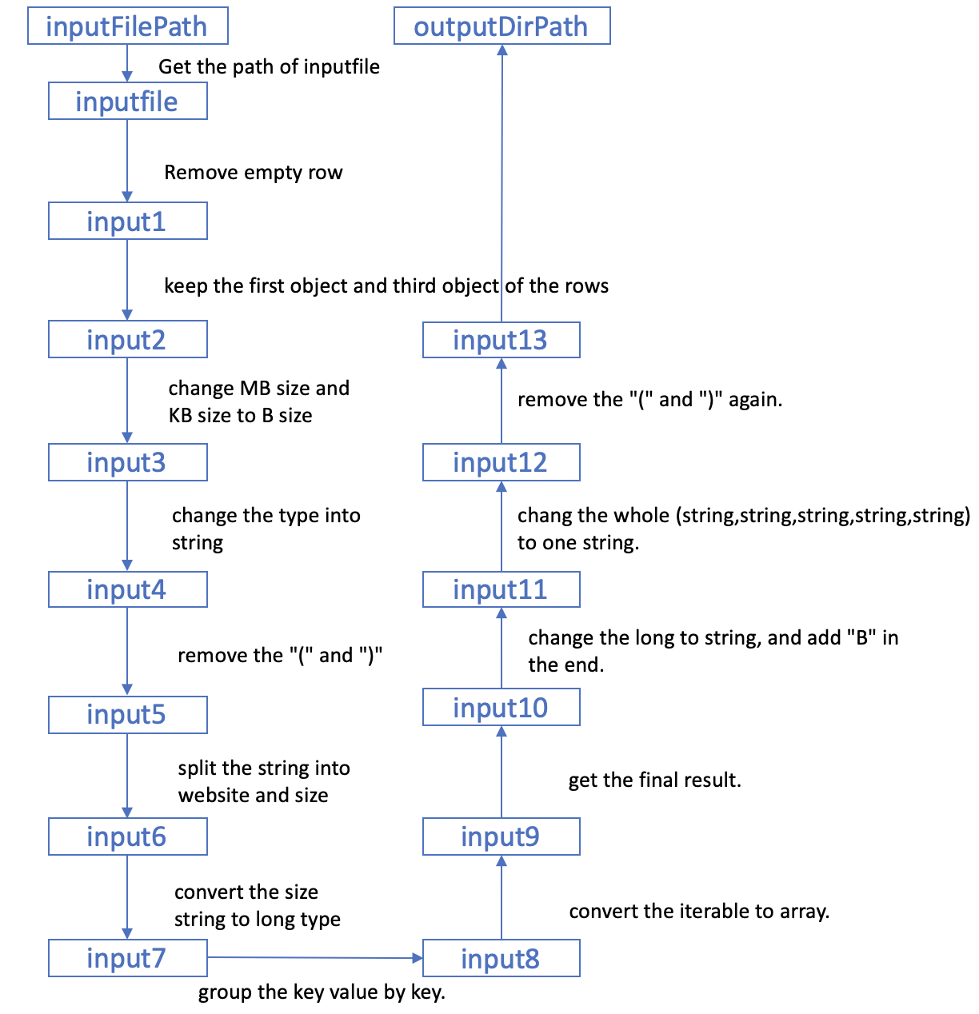

Two functions are defined by myself to calculate the mean and variance:

