CROSS-BRAND PATTERN REPORT
What five successful supplement brands have in common
Cross-brand patterns: MaryRuth's, Free Soul, Novomins, Vida Glow, SmartyPants
Supplements, wellness and nutricosmetics. Home markets: US, UK, Australia. Lens: what successful brands share, where they differ, and the warning signs.
Run date: 6 October 2026 | Analyst: brand-pattern-finder | Design: report-designer

How to read the confidence tags
Patterns are rated MEDIUM (several brands support it) or EARLY SIGNAL (one or two brands). No pattern is rated higher than medium because the evidence is snippet-based and the set has no failed brands. Dated facts carry the brand reports' tags: CONFIRMED (brand or investor statement, solid data), REPORTED (credible third party), INFERRED (analyst reasoning), USER-SUPPLIED (from the user; none in this set).

Contents
1. Key findings 3
2. Summary and caveats 4
Caveats that apply to everything in this report 4
3. Scorecard 5
4. How the five brands compare 6
Story, hero product and price 6
Marketing and sales channels 6
Success measures 7
5. What the successful brands share 8
P1. Founder's personal problem is the origin story 9
P2. Format or hero makes the promise visible at a glance 9
P3. Demand proven online before physical retail 9
P4. Amazon was an early growth engine 10
P5. Creators and social commerce drive sales 10
P6. Women buy; ranges follow life stages 10
P7. Beauty-from-within is a growth extension 10
P8. A trust stack stands in for clinical trials 10
P9. Founder-controlled, capital-light growth 11
6. Different routes to the same result 12
P10. Deep home market vs early internationalisation 12
P11. Retail destination differs: mass/club, pharmacy or prestige beauty 13
P12. Success by exit vs founder-retained scale 13
7. Warning signs: where story and product or channel pulled apart 14
W1. Range sprawl into trend SKUs 14
W2. Claims escalate beyond the evidence 14
W3. 'Premium' story vs deep discounting 14
W4. 'Global' story vs unmanaged international 14
8. Distinct success models 15
Alternative explanations 15
9. Implications for a new brand or product launch 16
10. Open questions and gaps 17
Evidence quality 17
Failed or stalled brands to add (the set has none) 17
Recommended Spate category searches 17
11. Sources 19

1. Key findings
Five successful brands share a founder story, an online-first path and a format that shows the promise; they also share the same two warning signs. All of it is medium-confidence correlation.
5 of 5  brands with a founder-problem origin story | All five brands began with a founder's personal problem and proved demand online before physical retail. [MEDIUM]  Pill aversion (MaryRuth's), a family health scare (Free Soul), unfinished vitamin tubs (Novomins), hair loss (Vida Glow) and a child who would not take vitamins (SmartyPants). Story clarity scores 4-5 for every brand, the highest-scoring criterion. Four brands built reviews, velocity or virality online first and used it to win retail; the gap between launch and major retail was 2-7 years (P1, P3).

4 of 5  brands where the format itself proves the story | The clearest shared lever is a format or hero that makes the promise visible at a glance. [MEDIUM]  Liquid for 'no pills' (MaryRuth's), gummy for 'kids will take it' and 'easy to remember' (SmartyPants, Novomins), a single 100%-collagen sachet (Vida Glow). It works in a 15-second video, an Amazon thumbnail or a shelf facing without explanation. Free Soul is the exception: it differentiates by audience (women-first), though it still needed a viral hero, Mango Greens (17m+ servings), to break out (P2).

3 routes  two of them rest on one brand each | Three routes reach success: a mass engine, a pharmacy shelf block and prestige beauty. [MEDIUM / EARLY SIGNAL]  Marketplace-and-creator mass engine: MaryRuth's, Free Soul, earlier SmartyPants (medium, 3 brands). Pharmacy-shelf need-state block: Novomins (early signal, 1 brand). Prestige-beauty placement with celebrity launches: Vida Glow (early signal, 1 brand). SmartyPants also shows a fourth outcome, a strategic exit to Unilever (early signal).

5 of 5  brands with trend-SKU sprawl and claims escalation | The same warning signs appear in all five: range sprawl and claims that run ahead of evidence. [MEDIUM (COMMON) / EARLY SIGNAL (HARM)]  Story-product fit is the lowest or joint-lowest score for four of the five brands. SmartyPants already faces two class actions aimed at its core promise (2021 'Complete', 2025 fiber). For the other brands no ASA, FTC or court action was found; the risk is mainly that these claims block or reshape EU/UK entry (W1, W2).

0  failed or stalled brands in the set | Treat every pattern as a medium-confidence correlation, not a proven cause. [CAVEAT]  Evidence comes from search-result snippets, and some success figures are self-reported or estimated. Timing (TikTok Shop, the gummy boom), category growth, funding and founder networks explain part of the results. Adding failed brands and Spate category data would test the patterns.

2. Summary and caveats
The shared path is founder problem, visible format, online proof, then retail; three different retail destinations then lead to success.
All five brands started with a founder's personal problem, proved demand online (own site and/or Amazon) before entering physical retail, and sell mainly to women buying for themselves or their families. Within that, the clearest shared lever is a product format or hero that makes the founding promise visible at a glance (liquid, gummy, sachet, mango greens), which then suits the brand's lead channel, whether that is TikTok, Amazon thumbnails or a pharmacy or beauty shelf. Three routes reach success: a marketplace-and-creator mass engine (MaryRuth's, Free Soul, earlier SmartyPants), a pharmacy-shelf need-state block (Novomins) and prestige-beauty placement backed by celebrity launches (Vida Glow), with the last two each resting on one brand only. The same warning signs appear in all five: range sprawl into trend SKUs and claims that run ahead of evidence, which has already produced lawsuits at SmartyPants and is the main EU/UK exposure for the others. Because the evidence is snippet-based and the set has no failures, these are medium-confidence correlations; timing (TikTok Shop, the gummy boom), category growth and founder audiences explain part of the result.

Caveats that apply to everything in this report
Evidence caveat [CAVEAT]
All five brand reports were built from search-result snippets, because the network blocked direct page fetches (brand sites, Forbes, Lloyds, The Grocer, founder interviews and others). Exact figures, dates and wording have not been checked against full pages. Several success figures are self-reported (Vida Glow units, Novomins velocity, Free Soul revenue) or third-party estimates (MaryRuth's revenue from Forbes, SmartyPants revenue from databases). For this reason no pattern is rated higher than medium, even where all five brands support it.

Survivorship caveat [CAVEAT]
All five brands are successes by their own measure. With no failed or stalled brands in the set, every shared trait is a correlation, not a proven cause.

Brands compared (5): MaryRuth's (US), Free Soul (UK), Novomins (UK), Vida Glow (Australia), SmartyPants (US). No Spate export was available in inputs/category/ and Revuze was not used.

3. Scorecard
Every brand scores 4-5 on story clarity, while story-product fit is the lowest or joint-lowest score for four of the five.
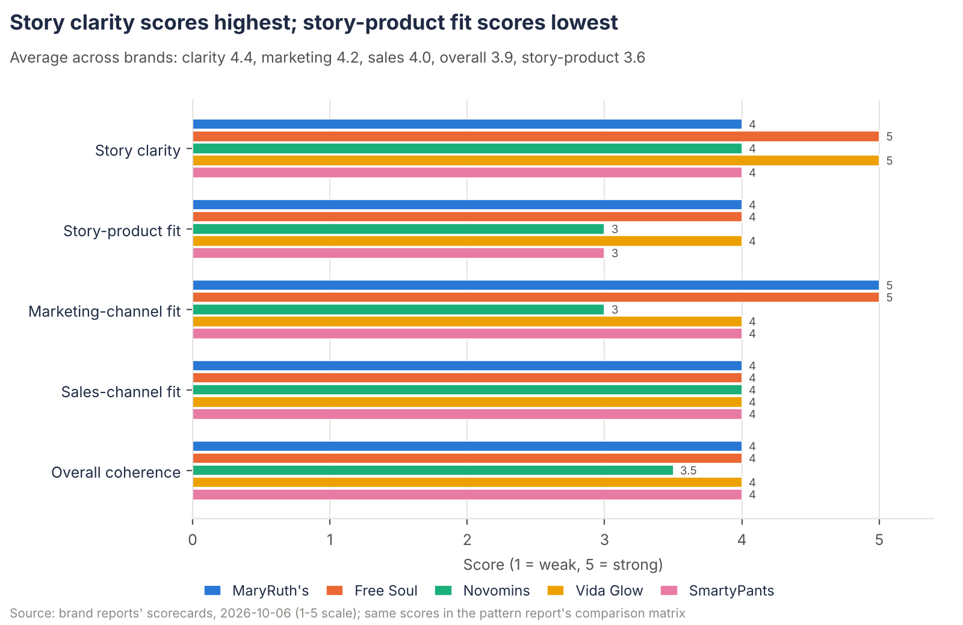
Figure 1: Brand scorecards on five criteria (1-5). Source: brand reports, 2026-10-06.
Table 1: Scorecard as a heat-map table (darker = higher). Novomins' overall score is 3.5.
Brand | Story clarity | Story-product fit | Marketing-channel fit | Sales-channel fit | Overall coherence
MaryRuth's | 4 | 4 | 5 | 4 | 4
Free Soul | 5 | 4 | 5 | 4 | 4
Novomins | 4 | 3 | 3 | 4 | 3.5
Vida Glow | 5 | 4 | 4 | 4 | 4
SmartyPants | 4 | 3 | 4 | 4 | 4

Reading the scores: story clarity is the highest-scoring criterion in the set (P1). Story-product fit is pulled down by range sprawl into trend SKUs (W1). Novomins scores 3 on marketing-channel fit because little social or creator activity was found, which the report treats as a gap rather than evidence of absence.

4. How the five brands compare
All five tell a founder-problem story, but their hero formats, price tiers and success measures differ widely.

Story, hero product and price
Table 2: Story type, hero product and price tier. Source: pattern report comparison matrix.
Brand | Story type | Hero product and format | Price tier
MaryRuth's (US, 2014) | Founder-problem: health coach whose clients could not take pills ("liquids until lunch"); family, clean, mother-founded | Liquid Morning Multivitamin (sugar-free liquid); 2025 growth hero Liquid Multivitamin + Hair Growth (Lustriva, biotin) | Mid-premium mass (about $31-54 per bottle; deep Amazon deals)
Free Soul (UK, 2017) | Founder-problem: mother and son after a family health scare; "female-first nutrition", how women feel, not how they look | Started with women's protein powders; viral hero Mango Greens powder (17m+ servings), 7-sachet retail packs | Masstige (about £15 multi, about £30 greens)
Novomins (UK, 2020) | Founder-problem: clinician founders (dentist, pharmacologist) saw unfinished, expired vitamin tubs; "make the healthy choice the obvious choice" | Gummy-only range (40+ SKUs); heroes Women's Bio-Balance, Collagen, Magnesium | Mass-premium (£19.99 per 60)
Vida Glow (Australia, 2014) | Founder-problem plus discovery: founder's hair loss, fixed with marine collagen found in Japan | Natural Marine Collagen 3g sachets (powder); later Pro Collagen+, Collagen Liquid Advance | Prestige beauty (US$50 per 30 sachets)
SmartyPants (US, 2010-11) | Founder-problem: parent founders could not find a vitamin that was premium, tasty and affordable; "all-in-one" | Kids multi + omega-3 + D3 gummy; later life-stage, organic, sugar-free gummies | Masstige list price, often value-tier paid price (Amazon deals)

Marketing and sales channels
Table 3: Lead marketing channel, first sales channel and channel expansion sequence. Source: pattern report.
Brand | Lead marketing channel | First sales channel | Channel expansion sequence
MaryRuth's (US, 2014) | Always-on creator programme (1,000+ creators) plus TikTok Shop 24/7 LIVE and Amazon ads | Founder's coaching practice and Amazon (2014-15) | Coaching practice > Amazon > DTC > US natural and mass retail from 2021 (Whole Foods, 800+ Target, Walmart, Costco, Ulta, CVS) > TikTok Shop from 2024; EU/UK grey-market only
Free Soul (UK, 2017) | TikTok organic, LIVE and TikTok Shop (first UK brand with two Super Brand Days, Oct 2024 and Jan 2026) | DTC Shopify with subscription, seeded by gym sampling | DTC > Amazon UK > TikTok Shop (by 2024) > UK mass retail 2024-25 (H&B, Boots, Tesco, Superdrug, Sainsbury's, Waitrose, Ocado) > Ireland; No US
Novomins (UK, 2020) | Trade and business press, reviews (Trustpilot 4.8, Amazon 5.0); social/creator activity not found | DTC and Amazon UK (2020) | DTC / Amazon > Chemist Warehouse Ireland (Nov 2022) > UK Boots, Superdrug, H&B (about 20,000 points claimed) > Chemist Warehouse Australia (550 stores, c. 2025) > DE/AT online; US thin
Vida Glow (Australia, 2014) | Celebrity launch events per market, founder Instagram, glossy beauty press | DTC Australia (2014) | DTC > AU health-food wholesale > China demand (2017) > 2021 global rebrand > US prestige (Revolve, Neiman Marcus, 2022) > UK prestige (Harrods, Space NK, Cult Beauty, Sephora UK) > Sephora AU; EU light
SmartyPants (US, 2010-11) | Amazon reviews and search ranking; mom influencers; Vitamin Angels 1-for-1 cause | DTC and Amazon (2010-11) | DTC / Amazon > Natural (Whole Foods, Sprouts) > Mass and club (30,000+ doors by 2018: Target, Walmart, Costco) > Unilever (2020) > Walmart-specific line (2023); No EU/UK

Success measures
Success is measured differently for each brand, so the figures cannot be ranked against each other.
Table 4: Success measure per brand, with the evidence tag from the brand report.
Brand | Success measure | Evidence
MaryRuth's (US, 2014) | Scale, profit and founder control: about $600M TTM revenue, about $125M EBITDA, at least $1.5B equity value (Forbes estimate, Aug 2026); family owns about 97% | REPORTED (estimate)
Free Soul (UK, 2017) | Founder-retained revenue growth: £35-42m (2025 to year to Apr 2026), Sunday Times 100 #10, reported EBITDA positive; one angel round | REPORTED
Novomins (UK, 2020) | Bootstrapped growth (£70k savings, Lloyds debt): £3.5m in about 2 years (company figure), Sunday Times 100 #27 (Jun 2026); current revenue not found | REPORTED
Vida Glow (Australia, 2014) | Units and footprint, mostly self-reported ("one unit every four seconds", "world's No.1 marine collagen brand"); revenue, funding, ownership not found | Self-reported
SmartyPants (US, 2010-11) | Exit: acquired by Unilever (Nov-Dec 2020, terms undisclosed); revenue estimates conflict ($52M 2017; "over $100M" pre-exit) | CONFIRMED (exit) / REPORTED (revenue)

5. What the successful brands share
Two traits (founder-problem origin, women as buyer) appear in all five brands; four more appear in four; none is rated above medium confidence.
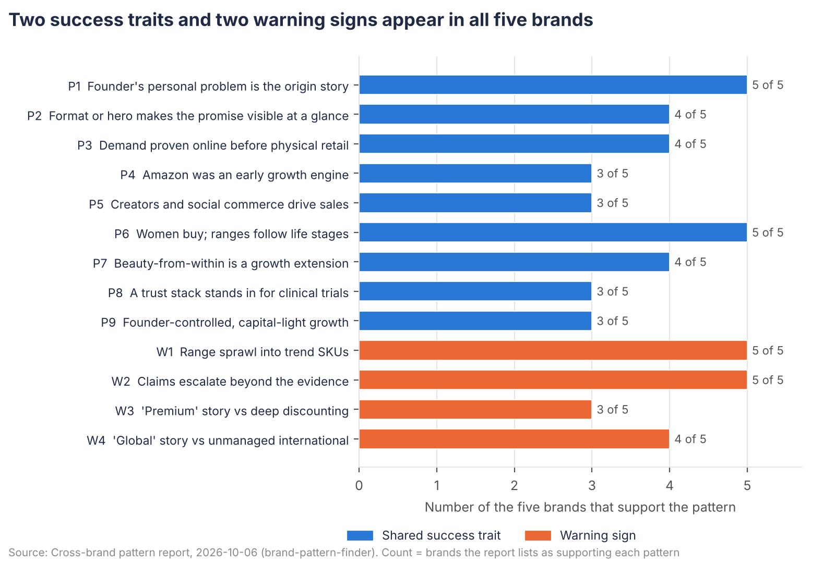
Figure 2: Number of brands supporting each pattern. Source: pattern report, 2026-10-06.
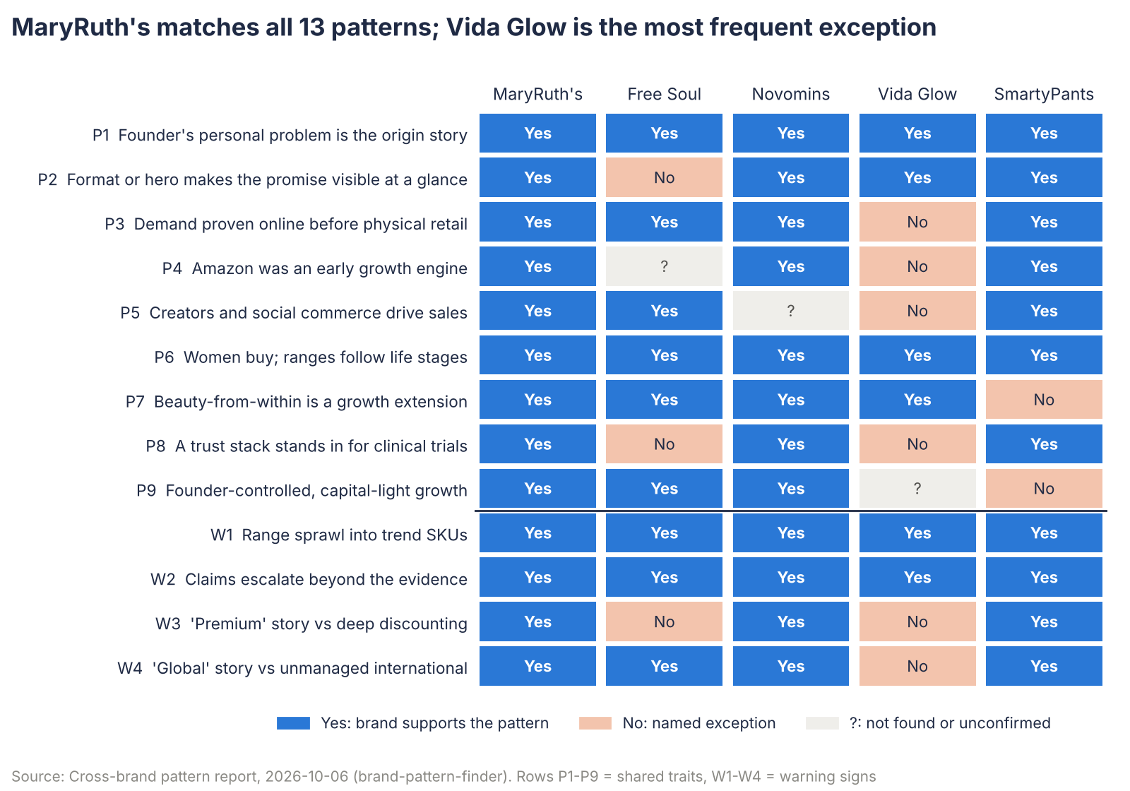
Figure 3: Pattern-by-brand matrix: which brands support each pattern, which are named exceptions, and where evidence was not found. Source: pattern report, 2026-10-06.

P1. Founder's personal problem is the origin story
Confidence: [MEDIUM]
Every brand opens with a first-person problem, and the story stays the same for years. Story-clarity scores are 4-5 for all five, the highest-scoring criterion in the set.
- Supporting: MaryRuth's, Free Soul, Novomins, Vida Glow, SmartyPants (5)
- Exceptions and caveats: None in the set. But this is near-universal in the category, including in brands that fail, so it is probably necessary rather than distinctive.

P2. Format or hero makes the promise visible at a glance
Confidence: [MEDIUM]
The product itself is the proof of the story, so it can be shown in a 15-second video, an Amazon thumbnail or a shelf facing without explanation.
- Supporting: MaryRuth's, Novomins, Vida Glow, SmartyPants (4)
- Exceptions and caveats: Free Soul differentiates by audience (women-first), not by format; Mango Greens is a flavour and positioning win within an existing format. Partial: Novomins has no single hero, it has a format applied to a 40+ SKU range.

P3. Demand proven online before physical retail
Confidence: [MEDIUM]
Each brand built evidence of demand (reviews, sales velocity, social virality) online, then used it to win retail listings. The gap between launch and major retail was 2-7 years.
- Supporting: MaryRuth's, Free Soul, Novomins, SmartyPants (4)
- Exceptions and caveats: Vida Glow moved into Australian health-food wholesale within two years of launch; its prestige retail push (2021-22) did follow years of DTC and China demand. Alternative explanation: this is the standard route for any small brand without retail funding.

P4. Amazon was an early growth engine
Confidence: [MEDIUM]
Amazon was a primary channel from the start; reviews and search rank served as both a sales channel and proof for retail buyers.
- Supporting: MaryRuth's, Novomins, SmartyPants (3)
- Exceptions and caveats: Vida Glow (Amazon presence unclear, may be a reseller). Free Soul has a 'strong Amazon channel' but its start date is not found. Weakened by heavy Amazon discounting at MaryRuth's and SmartyPants: rank may partly be bought.

P5. Creators and social commerce drive sales
Confidence: [MEDIUM]
The founder's voice is multiplied by creators who resemble the founder or buyer; in the two newest cases sales happen on the same platform (TikTok Shop). MaryRuth's was the #4 TikTok Shop seller in Jan 2025 with 1,000+ creators; Free Soul held two Super Brand Days; SmartyPants ran a mom-influencer programme (26M+ reach).
- Supporting: MaryRuth's, Free Soul, SmartyPants (3)
- Exceptions and caveats: Novomins: no social or creator evidence found (a gap, not evidence of absence). Vida Glow uses celebrities and founder Instagram instead. Timing explains part: TikTok Shop opened in the UK in 2021 and the US in late 2023.

P6. Women buy; ranges follow life stages
Confidence: [MEDIUM]
Every brand sells mainly to women, for themselves or for their families. Need-state naming maps onto how retail fixtures are organised.
- Supporting: MaryRuth's, Free Soul, Novomins, Vida Glow, SmartyPants (5)
- Exceptions and caveats: None, though SmartyPants and MaryRuth's address the mother as buyer for the family. Women are the majority supplement buyer, so this is close to a category trait.

P7. Beauty-from-within is a growth extension
Confidence: [MEDIUM]
Four brands started in or moved into hair, skin and collagen; in two cases that extension became a top seller (MaryRuth's Hair Growth liquid was the #2 TikTok Shop product in Jan 2025; Novomins Collagen gummies are a stated bestseller).
- Supporting: MaryRuth's, Free Soul, Novomins, Vida Glow (4)
- Exceptions and caveats: SmartyPants (no beauty line found). Beauty claims carry the highest claim risk (see W2).

P8. A trust stack stands in for clinical trials
Confidence: [MEDIUM]
None of the five has a published clinical trial on a finished product. Trust comes from certifications (B Corp, Clean Label Project, Vegan Society), contaminant testing, cause programmes, clinician founders or ingredient-supplier studies.
- Supporting: MaryRuth's, Novomins, SmartyPants (3)
- Exceptions and caveats: Free Soul (Informed Sport page exists, SKUs unconfirmed; relies on customer surveys); Vida Glow (no certifications found; relies on brand-run, unpublished studies and celebrity).

P9. Founder-controlled, capital-light growth
Confidence: [MEDIUM]
Brands grew on founder money, an angel or debt rather than venture equity: MaryRuth's bootstrapped to about $100M, took PE in 2021 and bought it back with debt in 2024; Free Soul self-funded with one angel round; Novomins used £70k savings plus Lloyds debt.
- Supporting: MaryRuth's, Free Soul, Novomins (3)
- Exceptions and caveats: SmartyPants (crowdfunding, then PE, then sale to Unilever). Vida Glow (funding not found). Profitable founders talk about bootstrapping more, so the trait may be over-reported among winners.

6. Different routes to the same result
The online-first start is shared, but the retail destination, the geography and the ownership outcome differ by brand.
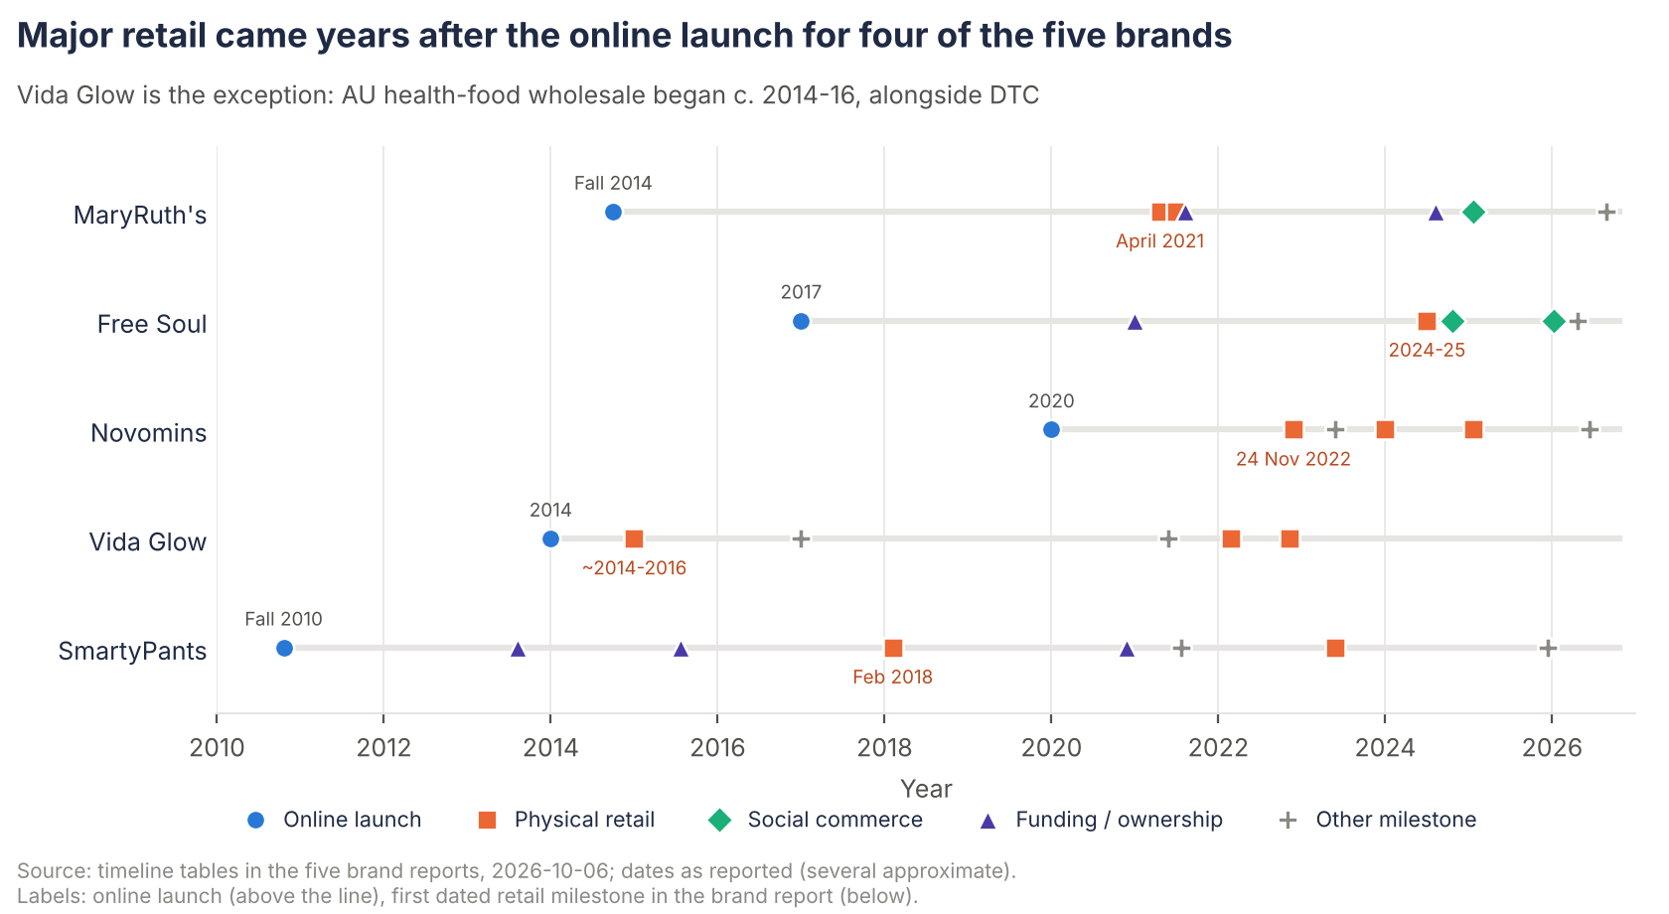
Figure 4: Dated milestones per brand (online launch, physical retail, social commerce, funding, other). Source: brand-report timelines, 2026-10-06.
Table 5: Sales-channel presence as listed in the pattern report. First = first sales channel; - = not listed (not proof of absence); No = stated as absent or unofficial.
Brand | DTC site | Amazon | TikTok Shop | Natural / health store | Mass, grocery, club | Pharmacy | Prestige beauty | Official international
MaryRuth's | Yes | First | Yes | Yes | Yes | Yes | - | No
Free Soul | First | Yes | Yes | Yes | Yes | Yes | - | Yes
Novomins | First | First | - | Yes | - | Yes | - | Yes
Vida Glow | First | - | - | Yes | - | - | Yes | Yes
SmartyPants | First | First | - | Yes | Yes | - | - | No

- MaryRuth's: Started in the founder's coaching practice and on Amazon; CVS for pharmacy; EU/UK grey-market only.
- Free Soul: H&B (health store), Boots and Superdrug (pharmacy), Tesco, Sainsbury's, Waitrose, Ocado (grocery); international = Ireland; no US.
- Novomins: H&B (health store); Boots, Superdrug and Chemist Warehouse (pharmacy); international = Ireland, Australia, DE/AT online; US thin.
- Vida Glow: AU health-food wholesale; Revolve, Neiman Marcus, Harrods, Space NK, Cult Beauty, Sephora; official in AU, US, UK; EU light. Amazon presence unclear.
- SmartyPants: Whole Foods and Sprouts (natural); Target, Walmart, Costco (30,000+ doors by 2018); no EU/UK.

P10. Deep home market vs early internationalisation
Confidence: [MEDIUM (HOME MARKET) / EARLY SIGNAL (INTERNATIONAL)]
Three brands scaled almost entirely in one home market and left international sales unmanaged: MaryRuth's (US), SmartyPants (US), Free Soul (UK plus Ireland). Two expanded early through a specific partner or demand pocket: Novomins (Ireland, Australia, Germany via Chemist Warehouse and online pharmacy), Vida Glow (China demand, then US and UK prestige).

P11. Retail destination differs: mass/club, pharmacy or prestige beauty
Confidence: [MEDIUM (MASS) / EARLY SIGNAL (PHARMACY, PRESTIGE)]
The online-first start is shared, but the retail destination matches price tier and story: mass and club for a family staple (MaryRuth's, SmartyPants, Free Soul's grocery listings), pharmacy and health-store fixtures for a need-state gummy block (Novomins), prestige beauty for a US$50 sachet sold as beauty (Vida Glow).

P12. Success by exit vs founder-retained scale
Confidence: [EARLY SIGNAL (EXIT ROUTE)]
SmartyPants succeeded by selling to a strategic buyer; MaryRuth's, Free Soul and Novomins by growing while keeping control. Vida Glow is unknown.

7. Warning signs: where story and product or channel pulled apart
Range sprawl and claims escalation appear in all five brands; only SmartyPants has faced legal action so far.

W1. Range sprawl into trend SKUs
Confidence: [MEDIUM (COMMON) / EARLY SIGNAL (HARM)]
300+ SKUs vs 'make wellness simple' (MaryRuth's); Sculpt and 'glow' vs 'how women feel, not how they look' (Free Soul); NAD+, shilajit and libido vs 'established science' (Novomins); acne, sleep, topicals and a tea collaboration vs 'the marine collagen brand' (Vida Glow); sleep, fiber and pet SKUs vs 'all-in-one' (SmartyPants).
- Brands affected: MaryRuth's, Free Soul, Novomins, Vida Glow, SmartyPants (5)
- What followed / exceptions: No commercial damage documented yet for any brand. At SmartyPants, sprawl coincides with a post-acquisition period in which it is not named among Unilever's growth leaders (weak signal).

W2. Claims escalate beyond the evidence
Confidence: [MEDIUM (COMMON) / EARLY SIGNAL (CONSEQUENCES)]
'Clinically shown' hair growth on an ingredient-supplier study plus 10,000 mcg biotin (MaryRuth's); survey percentages and 'hormone balance' (Free Soul); disease-adjacent naming such as 'Endo' (Novomins); 'clinically proven' and 'world's No.1' without published data (Vida Glow); 'Complete' and fiber claims (SmartyPants).
- Brands affected: MaryRuth's, Free Soul, Novomins, Vida Glow, SmartyPants (5)
- What followed / exceptions: SmartyPants faces two class actions (2021 'Complete', 2025 fiber). MaryRuth's had a 2021 infant probiotic recall (safety, not claims). For the other three, no ASA, FTC or court action was found.

W3. 'Premium' story vs deep discounting
Confidence: [MEDIUM (OCCURS) / EFFECT NOT SHOWN]
List prices say premium while the price paid is often value-tier: MaryRuth's (50% off list on Amazon), SmartyPants (120 ct for $5-9 with coupons), Novomins (H&B 15-20% multibuys).
- Brands affected: MaryRuth's, Novomins, SmartyPants (3)
- What followed / exceptions: Vida Glow (only 15% subscription discount found); Free Soul (25% first-order affiliate offers, not persistent). No measured effect on margin; MaryRuth's still reports about 20% EBITDA (Forbes estimate).

W4. 'Global' story vs unmanaged international
Confidence: [MEDIUM]
MaryRuth's (grey-market EU/UK), Free Soul ('4 million women globally', no US), Novomins (US push announced c. 2022, by 2026 only a third-party Amazon listing), SmartyPants (no EU/UK under Unilever).
- Brands affected: MaryRuth's, Free Soul, Novomins, SmartyPants (4)
- What followed / exceptions: Vida Glow (official presence in AU, US, UK; EU light).

8. Distinct success models
Four models explain the five successes; only the mass engine rests on more than one brand.
Table 6: Success models, the brands that fit and confidence. Source: pattern report.
Model | How it works | Brands that fit | Confidence
Marketplace-and-creator mass engine | Visibly different format or positioning, proven on Amazon and/or DTC, scaled through creators and social commerce, then turned into mass, grocery and club listings. | MaryRuth's (US), Free Soul (UK), SmartyPants (US, pre-TikTok version with Amazon and mom influencers) | Medium (3 brands)
Pharmacy-shelf need-state block | One format (gummy) across many need-state SKUs at one price point, giving retailers a ready-made fixture block; clinician founders and B Corp reassure pharmacy buyers; growth funded by debt and retail partners across countries. | Novomins (partly SmartyPants in its life-stage mass listings) | Early signal (1 brand)
Prestige-beauty placement | Supplement sold as beauty: single-ingredient hero, giftable sachets, celebrity launch per market, beauty-retail doors at prestige prices. | Vida Glow | Early signal (1 brand)
Strategic exit | Staged capital (crowdfund, PE, growth equity) matched to staged channels, building a scaled US asset for a strategic buyer. | SmartyPants | Early signal (1 brand)

Alternative explanations
Timing, category growth, funding, founder networks and uneven measurement each explain part of the result, so the patterns above are correlations, not proven causes.
- Timing. TikTok Shop launched in the UK (2021) and US (late 2023) with heavy platform support for early brands; MaryRuth's and Free Soul were early and visible. SmartyPants rode the 2010-2020 rise of gummies and clean label. Vida Glow launched in 2014 as ingestible collagen was emerging, and caught Chinese cross-border demand in 2017. Each brand's main channel or format was growing fast when it entered.
- Category growth. Gummy supplements grew 7.9% in 2025 (New Hope, US data, cited in the Novomins report); collagen, greens and women's health have been fast-growing need-states. Without Spate category data, brand share gain cannot be separated from category growth for any of the five.
- Funding. MaryRuth's took PE in 2021 at the point it entered mass retail; SmartyPants raised repeatedly before 30,000 doors; Novomins used Lloyds debt for international retail. Capital access, not strategy alone, may explain the speed of retail rollout.
- Founder audience and networks. MaryRuth's started with the founder's coaching clients; Vida Glow used the founders' celebrity and fashion network (Rita Ora, later a Typebea co-founder); Free Soul used diaspora and business press. These are hard to copy and could explain early traction as well as any strategy.
- Measurement. The success evidence is uneven: Forbes estimates (MaryRuth's), company-stated and press-ranked figures (Free Soul, Novomins), unverified unit claims (Vida Glow) and an undisclosed exit price (SmartyPants). Some 'successes' may be smaller than presented.

9. Implications for a new brand or product launch
A new launch should pick a self-explaining format, prove demand online, choose one retail destination and write claims for the strictest market from day one.
1. Choose a format or hero that proves the promise by itself. If the product needs a paragraph to explain why it is different, it will not travel on TikTok, Amazon or a retail shelf (P2). Free Soul shows the alternative is a sharp audience position, but it still needed a viral hero (Mango Greens) to break out.
2. Plan the online-proof-then-retail sequence on purpose. Collect reviews, velocity and repeat data in DTC and Amazon first, then take them to retail buyers (P3, P4). Design trial-size sachets or small packs for retail entry price points, as Free Soul and Vida Glow did (early signal).
3. Match the retail destination to price and story. Mass and club for a family staple, pharmacy for need-state blocks, prestige beauty for a beauty-priced ingestible (P11). Mixing them (Vida Glow at Harrods and at Nasty Gal) creates price and positioning tension.
4. Build the trust stack early. With no finished-product clinical trial, certifications, testing and clinician or educator voices did the reassuring for three brands (P8). For a nutricosmetics launch, a finished-product study would be a real differentiator, since none of the five has one.
5. Write claims for the strictest target market from day one. All five brands' growth claims would need rework under EFSA/GB rules (W2). A brand planning UK/EU sales should build heroes around authorised nutrient claims (e.g. biotin, zinc, vitamin C for skin, hair and collagen formation) rather than adapting US claims later.
6. Set rules for line extension. Every brand drifted into trend SKUs (W1). A simple test: does the new SKU make the founding promise more tangible, or does it borrow a trend? Beauty extensions worked commercially for four brands (P7) but carry the highest claim risk.
7. Treat social commerce as a time-limited window. Early entry to a new platform (TikTok Shop) gave outsized reach to two brands; that advantage shrinks as the platform fills. A new brand should look for the next under-served channel rather than assume the same result.

10. Open questions and gaps
Full-page evidence, channel revenue mix and failed comparison brands are the three gaps that would most change confidence in these patterns.

Evidence quality
- All five brand reports rest on search-result snippets because direct fetches were blocked. Rerunning brand-analyst with full page access (brand sites, Forbes, Lloyds, The Grocer, Sunday Times 100, Unilever releases) would let several patterns move from medium to high confidence. Priorities: Free Soul and Novomins revenue (Companies House, Sunday Times 100 entries), Vida Glow revenue and ownership (ASIC), SmartyPants post-2020 performance.
- Channel revenue mix (Amazon vs DTC vs retail vs TikTok Shop) was not found for any brand. This is the single biggest gap for P4 and P5.
- Novomins social and creator activity was not found; checking it would confirm or break P5.

Failed or stalled brands to add (the set has none)
These are candidates from general category knowledge, not from the brand reports; their status should be checked by a brand-analyst run before use.
- Care/of: US personalised vitamin packs, Bayer-owned; reported closed in 2024: DTC subscription model with no retail-first proof; a test of P3.
- Sugarbear: US influencer-led hair gummies: celebrity and influencer demand without a trust stack; a test of P5 and P8.
- Goli Nutrition: US ACV gummies, viral c. 2020, reported financial difficulties later: a format-led hero that rode a trend; a test of P2 and of the timing explanation.
- SmartyPants after 2020: Already in the set: a possible stall under corporate ownership, which could be tested with Unilever segment data and Spate brand search.
- Comparable survivors: Bears With Benefits and Vitabiotics gummies (UK pharmacy model, alongside Novomins), Absolute Collagen or The Beauty Chef (prestige ingestible beauty, alongside Vida Glow), Women's Best (women-first, alongside Free Soul), Olly (US gummy mass, alongside SmartyPants).

Recommended Spate category searches
Adding these exports to inputs/category/ would let the next run separate brand success from category growth.
Table 7: Recommended Spate searches. Source: pattern report.
Spate search | Markets | What it would test
"gummy vitamins" / "gummies supplements" | US, UK, AU | Category tailwind behind SmartyPants and Novomins (P2, timing)
"liquid vitamins" / "liquid multivitamin" | US, UK | Whether MaryRuth's grew with or ahead of its format
"marine collagen" / "collagen supplement" / "liquid collagen" / "collagen sachets" | US, UK, AU | Collagen tailwind for Vida Glow, Novomins and Free Soul; format shifts
"greens powder" / "mango greens" | UK, US | Whether Free Soul rode or created the greens wave
"supplements for women" / "women's multivitamin" / "perimenopause supplements" | UK, US | Size and growth of the women's need-state all five target (P6)
"hair growth supplement" / "biotin" / "hair vitamins" | US, UK | The beauty-extension pattern (P7)
"creatine for women" / "magnesium gummies" / "magnesium glycinate" | UK, US | Trend SKUs and the timing of entry
"kids vitamins" / "prenatal vitamins" | US, UK | Life-stage demand behind MaryRuth's and SmartyPants
Brand-name searches for all five brands, side by side | US, UK, AU, DE | Relative brand trajectories; whether TikTok Shop events, retail listings and celebrity launches lifted search; whether SmartyPants stalled after 2020

11. Sources
Every finding comes from the 2026-10-06 pattern report; the brand reports supplied only scorecard scores and milestone dates for charts.
- reports/patterns/supplement-brands-2026-10-06.md: Cross-brand pattern report (brand-pattern-finder), run 2026-10-06. The source of every finding in this document.
- reports/brands/maryruths.md: MaryRuth's brand strategy report, 2026-10-06. Scorecard and timeline dates.
- reports/brands/freesoul.md: Free Soul brand strategy report, 2026-10-06. Scorecard and timeline dates.
- reports/brands/novomins.md: Novomins brand strategy report, 2026-10-06. Scorecard and timeline dates.
- reports/brands/vida-glow.md: Vida Glow brand strategy report, 2026-10-06. Scorecard and timeline dates.
- reports/brands/smartypants.md: SmartyPants brand strategy report, 2026-10-06. Scorecard and timeline dates.
Each brand report lists its own primary sources (for example Forbes, BusinessWire, TikTok Newsroom, Lloyds, The Grocer, NutraIngredients, Unilever and Morgan Stanley releases, retailer listings), all accessed 2026-10-06, mostly through search-result extracts. No Spate export was in inputs/category/ and Revuze was not used. No new research was done for these deliverables.

