**Search Robot**

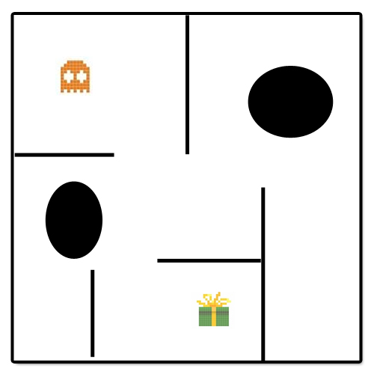

**Design Model**

**Roboter**

**Camille Zanni (zannc2)**

**Simon Gfeller (gfels4)**

# Inhalt

Inhalt 2

Revision History 3

Domain Model 3

Ziel suchen 4

SD 4

Design Class 4

# Revision History

|  |  |  |  |
| --- | --- | --- | --- |
| Version | Date | Description | Author |
| First Draft | 11. November 2013 | First Draft | gfels4/zannc2 |
| Last Draft | 7. Januar 2014 | Last Draft | gfels4/zannc2 |

# Domain Model

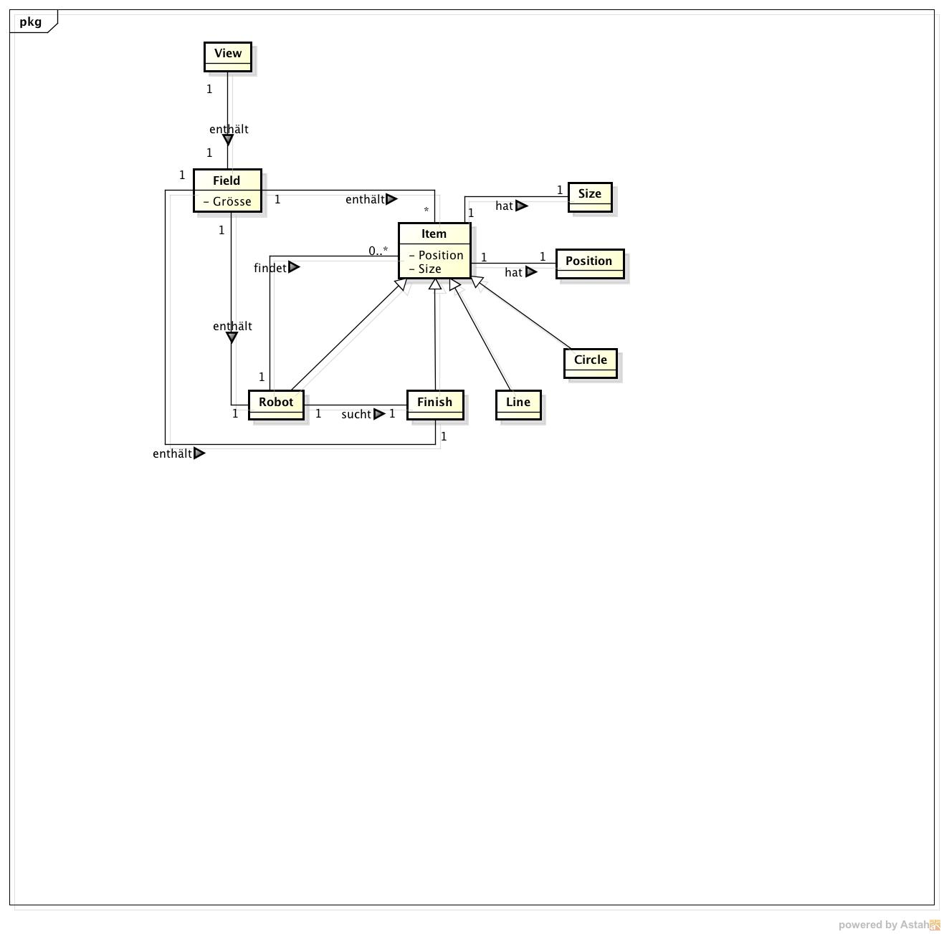

# Ziel suchen

## SD

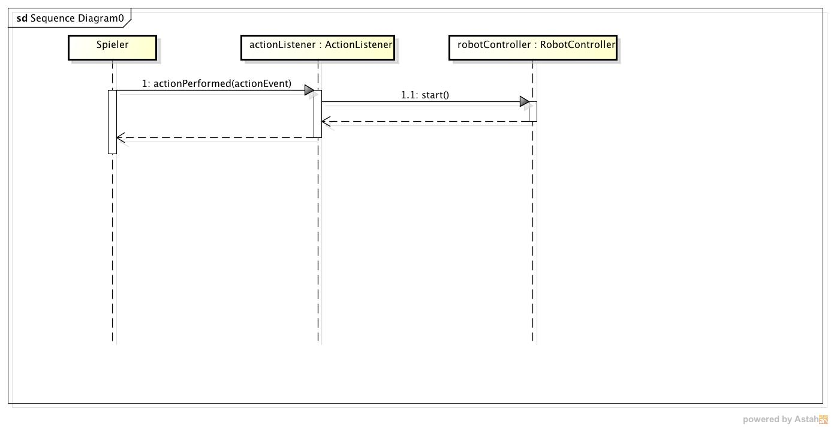

## Design Class

