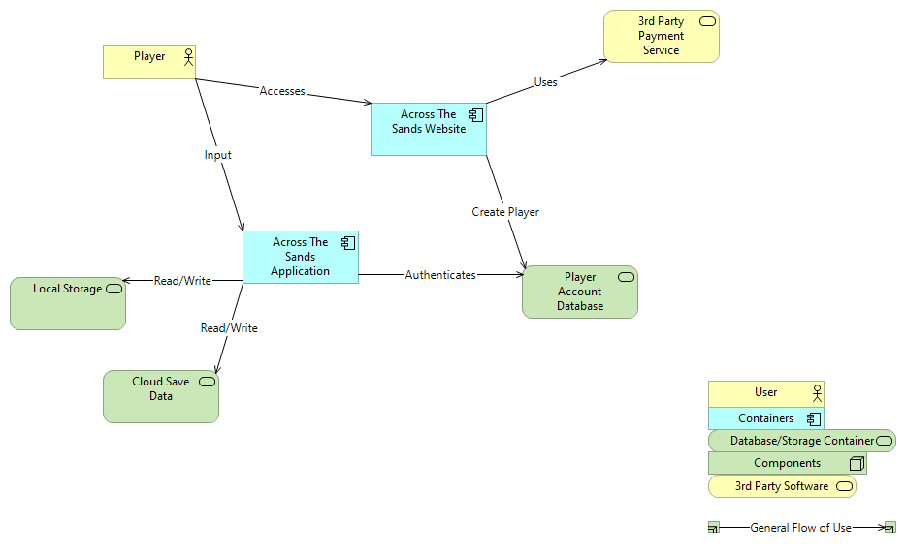

This first image is a high-level view of the entire system that would be needed for my game. We have the purchase of the game on the website with the creation of a Player Account. Then when launching the game itself it is authenticating the player in the player database and checking both the local storage and cloud save data comparing the two for loading any previous saved game data.

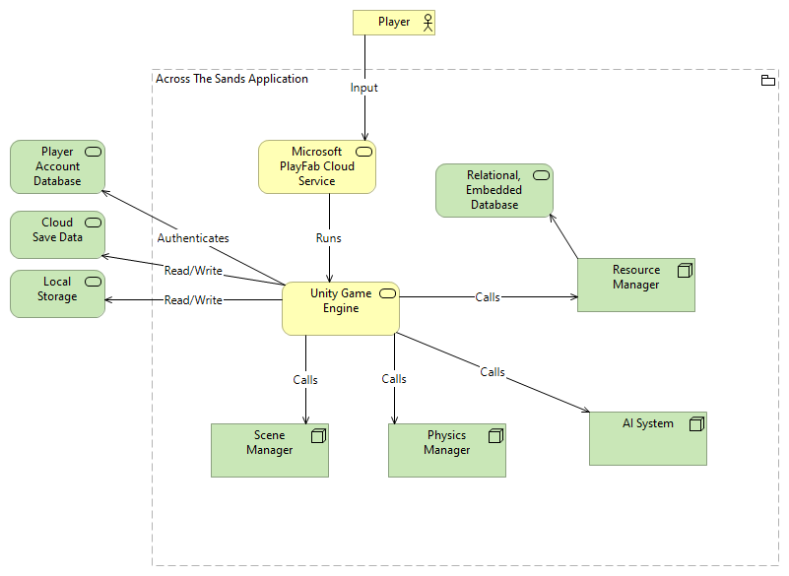

This is the container level of the game application itself. The game is being hosted on the PlayFab Cloud servers. Creating a new instance with the Unity Game Engine being the main force behind the running of the game. It is authenticating the player’s account, and retrieving/writing any save data to local storage and cloud storage. Based on the player’s input it is calling the various components inside it like the Scene Manager, Physics Manager, the AI System for the NPCs, and the Resource Manager. The Resource Manager is in charge of reading from the SQLLite relational database that is embedded within the system.