# DNS Diagram:

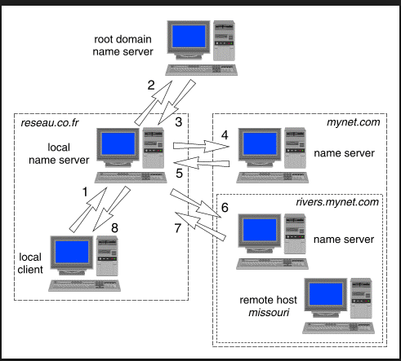

<http://uw714doc.sco.com/en/NET_tcpip/dnsN.main.html> (see steps)

**Obtaining an IP address by iterative query**

The steps taken to resolve *missouri.rivers.mynet.com* to its IP address are:

1. The local client asks the local name server for the IP address of *missouri.rivers.mynet.com*.
2. The local name server does not KNOW the IP address of *missouri.rivers.mynet.com*. It also does not know the IP address of the name servers for *rivers.mynet.com* or *mynet.com* so it asks a root name server for the IP address of *missouri.rivers.mynet.com*.
3. The root name server does not know the IP address of *missouri.rivers.mynet.com*, but it does know the IP address of the name server for *mynet.com* so it tells this to the local name server.
4. The local name server asks *mynet.com*'s name server for the IP address of *missouri.rivers.mynet.com*.
5. *mynet.com*'s name server do not know the IP address of *missouri.rivers.mynet.com*, but it does know the IP address of the nameserver for *rivers.mynet.com* so it tells this to the local name server.
6. The local name server asks *rivers.mynet.com*'s name server for the IP address of *missouri.rivers.mynet.com*.
7. *rivers.mynet.com*'s name server is authoritative for its zone so it can supply the IP address of *missouri.rivers.mynet.com*
8. The local name server passes the IP address of *missouri.rivers.mynet.com* to the local client.

The first time that the local client asks for the IP address of *missouri.rivers.mynet.com*, it receives the ``authoritative'' answer that the local name server discovered from the name server for *rivers.mynet.com*. Local clients that subsequently ask for the *missouri*'s IP address will probably receive the ``non-authoritative'' answer stored in the cache of the local name server. This will disappear from the cache when it has been there at least as long as the time-to-live value that was returned along with the data, or when the **named** daemon is next stopped.

## Questions

In the above diagram:

* Is Cloudflare the Name Server (Missouri in the above example) in our case?
  + Is DSN Server the same that Name Server?

[ROS] yes, Cloudflare will be your name server. And yes, Name Server is how “authoritative” (see below) DNS servers are called on the domain registration page.

* “Authoritative for its Zone”. Does it mean that Cloudflare will be the new authoritative entity for our servers? (in CentrextIT)?

[ROS] Yes, but your statement is incorrect. Cloudflare will be authoritative for your Domain name. The location of the servers is irrelevant

* What is the Registrar? And where is in our case? (is the registrar in the above diagram?)

[ROS] The registrar is an authority that tells the entity number 2 (root domain server) in the diagram above who is the authoritative DNS (i.e.: cloudflare). I don’t know where you have it, “finding this out” was one of the tasks you were charged with

* What is the NS Record? And where is it? (in the registrar?)

[ROS] the NS record is the IP of the name server and it is defined in the registrar

* It seems that each domain have different owners:
  + Registered owner: I guess this is Seth
  + Technical owner: Now, I have created a new email address [domains@omaorg.org](mailto:domains@omaorg.org).
    - My initial intention is to set this distribution for the registered owner and Technical owner. Is this the correct approach?

[ROS] yes, that would work

* + Administrator owner? What is this and who is playing this role in our case?

[ROS] no idea, this is administrative stuff, a generic email like the one above will do.

* When we should lower the TTL, in preparation for these changes?

[ROS] No, we can change that 3 days before the migration