What is a Variational Autoencoder?
A Variational Autoencoder (VAE) is a powerful generative model that learns to create new data (like images, text, or sounds) by understanding the underlying patterns in training data. Think of it as a sophisticated machine that not only compresses information but also learns to generate brand new, realistic examples similar to what it has seen before.^{[1]}
Real-world analogy: Imagine you're learning to draw faces. First, you study many faces and notice patterns (eye position, nose shape, etc.). Then, you develop a mental "code" for faces. Later, you can create entirely new, realistic faces by sampling from your learned code—this is essentially what a VAE does.^{[1]}
Why Do We Need VAEs?
Traditional autoencoders have a fundamental limitation: they create disconnected clusters in their latent space (the compressed representation), making it difficult to generate smooth, realistic new samples.^{[1]}
Concrete example with MNIST digits: When a regular autoencoder learns to encode handwritten digits, it might place all "3"s in one cluster and all "8"s in another distant cluster. The problem? The space between clusters is empty and meaningless. If you randomly sample from this space, you might get garbage instead of a realistic digit.^{[1]}
VAEs solve this by ensuring the latent space is continuous and well-structured, allowing smooth interpolation and meaningful new sample generation.^{[1]}
Core Components of a VAE
1. Encoder (Recognition Network)
The encoder compresses input data x into a latent representation z. Unlike traditional autoencoders, the VAE encoder outputs parameters of a probability distribution rather than a fixed code.^{[1]}
Mathematical representation:
$$q_{λ}(z|x)=N(z;μ,\text{diag}(σ^{2}))$$
where the encoder neural network outputs:
$$(μ,log⁡σ)={\text{EncoderNN}}_{λ}(x)$$
Concrete example:
- Input: A 28×28 MNIST digit image (784 pixels)
- Encoder: Neural network with layers 784 → 400 → 20^{[1]}
- Output: Two 20-dimensional vectors representing mean ($μ$) and standard deviation ($σ$)
- Instead of a single fixed encoding, we get a probability distribution from which we can sample^{[1]}
2. Latent Space
The latent space z is a lower-dimensional representation where each point corresponds to some data characteristics. For VAEs, this is typically assumed to follow a standard normal distribution $p(z)=N(0,I)$.^{[1]}
Concrete example with faces:
- A 2D latent space might encode: z₁ = face orientation (azimuth), z₂ = hair length
- Point (0, 0) might represent a frontal face with medium hair
- Point (2, -1) might represent a face turned right with short hair
- You can smoothly interpolate between any two points to create realistic intermediate faces^{[1]}
3. Decoder (Generative Network)
The decoder reconstructs data from the latent representation. It learns the mapping:^{[1]}
$$p_{θ}(x|z)$$
Concrete example:
- Input: 20-dimensional latent vector z
- Decoder: Neural network with layers 20 → 400 → 784^{[1]}
- Output: Reconstructed 28×28 image with pixel values between 0 and 1^{[1]}
4. Reparameterization Trick
This crucial technique allows gradients to flow through the random sampling process during training.^{[1]}
The problem: If we directly sample $z∼q_{λ}(z|x)$, we can't backpropagate through a random sampling operation.
The solution: Rewrite sampling as:
$$z=μ+σ⊙ϵ, ϵ∼N(0,I)$$
Concrete example:
- Encoder outputs: $μ=[1.2,-0.5]$, $σ=[0.3,0.4]$
- Sample random noise: $ϵ=[0.8,-1.1]$ from standard normal
- Compute latent code: $z=[1.2,-0.5]+[0.3,0.4]⊙[0.8,-1.1]=[1.44,-0.94]$
- Now gradients can flow through $μ$ and $σ$^{[1]}

The VAE Loss Function: ELBO
The Evidence Lower Bound (ELBO) is the objective function VAEs maximize:^{[1]}
$$\text{ELBO}=E_{q_{λ}(z|x)}[log⁡p_{θ}(x|z)]-D_{KL}(q_{λ}(z|x)||p(z))$$
This has two components:
Reconstruction Loss (First term)
Measures how well the decoder reconstructs the input.^{[1]}
Concrete example:
- Original MNIST digit: pixel values [0, 1, 0.9, 0.2, ...]
- Reconstructed digit: pixel values [0.1, 0.95, 0.85, 0.25, ...]
- Loss penalizes the difference between these^{[1]}
KL Divergence (Second term)
Ensures the learned distribution $q_{λ}(z|x)$ stays close to the prior $p(z)=N(0,I)$^{[1]}.
Concrete example:
- If encoder outputs $μ=[5.0,-3.0]$, $σ=[2.0,1.5]$, this is very different from $N(0,I)$
- KL divergence will be large, penalizing this encoding
- This forces the encoder to use the latent space efficiently and prevents overfitting^{[1]}
The trade-off:
- High reconstruction weight → detailed but clustered encodings (like regular autoencoders)
- High KL weight → smooth, continuous latent space but blurrier reconstructions
- VAEs balance both for optimal results^{[1]}
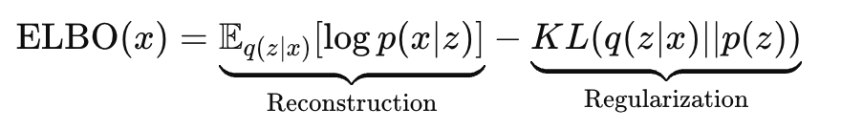

If x is binary → Bernoulli likelihood
Use cross-entropy loss

If x is real → Gaussian likelihood
Use mean squared error (MSE)

Training a VAE: Step-by-Step Process
For each training iteration:
- Forward pass through encoder:
  - Input image x → Encoder → outputs $μ$, $σ$
- Sample latent code:
  - Sample $ϵ∼N(0,I)$
  - Compute $z=μ+σ⊙ϵ$
- Forward pass through decoder:
  - Latent code z → Decoder → reconstructed image $\overset{ˆ}{x}$
- Compute loss:
  - Reconstruction loss: compare $x$ and $\overset{ˆ}{x}$
  - KL divergence: measure distance from $q_{λ}(z|x)$ to $N(0,I)$
  - Total loss = -ELBO
- Backpropagation:
  - Compute gradients using the reparameterization trick^{[1]}
  - Update encoder parameters $λ$ and decoder parameters $θ$^{[1]}
Concrete MNIST example:
- Dataset: 60,000 handwritten digits
- Architecture: 784 → 400 → 20 (encoder), 20 → 400 → 784 (decoder)^{[1]}
- Training: Adam optimizer, learning rate 0.001, batch size 128, 10 epochs^{[1]}
- Results: After training, the model can reconstruct digits and generate new realistic digits^{[1]}
Generating New Data with a Trained VAE
Once trained, generating new samples is straightforward:
- Sample from prior: $z∼N(0,I)$
- Decode: $x_{\text{new}}=\text{Decoder}(z)$^{[1]}
Concrete example:
- Sample random 20D vector: z = [0.5, -0.3, 1.2, ..., -0.8]
- Feed through decoder
- Output: A brand new, never-before-seen handwritten digit!^{[1]}

Advanced VAE Variants
β-VAE (Beta-VAE)
Modifies the loss function to emphasize disentangled representations:^{[1]}
$$\text{Loss}=E_{q_{λ}(z|x)}[log⁡p_{θ}(x|z)]-β⋅D_{KL}(q_{λ}(z|x)||p(z))$$
where $β>1$.^{[1]}
What is disentanglement? Each dimension of z controls one independent factor of variation.^{[1]}
Concrete face example:
- Regular VAE ($β=1$): Changing z₁ might simultaneously change face orientation AND presence of glasses—entangled^{[1]}
- β-VAE ($β=250$): z₁ controls ONLY face orientation, z₂ controls ONLY glasses, z₃ controls ONLY hair length—disentangled^{[1]}
- Benefit: Better interpretability and control over generation^{[1]}
Conditional VAE (CVAE)
Allows controlled generation by conditioning on labels:^{[1]}
$$\text{ELBO}=E_{q_{λ}(z|x,c)}[log⁡p_{θ}(x|z,c)]-D_{KL}(q_{λ}(z|x,c)||p(z|c))$$
Concrete example:
- Want to generate only the digit "2"? Set condition c = "2"
- Encoder and decoder both receive this condition
- Result: Generated samples will all be variations of "2"^{[1]}
Importance Weighted Autoencoder (IWAE)
Uses multiple samples (k samples) for tighter bounds on the likelihood:^{[1]}
Key insight: More samples → better approximation → higher quality generations
Concrete example:
- Standard VAE (k=1): Sample one z per data point
- IWAE (k=5): Sample five z values, weight them by importance
- Result: Improved reconstruction quality and tighter bound on log-likelihood^{[1]}
Practical Tips for Beginners
- Start simple: Use 2D latent space for visualization and understanding
- Monitor both losses: Track reconstruction and KL divergence separately during training^{[1]}
- Experiment with β: Try different values to find the right balance for your application
- Visualize latent space: Plot encodings to verify continuity and structure
- Check generations: Periodically sample and decode to verify model quality^{[1]}
Common Pitfalls
- Posterior collapse: KL divergence goes to zero, decoder ignores latent code
  - Solution: Increase reconstruction loss weight or use β < 1 initially
- Blurry reconstructions: Overly strong KL regularization
  - Solution: Decrease β or use more expressive decoders
- Mode collapse: Model generates limited variety
  - Solution: Increase latent dimensionality or use IWAE^{[1]}

10. Why VAE Gives Smooth Latent Space
Because:
- q(z|x) is forced toward N(0, I)
- each datapoint contributes a KL term
- all points "share" the same prior
Therefore:
- latent space no longer forms disjoint clusters
- sampling from N(0,I) gives meaningful outputs
- linear interpolation in latent space → smooth morphing
between digits/faces/etc.

12. Comparing VAE vs Autoencoder vs GAN
Model | Type | Pros | Cons
Autoencoder | deterministic | simple, fast | bad generative model
VAE | probabilistic | smooth latent space, stable training | blurry outputs
GAN | implicit generative | sharp images | unstable, mode collapse

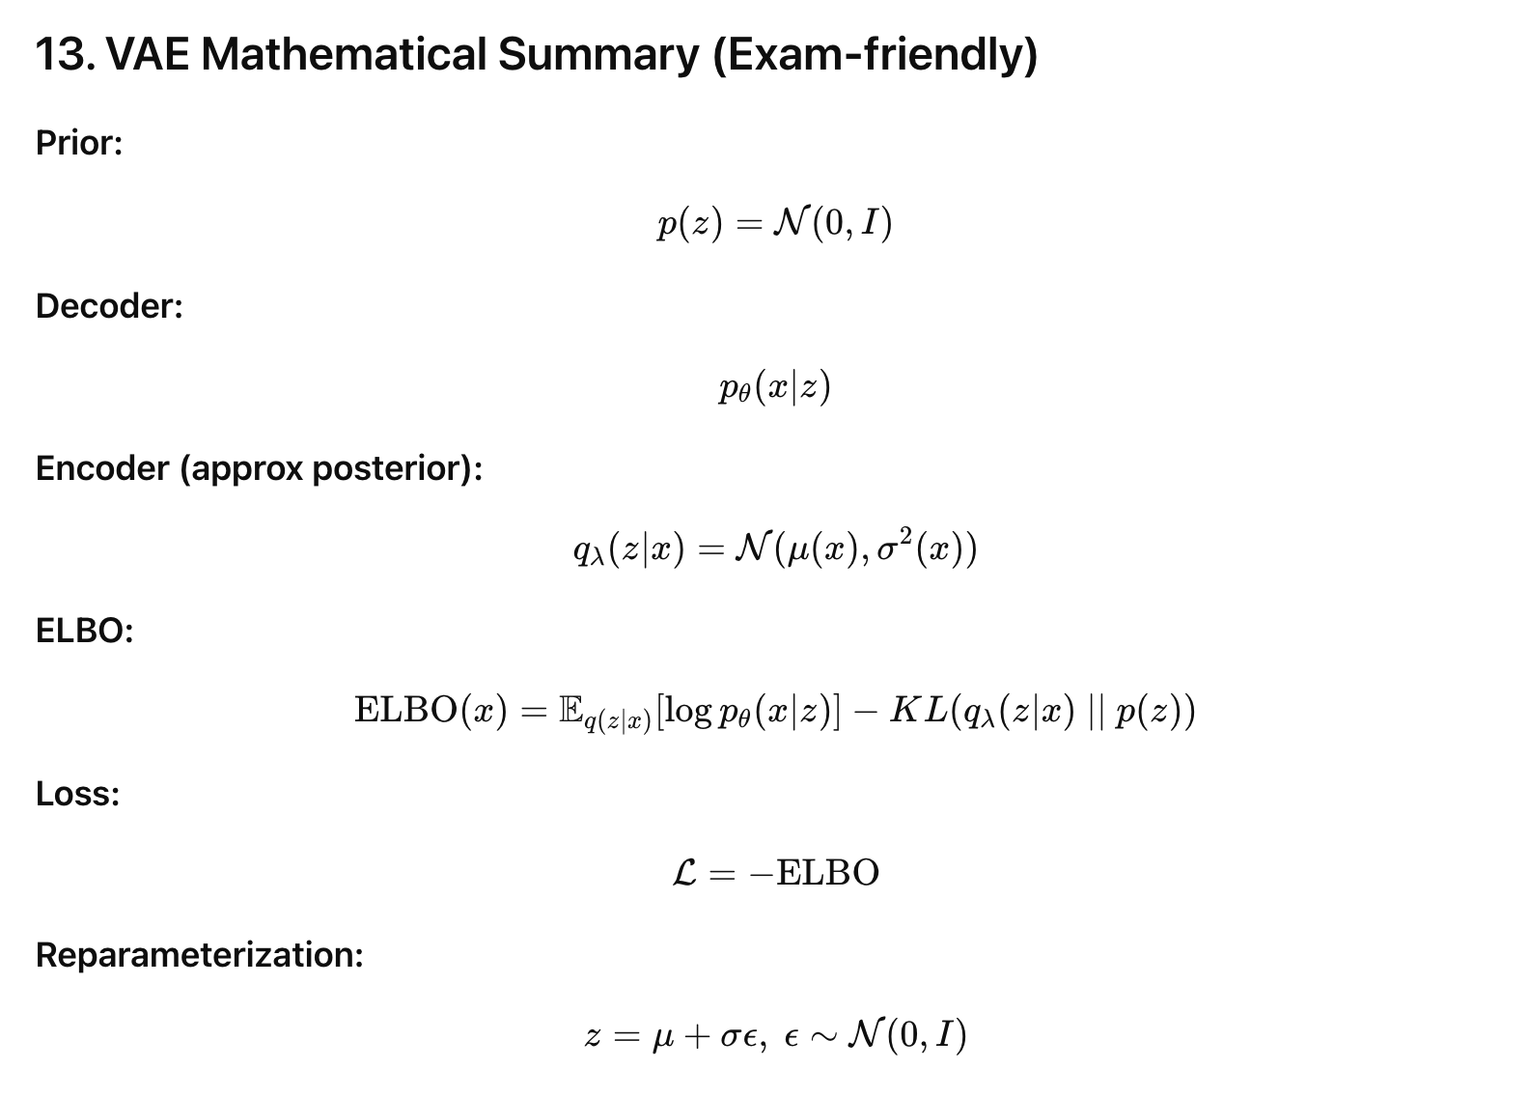

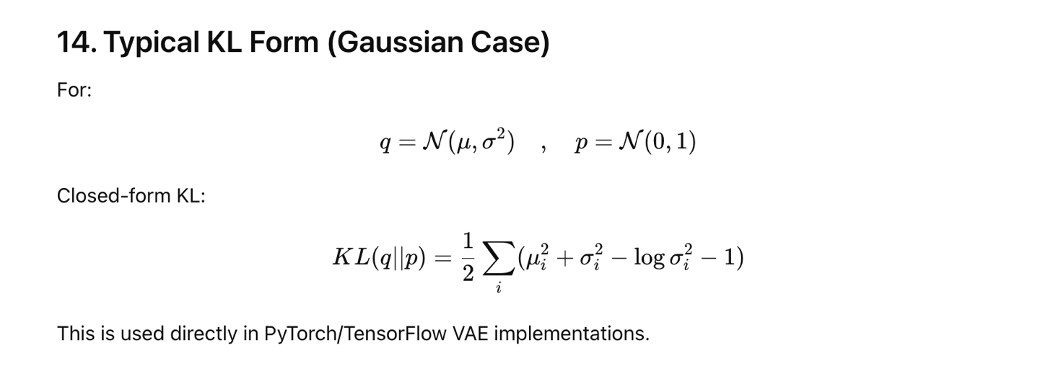

15. VAE Strengths and Weaknesses

✔ Strengths
- stable training
- interpretable latent variables
- easy to sample
- principled probabilistic model
- works well on smooth data (MNIST, faces, etc.)

✘ Weaknesses
- blurry images
- suffers from KL collapse sometimes (posterior collapse)
- decoder may ignore latent variables if too strong

Summary
VAEs are powerful generative models that learn structured, continuous latent representations enabling smooth interpolation and high-quality sample generation. By balancing reconstruction accuracy with distributional constraints through the ELBO objective, VAEs create meaningful compressed representations of complex data. The reparameterization trick makes training feasible through standard backpropagation, while variants like β-VAE and CVAE extend capabilities for specialized applications.^{[1]}

