Owl

Owl is a custom framework to make easier the document's development using OpenXML. Enjoy it!

Title

# Heading 1

## Heading 2

### Heading 3

Normal text.

Normal text.

Normal text.

Normal text.

None style text.

Warning to this point. Pay attention!

Title

# Heading 1

## Heading 2

### Heading 3

Normal text.

None style text.

Warning to this point. Pay attention!

Title

# Heading 1

## Heading 2

### Heading 3

### Normal text.

None style text.

Warning to this point. Pay attention!

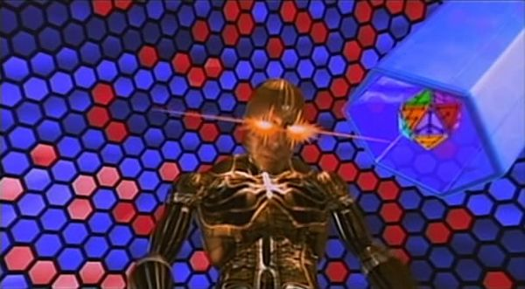







Title

# Heading 1

## Heading 2

### Heading 3

Normal text.

Normal text.

Normal text.

Normal text.

None style text.

Warning to this point. Pay attention!

### \begin{document} $x = \frac{-b \pm \sqrt{b^2 - 4ac}}{2a}$ \end{document} -----

$x=\frac{-b±\sqrt{b^{2}-4ac}}{2a}$

### \begin{document} $\sqrt{x^2+1}$ \end{document} -----

$\sqrt{x^{2}+1}$

### \begin{document} $\[ \sum_{i=1}^{\infty} \frac{1}{n^s} = \prod_p \frac{ 1} { 1 - p ^{ -s} } \]$ \end{document} -----

$\sum_{i=1}^{∞}{}\frac{1}{n^{s}}={}_{p}\frac{1}{1-p^{-s}}$

\begin{document} $F_u = γ_t γ_c \sum_{}^{}R_{af, i} A_{af, i}$ \end{document} -----

$F_{u}=γ_{t}γ_{c}\sum{}R_{af,i}A_{af,i}$

### R(a,b)

**************************

**************************