AODC

An OpenDocument Converter

Autor: Lars Behrmann, 18. December 2005

Content:

- About AODC
  - Which format input and output formats are supported?
- How to use AODC?
- FAQ

1. About AODC

AODC -An OpenDocument Converter should giveWindows user the possibilty to view resp. edit files in the OpenDocument format even if they haven't an Office Suite with OpenDocument support installed. Up to now, AODC is a first developer release so don't be disappointed if something wouldn't be converted in the same style as it's displayed e.g. in OpenOffice.

1.1 Which format input and output formats are supported?
Until now, the only possible input format is the OpenDocument text document format and the only possible output format is HTML. Why HTML? Because all users will have the possibilty to display a HTML file. The generated HTML file is optimized to be displayed in all popular browsers and MS Word (Version >= 2002) in the same formatting.

2. How to use AODC?

The usage of AODC is as simple as possible. Simply start the application by double clicking the .exe as usual. Now you should see the following:

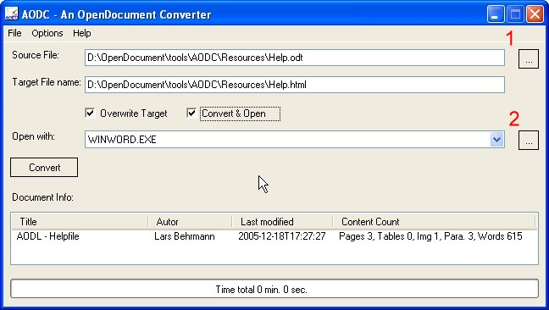
Picture 1: AODC Gui

The next step you should do is to choose a file to convert. To do that click button 1.. In the following Open File Dialog you navigate to a OpenDocument text document. After you selected a file to convert AODC will suggest to save the converted file with the same name in the HTML format. Normally you should accept this. The checkbox “Overwrite Target” can be used to overwrite a target file. If you later convert a document using the same target file the second time you have to set it to true, otherwise the document wouldn't be overwritten. Now you can choose an application which should display the converted file. This could be any application that could edit or display a HTML file resp. both. You can add the applications by using button 2. The choosed applications will be stored in the AODC settings for later usage. At least you can convert your file. You can choose between two different ways. If you use the button “Convert” the file will only be converted. If you choose button “Convert Only” the file will be converted and opened with the choosed application. That's it.

3. FAQ

What will happen if the document contains Header and Footer?

Up to now, they won't be converted. For the next version it's planned to add this via an AODC programm setting. But nonetheless, there's no opportunity to use Header and Footer within HTML documents, so that the implementation only will be to write the Header at the top and the Footer at the end of the document.

Which document content would be converted?

In principle all document content will be converted that could be handled with the underlying AODL (An OpenDocument Library) library which offer the complete OpenDocument document. handling. This .net library is also written by my own and is published under the LGPL. For further information and all supported document content visit the homepage. http://aodl.sourceforge.net . At least i could say that nearly all popular content will be converted.

How to create a Word document?

As usual you first have to choose which OpenDocument file should be converted. Next, if not already done, you have to add the Winword.exe file to your “Open with” file list and select it. Now, you can click the “Convert” button. After the OpenDocument file is converted into a HTML file this will be loaded into Word. At least you choose File -> Save as within Winword and save the file as Word document. That's it.

