PSLE Math: Topic Marks 2016-2025
A decade of PSLE Mathematics papers, broken down by syllabus topic. Unlike Science, the bank holds individual yearly papers for every year 2016-2025 (10 papers, 100 marks each), so the analysis below is a clean 10-paper sample with no aggregated buckets.

Window totals
- Papers: 10
- Total marks: 1000
- Paper-equivalents: 10.00
- Average marks per paper across all topics: 100.0
Topic merge: 'Basic Math Operations' and 'Basic math operations' (a casing duplicate in the bank) are summed into a single row.

Top 5 topics — Avg marks per year
Marks per paper-equivalent (i.e. the expected weight on a single PSLE Math paper) averaged across the decade.

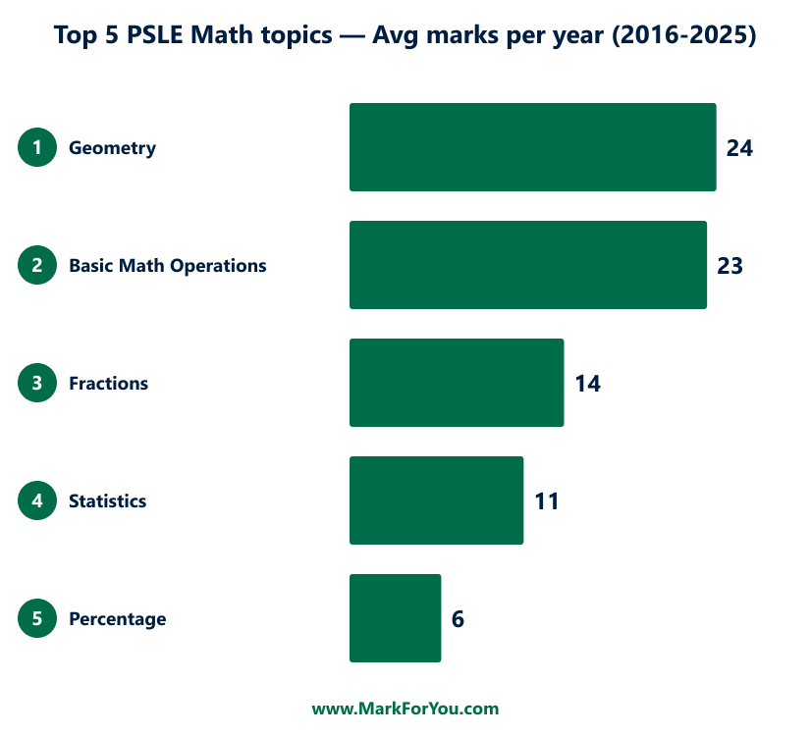

10-year ranking — every topic
Top 5 highlighted in green. /year is marks per paper-equivalent; share % is the topic's slice of total marks; OEQ share is the percentage of the topic's marks that come from open-ended (non-MCQ) questions.

Rank | Topic | Total marks | Marks / year | Share % | MCQ : OEQ | OEQ share
1 | Geometry | 236 | 23.6 | 23.6% | 54:182 | 77%
2 | Basic Math Operations | 230 | 23.0 | 23.0% | 55:175 | 76%
3 | Fractions | 138 | 13.8 | 13.8% | 38:100 | 72%
4 | Statistics | 112 | 11.2 | 11.2% | 16:96 | 86%
5 | Percentage | 59 | 5.9 | 5.9% | 7:52 | 88%
6 | Ratio | 56 | 5.6 | 5.6% | 8:48 | 86%
7 | Algebra | 49 | 4.9 | 4.9% | 12:37 | 76%
8 | Area and circumference of circle | 48 | 4.8 | 4.8% | 4:44 | 92%
9 | Volume of cube and cuboid | 48 | 4.8 | 4.8% | 3:45 | 94%
10 | Time | 11 | 1.1 | 1.1% | 2:9 | 82%
11 | Volume measurement | 7 | 0.7 | 0.7% | 0:7 | 100%
12 | (Untagged) | 6 | 0.6 | 0.6% | 1:5 | 83%

The top 5 together account for 78% of total PSLE Math marks across the decade. Drilling these five well covers the bulk of the test weight.

Year-by-year variations
Marks per topic per year. An em-dash (—) means zero marks on that topic that year. Avg/yr is the 10-year mean per topic.

Topic | 2016 | 2017 | 2018 | 2019 | 2020 | 2021 | 2022 | 2023 | 2024 | 2025 | Avg/yr
Geometry | 17 | 19 | 20 | 25 | 30 | 24 | 23 | 28 | 25 | 25 | 23.6
Basic Math Operations | 36 | 35 | 25 | 27 | 10 | 19 | 19 | 25 | 27 | 7 | 23.0
Fractions | 17 | 14 | 14 | 11 | 16 | 15 | 14 | 13 | 12 | 12 | 13.8
Statistics | 6 | 6 | 14 | 14 | 12 | 11 | 12 | 10 | 14 | 13 | 11.2
Percentage | 6 | 8 | 5 | 4 | 6 | 5 | 4 | 10 | 6 | 5 | 5.9
Ratio | 4 | 2 | 6 | 5 | 8 | 8 | 8 | 2 | 4 | 9 | 5.6
Algebra | 4 | 4 | 5 | 5 | 5 | 3 | 5 | 4 | 3 | 11 | 4.9
Area and circumference of circle | 4 | 6 | 4 | 5 | 4 | 6 | 4 | 4 | 6 | 5 | 4.8
Volume of cube and cuboid | 6 | 6 | 7 | 4 | — | 2 | 11 | 4 | 3 | 5 | 4.8
Time | — | — | — | — | 8 | — | — | — | — | 3 | 1.1
Volume measurement | — | — | — | — | — | 7 | — | — | — | — | 0.7
(Untagged) | — | — | — | — | 1 | — | — | — | — | 5 | 0.6

Observations
- Geometry: averages 23.6 marks/year, trending up (early-5 avg 22.2 → recent-5 avg 25.0). Range 17–30 marks (low in 2016, peak in 2020).
- Basic Math Operations: averages 23.0 marks/year, trending down (early-5 avg 26.6 → recent-5 avg 19.4). Range 7–36 marks (low in 2025, peak in 2016).
- Fractions: averages 13.8 marks/year, trending down (early-5 avg 14.4 → recent-5 avg 13.2). Range 11–17 marks (low in 2019, peak in 2016).
- Statistics: averages 11.2 marks/year, trending up (early-5 avg 10.4 → recent-5 avg 12.0). Range 6–14 marks (low in 2016, peak in 2018).
- Percentage: averages 5.9 marks/year, stable (early-5 avg 5.8 → recent-5 avg 6.0). Range 4–10 marks (low in 2019, peak in 2023).

Paper inventory
Year | Paper | Questions | Marks
2016 | PSLE Mathematics 2016 | 48 | 100
2017 | PSLE Mathematics 2017 | 48 | 100
2018 | PSLE Mathematics 2018 | 47 | 100
2019 | PSLE Mathematics 2019 | 47 | 100
2020 | PSLE math 2020 | 47 | 100
2021 | PSLE Math 2021 | 47 | 100
2022 | PSLE 2022 MATHEMATICS | 47 | 100
2023 | PSLE Mathematics 2023 | 47 | 100
2024 | PSLE Mathematics 2024 | 47 | 100
2025 | PSLE Mathematics 2025 | 47 | 100

Reproducibility
Run: npx tsx scripts/_psle-math-10y-docx.ts

