PSLE Science: 10-Year Topic-Marks Average (2016-2025)
A decade of PSLE Science papers — every topic's average marks per paper-equivalent. The 2022-2024 papers exist in the bank as four aggregated question-shape buckets (Life Sci MCQ + Life Sci OEQ + Physical Sci MCQ + Physical Sci OEQ); they are summed and added to the 2016-2021 and 2025 yearly papers as ~3 paper-equivalents of recent content.

Window totals
- Papers + buckets: 11 inputs
- Total marks tagged: 997
- Paper-equivalents: 9.97 (across 2016-2025)
- Average marks per paper-equivalent across all topics: 100.0

Top 5 topics — 10-year average
Marks per paper-equivalent (i.e. expected marks on a single PSLE Science paper) averaged across the decade. Total marks across all 10 paper-equivalents shown below each bar.

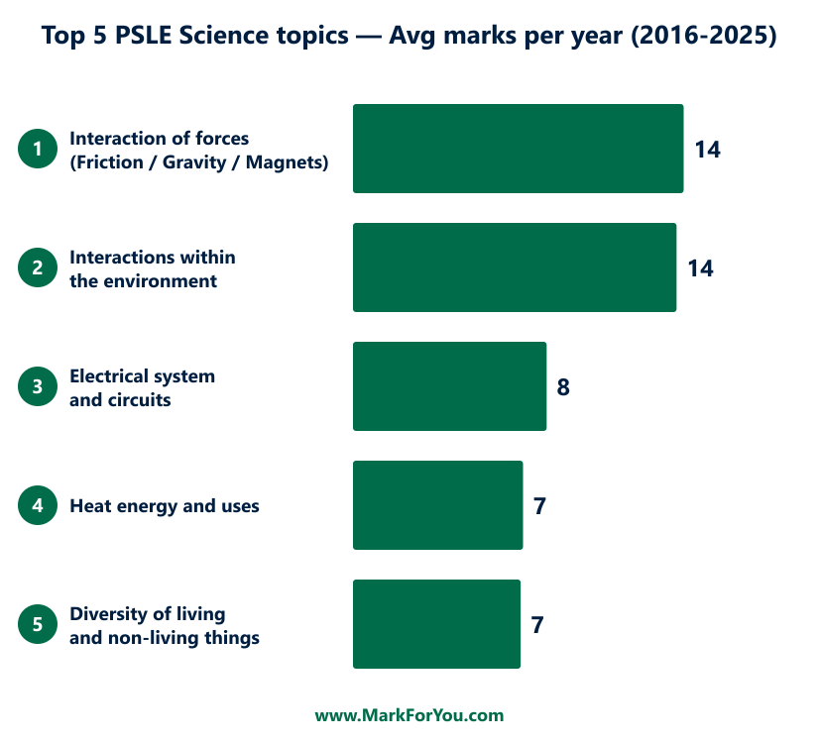

Full ranking — every topic, 10-year average
Top 5 highlighted in green. /paper-equiv lets you read the topic's expected weight on a single paper; share % is its slice of the 10-year total; OEQ share is the percentage of the topic's marks that come from open-ended (non-MCQ) questions.

Rank | Topic | Total marks | Marks / paper-equiv | Share % | MCQ : OEQ | OEQ share
1 | Interaction of forces (Friction / Gravity / Magnets) | 140 | 14.0 | 14.0% | 76:64 | 46%
2 | Interactions within the environment | 137 | 13.7 | 13.7% | 58:79 | 58%
3 | Electrical system and circuits | 82 | 8.2 | 8.2% | 38:44 | 54%
4 | Heat energy and uses | 72 | 7.2 | 7.2% | 30:42 | 58%
5 | Diversity of living and non-living things | 71 | 7.1 | 7.1% | 64:7 | 10%
6 | Reproduction in plants and animals | 62 | 6.2 | 6.2% | 38:24 | 39%
7 | Energy conversion | 57 | 5.7 | 5.7% | 28:29 | 51%
8 | Cycles in matter | 54 | 5.4 | 5.4% | 42:12 | 22%
9 | Life cycles in plants and animals | 53 | 5.3 | 5.3% | 30:23 | 43%
10 | Photosynthesis | 52 | 5.2 | 5.2% | 20:32 | 62%
11 | Plant parts and functions | 50 | 5.0 | 5.0% | 28:22 | 44%
12 | Human respiratory and circulatory systems | 40 | 4.0 | 4.0% | 22:18 | 45%
13 | Water cycle, evaporation, condensation | 39 | 3.9 | 3.9% | 20:19 | 49%
14 | Diversity of materials | 36 | 3.6 | 3.6% | 30:6 | 17%
15 | Human digestive system | 24 | 2.4 | 2.4% | 14:10 | 42%
16 | Light energy and uses | 22 | 2.2 | 2.2% | 22:0 | 0%
17 | (Untagged) | 4 | 0.4 | 0.4% | 4:0 | 0%
18 | Plant respiratory and circulatory systems | 2 | 0.2 | 0.2% | 2:0 | 0%

Reading the table
- #1 Interaction of forces (Friction/Gravity/Magnets) at 14.0 marks/paper — the single biggest topic across the decade, on average bigger even than Interactions in the long run. Steady year-on-year.
- #2 Interactions within the environment at 13.7 marks/paper — bumpy across years but still the second-biggest in aggregate. Most volatile of the top 5.
- #3 Electrical system and circuits at 8.2 marks/paper — gentle climb across the decade.
- #4 Heat energy and uses at 7.2 marks/paper — quiet but consistent.
- #5 Diversity of living and non-living things at 7.1 marks/paper — MCQ-dominated (10% OEQ share).

The top 5 together account for 50% of total PSLE Science marks across the decade. Drilling these five well should cover the bulk of the test weight.

Data caveat
The 2022-2024 entries in the bank are not three separate yearly papers. They are four aggregated buckets (Life Science MCQ + Life Science OEQ + Physical Science MCQ + Physical Science OEQ) totalling 297 marks ≈ 3 paper-equivalents. The 10-year average above treats them as a single 3-paper-equivalent contribution to the decade total — equivalent to weighting each individual 2016-2021 / 2025 paper equally and the 2022-2024 bucket as three papers' worth.

Paper inventory
Period | Paper | Questions | Marks
2016 | PSLE Science 2016 | 45 | 100
2017 | PSLE SCIENCE 2017 | 42 | 100
2018 | PSLE Science 2018 | 41 | 100
2019 | PSLE Science 2019 | 41 | 100
2020 | PSLE Science 2020 | 42 | 100
2021 | PSLE Science 2021 | 42 | 100
2022-2024 | PSLE Life Science MCQ 2022-2024 | 42 | 84
2022-2024 | PSLE Life Science OEQ 2022-2024 | 20 | 63
2022-2024 | PSLE Physical Science MCQ 2022-2024 | 42 | 84
2022-2024 | PSLE Physical science OEQ 2022-2024 | 18 | 66
2025 | PSLE Science 2025 | 42 | 100

Reproducibility
Run: npx tsx scripts/_psle-science-10y-docx.ts

