PSLE Science Topic Marks: 2021-2025 vs 2016-2020
A five-year-window analysis of PSLE Science by topic. Numbers come from the master examPaper bank, normalised to marks per paper-equivalent so both windows compare on the same scale.

Data caveat — read first
The bank does not hold individual 2022, 2023, 2024 PSLE Science papers. Instead it has four aggregated buckets, all dated 2022 in the bank but representing 2022-2024 combined:
- PSLE Life Science MCQ 2022-2024 (42 questions, 84 marks)
- PSLE Life Science OEQ 2022-2024 (20 questions, 63 marks)
- PSLE Physical Science MCQ 2022-2024 (42 questions, 84 marks)
- PSLE Physical science OEQ 2022-2024 (18 questions, 66 marks)
Combined: 297 marks across 122 questions — equivalent to roughly 3 papers' worth of content (each real PSLE Science paper is 100 marks). The 2021-2025 window below sums these four buckets along with the actual 2021 paper and the actual 2025 paper, giving 497 marks total — 4.97 paper-equivalents.
Earlier analyses that kept only ONE of the four buckets after de-duplication were silently dropping ~75% of the 2022-2024 evidence and produced misleading conclusions on OEQ-heavy topics. The numbers below sum all four.

Paper inventory
Period | Paper | Questions | Marks
2016 | PSLE Science 2016 | 45 | 100
2017 | PSLE SCIENCE 2017 | 42 | 100
2018 | PSLE Science 2018 | 41 | 100
2019 | PSLE Science 2019 | 41 | 100
2020 | PSLE Science 2020 | 42 | 100
2021 | PSLE Science 2021 | 42 | 100
2022-2024 | PSLE Life Science MCQ 2022-2024 | 42 | 84
2022-2024 | PSLE Life Science OEQ 2022-2024 | 20 | 63
2022-2024 | PSLE Physical Science MCQ 2022-2024 | 42 | 84
2022-2024 | PSLE Physical science OEQ 2022-2024 | 18 | 66
2025 | PSLE Science 2025 | 42 | 100

Window totals
- 2016-2020: 5 actual papers, 500 marks, 5.00 paper-equivalents
- 2021-2025: 6 inputs (2021 + 4 buckets + 2025), 497 marks, 4.97 paper-equivalents

Topic marks at a glance
Clustered bar chart, sorted descending by 2021-2025 marks per paper-equivalent. Pale green = 2016-2020; solid green = 2021-2025. The two bars per topic make the year-on-year shift easy to scan.

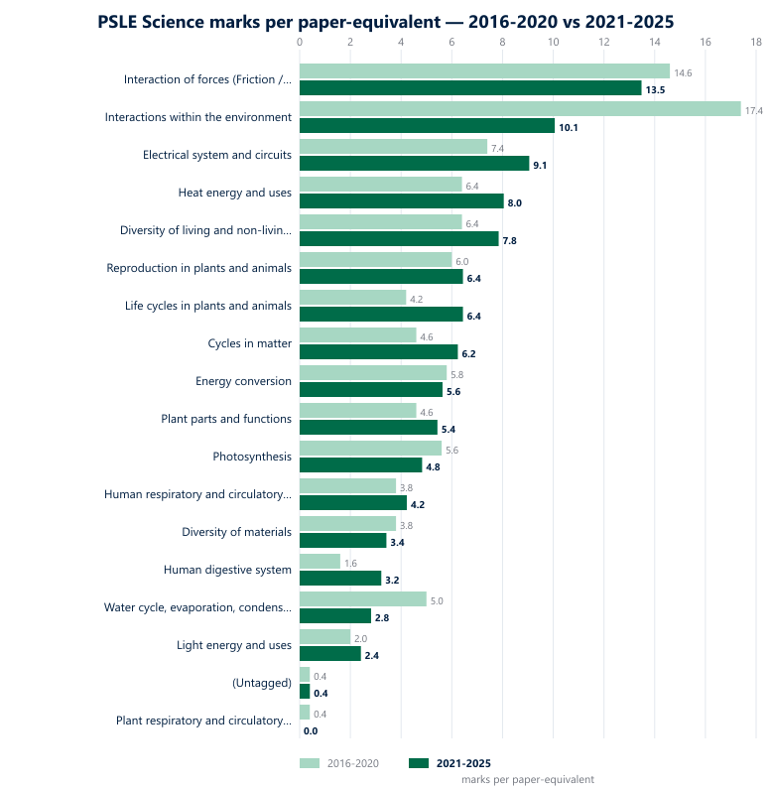

2021-2025 single-window breakdown
Ranked by absolute marks. /paper is marks normalised by paper-equivalents; share % is the topic's slice of the 497-mark window total; OEQ share is the percentage of that topic's marks that come from open-ended (non-MCQ) questions.

Topic | Marks | /paper | Share % | MCQ marks | OEQ marks | OEQ share
Interaction of forces (Friction / Gravity / Magnets) | 67 | 13.5 | 13.5% | 38 | 29 | 43%
Interactions within the environment | 50 | 10.1 | 10.1% | 20 | 30 | 60%
Electrical system and circuits | 45 | 9.1 | 9.1% | 20 | 25 | 56%
Heat energy and uses | 40 | 8.0 | 8.0% | 16 | 24 | 60%
Diversity of living and non-living things | 39 | 7.8 | 7.8% | 36 | 3 | 8%
Reproduction in plants and animals | 32 | 6.4 | 6.4% | 20 | 12 | 38%
Life cycles in plants and animals | 32 | 6.4 | 6.4% | 20 | 12 | 38%
Cycles in matter | 31 | 6.2 | 6.2% | 22 | 9 | 29%
Energy conversion | 28 | 5.6 | 5.6% | 14 | 14 | 50%
Plant parts and functions | 27 | 5.4 | 5.4% | 14 | 13 | 48%
Photosynthesis | 24 | 4.8 | 4.8% | 8 | 16 | 67%
Human respiratory and circulatory systems | 21 | 4.2 | 4.2% | 10 | 11 | 52%
Diversity of materials | 17 | 3.4 | 3.4% | 14 | 3 | 18%
Human digestive system | 16 | 3.2 | 3.2% | 6 | 10 | 63%
Water cycle, evaporation, condensation | 14 | 2.8 | 2.8% | 8 | 6 | 43%
Light energy and uses | 12 | 2.4 | 2.4% | 12 | 0 | 0%
(Untagged) | 2 | 0.4 | 0.4% | 2 | 0 | 0%

2016-2020 baseline vs 2021-2025 comparison
Ranked by combined 10-year marks. Δ / paper is the change in marks per paper-equivalent between windows; green up-arrows = gained ≥1 m/p, red down-arrows = lost ≥1 m/p.

Topic | 2016-2020 marks | /paper | MCQ : OEQ | 2021-2025 marks | /paper | MCQ : OEQ | Δ / paper
Interaction of forces (Friction / Gravity / Magnets) | 73 | 14.6 | 38:35 | 67 | 13.5 | 38:29 | -1.1 ↓
Interactions within the environment | 87 | 17.4 | 38:49 | 50 | 10.1 | 20:30 | -7.3 ↓
Electrical system and circuits | 37 | 7.4 | 18:19 | 45 | 9.1 | 20:25 | +1.7 ↑
Heat energy and uses | 32 | 6.4 | 14:18 | 40 | 8.0 | 16:24 | +1.6 ↑
Diversity of living and non-living things | 32 | 6.4 | 28:4 | 39 | 7.8 | 36:3 | +1.4 ↑
Reproduction in plants and animals | 30 | 6.0 | 18:12 | 32 | 6.4 | 20:12 | +0.4
Life cycles in plants and animals | 21 | 4.2 | 10:11 | 32 | 6.4 | 20:12 | +2.2 ↑
Cycles in matter | 23 | 4.6 | 20:3 | 31 | 6.2 | 22:9 | +1.6 ↑
Energy conversion | 29 | 5.8 | 14:15 | 28 | 5.6 | 14:14 | -0.2
Plant parts and functions | 23 | 4.6 | 14:9 | 27 | 5.4 | 14:13 | +0.8
Photosynthesis | 28 | 5.6 | 12:16 | 24 | 4.8 | 8:16 | -0.8
Human respiratory and circulatory systems | 19 | 3.8 | 12:7 | 21 | 4.2 | 10:11 | +0.4
Diversity of materials | 19 | 3.8 | 16:3 | 17 | 3.4 | 14:3 | -0.4
Human digestive system | 8 | 1.6 | 8:0 | 16 | 3.2 | 6:10 | +1.6 ↑
Water cycle, evaporation, condensation | 25 | 5.0 | 12:13 | 14 | 2.8 | 8:6 | -2.2 ↓
Light energy and uses | 10 | 2.0 | 10:0 | 12 | 2.4 | 12:0 | +0.4
(Untagged) | 2 | 0.4 | 2:0 | 2 | 0.4 | 2:0 | +0.0
Plant respiratory and circulatory systems | 2 | 0.4 | 2:0 | 0 | 0.0 | 0:0 | -0.4

Five biggest gainers (per paper-equivalent)
- Life cycles in plants and animals: 4.2 → 6.4 marks/paper (Δ +2.2)
- Electrical system and circuits: 7.4 → 9.1 marks/paper (Δ +1.7)
- Heat energy and uses: 6.4 → 8.0 marks/paper (Δ +1.6)
- Cycles in matter: 4.6 → 6.2 marks/paper (Δ +1.6)
- Human digestive system: 1.6 → 3.2 marks/paper (Δ +1.6)

Five biggest losers (per paper-equivalent)
- Interactions within the environment: 17.4 → 10.1 marks/paper (Δ -7.3)
- Water cycle, evaporation, condensation: 5.0 → 2.8 marks/paper (Δ -2.2)
- Interaction of forces (Friction / Gravity / Magnets): 14.6 → 13.5 marks/paper (Δ -1.1)
- Photosynthesis: 5.6 → 4.8 marks/paper (Δ -0.8)
- Plant respiratory and circulatory systems: 0.4 → 0.0 marks/paper (Δ -0.4)

Reading the shift
The headline movement: Interactions within the environment was the dominant topic in 2016-2020 (17.4 marks per paper-equivalent, 49 of those from OEQ). In 2021-2025 it falls to 10.1 m/p — still significant in absolute terms but losing 7.3 marks per paper-equivalent. Most of the shift is on the OEQ side; the MCQ representation is roughly steady.
The gains spread across physical-systems topics (Electrical, Heat, Energy conversion balanced) and life-process topics (Life cycles, Diversity of living/non-living, Cycles in matter). No single topic moves into the top spot; Interactions stays number one in absolute marks despite the drop.
Per-topic OEQ share is the most actionable column for revision plans. Topics with ≥50% OEQ share (Interactions, Friction/Gravity, Heat, Electrical, Energy conversion, Photosynthesis, Magnets, Cycles in matter) are where the bulk of structured-response practice should sit. Topics with <20% OEQ share (Diversity of living/non-living, Light, Plant parts, Diversity of materials) are quicker-tempo MCQ pools and benefit from short-burst drills.

Reproducibility
Run: npx tsx scripts/_psle-science-5y.ts for the console output.
Run: npx tsx scripts/_psle-science-5y-docx.ts to regenerate this document.

