PSLE Science: Year-by-Year Topic Marks
Per-year breakdown of marks per topic across 2016-2025. The 2022-2024 column shows the aggregated bucket total; the next column (2022-24/yr) divides by 3 for a per-year-equivalent estimate. Topics sorted descending by 2021-2025 combined total.

Trend chart — top 6 topics by 2021-2025 total
Lines plot marks per year. The 2022-2024 bucket is plotted at 2023 (midpoint) using marks/3 so the bucket sits on a per-year scale with the individual papers. The shaded band marks the 2022-2024 window.

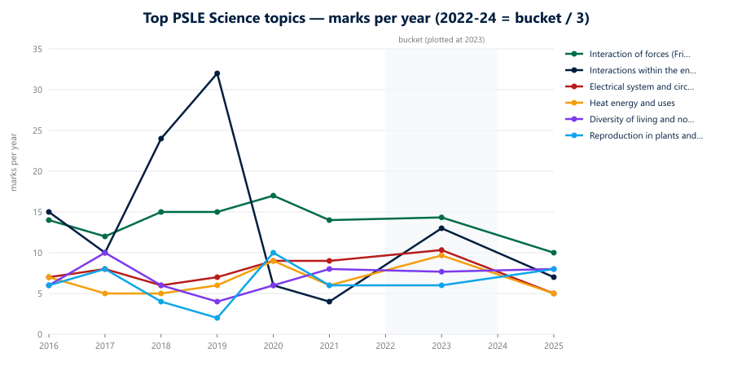

Year-by-year matrix
Marks per topic per year (raw). 2022-24 column = combined bucket total across the 4 sub-buckets (Life Sci MCQ + Life Sci OEQ + Physical Sci MCQ + Physical Sci OEQ). 2022-24/yr = bucket ÷ 3 for per-year-equivalent.

Topic | 2016 | 2017 | 2018 | 2019 | 2020 | 2021 | 2022-24 | 2025 | 2022-24 / yr | 2021-25 total
Interaction of forces (Friction / Gravity / Magnets) | 14 | 12 | 15 | 15 | 17 | 14 | 43 | 10 | 14.3 | 67
Interactions within the environment | 15 | 10 | 24 | 32 | 6 | 4 | 39 | 7 | 13.0 | 50
Electrical system and circuits | 7 | 8 | 6 | 7 | 9 | 9 | 31 | 5 | 10.3 | 45
Heat energy and uses | 7 | 5 | 5 | 6 | 9 | 6 | 29 | 5 | 9.7 | 40
Diversity of living and non-living things | 6 | 10 | 6 | 4 | 6 | 8 | 23 | 8 | 7.7 | 39
Reproduction in plants and animals | 6 | 8 | 4 | 2 | 10 | 6 | 18 | 8 | 6.0 | 32
Life cycles in plants and animals | 5 | 8 | 6 | 2 | 0 | 8 | 16 | 8 | 5.3 | 32
Cycles in matter | 4 | 4 | 4 | 5 | 6 | 8 | 14 | 9 | 4.7 | 31
Energy conversion | 7 | 10 | 6 | 6 | 0 | 2 | 13 | 13 | 4.3 | 28
Plant parts and functions | 3 | 0 | 5 | 4 | 11 | 7 | 18 | 2 | 6.0 | 27
Photosynthesis | 9 | 7 | 3 | 4 | 5 | 6 | 13 | 5 | 4.3 | 24
Human respiratory and circulatory systems | 2 | 5 | 2 | 2 | 8 | 4 | 10 | 7 | 3.3 | 21
Diversity of materials | 5 | 2 | 4 | 4 | 4 | 5 | 10 | 2 | 3.3 | 17
Human digestive system | 2 | 0 | 2 | 0 | 4 | 5 | 8 | 3 | 2.7 | 16
Water cycle, evaporation, condensation | 4 | 7 | 6 | 5 | 3 | 2 | 6 | 6 | 2.0 | 14
Light energy and uses | 2 | 2 | 2 | 2 | 2 | 4 | 6 | 2 | 2.0 | 12
(Untagged) | 0 | 2 | 0 | 0 | 0 | 2 | 0 | 0 | 0.0 | 2

Observations
- Interactions within the environment: peaked sharply in 2018 (24) and 2019 (32), collapsed in 2020-2021 (6 and 4), rebounded in the 2022-2024 bucket (~13/yr), then back down to 7 in 2025.
- Interaction of forces (combined): consistently 6-15 marks/year across the whole window — steadiest of the big topics. Note the 20-mark spike in 2021.
- Electrical system and circuits: gradual climb across the window — 7 (2016) → 9 (2020-21 each) → ~10/yr in 2022-24 → 9 (2025).
- Heat energy: low base (5-9 marks) through 2018-2021, then jumped to ~10/yr in 2022-2024 and held at 8 in 2025.
- Life cycles in plants and animals: doubled from ~4-8 marks/year through 2020 to ~5/yr in 2022-2024 to 8 in 2025.
- Magnets: cleared a 7-mark band in 2017-2019, then halved in 2020-2021 and stays low (~3/yr) in the recent bucket. The trajectory looks like a deliberate de-emphasis.

Reproducibility
Run: npx tsx scripts/_psle-science-year-matrix.ts

