Progress report — admin's children
Generated 2026-06-05. Each subject section shows one bar per marked paper (chronological). Dashed red line = that child's own average across the papers shown. Bars in green ≥ average; slate < average.

Emily lim

English (avg 86.3%, 147 attempts across 6 topics with ≥3 attempts)
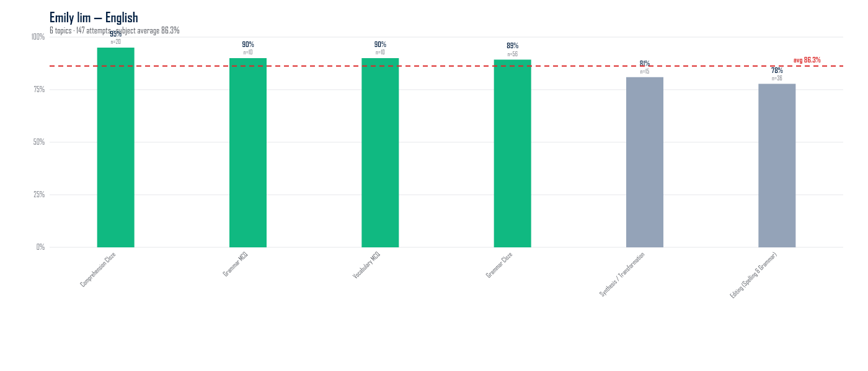
Topic | Attempts | Marks | % | Gap to subj avg (pp)
Comprehension Cloze | 20 | 19 / 20 | 95.0% | +8.7
Grammar MCQ | 10 | 9 / 10 | 90.0% | +3.7
Vocabulary MCQ | 10 | 9 / 10 | 90.0% | +3.7
Grammar Cloze | 56 | 50 / 56 | 89.3% | +3.0
Synthesis / Transformation | 15 | 17 / 21 | 81.0% | -5.3
Editing (Spelling & Grammar) | 36 | 28 / 36 | 77.8% | -8.5

Math (avg 67.1%, 232 attempts across 5 topics with ≥3 attempts)
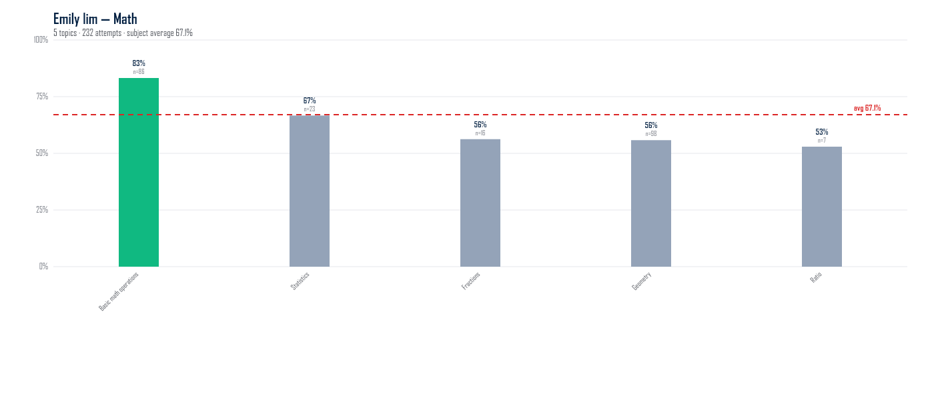
Topic | Attempts | Marks | % | Gap to subj avg (pp)
Basic math operations | 86 | 139 / 167 | 83.2% | +16.2
Statistics | 23 | 32 / 48 | 66.7% | -0.4
Fractions | 16 | 18 / 32 | 56.3% | -10.8
Geometry | 98 | 111 / 198 | 55.8% | -11.3
Ratio | 7 | 9 / 17 | 52.9% | -14.1

Science (avg 89.8%, 207 attempts across 9 topics with ≥3 attempts)
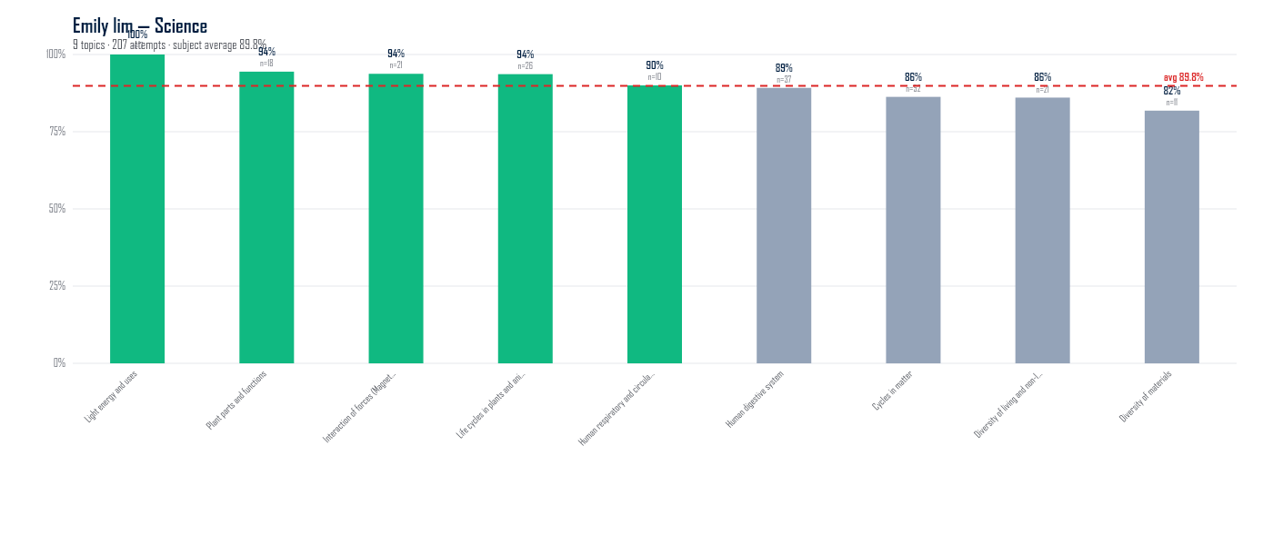
Topic | Attempts | Marks | % | Gap to subj avg (pp)
Light energy and uses | 7 | 14 / 14 | 100.0% | +10.2
Plant parts and functions | 18 | 34 / 36 | 94.4% | +4.6
Interaction of forces (Magnets) | 21 | 45 / 48 | 93.8% | +3.9
Life cycles in plants and animals | 26 | 52 / 55 | 93.6% | +3.8
Human respiratory and circulatory systems | 10 | 18 / 20 | 90.0% | +0.2
Human digestive system | 37 | 66 / 74 | 89.2% | -0.6
Cycles in matter | 52 | 98 / 113 | 86.3% | -3.6
Diversity of living and non-living things | 21 | 37 / 43 | 86.0% | -3.8
Diversity of materials | 11 | 18 / 22 | 81.8% | -8.0

David lim

English (avg 76.4%, 2,433 attempts across 9 topics with ≥3 attempts)
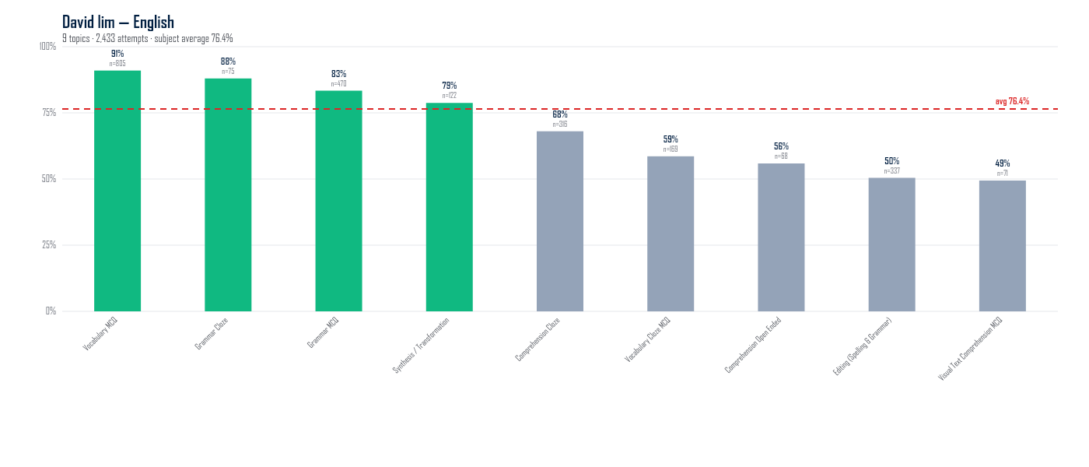
Topic | Attempts | Marks | % | Gap to subj avg (pp)
Vocabulary MCQ | 805 | 838 / 921 | 91.0% | +14.5
Grammar Cloze | 75 | 66 / 75 | 88.0% | +11.6
Grammar MCQ | 470 | 572 / 686 | 83.4% | +6.9
Synthesis / Transformation | 122 | 189 / 240 | 78.8% | +2.3
Comprehension Cloze | 316 | 215 / 316 | 68.0% | -8.4
Vocabulary Cloze MCQ | 169 | 99 / 169 | 58.6% | -17.9
Comprehension Open Ended | 68 | 76 / 136 | 55.9% | -20.6
Editing (Spelling & Grammar) | 337 | 170 / 337 | 50.4% | -26.0
Visual Text Comprehension MCQ | 71 | 43 / 87 | 49.4% | -27.0

Math (avg 83.0%, 74 attempts across 5 topics with ≥3 attempts)
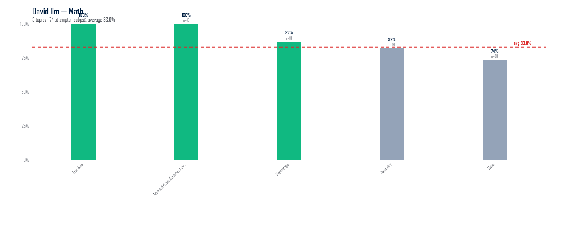
Topic | Attempts | Marks | % | Gap to subj avg (pp)
Fractions | 5 | 7 / 7 | 100.0% | +17.0
Area and circumference of circle | 10 | 30 / 30 | 100.0% | +17.0
Percentage | 10 | 20 / 23 | 87.0% | +3.9
Geometry | 19 | 32 / 39 | 82.1% | -1.0
Ratio | 30 | 53 / 72 | 73.6% | -9.4

Science (avg 79.8%, 281 attempts across 13 topics with ≥3 attempts)
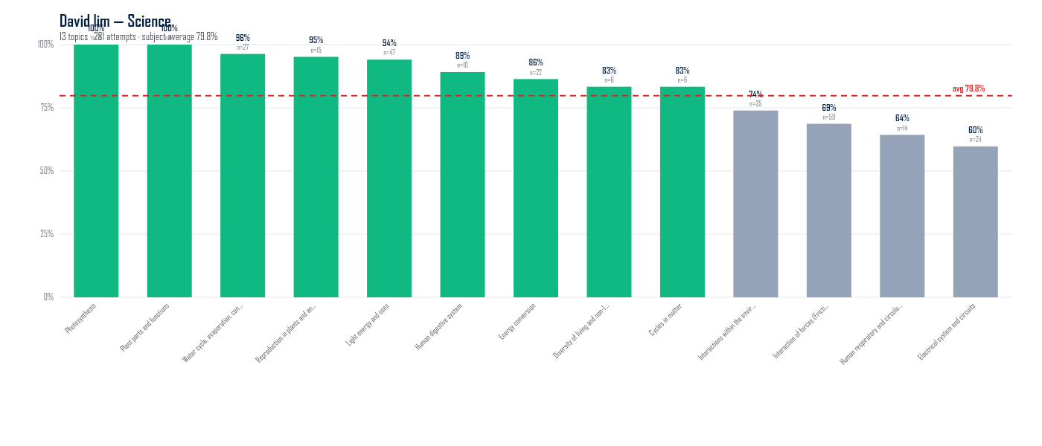
Topic | Attempts | Marks | % | Gap to subj avg (pp)
Photosynthesis | 9 | 18 / 18 | 100.0% | +20.2
Plant parts and functions | 4 | 8 / 8 | 100.0% | +20.2
Water cycle, evaporation, condensation | 27 | 52 / 54 | 96.3% | +16.5
Reproduction in plants and animals | 15 | 30 / 31 | 95.2% | +15.3
Light energy and uses | 47 | 95 / 101 | 94.1% | +14.2
Human digestive system | 10 | 21 / 23 | 89.1% | +9.3
Energy conversion | 22 | 38 / 44 | 86.4% | +6.5
Diversity of living and non-living things | 6 | 10 / 12 | 83.3% | +3.5
Cycles in matter | 6 | 10 / 12 | 83.3% | +3.5
Interactions within the environment | 35 | 68 / 92 | 73.9% | -5.9
Interaction of forces (Frictional force, gravitational force, elastic spring force) | 59 | 92 / 134 | 68.7% | -11.2
Human respiratory and circulatory systems | 14 | 27 / 42 | 64.3% | -15.5
Electrical system and circuits | 24 | 40 / 67 | 59.7% | -20.1

student555

English (avg 59.2%, 289 attempts across 9 topics with ≥3 attempts)
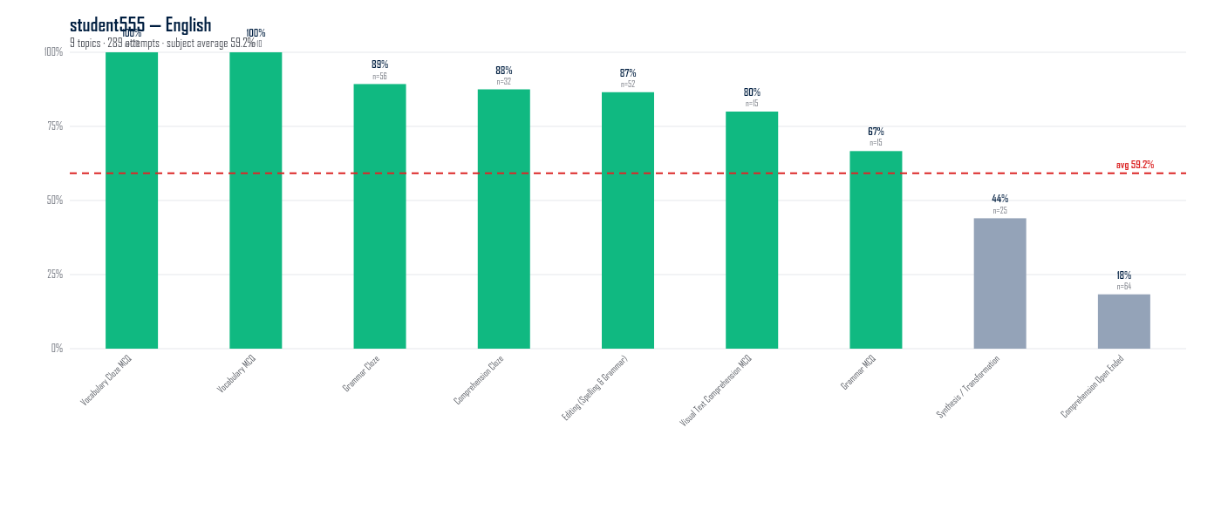
Topic | Attempts | Marks | % | Gap to subj avg (pp)
Vocabulary Cloze MCQ | 20 | 20 / 20 | 100.0% | +40.8
Vocabulary MCQ | 10 | 10 / 10 | 100.0% | +40.8
Grammar Cloze | 56 | 50 / 56 | 89.3% | +30.1
Comprehension Cloze | 32 | 28 / 32 | 87.5% | +28.3
Editing (Spelling & Grammar) | 52 | 45 / 52 | 86.5% | +27.3
Visual Text Comprehension MCQ | 15 | 12 / 15 | 80.0% | +20.8
Grammar MCQ | 15 | 10 / 15 | 66.7% | +7.5
Synthesis / Transformation | 25 | 22 / 50 | 44.0% | -15.2
Comprehension Open Ended | 64 | 22 / 120 | 18.3% | -40.9

Math (avg 49.1%, 73 attempts across 4 topics with ≥3 attempts)
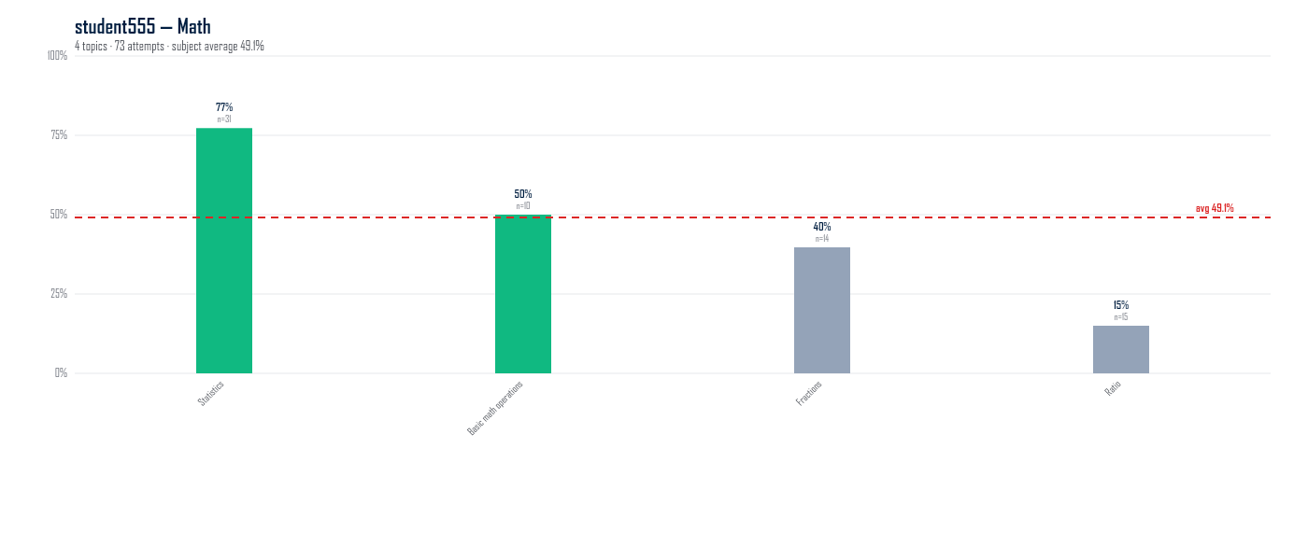
Topic | Attempts | Marks | % | Gap to subj avg (pp)
Statistics | 31 | 51 / 66 | 77.3% | +28.2
Basic math operations | 10 | 10 / 20 | 50.0% | +0.9
Fractions | 14 | 14 / 34 | 39.7% | -9.4
Ratio | 15 | 6 / 40 | 15.0% | -34.1

Science (avg 72.0%, 156 attempts across 7 topics with ≥3 attempts)
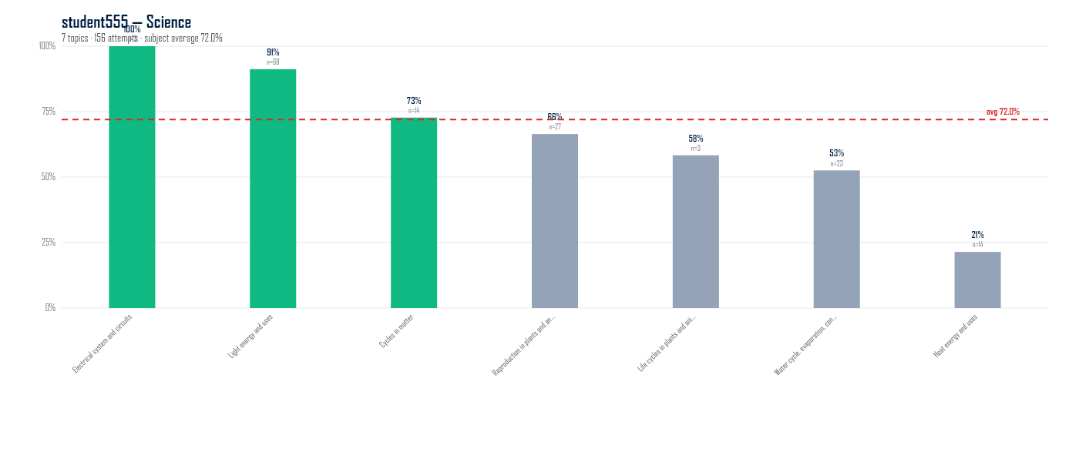
Topic | Attempts | Marks | % | Gap to subj avg (pp)
Electrical system and circuits | 3 | 7 / 7 | 100.0% | +28.0
Light energy and uses | 68 | 135 / 148 | 91.2% | +19.2
Cycles in matter | 14 | 24 / 33 | 72.7% | +0.7
Reproduction in plants and animals | 27 | 49 / 73 | 66.4% | -5.5
Life cycles in plants and animals | 3 | 4 / 6 | 58.3% | -13.6
Water cycle, evaporation, condensation | 23 | 31 / 59 | 52.5% | -19.4
Heat energy and uses | 14 | 6 / 28 | 21.4% | -50.5

Mark lim

English (avg 87.3%, 3,316 attempts across 8 topics with ≥3 attempts)
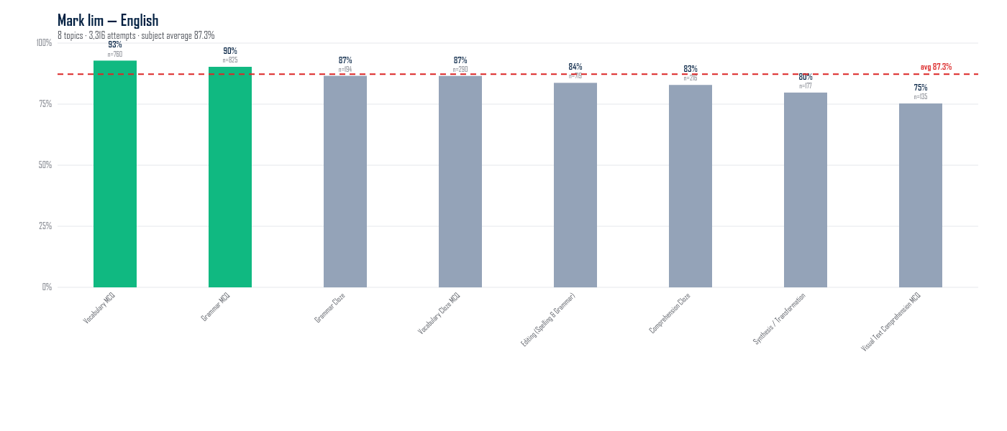
Topic | Attempts | Marks | % | Gap to subj avg (pp)
Vocabulary MCQ | 760 | 880 / 948 | 92.8% | +5.6
Grammar MCQ | 825 | 1004 / 1112 | 90.3% | +3.0
Grammar Cloze | 194 | 168 / 194 | 86.6% | -0.7
Vocabulary Cloze MCQ | 290 | 251 / 290 | 86.6% | -0.7
Editing (Spelling & Grammar) | 719 | 602 / 719 | 83.7% | -3.5
Comprehension Cloze | 216 | 179 / 216 | 82.9% | -4.4
Synthesis / Transformation | 177 | 282 / 353 | 79.7% | -7.5
Visual Text Comprehension MCQ | 135 | 134 / 178 | 75.3% | -12.0

Math (avg 84.2%, 1,167 attempts across 10 topics with ≥3 attempts)
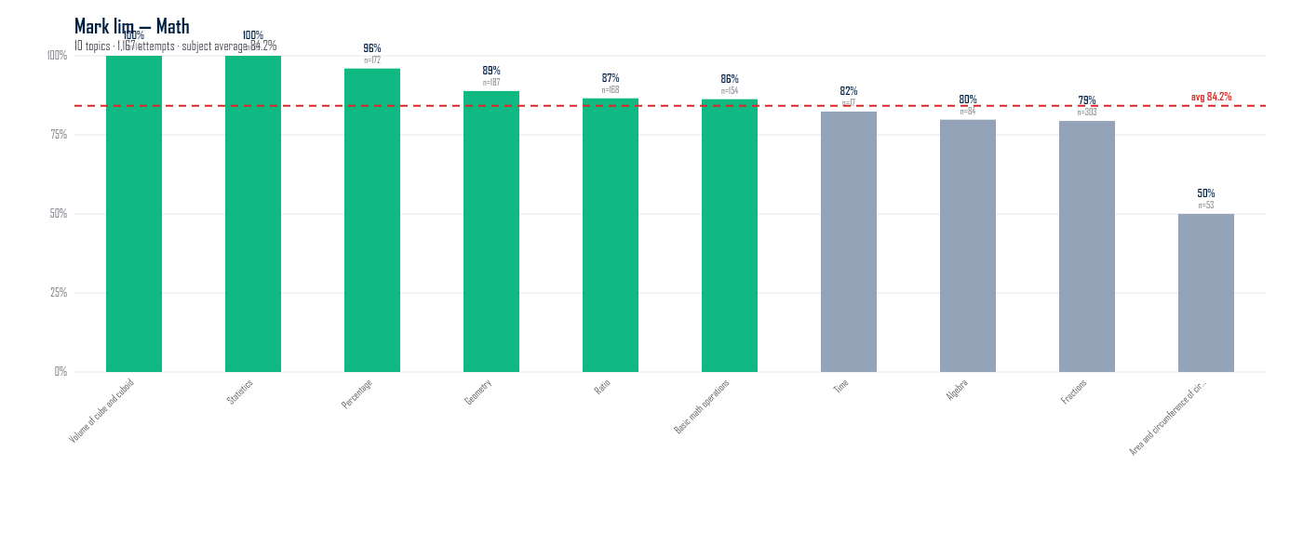
Topic | Attempts | Marks | % | Gap to subj avg (pp)
Volume of cube and cuboid | 14 | 28 / 28 | 100.0% | +15.8
Statistics | 13 | 26 / 26 | 100.0% | +15.8
Percentage | 172 | 334 / 348 | 96.0% | +11.8
Geometry | 187 | 351 / 395 | 88.9% | +4.7
Ratio | 168 | 309 / 357 | 86.6% | +2.4
Basic math operations | 154 | 264 / 306 | 86.3% | +2.1
Time | 17 | 28 / 34 | 82.4% | -1.8
Algebra | 84 | 158 / 198 | 79.8% | -4.4
Fractions | 303 | 493 / 621 | 79.4% | -4.8
Area and circumference of circle | 53 | 65 / 130 | 50.0% | -34.2

Science (avg 73.7%, 342 attempts across 9 topics with ≥3 attempts)
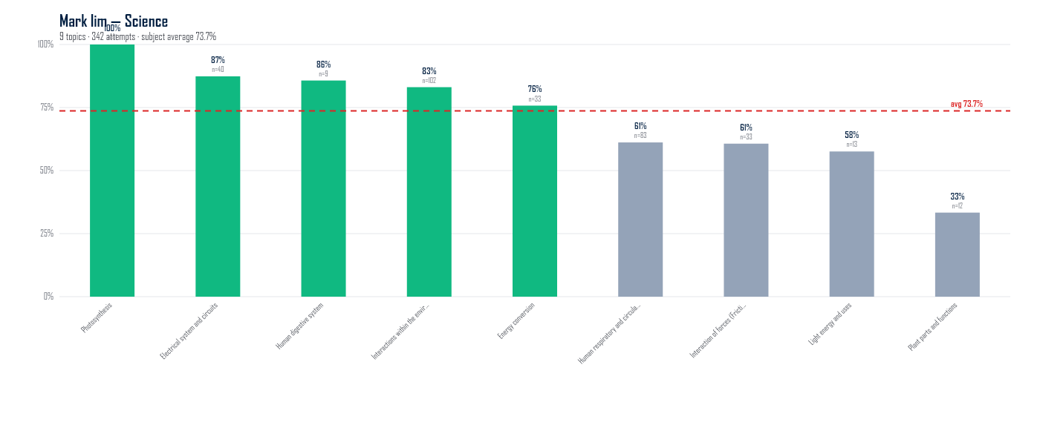
Topic | Attempts | Marks | % | Gap to subj avg (pp)
Photosynthesis | 11 | 22 / 22 | 100.0% | +26.3
Electrical system and circuits | 40 | 94 / 107 | 87.4% | +13.7
Human digestive system | 9 | 18 / 21 | 85.7% | +12.0
Interactions within the environment | 102 | 219 / 263 | 83.1% | +9.4
Energy conversion | 33 | 50 / 66 | 75.8% | +2.1
Human respiratory and circulatory systems | 83 | 126 / 206 | 61.2% | -12.5
Interaction of forces (Frictional force, gravitational force, elastic spring force) | 33 | 54 / 89 | 60.7% | -13.0
Light energy and uses | 13 | 19 / 33 | 57.6% | -16.1
Plant parts and functions | 12 | 8 / 24 | 33.3% | -40.3

JeremiahSy

English (avg 79.1%, 235 attempts across 8 topics with ≥3 attempts)
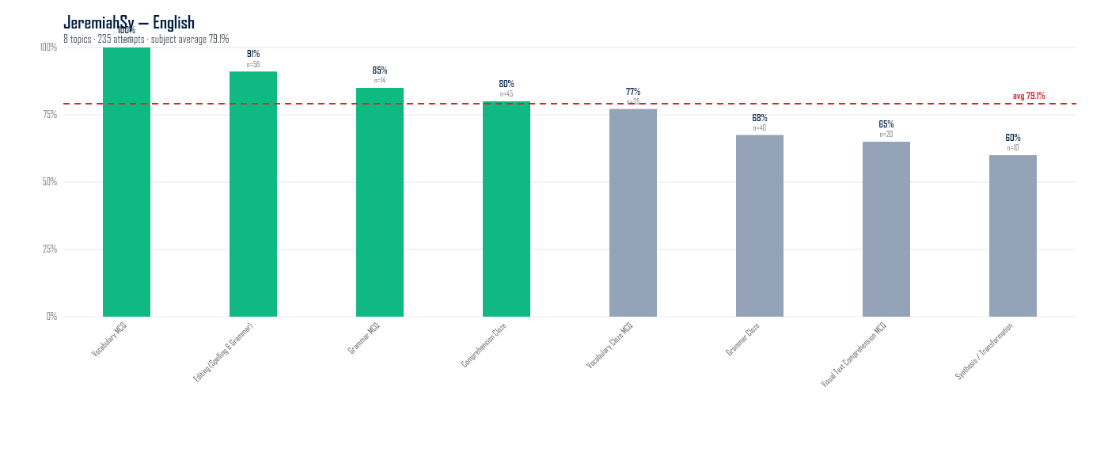
Topic | Attempts | Marks | % | Gap to subj avg (pp)
Vocabulary MCQ | 15 | 18 / 18 | 100.0% | +20.9
Editing (Spelling & Grammar) | 56 | 51 / 56 | 91.1% | +11.9
Grammar MCQ | 14 | 17 / 20 | 85.0% | +5.9
Comprehension Cloze | 45 | 36 / 45 | 80.0% | +0.9
Vocabulary Cloze MCQ | 35 | 27 / 35 | 77.1% | -2.0
Grammar Cloze | 40 | 27 / 40 | 67.5% | -11.6
Visual Text Comprehension MCQ | 20 | 13 / 20 | 65.0% | -14.1
Synthesis / Transformation | 10 | 12 / 20 | 60.0% | -19.1

Math (avg 86.9%, 112 attempts across 7 topics with ≥3 attempts)
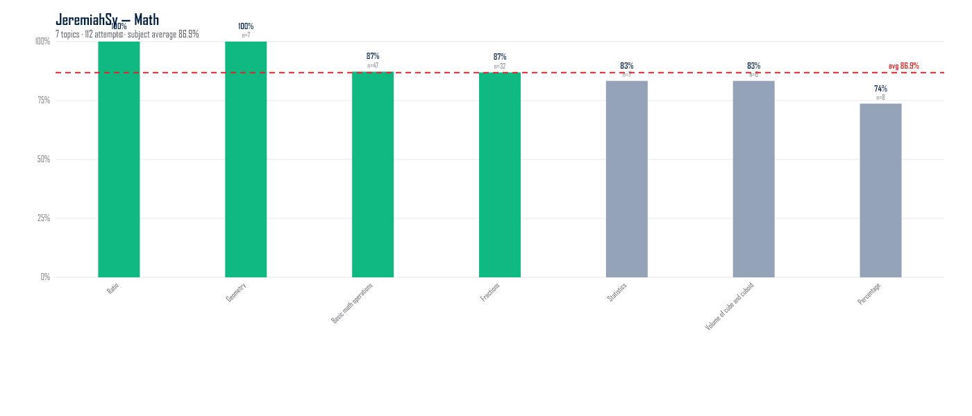
Topic | Attempts | Marks | % | Gap to subj avg (pp)
Ratio | 3 | 6 / 6 | 100.0% | +13.1
Geometry | 7 | 14 / 14 | 100.0% | +13.1
Basic math operations | 47 | 82 / 94 | 87.2% | +0.4
Fractions | 32 | 57 / 65 | 86.9% | +0.1
Statistics | 7 | 15 / 18 | 83.3% | -3.5
Volume of cube and cuboid | 6 | 10 / 12 | 83.3% | -3.5
Percentage | 8 | 14 / 19 | 73.7% | -13.2

Science (avg 50.9%, 104 attempts across 10 topics with ≥3 attempts)
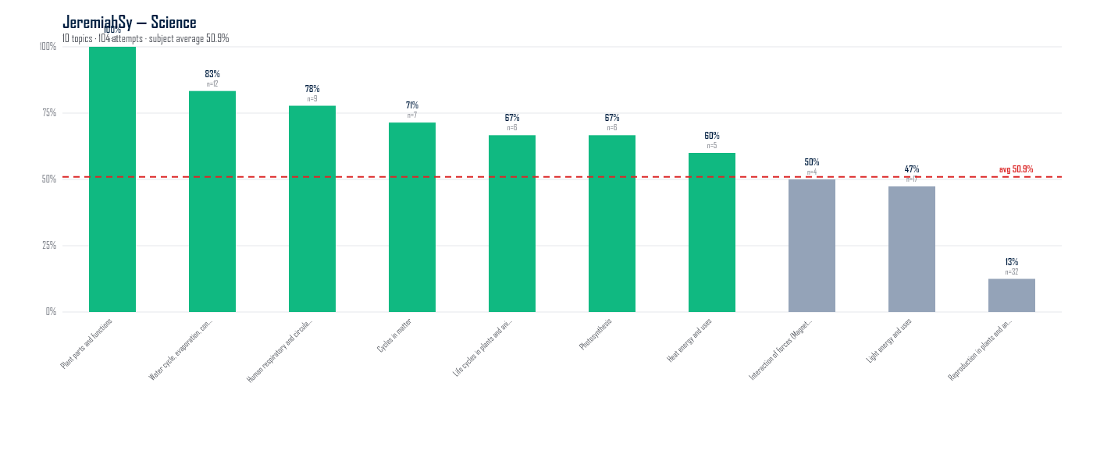
Topic | Attempts | Marks | % | Gap to subj avg (pp)
Plant parts and functions | 3 | 6 / 6 | 100.0% | +49.1
Water cycle, evaporation, condensation | 12 | 20 / 24 | 83.3% | +32.4
Human respiratory and circulatory systems | 9 | 14 / 18 | 77.8% | +26.8
Cycles in matter | 7 | 10 / 14 | 71.4% | +20.5
Life cycles in plants and animals | 6 | 8 / 12 | 66.7% | +15.7
Photosynthesis | 6 | 8 / 12 | 66.7% | +15.7
Heat energy and uses | 5 | 6 / 10 | 60.0% | +9.1
Interaction of forces (Magnets) | 4 | 4 / 8 | 50.0% | -0.9
Light energy and uses | 17 | 18 / 38 | 47.4% | -3.6
Reproduction in plants and animals | 32 | 8 / 64 | 12.5% | -38.4

Student666

English (avg 95.1%, 153 attempts across 9 topics with ≥3 attempts)
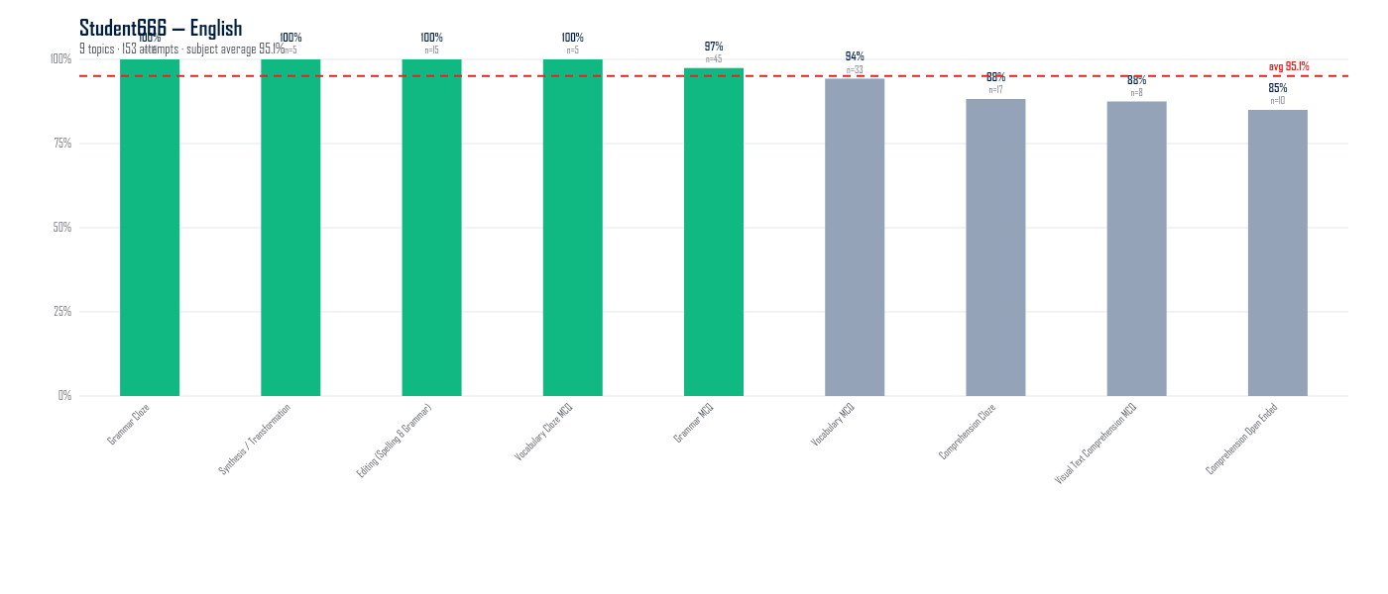
Topic | Attempts | Marks | % | Gap to subj avg (pp)
Grammar Cloze | 15 | 15 / 15 | 100.0% | +4.9
Synthesis / Transformation | 5 | 10 / 10 | 100.0% | +4.9
Editing (Spelling & Grammar) | 15 | 15 / 15 | 100.0% | +4.9
Vocabulary Cloze MCQ | 5 | 5 / 5 | 100.0% | +4.9
Grammar MCQ | 45 | 76 / 78 | 97.4% | +2.4
Vocabulary MCQ | 33 | 33 / 35 | 94.3% | -0.8
Comprehension Cloze | 17 | 15 / 17 | 88.2% | -6.8
Visual Text Comprehension MCQ | 8 | 7 / 8 | 87.5% | -7.6
Comprehension Open Ended | 10 | 17 / 20 | 85.0% | -10.1

Math (avg 40.8%, 91 attempts across 7 topics with ≥3 attempts)
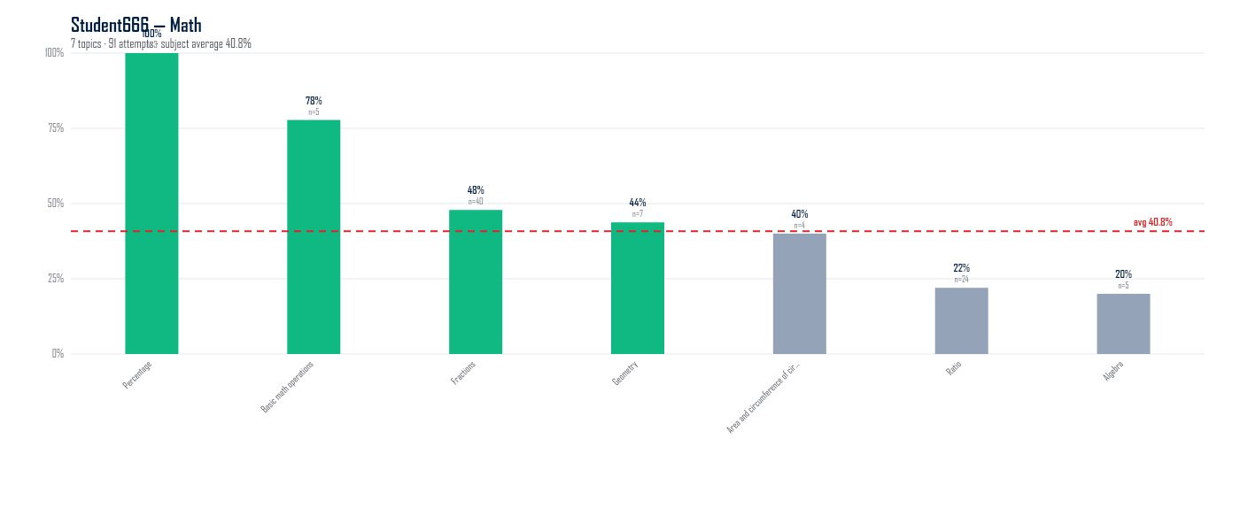
Topic | Attempts | Marks | % | Gap to subj avg (pp)
Percentage | 3 | 6 / 6 | 100.0% | +59.2
Basic math operations | 5 | 7 / 9 | 77.8% | +37.0
Fractions | 40 | 45 / 94 | 47.9% | +7.1
Geometry | 7 | 7 / 16 | 43.8% | +3.0
Area and circumference of circle | 4 | 4 / 10 | 40.0% | -0.8
Ratio | 24 | 11 / 50 | 22.0% | -18.8
Algebra | 5 | 2 / 10 | 20.0% | -20.8

Science (avg 72.2%, 68 attempts across 5 topics with ≥3 attempts)
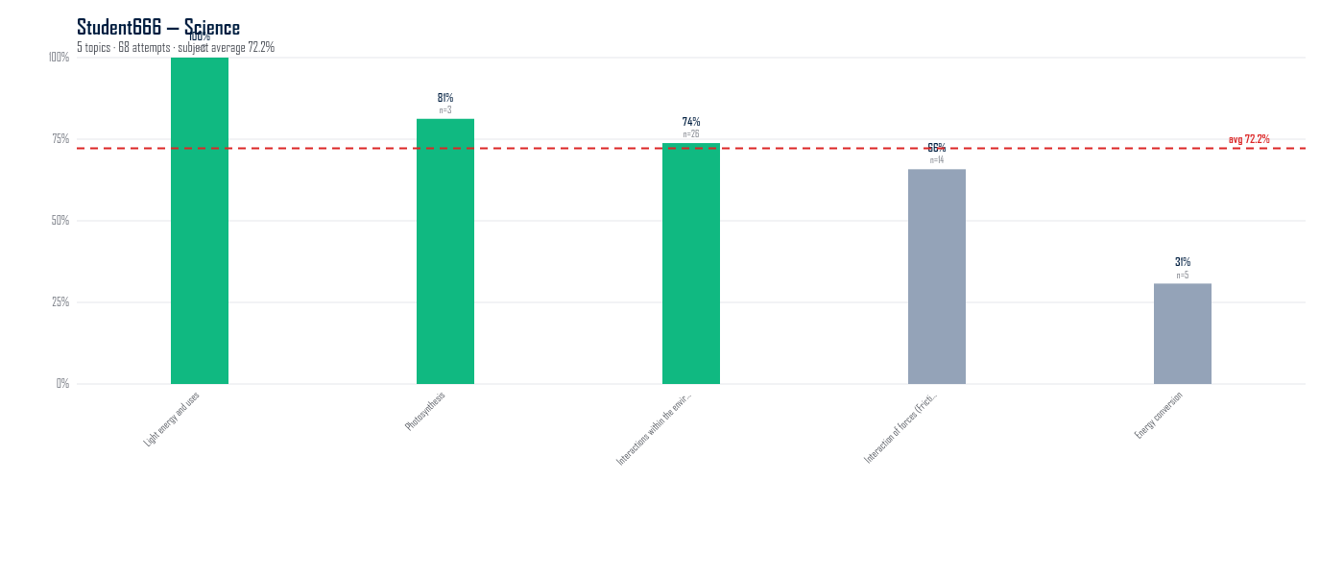
Topic | Attempts | Marks | % | Gap to subj avg (pp)
Light energy and uses | 8 | 19 / 19 | 100.0% | +27.8
Photosynthesis | 3 | 7 / 8 | 81.3% | +9.1
Interactions within the environment | 26 | 47 / 63 | 73.8% | +1.6
Interaction of forces (Frictional force, gravitational force, elastic spring force) | 14 | 25 / 38 | 65.8% | -6.4
Energy conversion | 5 | 4 / 13 | 30.8% | -41.4

Benjamin Ong

Math (avg 83.1%, 305 attempts across 9 topics with ≥3 attempts)
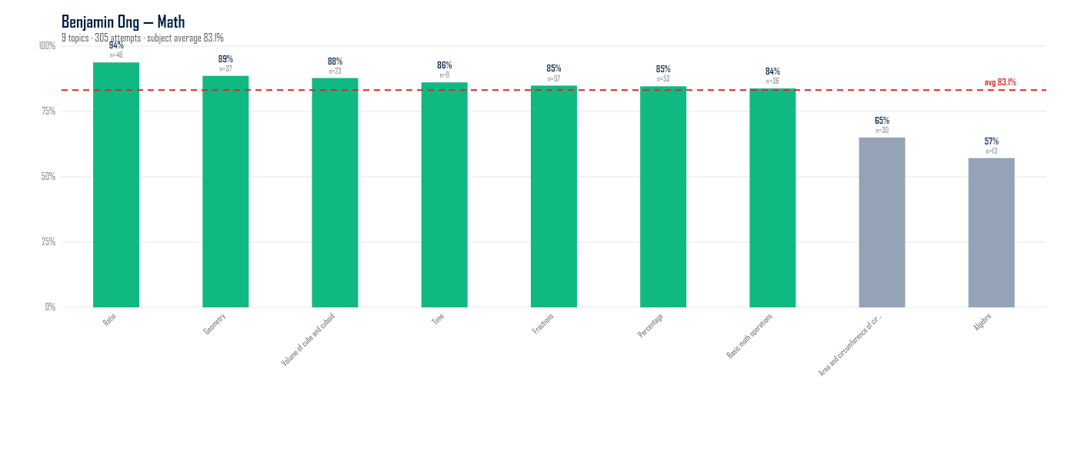
Topic | Attempts | Marks | % | Gap to subj avg (pp)
Ratio | 46 | 90 / 96 | 93.8% | +10.6
Geometry | 37 | 70 / 79 | 88.6% | +5.5
Volume of cube and cuboid | 23 | 40 / 45 | 87.8% | +4.6
Time | 9 | 16 / 18 | 86.1% | +3.0
Fractions | 57 | 101 / 119 | 84.9% | +1.7
Percentage | 53 | 99 / 117 | 84.6% | +1.5
Basic math operations | 36 | 62 / 74 | 83.8% | +0.7
Area and circumference of circle | 30 | 52 / 80 | 65.0% | -18.1
Algebra | 13 | 16 / 28 | 57.1% | -26.0

Science (avg 61.1%, 125 attempts across 10 topics with ≥3 attempts)
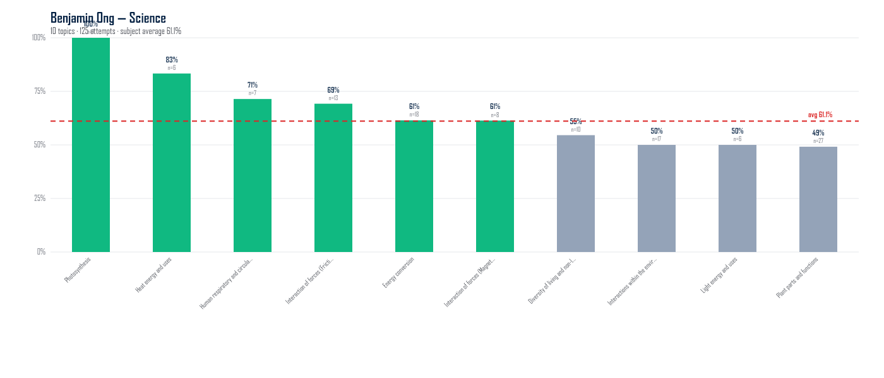
Topic | Attempts | Marks | % | Gap to subj avg (pp)
Photosynthesis | 7 | 14 / 14 | 100.0% | +38.9
Heat energy and uses | 6 | 10 / 12 | 83.3% | +22.2
Human respiratory and circulatory systems | 7 | 10 / 14 | 71.4% | +10.3
Interaction of forces (Frictional force, gravitational force, elastic spring force) | 13 | 18 / 26 | 69.2% | +8.1
Energy conversion | 18 | 30 / 48 | 61.5% | +0.4
Interaction of forces (Magnets) | 8 | 14 / 22 | 61.4% | +0.3
Diversity of living and non-living things | 10 | 12 / 22 | 54.5% | -6.5
Interactions within the environment | 17 | 22 / 43 | 50.0% | -11.1
Light energy and uses | 6 | 6 / 12 | 50.0% | -11.1
Plant parts and functions | 27 | 29 / 59 | 49.2% | -11.9

