PSLE Science — Tricky MCQs ("Always the Same")
Compiled 2026-06-06 · 4 questions

1. PSLE Physical Science MCQ 2022-2024 (Various (2022-2024)) — Q8 · 2 marks
Topic: Electrical system and circuits

Question
Mariam sets up four circuits using identical batteries and bulbs in working condition.
In which circuits will bulb L have the same brightness?
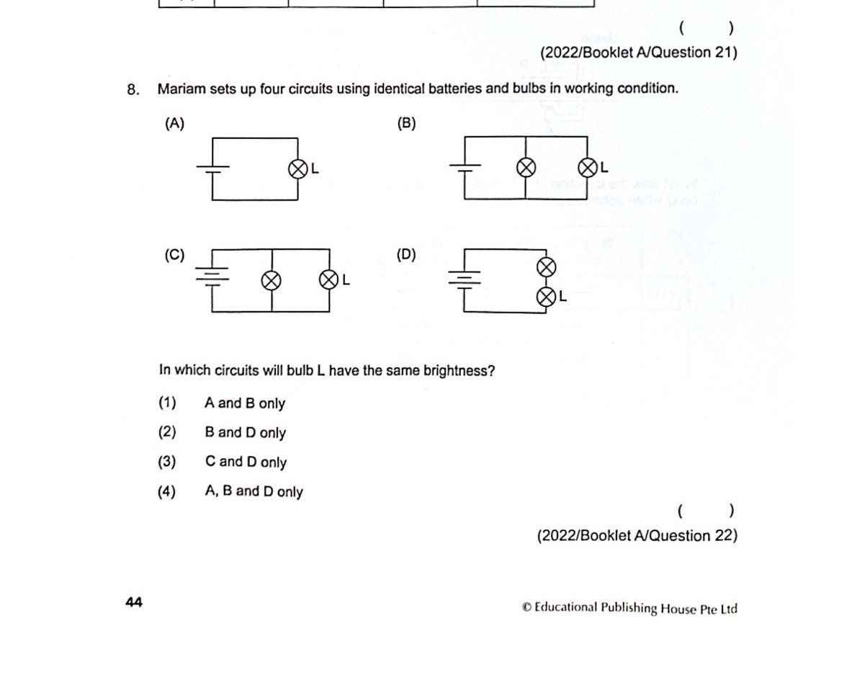

Options
(1) A and B only
(2) B and D only
(3) C and D only
(4) A, B and D only

Answer & Trick
Answer: (4)
The trick: Three of the four diagrams give bulb L the same current. Students compare numbers of components instead of tracing the actual current path — they miss that an 'extra' bulb on a parallel branch doesn't change L, and that a short-circuit wire across a battery does.

2. Test Quiz — PSLE Science 2025 (?) — Q18 · 2 marks
Topic: Electrical system and circuits

Question
Nurul set up four circuits using identical batteries and bulbs in working condition.
In which circuits will bulb G have the same brightness?
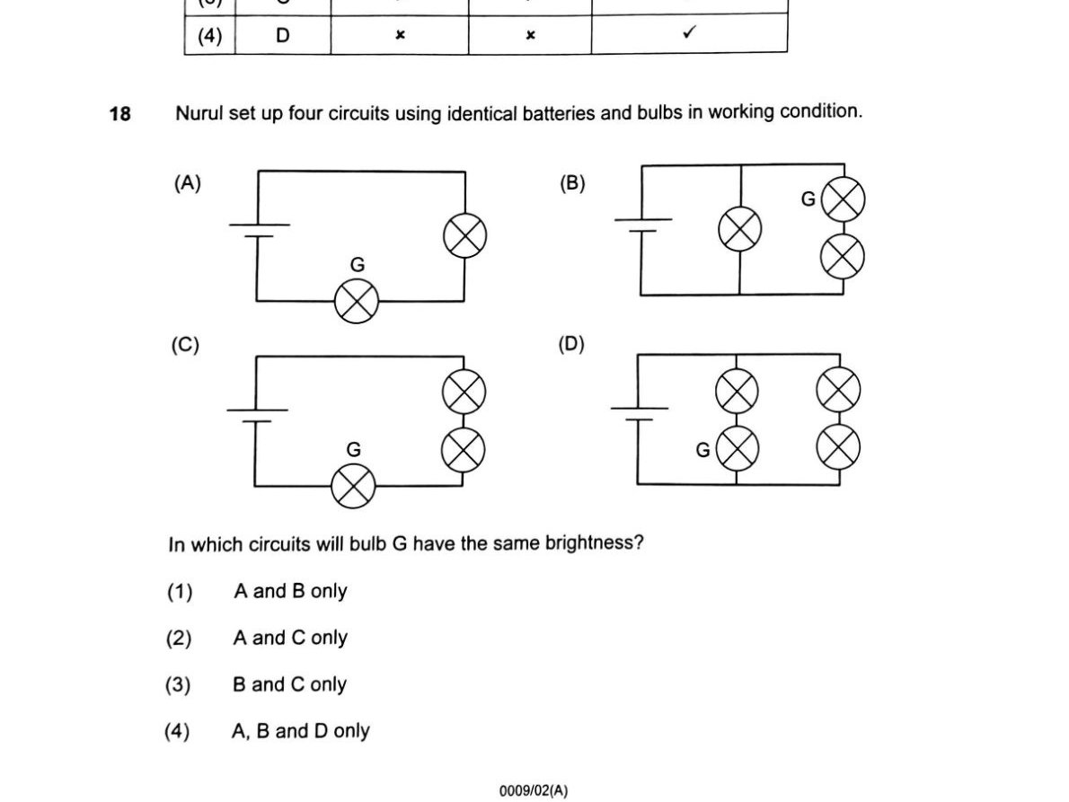

Options
(1) A and B only
(2) A and C only
(3) B and C only
(4) A, B and D only

Answer & Trick
Answer: (4)
The trick: Same family as Mariam's — three diagrams are equivalent for bulb G; the trap diagram (C here) changes G's series/parallel topology.

3. Test Quiz — PSLE Science 2016 (?) — Q18 · 2 marks
Topic: Electrical system and circuits

Question
In the four circuits, all the bulbs and batteries are new and identical.
Which of the following two bulbs have the same brightness?
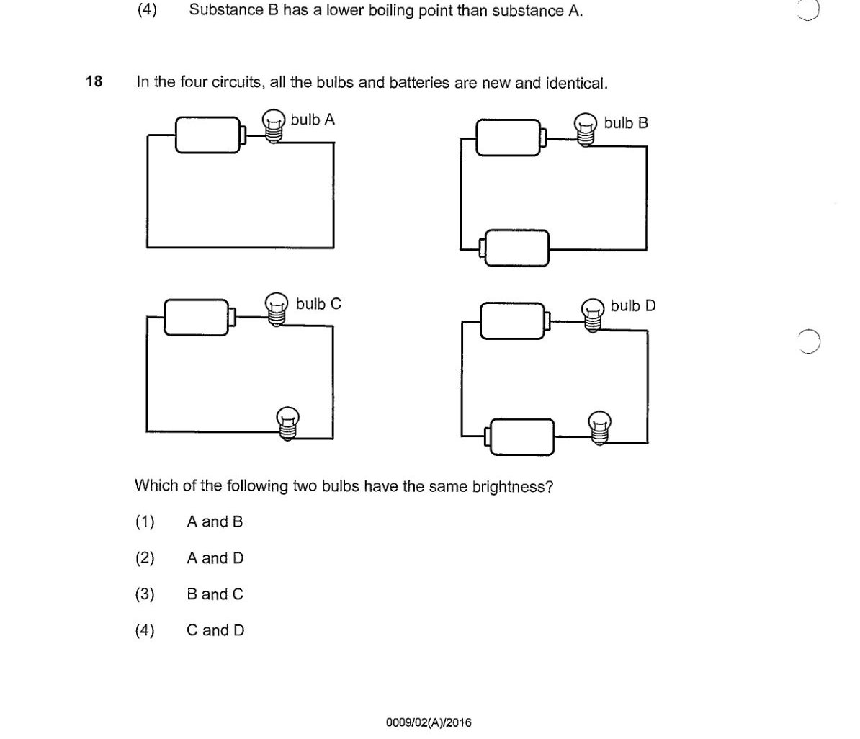

Options
(1) A and B
(2) A and D
(3) B and C
(4) C and D

Answer & Trick
Answer: (2)
The trick: Students often pick visually adjacent pairs. The matching pair is the one with equivalent current through the bulb — here that's the non-adjacent pair.

4. PSLE Science 2018 (2018) — Q15 · 2 marks
Topic: Interaction of forces (Frictional force, gravitational force, elastic spring force)

Question
Alex performed a jump. The three stages of his jump are as shown.
At which stage(s) did gravitational force act on him?
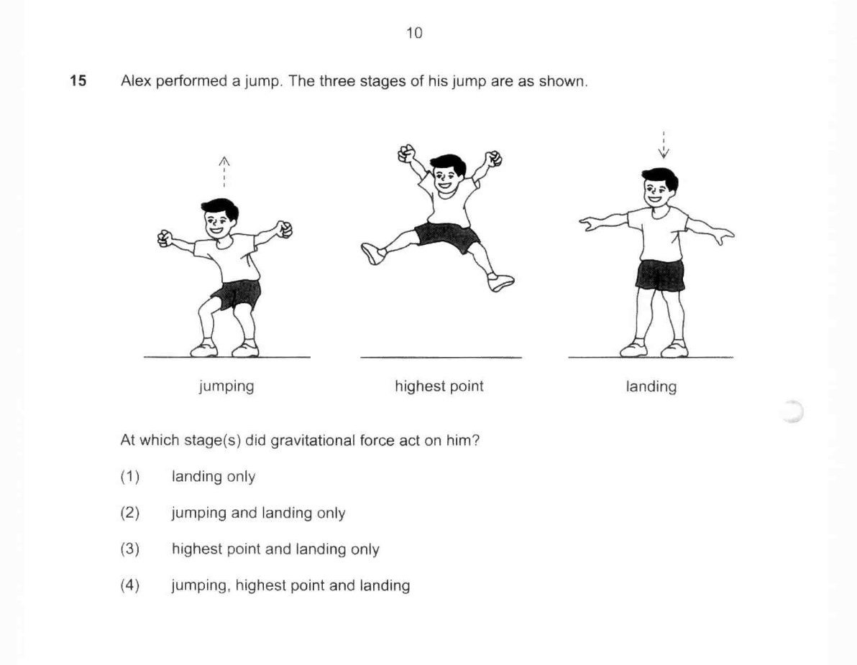

Options
(1) landing only
(2) jumping and landing only
(3) highest point and landing only
(4) jumping, highest point and landing

Answer & Trick
Answer: (4)
The trick: Gravity acts on every object with mass at every instant — including at the peak of a jump where you're momentarily stationary. Students think gravity 'only kicks in when going down' or 'only when touching the ground'.

