CP2 Report 2026 Assignment 2 (20264003, JuneyoungYoon)
All implementations are in scripts/ and results are in results/. Every script is run from scripts/ as a module, for example python -m Image_Blending.part1_1. NumPy is used for all algorithms. Matplotlib is used for reading the input images of Parts 1–2 and for figures, and OpenCV for reading the exposure brackets and reading/writing Radiance .hdr files.

1. Image Blending

1.1. Gaussian and Laplacian Pyramids
Implementation. The pyramids are built from a 5×5 Gaussian kernel (σ = 1) and a convolution written with NumPy (conv2d). reduce blurs the image and keeps every second row and column. expand inserts zeros between the samples, blurs with the same kernel and multiplies by 4. gaussian_pyramid applies reduce six times to obtain 7 levels. laplacian_pyramid stores L_k = G_k − expand(G_{k+1}) for k = 0…5 and keeps the coarsest Gaussian level as L_6. collapse reverses this from the coarsest level: I_k = L_k + expand(I_{k+1}). (scripts/Image_Blending/part1_1.py)
Details.
- Convolution. conv2d pads the image with np.pad(..., mode='symmetric'), flips the kernel, and accumulates kernel[i, j] × (shifted image) over all kernel taps. Zero padding would darken the image borders at every level, so mirrored padding is used.
- Kernel. get_gaussian_kernel(size, sigma) evaluates the 2D Gaussian on a size×size grid and normalizes its sum to 1, so blurring keeps the mean brightness.
- Factor 4 in expand. Zero insertion keeps one sample in four, so after blurring the image is about 1/4 as bright. Multiplying by 4 restores the brightness.
- Odd sizes. expand(image, shape) takes the target shape of the finer level, so a level with an odd size can still be subtracted from its parent. For the 512×512 inputs every level size is even.
- Precision. Images are converted to float64 in [0, 1] before building the pyramids. Laplacian levels are signed, so they are displayed as 0.5 + 0.5·L.
Output.
Image | Level sizes (7 levels) | max |error| | MSE | PSNR
apple | 512, 256, 128, 64, 32, 16, 8 | 2.22e-16 | 1.40e-36 | 358.5 dB
orange | 512, 256, 128, 64, 32, 16, 8 | 1.11e-16 | 1.29e-37 | 368.9 dB

The reconstruction error is at the level of float64 rounding (about 1e-16). collapse uses exactly the same expand as laplacian_pyramid, so adding L_k back undoes each subtraction. The Laplacian level stores precisely what expand cannot recover, which makes the reconstruction exact for any kernel.
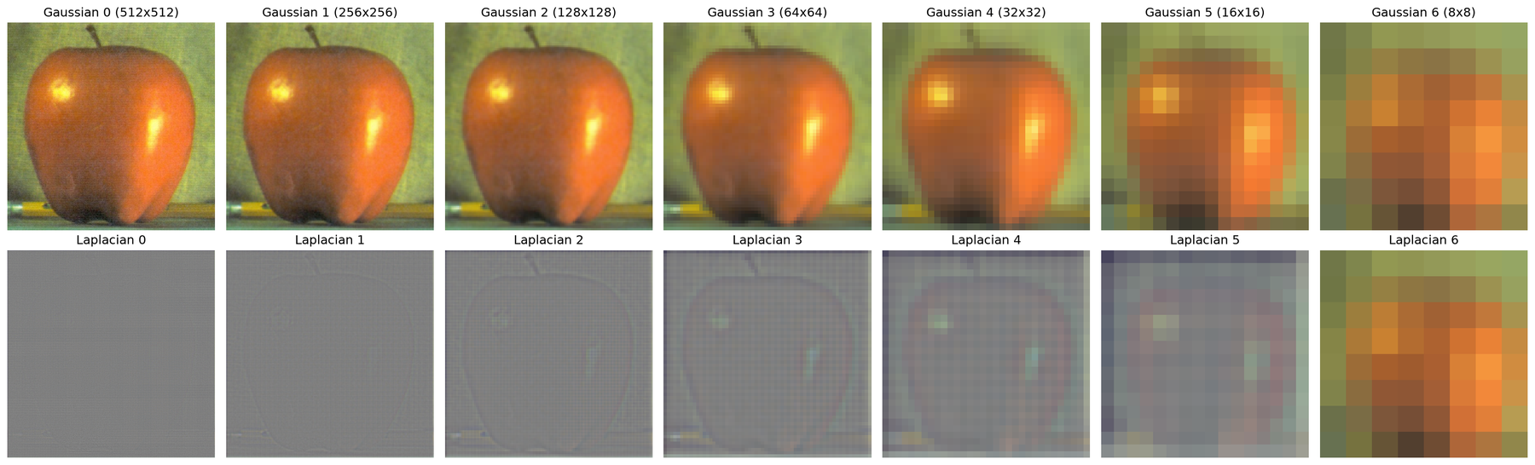
Figure 1. Gaussian pyramid (top) and Laplacian pyramid (bottom) of apple.png, 7 levels from 512×512 to 8×8.
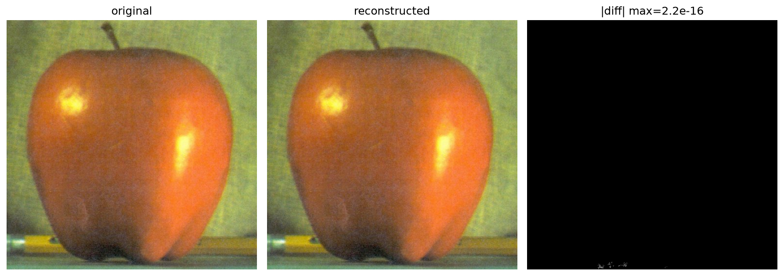
Figure 2. apple.png: original, image reconstructed by collapsing the Laplacian pyramid, and absolute difference.
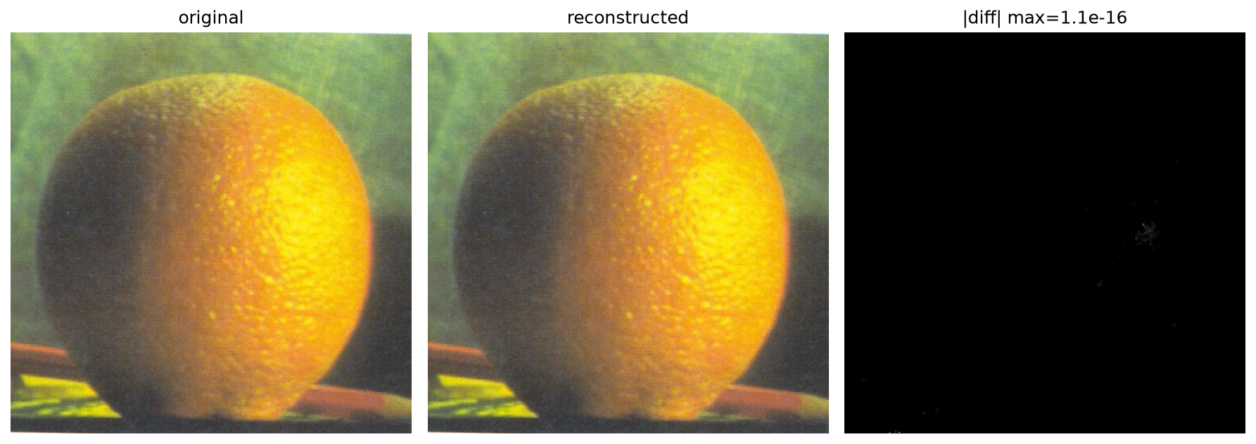
Figure 3. orange.png: original, reconstructed image, and absolute difference.

1.2. Multi-band Image Blending
Implementation. The Laplacian pyramids of apple (I_A) and orange (I_B) and the Gaussian pyramid of the mask are combined level by level and the result is collapsed. The mask is 1 on the left half (apple) and 0 on the right half (orange). For comparison, the images are also pasted directly as I_A·M + I_B·(1 − M). (scripts/Image_Blending/part1_2.py)
L_k = L_k^A · m_k + L_k^B · (1 − m_k), k = 0, …, 6
output = collapse(L), clipped to [0, 1]
Details.
- make_mask(shape, split=0.5) builds a 3-channel binary mask. Its Gaussian pyramid is computed with the same reduce as the images, so m_k at a coarse level is a strongly blurred step.
- At level k one pixel covers 2^k pixels of the original image. A transition of a few pixels in m_k therefore spans roughly 2^k original pixels: low frequencies (overall color) are mixed over a wide band, and high frequencies (texture) over a narrow band. This is why the seam disappears without the two textures overlapping.
- The coarsest level L_6 (the 8×8 Gaussian) is blended with the same rule, so the average colors of the two fruits are also mixed smoothly.
- The two inputs must have the same size (both are 512×512), which is checked with an assert.
Output.
Direct pasting leaves a sharp vertical seam. The multi-band result changes gradually from the red apple to the orange, and the dimpled orange texture ends near the center line without visible doubling. The mean absolute difference between the two results is 0.0083 (in [0, 1]).
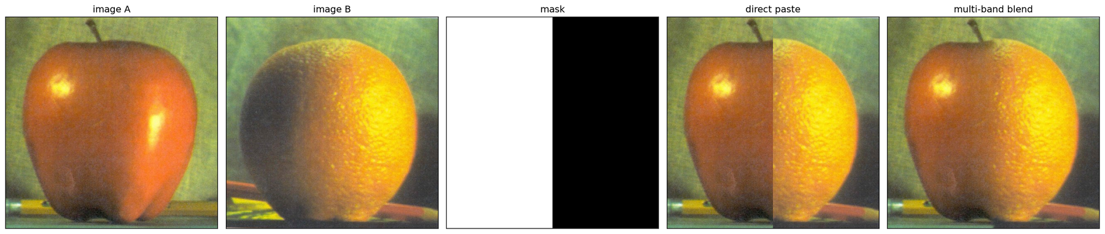
Figure 4. Inputs, mask, direct paste, and multi-band blend.
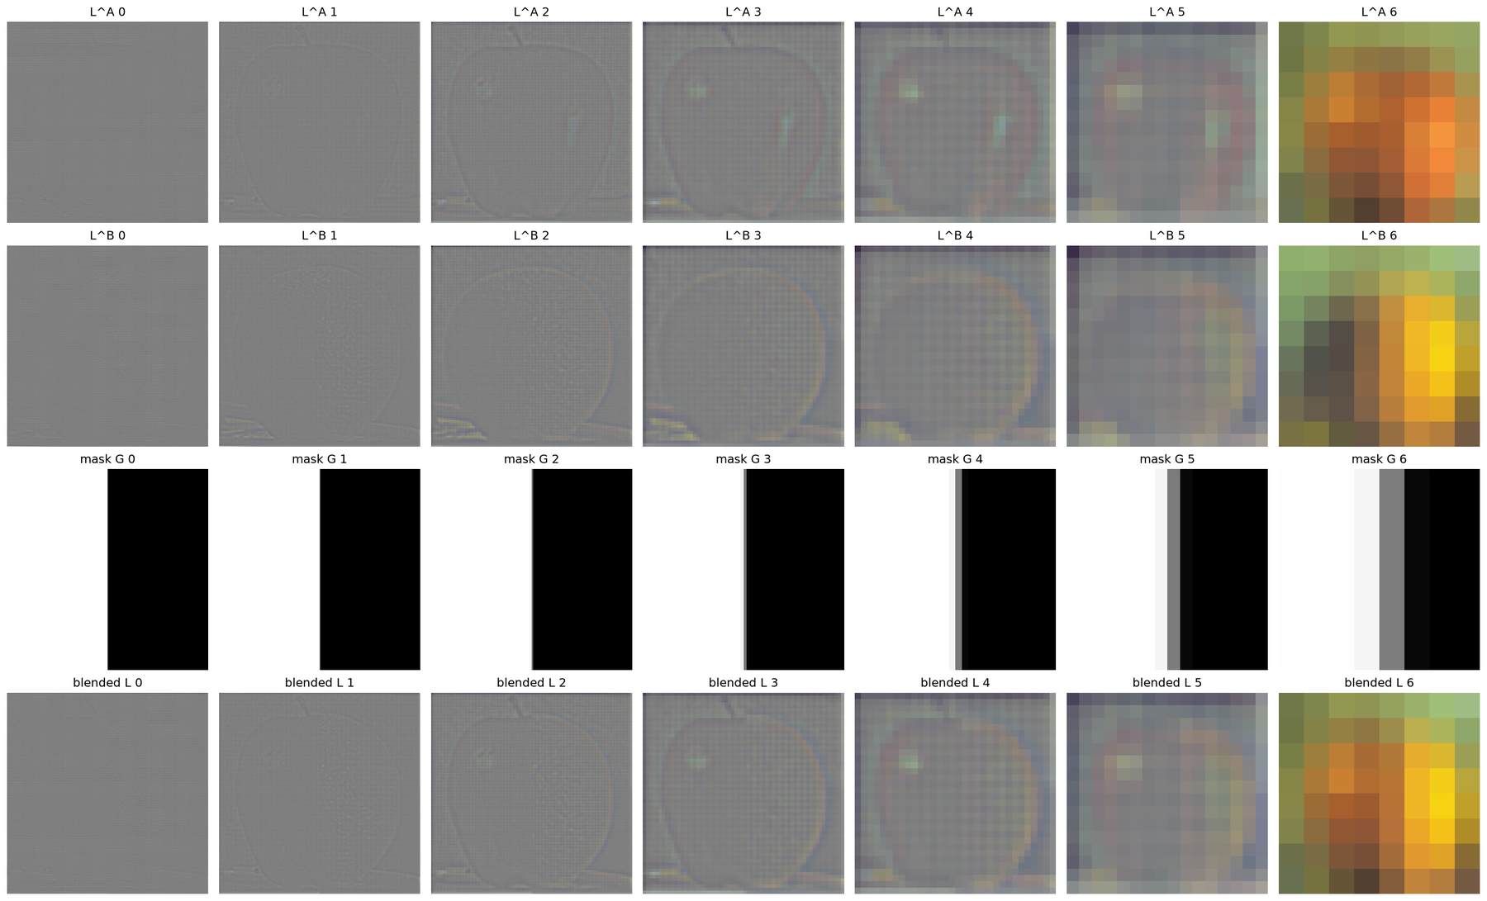
Figure 5. Laplacian pyramids of A and B, Gaussian pyramid of the mask, and the blended Laplacian pyramid.
Question. How does changing the number of pyramid levels affect the blending result? How does changing the Gaussian kernel size affect the blending result?
To answer this, the blend was repeated with 1, 3, 5 and 7 levels (5×5 kernel), and with 3×3, 5×5, 9×9 and 15×15 kernels (7 levels). The kernel σ grows with the size as σ = (size − 1)/4, so the kernel radius is 2σ and the default 5×5 keeps σ = 1. The second row of each figure enlarges the 128×128 region at the seam.
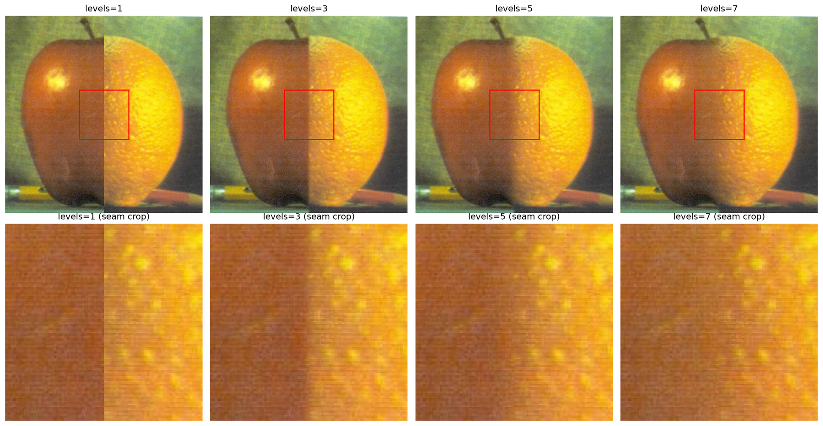
Figure 6. Blending with 1, 3, 5 and 7 pyramid levels (5×5 kernel). Bottom: seam crops.
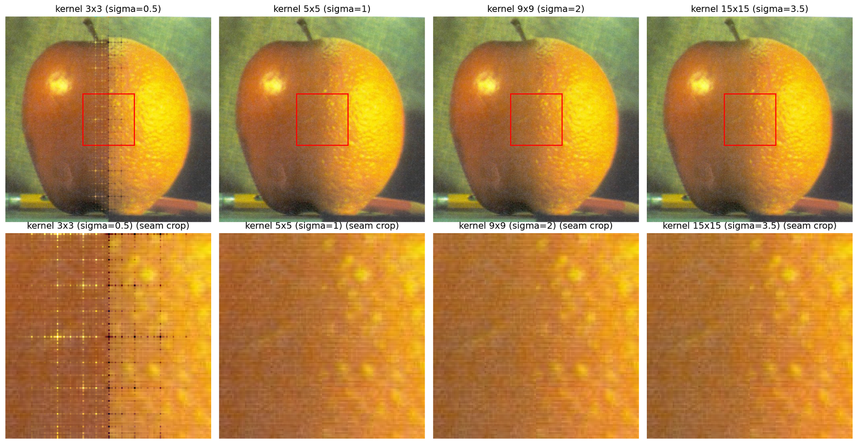
Figure 7. Blending with 3×3, 5×5, 9×9 and 15×15 kernels (7 levels). Bottom: seam crops.
Answer. Number of levels. With 1 level the pyramid is the image itself and the mask is not blurred, so the result equals direct pasting with a hard seam. With 3 levels the seam is softer but still visible as a vertical line: the coarsest level is still 128×128 and holds most of the color difference, which is mixed only over a narrow band. With 5 levels the seam becomes a faint band, and with 7 levels (coarsest level 8×8) the color difference is spread over a wide region and the seam disappears. More levels widen the region over which low frequencies are mixed. Once the seam is gone, additional levels would only spread the color transition over a larger part of the fruits.
Kernel size. The 3×3 kernel (σ = 0.5) produces a lattice of bright and dark dots in a band around the seam. Such a small σ cannot remove the frequencies above the new Nyquist limit before subsampling, and it cannot interpolate the zero-inserted samples in expand, so every level leaves a periodic residual. For a single image these residuals cancel exactly in collapse, but in blending the levels of two images are mixed with weights that change across the seam, so the residuals no longer cancel there. Away from the seam the mask is 0 or 1 at every level and the artifact does not appear. From 5×5 the result is clean. The 9×9 and 15×15 kernels blur the mask more at every level, so the transition becomes slightly wider and smoother, but the seam crops look almost the same as with 5×5, while the convolution cost grows from 25 to 225 taps. The kernel must be wide enough to suppress aliasing (σ ≈ 1 or more). Beyond that its effect is small.

2. Image Enhancement
Both parts use palace.jpeg (1500 × 2000, W × H), a photograph of carved stucco arches with a bright courtyard.

Part 1. Detail Enhancement: Unsharp Masking
Implementation. Each RGB channel is processed with I_out = I_in + α(I_in − G_σ ∗ I_in), reusing get_gaussian_kernel and conv2d from Part 1.1. The single-convolution version builds one kernel K = (1 + α)δ − αG_σ, where δ is the identity kernel (1 at the center), and computes I_out = K ∗ I_in. α ∈ {1, 2, 3, 4} is compared at σ = 1.4, and σ ∈ {0.5, 1, 2, 3} at α = 1.5. (scripts/Image_Enhancement/part2_1.py)
Details.
- Single kernel. Because convolution is linear, I + α(I − G∗I) = (1 + α)I − αG∗I = ((1 + α)δ − αG) ∗ I. The two versions differ by at most 6.0e-15 over all eight settings, i.e. only by floating-point rounding.
- Kernel size. kernel_size(σ) = 2⌈3σ⌉ + 1 keeps the Gaussian up to 3σ (5×5 for σ = 0.5, 9×9 for σ = 1.4, 19×19 for σ = 3).
- Flat regions. The sum of K is (1 + α) − α = 1, so a region of constant intensity is unchanged. Only the neighborhood of edges and texture changes.
- Range. The output can leave [0, 1] near strong edges (overshoot). It is clipped to [0, 1] for display and saving.
- Crops. Detail is easier to judge at pixel level, so each comparison also shows a 128×128 crop taken 250 px above the image center, on the carved stucco.
Output.
Setting | Kernel | max |two-step − single kernel|
α = 1, 2, 3, 4 (σ = 1.4) | 9×9 | 2.66e-15, 3.00e-15, 5.22e-15, 6.00e-15
σ = 0.5, 1.0, 2.0, 3.0 (α = 1.5) | 5×5, 7×7, 13×13, 19×19 | 1.33e-15, 1.89e-15, 3.77e-15, 5.55e-15

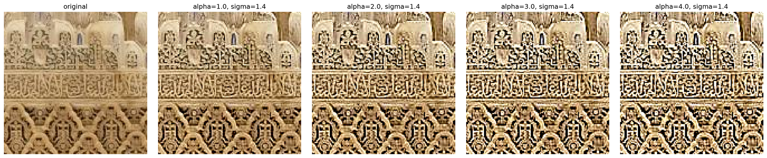
Figure 8. Effect of α at σ = 1.4 (128×128 crop).
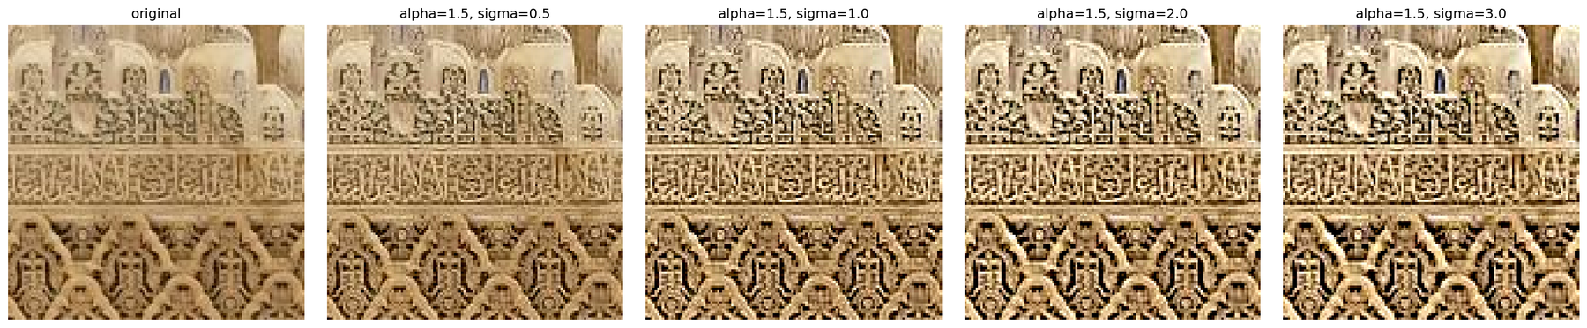
Figure 9. Effect of σ at α = 1.5 (128×128 crop).
The chosen setting is α = 1.5 and σ = 1.4. It separates the blurred stucco pattern clearly while the dark grooves do not yet turn black.
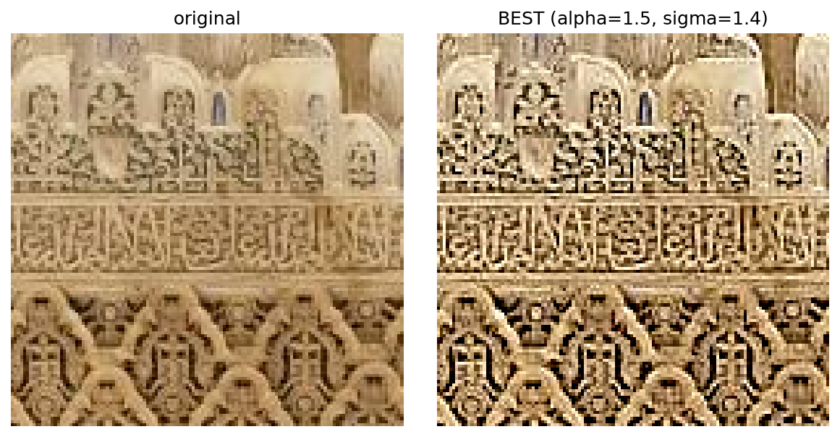
Figure 10. Original and chosen result (α = 1.5, σ = 1.4), crop.
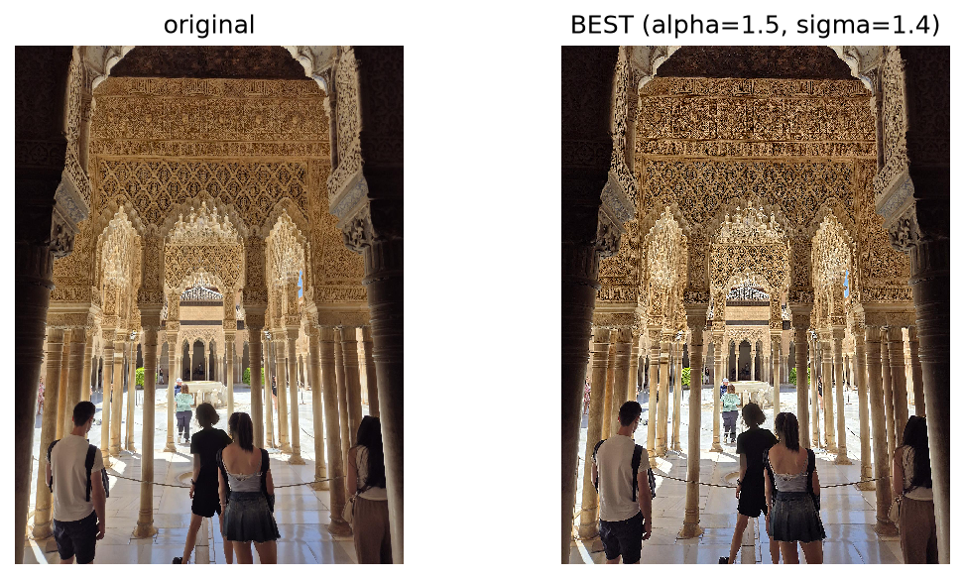
Figure 11. Original and chosen result (α = 1.5, σ = 1.4), full image.
Question. What are the respective effects of α and σ on the sharpening result?
Answer. α controls the strength. It scales the high-frequency component that is added back. At α = 1 the grooves of the carving already become darker and the ridges brighter. As α grows to 2–4 this contrast becomes progressively harsher, and at α = 3–4 dark grooves are pushed to black and highlights to white. These clipped overshoots appear as outlines (halos) around the pattern, and JPEG noise and blocking are amplified as well.
σ controls the scale. I − G_σ ∗ I keeps structures smaller than about σ, so σ decides what counts as detail. At σ = 0.5 only pixel-scale detail is boosted and the change is subtle. σ = 1–1.4 sharpens the fine ornament. At σ = 2–3 larger structures are boosted: the outlines around the ornament become thicker and darker, the overall local contrast rises, and halos become wider. In short, α sets how much is added and σ sets which details (and how wide a halo) are affected.

Part 2. Contrast Enhancement: Histogram Equalization
Implementation. The histogram h(r_k) of the 256 intensity levels is computed with np.bincount, the cumulative histogram with np.cumsum, and s_k = c(r_k)/MN. The mapping T(r_k) = round(255·s_k) is applied as a lookup table. For the color image, RGB is converted to YCbCr (BT.601 full range, implemented with its conversion matrix), only Y is equalized, Cb and Cr are kept, and the result is converted back to RGB. (scripts/Image_Enhancement/part2_2.py)
h = np.bincount(Y.ravel(), minlength=256)
c = np.cumsum(h); s = c / Y.size
lut = np.round(255 * s).astype(np.uint8); Y_eq = lut[Y]
Details.
- Y is quantized to 8 bits (0–255) before the histogram, so the 256 levels r_k match the equation. s_k lies in [0, 1] and is scaled by L − 1 = 255 to map back to intensities.
- The mapping is a cumulative sum, so it is monotonic: the order of intensities is preserved. This was checked in the log (range 0–255, monotonic = True).
- Equalizing R, G and B separately would apply a different mapping to each channel and shift the colors. Equalizing only Y changes brightness while keeping the chroma Cb and Cr.
- After the inverse conversion the RGB values are clipped to [0, 1].
Output.
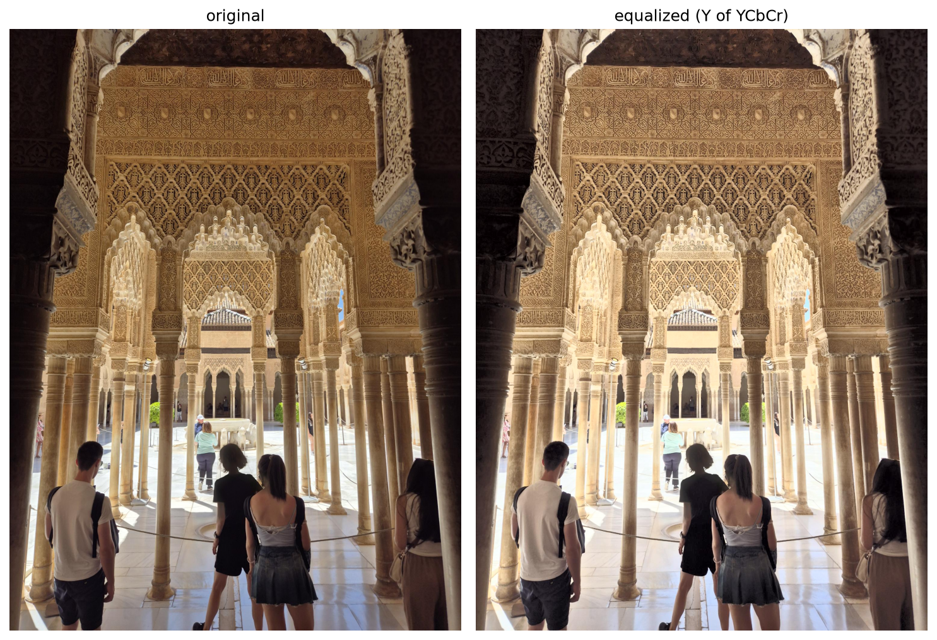
Figure 12. Original and histogram-equalized image (Y channel of YCbCr).
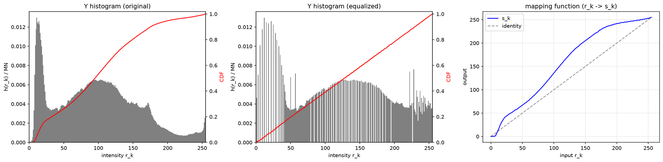
Figure 13. Y histogram with CDF (red) before and after equalization, and the mapping function s_k.
Histogram. The original Y histogram has a tall peak at about 10–20 (dark pillars and shaded foreground), a broad mode around 100, and a spike at 255 (saturated courtyard), so it is clearly multi-modal. After equalization the CDF is close to a straight line, as intended. The histogram becomes comb-shaped with empty bins: a discrete level can be moved but not split, so the tall dark peak remains as a few tall bins.
Mapping. The mapping curve lies above the identity everywhere, so the whole image becomes brighter. Inputs 8–25 are stretched to about 0–40 (steep slope), mid-tones are lifted, and inputs above about 180 are compressed into about 225–255 (nearly flat slope).
Failure case. This image is a failure case of global equalization. The output range is allotted in proportion to the number of pixels, so the many dark and mid-tone pixels receive most of it, while the relatively few bright pixels of the courtyard and floor are squeezed into the top of the range. The courtyard therefore merges into near-white, mid-tones look hazy (muddy) rather than more contrasty, and colors in the brightened regions look faded because Y increases while Cb and Cr stay the same. The steep slope in the darkest range also amplifies noise there. A bimodal histogram such as this one (dark shadows and a bright courtyard) is exactly where a single global mapping over-enhances one region at the expense of another.

3. HDRI and Tone Mapping
All three exposure sets in the HDRI folder are processed. A shared module, hdr_common.py, loads each set with its exposure times and defines the weighting functions. The provided MMSPG_0026.hdr is used in Part 3(c). 37.zip contains the same files as the image_1 set.
Set | Images | Size | Exposure times Δt | Source of Δt
image_1 | 9 | 5472×3648 | 1/500, 1/320, 1/200, 1/100, 1/60, 1/40, 1/15, 1/10, 1/6 s | README (image_1_x = 1/x s), matches EXIF (ISO 160, f/1.8)
office | 6 | 903×600 | 1/30, 1/10, 1/3, 0.625, 1.3, 4 s | EXIF ExposureTime of the files (f/22), written in hdr_common.py
tower | 3 | 341×512 | 1, 2, 4 (relative) | not provided: assumed 2^(k−1) for under, mean, over

Part 1. Radiometric Calibration: Linearize Bracketed Images
Implementation. N = 1000 pixel positions are sampled at random and read from every exposure. For each channel the system ‖Av − b‖² is built and solved with np.linalg.lstsq, giving g and log E_i. The default is λ = 50, and λ ∈ {1, 10, 50, 100, 1000} is compared. The images are linearized as I_lin = exp(g(I)) with a lookup table. The estimated g is saved to crf.npz for Part 2. (scripts/HDRI_and_Tone_Mapping/part3_1.py: build_system, solve_crf, linearize)
Details.
- Unknown vector (1.1). Columns 0–255 of A correspond to g(0)…g(255) and columns 256…256+N−1 to log E_1…log E_N.
- Data equations (1.2). The N·P rows are filled at once: np.repeat and np.tile give the pixel index i and exposure index j of each row, +w_ij is written in column I_ij, −w_ij in column 256 + i, and b = w_ij·log Δt_j.
- Scale constraint (1.3). One row with A[NP, 128] = 1 and b = 0 fixes g(128) = 0.
- Smoothness (1.4). For z = 1…254 one row holds √λ·w(z/255)·[1, −2, 1] at columns z − 1, z, z + 1, with b = 0.
- Solution (1.5). A is (NP + 255) × (256 + N): 9255 × 1256 for image_1, 6255 × 1256 for office and 3255 × 1256 for tower. This is small enough for a dense matrix, so no sparse representation is needed. R, G and B are solved separately.
- Weighting. The tent w(z) = min(z, 1 − z) is used without the Z_min/Z_max cut-off for the CRF. With the cut-off of Part 2 (0.05/0.95), every data and smoothness equation for z below about 13 or above about 242 would have weight 0 and g would be undetermined there. Part 2 applies the cut-off when merging.
- Display. The linearized images in the figure are subsampled. The lookup table works pixel by pixel, so subsampling before or after it gives the same values.
Output.
λ | weighted data residual RMS (R, G, B) | mean |∇²g|
1 | 0.0305, 0.0281, 0.0257 | 0.0494
10 | 0.0309, 0.0285, 0.0261 | 0.0163
50 | 0.0310, 0.0287, 0.0263 | 0.0064
100 | 0.0311, 0.0288, 0.0263 | 0.0044
1000 | 0.0312, 0.0289, 0.0264 | 0.0016

(image_1. The same trend holds for office and tower; see the log files.)
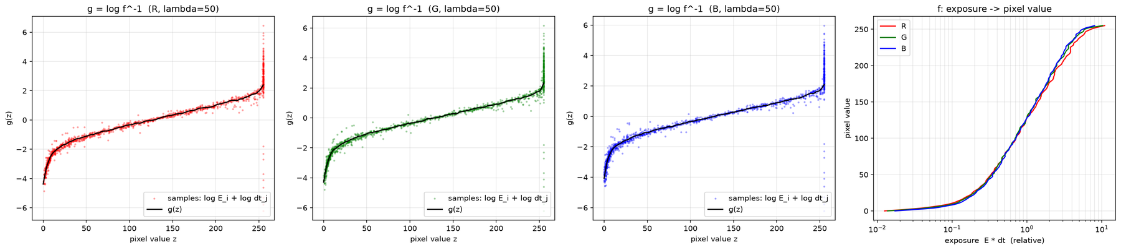
Figure 14. image_1: g = log f⁻¹ for R, G, B (λ = 50) with sample points, and f (exposure to pixel value).
CRF. g is steep near z = 0, almost linear in the middle and rises sharply near 255, which is the typical shape of a camera response. In the middle range the sample points log E_i + log Δt_j lie close to the curve. The points at z = 255 spread vertically: they are saturated, get weight 0 and carry no information. The curves of R, G and B are nearly identical.
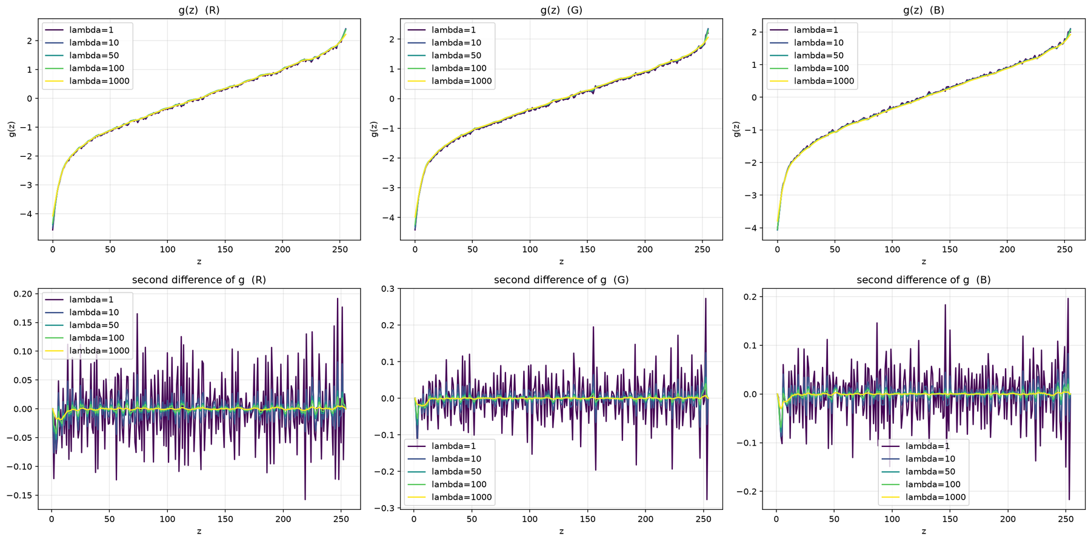
Figure 15. image_1: g for λ = 1, 10, 50, 100, 1000 (top) and its second difference (bottom).
Effect of λ. The overall shape of g does not change with λ. λ = 1 leaves small wiggles (second difference up to about ±0.2–0.3), and from λ = 100 the second difference is nearly flat. The data residual grows only from 0.0305 to 0.0312 (R) while mean |∇²g| drops from 0.049 to 0.0016, so smoothing costs almost nothing in fit here. The visible exception is the dark end, where the true curve bends most: at z = 0 the λ = 1000 curve starts higher (about −4.0 against −4.5 for λ = 1 in R), i.e. heavy smoothing flattens the strongly curved part. A value in the recommended range (10–100) is therefore a good compromise, and λ = 50 is used.
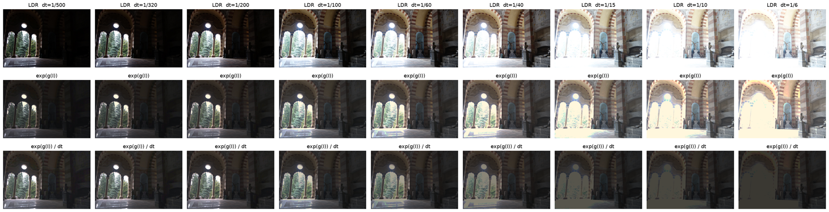
Figure 16. image_1: input exposures (top), linearized exp(g(I)) (middle), and exp(g(I))/Δt (bottom). Display gamma 2.2.
Linearization. After dividing by Δt, the six exposures from 1/500 s to 1/40 s look alike although their inputs differ by more than 3 stops, which shows that the images are now proportional to radiance. In 1/15–1/6 s the window region is saturated: its linearized value is the clipped maximum, so dividing by Δt gives a flat, too dark area. These pixels are excluded by Z_max in Part 2.
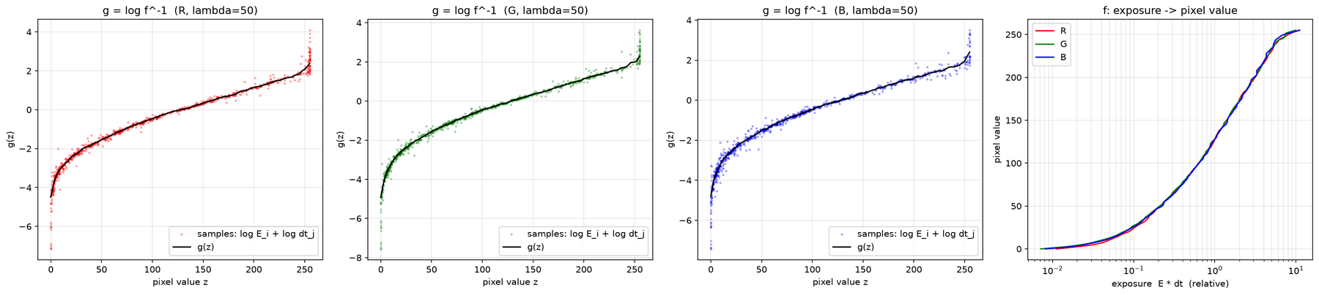
Figure 17. office: g and f (λ = 50).
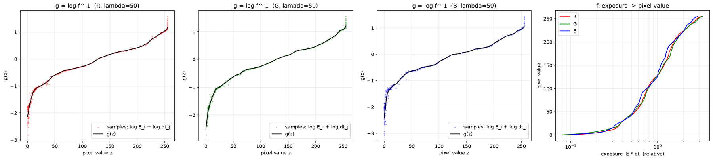
Figure 18. tower: g and f (λ = 50).
Other sets. office gives the same stable shape. tower is the least reliable: with only 3 exposures each pixel contributes 3 equations, g shows bumps near z ≈ 50, 100, 125 and 175, and the f curves of R, G and B differ visibly. Its small residual (about 0.0025) reflects the small number of constraints rather than accuracy. Its exposure ratios are also only assumed (2^(k−1)); if the true ratios differ, the whole g is distorted.

Part 2. Merge Exposure Brackets into HDR Image
Implementation. For each pixel and channel, the weighted average of log(I_lin + ε) − log Δt_j over all exposures is computed and exponentiated, with ε = 1e-6 and the g from Part 1. The three weighting functions (uniform, tent, Gaussian, Z_min = 0.05, Z_max = 0.95) are evaluated in the same pass. The tent result is saved as Radiance .hdr with cv2.imwrite and read back to check it. (scripts/HDRI_and_Tone_Mapping/part3_2.py: merge_hdr)
Details.
- Lookup tables. The weight and log(exp(g(z)) + ε) depend only on the 8-bit value z, so both are 256-entry tables. Each exposure is read once and accumulated into numerator and denominator arrays of shape (3, H, W) in float32. This keeps the 5472×3648 image_1 set manageable at full resolution.
- Zero weight sum. A pixel whose value is outside [Z_min, Z_max] in every exposure (saturated in all of them or dark in all of them) has Σw = 0. For such pixels the exposure whose z is closest to 0.5 is used instead: the shortest exposure for highlights that clip everywhere, the longest for very dark pixels. This affects 1.42 % of the pixels in image_1, 0.08 % in office and 1.63 % in tower. The three weights share the same support, so the fraction is identical for all of them.
- Comparison of weights. Besides previews, the difference |log2 E_k − log2 E_tent| (in stops) is shown as a map, together with crops where it is largest (A) and in a dark region (B). All previews use the same simple global tone curve so that they are comparable.
Output.
Set | Σw = 0 (fallback) | Dynamic range (0.1–99.9 %) | uniform − tent: mean / 99.9 % | Gaussian − tent: mean / 99.9 %
image_1 | 1.42 % | 10.8 stops | 0.040 / 0.32 stops | 0.018 / 0.16 stops
office | 0.08 % | 10.1 stops | 0.027 / 0.29 stops | 0.012 / 0.14 stops
tower | 1.63 % | 5.5 stops | 0.005 / 0.07 stops | 0.002 / 0.03 stops

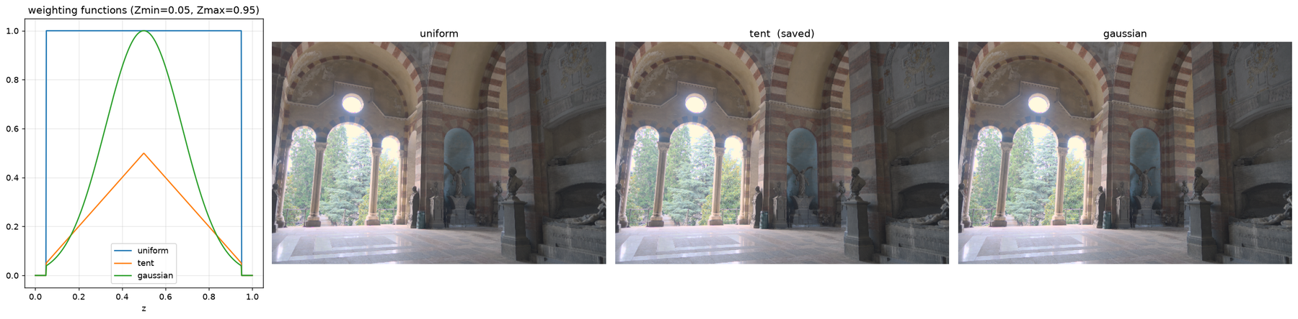
Figure 19. image_1: weighting functions and HDR previews for each weight.
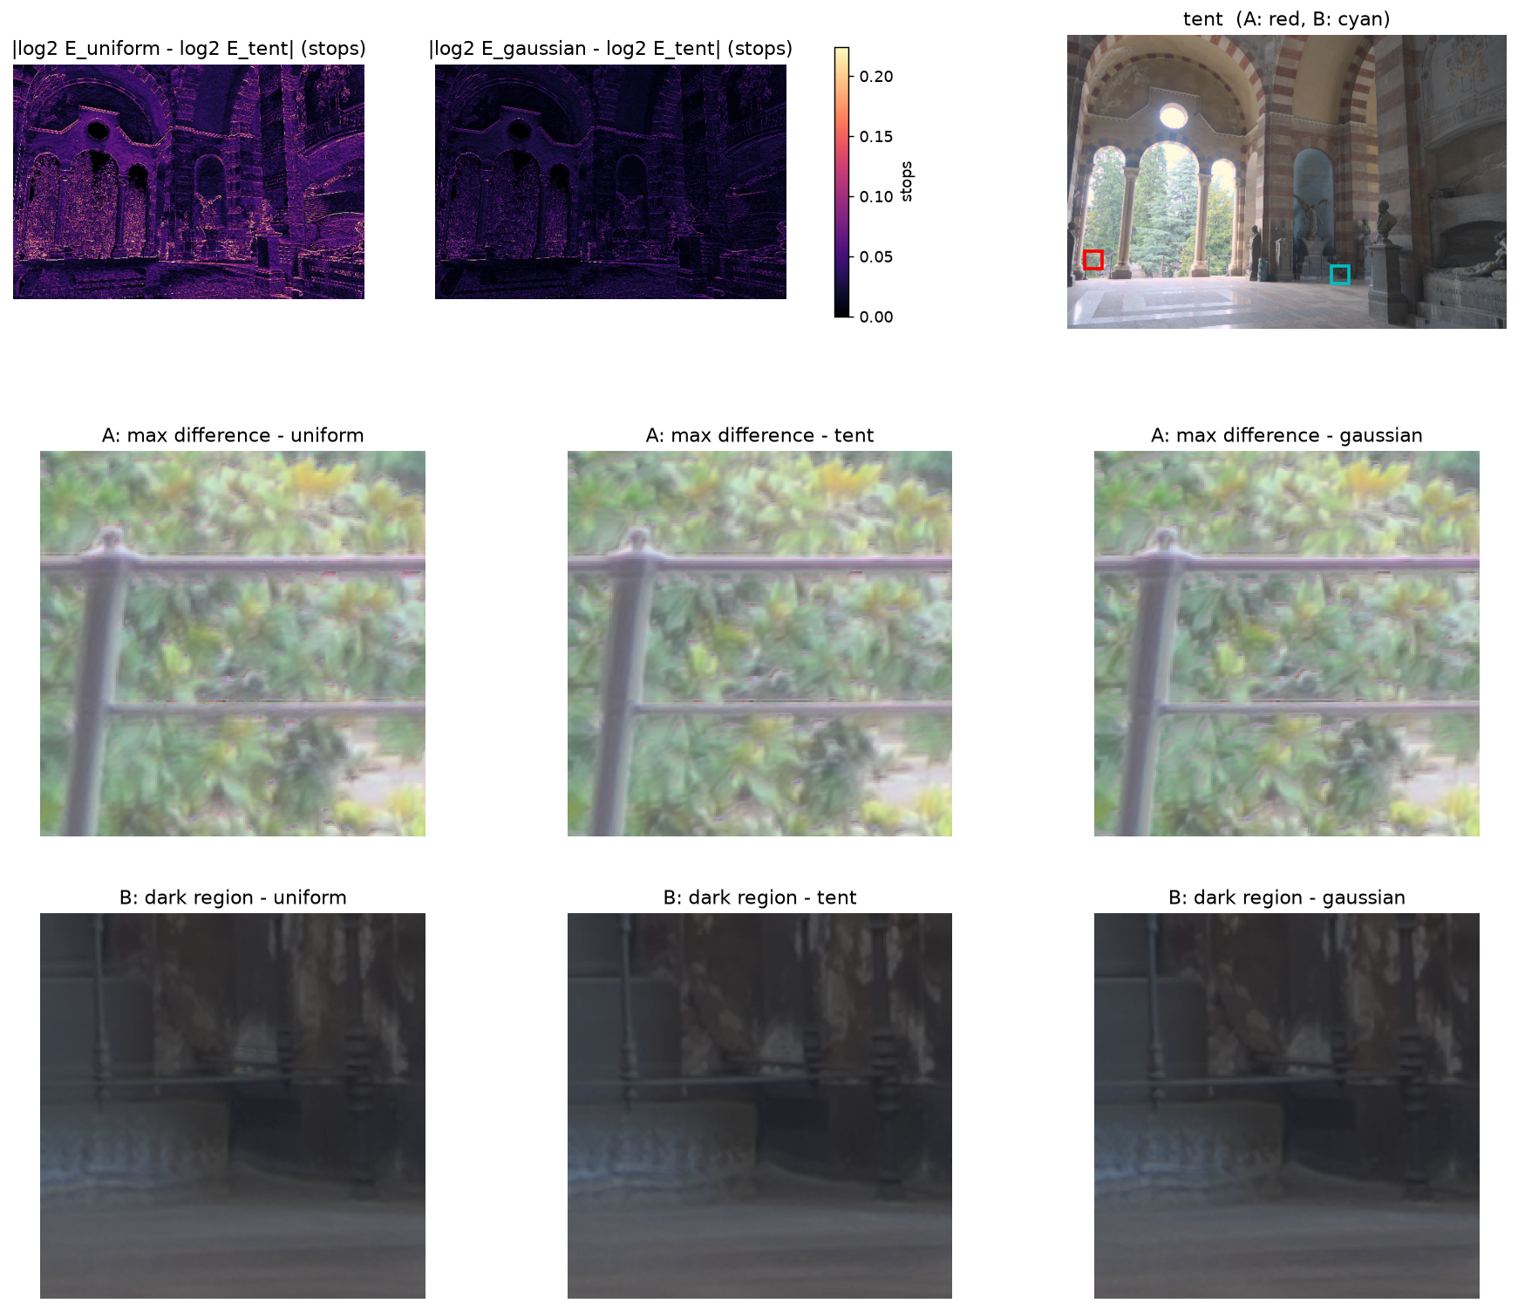
Figure 20. image_1: difference to the tent result in stops, and crops A (largest difference) and B (dark region).
Comparison. At preview size the three results are almost indistinguishable. The mean difference is 0.04 stops (about 3 % in radiance) for uniform and 0.018 stops for Gaussian, compared with tent. The weights only change how the radiance estimates of the individual exposures are averaged. When the CRF is accurate and the exposures agree, the average is nearly independent of the weights, so the differences concentrate on edges and textured regions, while flat regions show almost no difference.
Ghosting. In image_1 the largest differences are in the foliage behind the arches (crop A). The leaves move between exposures taken over 1/500–1/6 s, so the exposures do not agree there and the result depends on the weights. The merged image shows ghosting in this region with every weight: weighting cannot remove motion between exposures. office and tower show no such region (static scenes, and tower has only 3 exposures), and their differences are even smaller.
Choice. No weight is clearly more pleasing visually. Tent is chosen: unlike uniform it fades an exposure in and out smoothly at Z_min/Z_max instead of switching it on and off, it is the weight of Debevec and Malik and the one used for the CRF, and the Gaussian result is within 0.02 stops of it. The HDR images are saved as results/HDRI_and_Tone_Mapping/part3_2/<set>/<set>.hdr. tower reaches only 5.5 stops, limited by its 3 exposures.

Part 3. Tone Mapping
Implementation. The luminance L_w = 0.2126R + 0.7152G + 0.0722B is scaled by the log-average luminance with key a = 0.18. Both global operators are applied to the scaled luminance L, and the color is restored by scaling RGB with L_d/L_w. The result is clipped to [0, 1], encoded with gamma 1/2.2 and stored in 8 bits. (scripts/HDRI_and_Tone_Mapping/part3_3.py)
L̄ = exp(mean(log(δ + L_w))), L = (a / L̄) · L_w, a = 0.18, δ = 1e-6
(a) Reinhard: L_d = L (1 + L / L_white²) / (1 + L), L_white = B · max(L)
(b) Logarithmic: L_d = log(1 + βL) / log(1 + β L_max), L_max = max(L)
C_d = C · L_d / L_w for C ∈ {R, G, B}
Details.
- B ∈ {0.1, 0.25, 0.5, 1.0} and β ∈ {1, 10, 100, 1000} are compared. The settings saved at full resolution are B = 1.0 and β = 10.
- Both operators are global: the curve depends only on L̄ and max(L), which are computed on the full-resolution image. The comparison figures apply the same curve to a subsampled image.
- Scaling RGB by L_d/L_w keeps the ratios between channels, so hue is preserved. Channels that exceed 1 after scaling are clipped.
- (c) The provided MMSPG_0026.hdr (1920×1080) is processed with the same code. Only the HDR file is provided, so its result is compared with the scaled image without tone mapping instead of input exposures.
Output.
Image | log-average L̄ | max(L) (scaled)
image_1 | 44.08 | 20.86
office | 0.860 | 6.41
tower | 0.321 | 1.82
MMSPG_0026 | 79.32 | 4.81

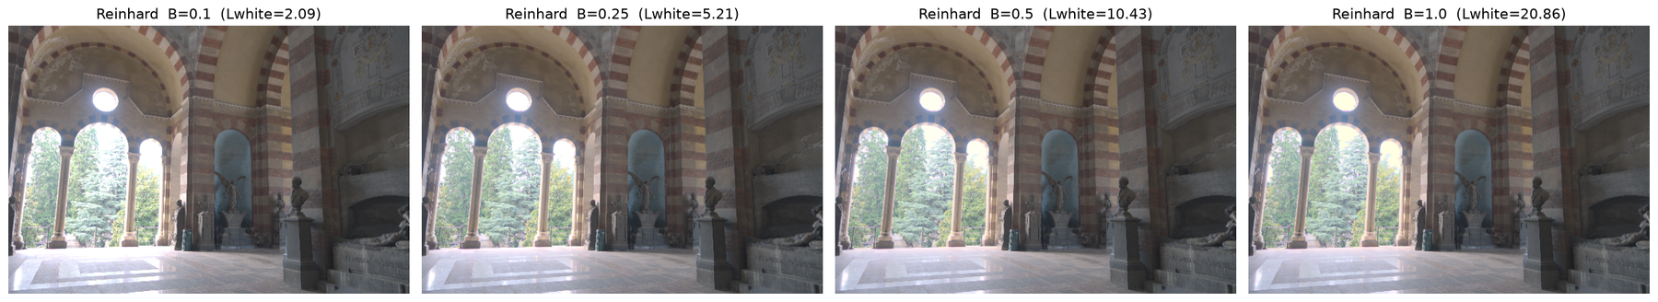
Figure 21. image_1: Reinhard with B = 0.1, 0.25, 0.5, 1.0.
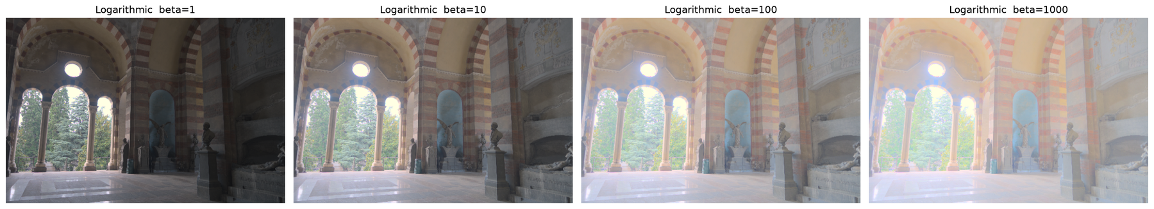
Figure 22. image_1: Logarithmic with β = 1, 10, 100, 1000.
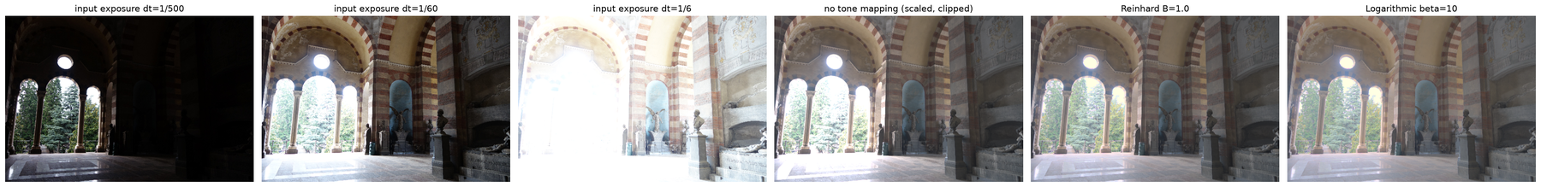
Figure 23. image_1: input exposures (1/500, 1/60, 1/6 s), scaled image without tone mapping, Reinhard (B = 1.0) and Logarithmic (β = 10).
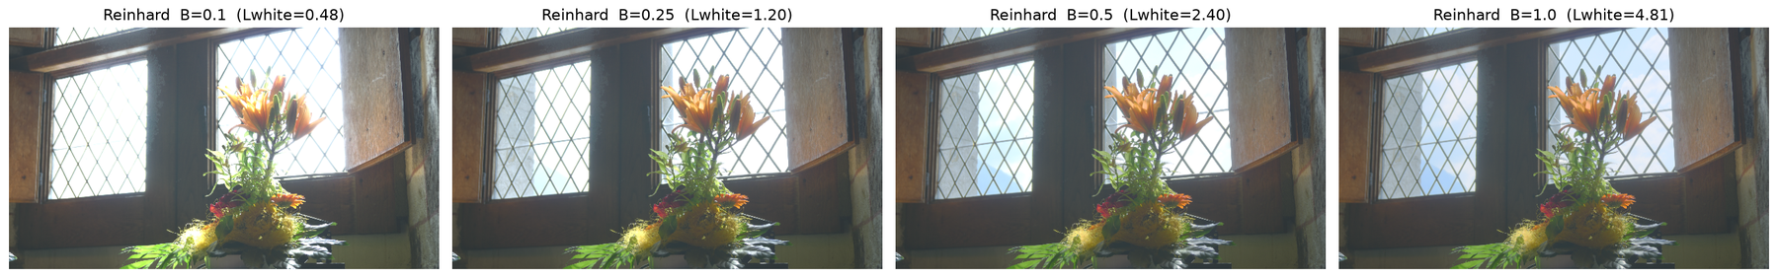
Figure 24. MMSPG_0026 (c): Reinhard with B = 0.1, 0.25, 0.5, 1.0.
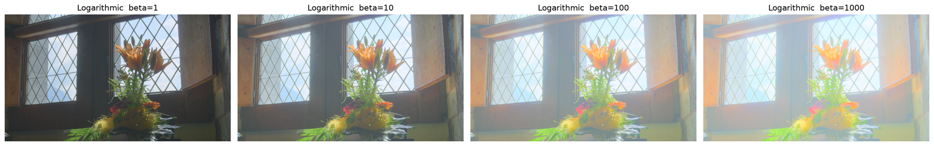
Figure 25. MMSPG_0026 (c): Logarithmic with β = 1, 10, 100, 1000.
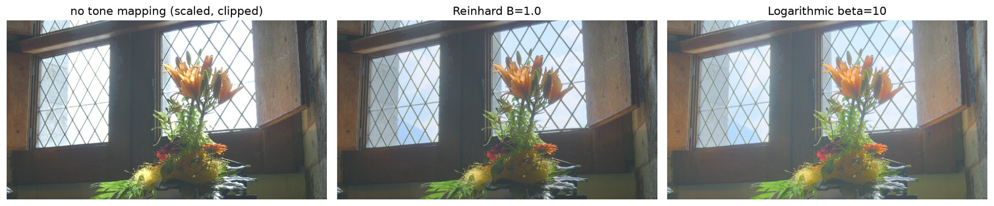
Figure 26. MMSPG_0026 (c): without tone mapping, Reinhard (B = 1.0) and Logarithmic (β = 10).
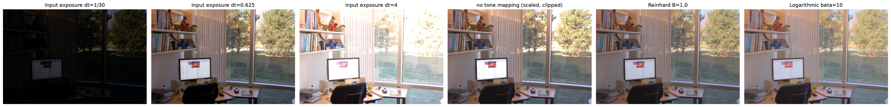
Figure 27. office: input exposures, without tone mapping, Reinhard (B = 1.0) and Logarithmic (β = 10).
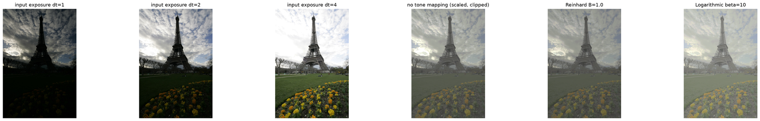
Figure 28. tower: input exposures, without tone mapping, Reinhard (B = 1.0) and Logarithmic (β = 10).
Discussion.
Parameter B. L_white is the luminance that is mapped to white, and every L above it gives L_d > 1 and is clipped. With B = 0.1 (L_white = 2.09 for image_1, 0.48 for MMSPG) the windows burn out. B = 1.0 sets L_white = max(L), so nothing is clipped, at the cost of a flatter image. B = 0.25–0.5 lies in between.
Parameter β. β = 1 gives a dark, contrasty image. β = 100 and 1000 lift the shadows and mid-tones so much that black turns gray, and the image becomes hazy and desaturated for all four inputs. β = 10 is the most balanced.
Reinhard vs. logarithmic. To compare the two operators fairly, both should keep the highlights: B = 1.0 against β = 10. For MMSPG (L_max = 4.81) the two curves give:
Scaled L | Reinhard (B = 1.0) | Logarithmic (β = 10)
0.18 (mid-tone) | 0.154 | 0.265
2.0 | 0.724 | 0.782
3.0 | 0.847 | 0.882
4.81 (max) | 1.0 | 1.0

At B = 1.0 both keep the sky and clouds behind the window panes, which are clipped to white without tone mapping, and their highlights are within a few percent of each other. The difference is in the dark and mid-tones, which the logarithmic curve maps about 1.7 times brighter. With B = 0.5, Reinhard clipped every L above 2.4, which is why the window looked better in the logarithmic result before B was raised.
Preferred method. The logarithmic operator (β = 10) is preferred. On MMSPG it keeps the view outside the window and shows the plant detail and colors in the shaded interior better, while Reinhard renders the flowers slightly darker. Reinhard keeps more mid-tone contrast, and on image_1 the two results look similar. tower is a weak case for both: its max(L) is only 1.82, so Reinhard is almost identical to the image without tone mapping, and the result looks flat and gray, consistent with its 5.5-stop HDR.
Comparison with the input exposures. No single exposure shows both the bright and the dark parts of the scene. In image_1 the 1/500 s exposure shows the trees behind the arches but leaves the interior black, and the 1/6 s exposure shows the interior but turns the arches white. The tone-mapped images show both at once. The image scaled without compression clips the highlights (the MMSPG window becomes white), which shows that the range has to be compressed and not only scaled.
Question. What information is lost or compressed during tone mapping?
Answer. A range of about 10–11 stops (image_1, office) is mapped into one 8-bit display range, so several kinds of information are lost or compressed:
- Absolute radiance and true ratios. The output only keeps the order of brightness. The ratio between the window and the interior is much smaller in the tone-mapped image than in the scene.
- Local contrast in the compressed range. Where the curve is flat, nearby values become almost equal. Reinhard compresses the highlights (and clips everything above L_white when B < 1), and the logarithmic curve compresses the contrast of mid-tones and highlights, which makes large β look hazy.
- Precision. After gamma encoding only 256 levels remain, so small radiance differences, especially in the compressed parts of the curve, are merged into the same code.
- Color. Scaling RGB by L_d/L_w and clipping each channel can desaturate or shift saturated colors in bright regions.
- Spatial adaptivity. A global operator applies one curve to the whole image, so the same texture is rendered with different contrast in a dark and in a bright region.
Some information is already missing before tone mapping: pixels saturated or underexposed in every exposure (fallback pixels) and moving regions (ghosting in image_1) are not recovered by the HDR merge itself.

Use of AI Tools

