# Homework Assignment (Problem Set) 3:

Note, Problem Set 3 directly focuses on Modules 5 and 6: Integer Programs, Nonlinear and Multiobjective Programming.

***5 questions***

## Rubric:

All questions worth 30 points

30 Points: Answer and solution are fully correct and detailed professionally.

26-29 Points: Answer and solution are deficient in some manner but mostly correct.

21-25 Points: Answer and solution are missing a key element or two.

1-20 Points: Answer and solution are missing multiple elements are significantly deficient/incomprehensible.

0 Points: No answer provided.

**1.** An engineer at Fertilizer Company has synthesized a sensational new fertilizer made of just two interchangeable basic raw materials. The company wants to take advantage of this opportunity and produce as much as possible of the new fertilizer. The company currently has $40,000 to buy raw materials at a unit price of $8000 and $5000 per unit, respectively. When amounts *x1* and *x2* of the basic raw materials are combined, a quantity *q* of fertilizer results given by: $q=4x_{1}+2x_{2}-0.5x_{1}^{2}-0.25x_{2}^{2}$

Part A: Formulate as a constrained nonlinear program. Clearly indicate the variables, objective function, and constraints.

Definitions:

*x1* : units to purchase of material 1

*x2:* units to purchase of material 2

Maximize objective function: $q=4x_{1}+2x_{2}-0.5x_{1}^{2}-0.25x_{2}^{2}$

Constrained by:

*8000 * x1* + 5000 * *x2* <= 40000

Part B: Solve the Program (provide exact values for all variables and the optimal objective function).

|  |
| --- |
| Objective : -11.3684210526224  Successful solution  ---------------------------------------------------  [3.1578947368, 2.947368421] |

**2.** The area of a triangle with sides of length *a*, *b*, and *c* is $\sqrt{s(s-a)(s-b)(s-c)}$, where *s* is half the perimeter of the triangle. We have 60 feet of fence and want to fence a triangular-shaped area.

Part A: Formulate the problem as a constrained nonlinear program that will enable us to maximize the area of the fenced area, with constraints. Clearly indicate the variables, objective function, and constraints.

Hint: *The length of a side of a triangle must be less than or equal to the sum of the lengths of the other two sides.*

Definitions:

*a, b, c: lengths of 3 sides of the triangles*

*s: half the perimeter of the triangle*

Maximize objective function:  

Constrained by:

a + b + c <= 60

a <= b + c

b <= a + c

c <= a + b

s == (a + b + c)/2

Part B: Solve the Program (provide exact values for all variables and the optimal objective function).

|  |
| --- |
| Objective : -173.205080814410  Successful solution  ---------------------------------------------------  [20.000000003, 20.000000003, 20.000000003, 30.000000005] |

**3.** The Tiny Toy Company makes three types of new toys: the tiny tank, the tiny truck, and the tiny turtle. Plastic used in one unit of each is 1.5, 2.0 and 1.0 pounds, respectively. Rubber for one unit of each toy is 0.5, 0.5, and 1.0 pounds, respectively. Also, each tank uses 0.3 pounds of metal and the truck uses 0.6 pounds of metal during production. The average weekly availability for plastic is 16,000 pounds, 9,000 pounds of metal, and 5,000 pounds of rubber. It takes two hours of labor to make one tank, two hours for one truck, and one hour for a turtle. The company allows no more than 40 hours a week for production (priority #1). Finally, the cost of manufacturing one tank is $7, 1 truck is $5 and 1 turtle is $4; a target budget of $164,000 is initially used as a guideline for the company to follow.

1. Minimize over-utilization of the weekly available supply of materials used in making the toys and place twice as much emphasis on the plastic (priority #2)
2. Minimize the under and over-utilization of the budget. Maximize available labor hour usage (priority #3).

Formulate the above decision problem as a single linear goal program. Clearly identify your achievement vector (i.e., hierarchy of priority levels for the goals). Do not solve.

Definitions:

*a: number of tiny tanks produced*

*r: number of tiny trucks produced*

*u: number of tiny turtles produced*

Priority #1, minimize labor overage

2a + 2r + u + η1 – ρ1 <= 40

priority 2, minimize overutilization of supplies:

1.5a + 2r + u + η2 – ρ2 <= 16000

.5a + .5r + u+ η3 – ρ3 <= 5000

.3a + .6r + η4 – ρ4 <= 9000

7a + 5r + 4u + η5 – ρ5 <= 164000

Lex Min

4. XYZ Company is planning an advertising campaign for its new product. The media considered are television and radio. Rated exposures per thousand dollars of advertising expenditure are 10,000 for TV and 7,500 for radio. Management has agreed that the campaign cannot be judged successful if total exposures are under 750,000. The campaign would be viewed as superbly successful if 1 million exposures occurred. In addition, the company has realized that the two most important audiences for its product are persons 18 to 21 years of age and persons 25 to 30 years of age. The following table estimates the number of individuals in the two age groups expected to be exposed to advertisements per $ 1,000 of expenditures:

|  |
| --- |
| Exposures per $1000  Age Television Radio |
| 18‑21 2,500 3,000  25‑30 3,000 1,500 |

Management has rank ordered five goals it wishes to achieve, arranged from highest to lowest priorities.

1. Achieve total exposures of at least 750,000 persons.
2. Avoid expenditures of more than $100,000.
3. Avoid expenditures of more than $70,000 for television advertisements.
4. Achieve at least 1 million total exposures.
5. Reach at least 250,000 persons in each of the two age groups, 18‑21 and 25‑30 years. In addition, management realizes and wishes to account for the fact that the purchasing power of the 25‑30 age group is twice that of the 18‑21 age group.

Formulate the above decision problem as a single linear goal program. Clearly identify your achievement vector (i.e., hierarchy of priority levels for the goals). Do not solve.

Definitions:

*r: radio units*

*t: tv units*

Priority #1, maximize exposure

10000t + 7500r + η1 – ρ1 >= 750000

priority 2, minimize overutilization of supplies:

1000t + 1000r + η2 – ρ2 <= 100000

1000t + η3 – ρ3 <= 70000

10000t+ 7500r + η4 – ρ4 >= 1000000

2500t + 3000r + η5 – ρ5 >= 250000

3000t + 1500r + η6 – ρ6 >= 250000

Lex Min

5. A large food chain owns a number of pharmacies that operate in a variety of settings. Some are situated in small towns and are open for only 8 hours a day, 5 days per week. Others are located in shopping malls and are open for longer hours. The analysts on the corporate staff would like to develop a model to show how a store’s revenues depend on the number of hours that it is open. They have collected the following information from a sample of stores.

|  |  |
| --- | --- |
| **Hours of Operation** | **Average Revenue ($)** |
| 40 | 5958 |
| 44 | 6662 |
| 48 | 6004 |
| 48 | 6011 |
| 60 | 7250 |
| 70 | 8632 |
| 72 | 6964 |
| 90 | 11097 |
| 100 | 9107 |
| 168 | 11498 |

1. Use a linear function (e.g., y = ax + b; where a and b are parameters to optimize) to represent the relationship between revenue and operating hours and find the values of the parameters using the nonlinear solver that provide the **best fit** to the given data. What revenue does your model predict for 120 hours?
2. Suggest a two-parameter nonlinear model (e.g., y = axb; where a and b are parameters to optimize) for the same relationship and find the parameters using the Nonlinear Solver that provide the **best fit**. What revenue does your model predict for 120 hours? Which if the models in (a) and (b) do you prefer and why?

Your solutions for (a) and (b) should contain a detailed spreadsheet model (where the decision variables, parameters, objective function and constraints are identified and explained), as well as answers to the questions posed. You may use Microsoft Excel, Python, or R to solve.

Constraints:

r1 = 40x + y - 5958

r2 = 44x + y - 6662

r3 = 48x + y - 6004

r4 = 48x + y - 6011

r5 = 60x + y - 7250

r6 = 70x + y - 8632

r7 = 72x + y - 6964

r8 = 90x + y – 11097

r9 = 100x + y - 9107

r10 = 168x + y – 11498

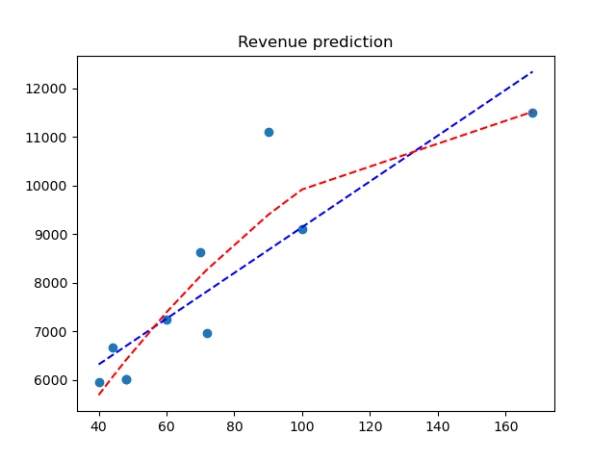

|  |
| --- |
| (array([ 47.07048984, 4435.08375149]), array([9249747.55758662]), 2, array([1.37709133, 0.32189978]), 2.220446049250313e-15)  result of linear regression:  y=47.1x + 4435.1  prediction at 120: 10084  (array([-3.66801624e-01, 1.21844118e+02, 1.40166166e+03]), array([6291859.67019942]), 3, array([1.63159132, 0.57727002, 0.06833074]), 2.220446049250313e-15)  result of non-linear, 2-degree regression:  y=-0.4x^2 + 121.8x + 1401.7  prediction at 120: 10741 |

The non-linear equation has better residuals, without being too complex, so I would choose it