**Cover Page**

**India**

For this project we have taken India as our home country, over the past 10 years, India's GDP has grown by an average of 7 percent each year when measured in US dollars, reaching a total of $3.6 trillion. This growth has propelled India from being the eighth largest economy to the fifth largest. Looking ahead, it's expected that India's GDP will likely reach $5 trillion within the next four years, making it the third largest economy by 2027. This would mean surpassing Japan and Germany. India is considered the fastest-growing large economy, benefiting from factors like a consistent labor force, improvements in institutions, and better governance. (Pti, 2024)

In December 2023, India's nominal GDP growth rate was reported at 10.075%, marking an increase from the previous rate of 9.622% in September 2023. This data, which is updated quarterly, has been averaged at 12.009% from June 1997 to December 2023, based on 107 observations. India's nominal GDP growth rate reached its highest point in June 2021 at 32.980% and hit a record low of -21.356% in June 2020. The Ministry of Statistics and Programme Implementation provides this data in local currency, adjusted for inflation, while CEIC calculates the quarterly growth rate from quarterly nominal GDP figures. These numbers reflect how India's economy has been performing over time in terms of its overall size and expansion, offering insights into the country's economic health and trajectory. (CEICdata.com, 2018) If we look at the graph below we can see how the Indian economy has been growing for the last 10 years.

**GDP Growth (annual %) - India (World Bank Open Data, 2024)**

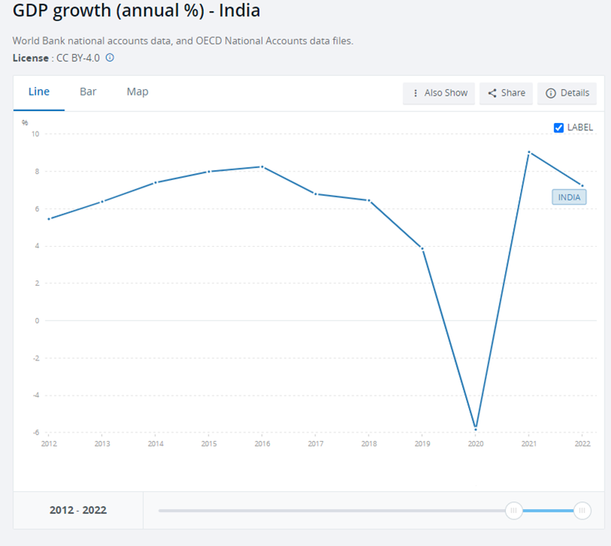

**Switzerland**

Switzerland is one of the world's most advanced and developed free-market economies. Key drivers of its economy include tourism and the service sector, particularly its renowned Swiss banking industry. Switzerland consistently ranks high in global competitiveness, securing the third position in the Global Competitiveness Report 2020 and holding the top spot in the Global Innovation Index since 2015. According to United Nations data from 2016, Switzerland stands as the third-wealthiest landlocked nation globally, trailing only Liechtenstein and Luxembourg. With a nominal GDP per capita exceeding $70,000. The below graph indicates the performance of the Swiss economy for the last 10 years.

**GDP Growth (annual %) - Switzerland (World Bank Open Data, 2024)**

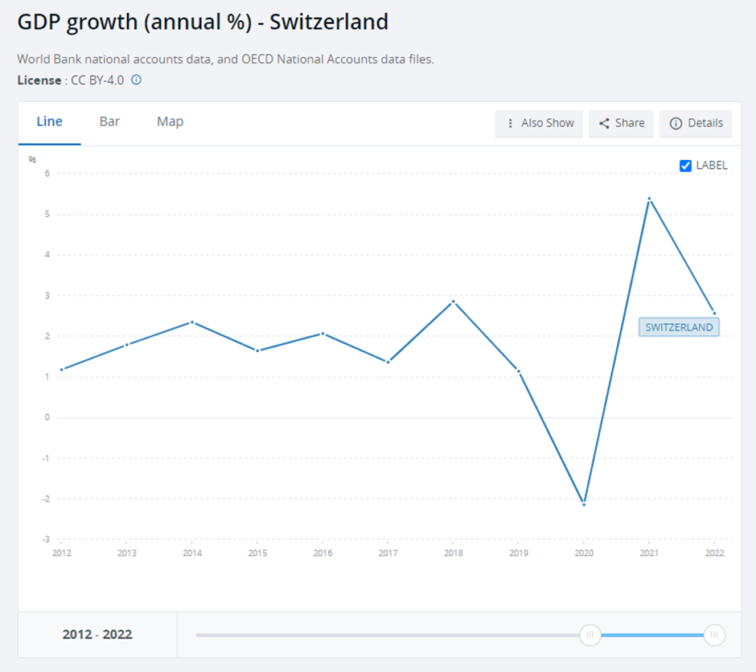

**Reason for Comparison between India and Switzerland**

**1. Trade:** India and Switzerland do a lot of business together.India is Switzerland’s fourth-largest trading partner in Asia and largest in South Asia. In 2018, Swiss exports to India totaled CHF 17.4 billion, primarily consisting of precious metals, machinery, pharmaceuticals, and chemicals. Conversely, imports from India, primarily including chemicals, textiles, precious metals, and agricultural products, amounted to CHF 1.83 billion in the same year. As of the end of 2016, Swiss direct investment in India reached CHF 4.7 billion. Currently, approximately 250 Swiss companies operate in India, either through joint ventures, subsidiaries, or branches.

**2. Investing:** People in India might want to invest in things like Swiss bonds or real estate. Checking exchange rates helps them understand if their money will go further in Switzerland and what they might get back when they cash out.

**3. Travel:** As reported by the Swiss Federal Statistics Office, Switzerland welcomed 347,750 Indian tourists in 2018, resulting in a total of 780,815 overnight stays in the country. Moreover, the agreed minutes from the 17th session of the India-Switzerland Joint Economic Commission (JEC), convened in Berne on March 2, 2020, reveal discussions about the potential signing of a Memorandum of Understanding (MoU) between the two nations in the realm of tourism.

**4. Government Decisions:** Indian leaders might watch the exchange rate with Switzerland to make decisions about things like inflation, trade, and how to manage the country's money.

**5. Banks and Finance:** Indian banks and finance groups might deal in Swiss money. Watching the exchange rate helps them make decisions about how to handle their money and keep things stable.

**6. Cooperation in education, research and innovation:** In 2003, Switzerland and India inked a science and technology agreement, followed by a memorandum of understanding on collaboration in the social sciences in 2012. These agreements encompass activities falling under the Indo-Swiss Joint Research Programme. Located in Bangalore, Swissnex India serves as a hub bridging Switzerland and India across various domains, including science, education, arts, and innovation. India holds a prominent position as a priority country for the Swiss Government Excellence Scholarships for Foreign Scholars and Artists, primarily targeting young researchers. Additionally, the Swiss VET Initiative India (SVETII) was initiated in 2008 to commemorate the 60th anniversary of the Treaty of Friendship between Switzerland and India.

**7.Cordial relationship:** Switzerland initiated diplomatic ties with India shortly after its Independence. On August 14, 1948, a Treaty of Friendship was signed between India and Switzerland in New Delhi. This treaty was among the earliest agreements inked by independent India and stands as a significant milestone in Indo-Swiss relations. The year 2023 will commemorate the 75th anniversary of the signing of the India-Switzerland Friendship Treaty.

**Analysis of Log Transformed Variables**

In time series analysis, understanding the underlying properties of the data, such as trends, seasonality, and stationarity, is crucial for accurate modeling and forecasting (Box, Jenkins, & Reinsel, 2015). For our dataset, analyzing these characteristics is particularly important to ensure that any models we develop are based on valid assumptions and can capture the true dynamics of the series. Stationarity, a state where a time series' statistical properties like mean and variance do not change over time, is a fundamental assumption in many time series models (Dickey & Fuller, 1979). If a time series is non-stationary, it can lead to misleading results in model estimation and inference (Enders, 2014). To assess stationarity, we employ statistical tests like the Augmented Dickey-Fuller (ADF) (Said & Dickey, 1984) and Phillips-Perron tests (Phillips & Perron, 1988), which help in determining whether to difference or transform the data for stationarity. Furthermore, by examining graphs of the variables, we can visually assess trends and seasonality. Trends indicate a long-term increase or decrease in the data, while seasonality refers to periodic fluctuations (Hyndman & Athanasopoulos, 2018). Recognizing these patterns is essential for selecting the appropriate time series model and for making accurate predictions.

**Augmented Dickey-Fuller (ADF) test on log Transformed Data**

The Augmented Dickey-Fuller (ADF) test is a statistical test in time series analysis to check for stationarity, particularly in the context of unit root testing (Dickey & Fuller, 1979). When applied to log-transformed data, the ADF test helps determine whether the series has a unit root, a characteristic of non-stationary time series where shocks can have a permanent effect on the level of the series (Said & Dickey, 1984). A key feature of this test is its ability to account for autocorrelation and higher-order serial correlation, which are common in time series data. By including lagged differences of the series in the regression model, the ADF test provides a robust way to assess stationarity. (Hamilton, 1994).

Graphical analysis complements the ADF test, offering a visual perspective on trends and seasonality. Trends in the data, either upward or downward, can be identified through plots of the log-transformed series over time (Hyndman & Athanasopoulos, 2018). Similarly, seasonality is observed as regular patterns or cycles in the data. If the ADF test indicates non-stationarity and the graphs show trends or seasonality, it suggests the need for further data transformations, such as differencing or detrending, to achieve stationarity (Enders, 2014). Stationary data is crucial for accurate forecasting and understanding the underlying process generating the time series, making the ADF test and graphical analysis indispensable tools in time series analysis.

**Python code snippet for ADF test (Below, with results)**

In the Python code below, we defined a function `adf_test` that performs the Augmented Dickey-Fuller (ADF) test on a given time series. For each series specified in the `variables` list, it conducts the ADF test and prints the results, including the test statistic, p-value, number of lags used, and critical values for different significance levels. The code also includes a loop to plot each log-transformed time series variables. These plots are valuable for visual inspection, allowing for an initial assessment of trends and seasonality in the data.

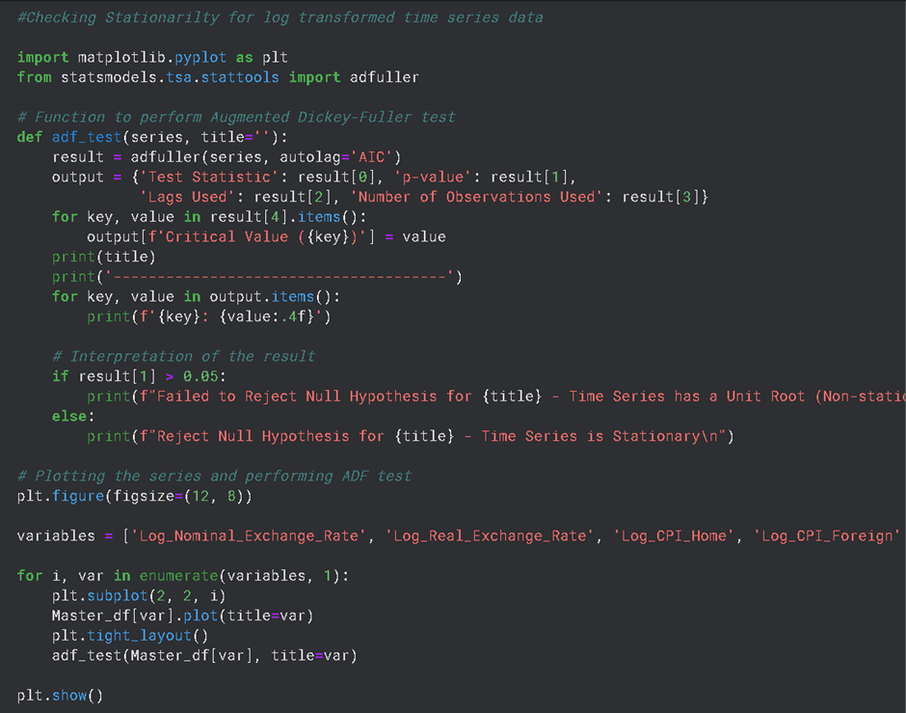

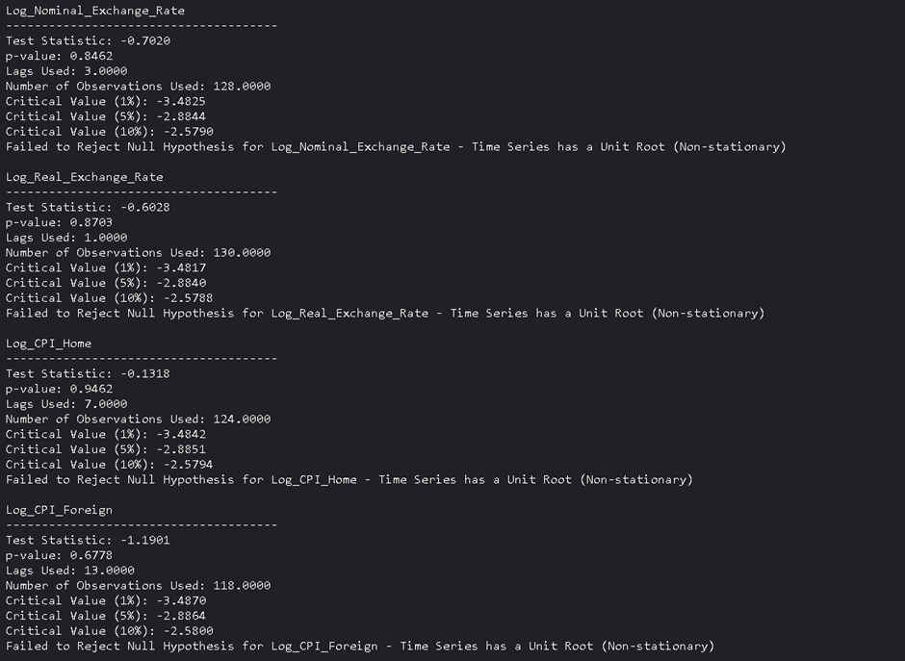

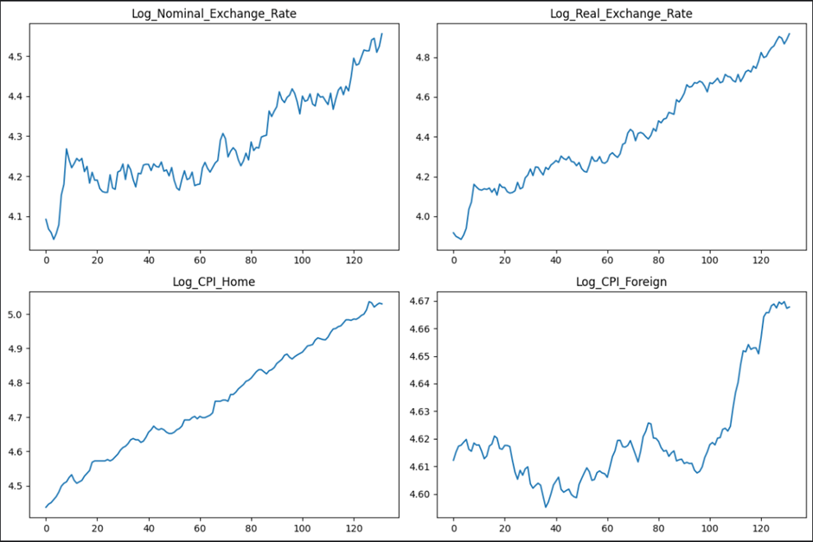

**Comments on the test outcomes (ADF test)**

The results displayed indicate the output of the Augmented Dickey-Fuller (ADF) test applied to four different log-transformed time series: Log_Nominal_Exchange_Rate, Log_Real_Exchange_Rate, Log_CPI_Home, and Log_CPI_Foreign. For all four-time series, the test statistics are greater than the critical values at the 1%, 5%, and 10% levels, and the p-values are well above the conventional threshold of 0.05. This suggests that we fail to reject the null hypothesis for each series, indicating that each one likely contains a unit root and is non-stationary. The non-stationarity implies that the time series data may have trends or random walks, which can affect the reliability of predictive models if not addressed through differencing or detrending techniques.

After visually examining the plots, all four graphs are clearly showing an upward trend, indicating a consistent increase over time. This is evident as each plot shows a rising trajectory, suggesting that both the nominal and real exchange rates, as well as the CPIs, are increasing in logarithmic terms. Although there are no immediately apparent periodic fluctuations that would suggest seasonality in these plots. The fluctuations appear more irregular and do not follow a consistent pattern that repeats at fixed intervals. Seasonality typically manifests as regular, predictable patterns within a fixed period, like annually or quarterly, which do not seem to be present here.

**Phillips-Perron test**

The Phillips-Perron (PP) test is another method in time series analysis for testing the presence of a unit root, which is a key indicator of non-stationarity in a time series (Phillips & Perron, 1988). Like the Augmented Dickey-Fuller (ADF) test, the PP test aims to determine whether a time series is stationary or if it exhibits trends or random walks that could impact the validity of statistical analyses. What sets the PP test apart is its robustness to a wide variety of serial correlation and heteroskedasticity in the error terms (Kwiatkowski, Phillips, Schmidt, & Shin, 1992). It achieves this by modifying the test statistics of the Dickey-Fuller test to account for these issues without adding lagged difference terms. This makes the PP test particularly useful in situations where the error terms are suspected to be correlated or exhibit non-constant variance. The outcomes of this test, when combined with a thorough graphical analysis, provide a comprehensive understanding of the time series' properties, informing the appropriate modeling and forecasting techniques to be employed.

**Python code snippet for Phillips-Perron test (Below, with results)**

This Python code snippet performs the Phillips-Perron unit root test on a set of time series variables. In the console, the test statistic, p-value, and critical values are printed for each variable, and a conclusion about the stationarity is given based on the p-value: a p-value greater than 0.05 implies failure to reject the null hypothesis, suggesting that the time series is non-stationary, whereas a p-value less than or equal to 0.05 suggests that the time series is stationary. A screen shot of a computer program
The plots are then displayed with their respective titles and p-values for a visual assessment alongside the statistical test results.

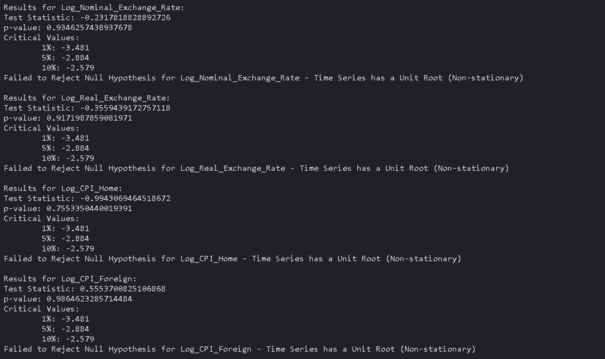

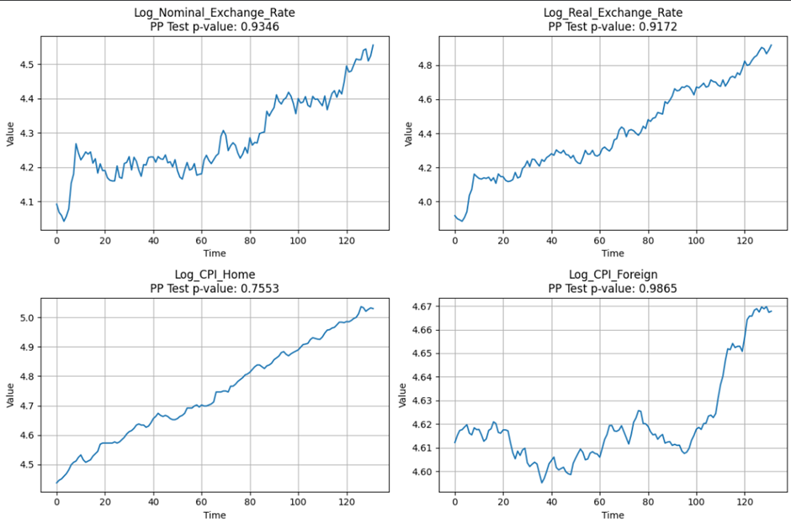

**Comments on the test outcomes (Phillips-Perron test)**

The results shows that the PP test statistics are above the critical values for the 1%, 5%, and 10% levels, and the p-values are much higher than the standard 0.05 threshold. Consequently, we fail to reject the null hypothesis for each variable, suggesting that all four-time series are non-stationary.

When compared with earlier Augmented Dickey-Fuller (ADF) test results, which also indicated non-stationarity for these time series, we find consistent conclusions across both types of unit root tests. Both tests suggest that the series have a unit root, and no evidence of stationarity is found.

**The Absolute form of Purchasing Power Parity**

Purchasing Power Parity (PPP) is a fundamental economic theory that posits that exchange rates between currencies are in equilibrium when their purchasing power is the same in each of the two countries. This absolute form of PPP can be particularly useful when analyzing time series data such as nominal exchange rates, Consumer Price Index (CPI) in both home and foreign countries, and the real exchange rate (Sarno & Taylor, 2002). For instance, the nominal exchange rate between two countries should adjust to the change in the ratio of the CPIs of these countries. In essence, if the domestic CPI increases relative to the foreign CPI, the home currency should depreciate to maintain PPP. Testing for PPP in time series data is crucial for several reasons. It serves as a guide for determining long-term equilibrium exchange rates, informs international investment and pricing strategies, and contributes to understanding inflation dynamics and their global interlinkages (Taylor, 2003).

Testing the absolute form of Purchasing Power Parity (PPP) using cointegration involves examining the relationship between the nominal exchange rate and the price levels (CPI) of two countries. Under absolute PPP, it's expected that the real exchange rate (the nominal exchange rate adjusted by the price levels) will be stationary. However, a more direct approach to testing absolute PPP with cointegration is to examine the relationship between the logarithms of the nominal exchange rate and the price levels. If these variables are cointegrated, it suggests a stable, long-term equilibrium relationship, supporting the idea of absolute PPP.

**Engle-Granger Two-Step Method**

In our analysis, we performed the Engle-Granger two-step cointegration test, as described by Engle and Granger (1987). This method is designed to test for a long-run equilibrium relationship between two or more non-stationary time series that are integrated of the same order. Initially, an ordinary least squares (OLS) regression is conducted on the variables, followed by testing the residuals from this regression for stationarity using an Augmented Dickey-Fuller (ADF) test, where stationarity of the residuals is indicative of cointegration (Engle & Granger, 1987). The approach taken is central to the analysis of non-stationary time series data, offering insights into the long-term relationships between variables (Banerjee, Dolado, Galbraith, & Hendry, 1993).

**Python code snippet for Regression and to test the Residuals for Stationarity**

In the Python code below, we performed a linear regression to model the relationship between the logarithm of the nominal exchange rate and the logarithms of home and foreign Consumer Price Indices (CPIs). Then, used the Augmented Dickey-Fuller (ADF) test on the residuals of this regression to check if they are stationary, helping to determine if there's a cointegrating relationship which implies whether the Absolute Purchasing Power Parity (PPP) holds or not.

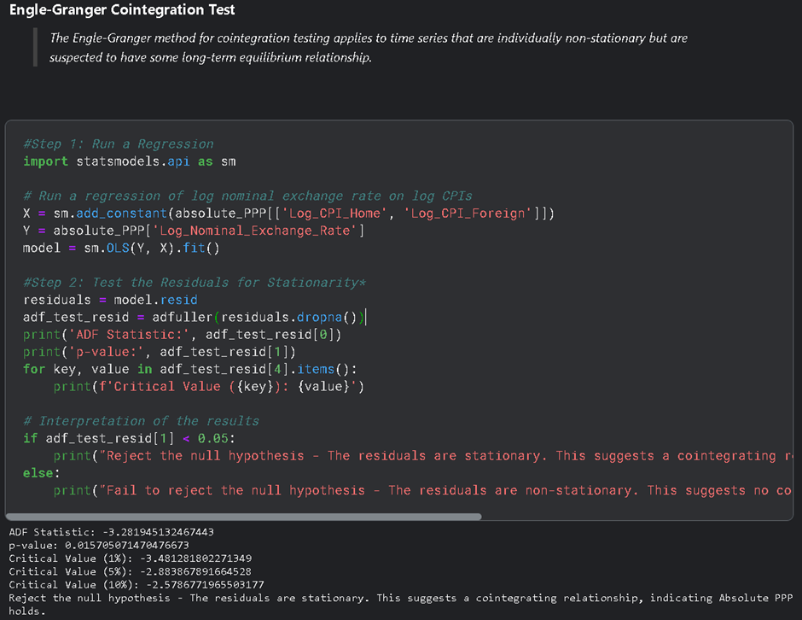

**Comments on the test outcomes (Absolute PPP)**

The outcome of the Augmented Dickey-Fuller (ADF) test indicates that the residuals from regression are stationary. This conclusion is drawn from the ADF statistic (-3.2819) being more negative than the critical value at the 5% level (-2.8838), and the p-value (0.01570) being less than the typical significance level of 0.05.

Since the null hypothesis of the ADF test is that the series has a unit root (i.e., it is non-stationary), the fact that we can reject this null hypothesis suggests that the residuals are indeed stationary and supports the existence of a cointegrating relationship, implying that the Absolute Purchasing Power Parity (PPP) holds for the data under study. In economic terms, it means that the nominal exchange rate between two countries is stabilized by the ratio of their price levels, as suggested by the theory of Absolute PPP.

**The Relative form of Purchasing Power Parity**

Unlike its absolute counterpart, relative PPP doesn’t assert that prices between two countries will be the same when converted at the current exchange rate; rather, it suggests that the rate of change in prices (inflation) in one country will be offset by corresponding changes in the exchange rate and inflation in another country (Rogoff, 1996). For instance, if inflation is higher in the home country than in the foreign country, the home currency is expected to depreciate accordingly. Testing for relative PPP is important because it provides insights into the inflation-exchange rate relationship, which is crucial for international trade, investment decisions, and economic policymaking.

Checking for the relative form of Purchasing Power Parity (PPP) involves comparing changes in exchange rates with changes in price levels between two countries. The relative PPP hypothesis states that the rate of appreciation or depreciation of one country's currency relative to another's should equal the difference in the inflation rates between the two countries.

**Regression Analysis**

The Relative form of Purchasing Power Parity (PPP) is typically examined through regression analysis by relating the changes in exchange rates to the differences in inflation rates between two countries (Taylor, 1995). This analysis aids in discerning whether the variations in purchasing power of currencies, denoted by inflation differentials, are manifest in the concomitant alterations in the exchange rates, in line with the hypothesis of Relative PPP (Froot & Rogoff, 1995).

**Python code snippet for OLS Regression**

First, we calculated annual inflation rates for both home and foreign countries and the percentage change in the nominal exchange rate. It does this by computing the percentage change in the Consumer Price Index (CPI) for each country, which represents the inflation rate, and the percentage change in the Nominal Exchange Rate, respectively. These values are then multiplied by 100 to convert them into percentages, providing a clear year-over-year comparison of inflation and exchange rate movements.

In the second code snippet, we used the “Statsmodels” library to fit a linear regression model. The dependent variable is the change in the exchange rate, and the independent variable is the differential between the home and foreign inflation rates. After adding a constant to the model for the intercept, it fits the model using Ordinary Least Squares (OLS) regression and prints a summary, which includes coefficients, statistics, and diagnostic information useful for understanding the relationship between the exchange rate changes and inflation rate differentials.

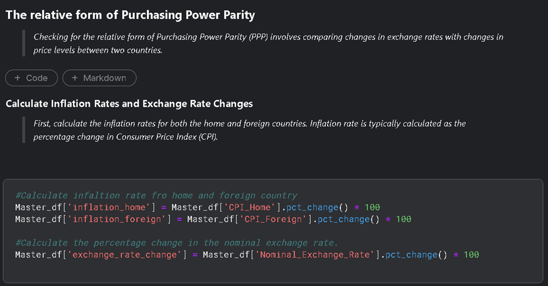

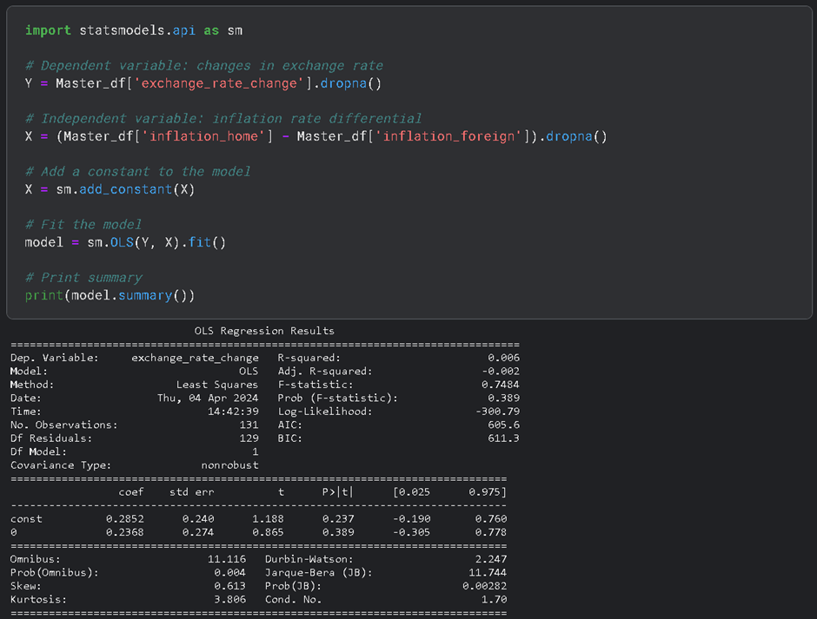

**Comments on the test outcomes (Relative PPP)**

The regression results testing the Relative Purchasing Power Parity (PPP) indicate a weak connection between exchange rate changes and inflation differentials. With an R-squared value of just 0.006, the model explains a mere 0.6% of the variance in exchange rate changes, suggesting a negligible relationship. Furthermore, the inflation differential's coefficient is not statistically significant, with a p-value well above the standard 0.05 threshold. Similarly, the constant term's coefficient (0.2852) is also not statistically significant, further undermines the model's predictive power. Overall, these findings imply that the Relative PPP hypothesis, which posits that exchange rate changes should mirror inflation rate differences, does not find strong support in the analyzed dataset.

**ARIMA Modelling with Stationary Data**

The term ARIMA modelling was coined by Box & Jenkins in their book “Time Series Analysis: Forecasting and Control” in 1976. As the above suggests, it is a technique that is used in time series analysis. ARIMA modelling was derived from AutoRegressive modelling Integrated with Moving Averages (ARIMA). It is a combination of 2 separate modelling techniques to create a superior model: autoregressive modelling and the moving averages model. An autoregressive (AR) model is one where the current value of a variable, y, depends upon only the values that the variable took in previous periods plus an error term. A moving average (MA) model is a linear combination of white noise processes. These models are useful for understanding patterns in time series data, however, when looking at forecasting we need data to be stationary. This is “because if a time series is nonstationary, we can study its behaviour only for the time period under consideration. As a consequence, it is not possible to generalize it to other time periods.” (Gao, J. 2024) As a result, if a time series is nonstationary, then it must be differenced (I) to make it stationary so the data can be used for forecasting. All of these elements combined give us ARIMA modelling.

In ARIMA modelling there are 3 key values that must be identified to produce the most accurate model possible, these are known as p, d and q values. These values are significant because they will indicate the accuracy of the model, “p denotes the number of autoregressive terms, d the number of times the series has to be differenced before it becomes stationary, and q the number of moving average terms.” (Gao, J. 2024) To get the p and q values we tested for Autocorrelation Function (ACF) and Partial Autocorrelation Function (PACF) and then plotted these functions. Testing for ACF shows the trend between a variable and its lag values, helping us determine our p value. Testing for PACF helps us decide our q values in the case of a moving average model there are direct connections between a variable and all its previous values.

**Analysis of Stationary ACF & PACF Plots**

Looking at our PACF plot, there is a significant spike at lag 1 followed by insignificant spikes for the subsequent lags. This suggests an AR (1) component, as the partial autocorrelation at lag 1 is above the significance level and cuts off sharply afterward. In the ACF plot, there are several lags that are significant, but there's no clear cut-off point, which sometimes suggests a mix of AR and MA components. The significant lags at 1 and 2, and again at 11 could suggest a possible seasonal component, or they may represent an MA process.

Based on these observations, we tested out an array of models because we did not get very clear indicators from our ACF and PACF plots. However, we did get a starting point as we knew the p and q values would be relatively low. As a result, we created 5 models with p and q values which we felt were best indicated by the data and tested them to find the superior model, listed below:

**1. ARIMA (1, 0, 0):** The PACF plot showed a significant spike at lag 1 with a cutoff after that, suggesting a first-order autoregressive model.

**2. ARIMA (1, 0, 1):** This model includes both AR and MA components of order 1, indicating a balanced approach when both ACF and PACF show significance at lag 1.

**3. ARIMA (1, 0, 2):** With our ACF plot showing significance at the first few lags, we figured an MA component of order 2 might capture the gradual decay in correlation.

**4. ARIMA (2, 0, 1):** Our PACF plot has a significant effect at lag 1, and possibly some effect at lag 2. This suggested trying a second-order AR component.

**5. ARIMA (1, 0, 11):** The spike at lag 11 in the ACF may suggest a long MA component. Although unlikely to be of any huge relevance we decided to test it anyway just to be on the safe side.

**ARIMA Modelling With Non-Stationary Data**

Since we were required to estimate at least 6 models and for the interest’s sake, we then decided to create another 5 models on our non-stationary data indicating one level of differencing (d=1) to see if we could get more accurate results. We followed the same process as above and created a PACF and ACF plot. Our PACF plot was quite similar to the one we got with our differenced data, with the spike at lag 1 suggests an AR (1) component is needed. There are no other significant spikes beyond the first lag, so higher-order AR terms may not be necessary. We got a very different result with our ACF plot, however. There is clearly a gradual decay in the ACF plot, which suggests the need for MA terms. However, without additional significant spikes at specific lags, there is a lack of indication as to what the MA order should be.

We then created 5 model with varied p and q values, while we let d=1 to indicate the one level of differencing needed to make the data stationary. Our selections were as follows:

**1. ARIMA (1,1,0):** The spike at lag 1 in the PACF suggests a significant AR (1) component, and no MA component is initially considered.

**2. ARIMA (1,1,1):** Both the ACF and PACF indicate a significant first lag, which suggests an AR (1) and MA (1) component might be a good starting model.

**3. ARIMA (1,1,2):** Given the gradual decay in the ACF plot, an MA (2) component may better capture the slowly declining autocorrelation.

**4. ARIMA (2,1,1):** Even though the PACF does not clearly indicate a second AR term, we attempted adding an extra AR term to capture any autocorrelation not accounted for by the first AR term and the MA component.

**5. ARIMA (1,1,3):** The ACF shows a more extended lag structure which could suggest that additional MA terms are needed to fully capture the autocorrelation structure.

**Data Modelling Outcomes**

Next, we evaluated the stationary and non-stationary models and identified which model performed the best out of each pool. We had divided our data into training and testing data when creating our models, meaning we were able to evaluate the performance of our models based on actual data available to us, not off of our forecasts. We measured the performance of these models by using several metrics: Mean Absolute Error (MAE), Root Mean Squared Error (RMSE), Mean Absolute Percentage Error (MAPE), Akaike Information Criterion (AIC), and Bayesian Information Criterion (BIC). Both our stationary and non-stationary models gave the similar results, with 1 p and 0 q providing our model with optimal performance.

**Models Created on Stationary Data (d=0)**

**Models Created on Non-Stationary Data (d=1)**

Our stationary model, ARIMA (1, 0, 0), has significantly lower MAE and RMSE values compared to the non-stationary ARIMA (1, 1, 0) model. This suggests that our model for stationary data is better at predicting values close to the actual numbers. However, MAPE, which is a relative measure, is notably higher in the stationary model, suggesting differences in the scale or nature of the data. Both models have a relatively low complexity, but the ARIMA (1, 0, 0) model has even lower AIC and BIC values. This indicates that it's a more efficient model in terms of the trade-off between goodness of fit and complexity.

The stationary nature of the dataset for the ARIMA (1, 0, 0) model could be a significant reason for its better performance. Stationary data, by definition, has properties like mean and variance that don't change over time, making it easier to model and predict. In contrast, non-stationary data often contains trends and seasonality, which can make accurate modelling more challenging. In conclusion, our ARIMA (1, 0, 0) model's performance is superior. This is going to be our chosen model for forecasting our future Real Exchange Rates.

**Forecasting**

Using our ARIMA (1,0,0) model, our next step was to make all of our data available to the model as this would improve its accuracy even further. We then got our model to forecast the next 12 values from our dataset, which would equate to a full year. (See below graph)

As we can see from the above graph, our model has predicted that the real exchance rate between the Indian Rupee and Swiss Franc will contine to grow at a stable rate. Looking at the historical data, we can assume that the results are quite accurate, as the real exchange rate between the two countries has been trending steadily upwards for some time.

**Conclusion**

In conclusion, the results we got from our modelling forecast indicate that the value of the Indian Rupee and Indian inflation rates will continue to rise at a stable rate. When we compare this to our home CPI we get the impression that these rates are rising because India’s economic power is also rising at a stable level, indicated by the steadily upwards trending graphs we observed throughout our analysis. The steady trend insinuates that the economy is rising at a healthy level and does not forecast any major change, such as a recession or a boom, but instead implies healthy, stable economic growth for the foreseeable future.

**References**

Banerjee, A., Dolado, J. J., Galbraith, J. W., & Hendry, D. (1993). Co-integration, Error Correction, and the Econometric Analysis of Non-Stationary Data. Oxford University Press. <https://www.researchgate.net/publication/227467389_Co-Integration_Error_Correction_And_the_Econometric_Analysis_of_Non-Stationary_Data>

Box, G. E. P., Jenkins, G. M., & Reinsel, G. C. (2015). Time series analysis: Forecasting and control. John Wiley & Sons.

CEICdata.com (2018) India Nominal GDP Growth. <https://www.ceicdata.com/en/indicator/india/nominal-gdp-growth>.

Dickey, D. A., & Fuller, W. A. (1979). Distribution of the estimators for autoregressive time series with a unit root. Journal of the American Statistical Association, 74(366a), 427-431. <https://www.jstor.org/stable/2286348>

Enders, W. (2014). Applied econometric time series. John Wiley & Sons.

Engle, R. F., & Granger, C. W. J. (1987). Co-integration and Error Correction: Representation, Estimation, and Testing. Econometrica, 55(2), 251-276. <https://www.jstor.org/stable/1913236>

Froot, K. A., & Rogoff, K. (1995). Perspectives on PPP and long-run real exchange rates. In G. M. Grossman & K. Rogoff (Eds.), Handbook of International Economics (Vol. 3, pp. 1647-1688). Elsevier.

Gao, J. (2024) 2.1 Introduction to ARIMA Modelling and Forecasting. Business Analytics. UCC. 2024

Hamilton, J. D. (1994). Time Series Analysis. Princeton University Press.

Hyndman, R. J., & Athanasopoulos, G. (2018). Forecasting: principles and practice. OTexts.

Kwiatkowski, D., Phillips, P. C. B., Schmidt, P., & Shin, Y. (1992). Testing the Null Hypothesis of Stationarity against the Alternative of a Unit Root. Journal of Econometrics, 54(1-3), 159-178. <https://doi.org/10.1016/0304-4076(92)90104-Y>

Phillips, P. C. B., & Perron, P. (1988). Testing for a unit root in time series regression. Biometrika, 75(2), 335-346. <https://www.jstor.org/stable/2336182>

Pti (2024) 'Strong reforms over last 10 years lays foundation of solid growth over next decade: Jefferies,' The Economic Times, 22 February. <https://economictimes.indiatimes.com/news/economy/indicators/strong-reforms-over-last-10-years-lays-foundation-of-solid-growth-over-next-decade-jefferies/articleshow/107912063.cms?from=mdr>.

Rogoff, K. (1996). The Purchasing Power Parity Debate. Journal of Economic Perspectives, 10(4), 17-45.

Said, S. E., & Dickey, D. A. (1984). Testing for unit roots in autoregressive-moving average models of unknown order. Biometrika, 71(3), 599-607. <https://www.jstor.org/stable/2336570>

Sarno, L., & Taylor, M. P. (2002). The Economics of Exchange Rates. Cambridge University Press.

Taylor, M. P. (1995). The economics of exchange rates. Journal of Economic Literature, 33(1), 13-47. <https://www.jstor.org/stable/2728909>

Taylor, M. P. (2003). Real Exchange Rates and Purchasing Power Parity: Mean-Reversion in Economic Thought. Applied Economics, 35(5), 557-566. <https://www.researchgate.net/publication/24070897_Real_exchange_rates_and_Purchasing_Power_Parity_Mean-reversion_in_economic_thought>

World Bank Open Data (2024). <https://data.worldbank.org/>.