PART D: Analysis of Log Transformed Variables
In time series analysis, understanding the underlying properties of the data, such as trends, seasonality, and stationarity, is crucial for accurate modeling and forecasting (Box, Jenkins, & Reinsel, 2015). For our dataset, analyzing these characteristics is particularly important to ensure that any models we develop are based on valid assumptions and can capture the true dynamics of the series. Stationarity, a state where a time series' statistical properties like mean and variance do not change over time, is a fundamental assumption in many time series models (Dickey & Fuller, 1979). If a time series is non-stationary, it can lead to misleading results in model estimation and inference (Enders, 2014). To assess stationarity, we employ statistical tests like the Augmented Dickey-Fuller (ADF) (Said & Dickey, 1984) and Phillips-Perron tests (Phillips & Perron, 1988), which help in determining whether to difference or transform the data for stationarity. Furthermore, by examining graphs of the variables, we can visually assess trends and seasonality. Trends indicate a long-term increase or decrease in the data, while seasonality refers to periodic fluctuations (Hyndman & Athanasopoulos, 2018). Recognizing these patterns is essential for selecting the appropriate time series model and for making accurate predictions.

Augmented Dickey-Fuller (ADF) test on log Transformed Data
The Augmented Dickey-Fuller (ADF) test is a statistical test in time series analysis to check for stationarity, particularly in the context of unit root testing (Dickey & Fuller, 1979). When applied to log-transformed data, the ADF test helps determine whether the series has a unit root, a characteristic of non-stationary time series where shocks can have a permanent effect on the level of the series (Said & Dickey, 1984). A key feature of this test is its ability to account for autocorrelation and higher-order serial correlation, which are common in time series data. By including lagged differences of the series in the regression model, the ADF test provides a robust way to assess stationarity. (Hamilton, 1994).
Graphical analysis complements the ADF test, offering a visual perspective on trends and seasonality. Trends in the data, either upward or downward, can be identified through plots of the log-transformed series over time (Hyndman & Athanasopoulos, 2018). Similarly, seasonality is observed as regular patterns or cycles in the data. If the ADF test indicates non-stationarity and the graphs show trends or seasonality, it suggests the need for further data transformations, such as differencing or detrending, to achieve stationarity (Enders, 2014). Stationary data is crucial for accurate forecasting and understanding the underlying process generating the time series, making the ADF test and graphical analysis indispensable tools in time series analysis.
*Python code snippet for ADF test (With results)
In the Python code below, we defined a function `adf_test` that performs the Augmented Dickey-Fuller (ADF) test on a given time series. For each series specified in the `variables` list, it conducts the ADF test and prints the results, including the test statistic, p-value, number of lags used, and critical values for different significance levels. The code also includes a loop to plot each log-transformed time series variables. These plots are valuable for visual inspection, allowing for an initial assessment of trends and seasonality in the data.
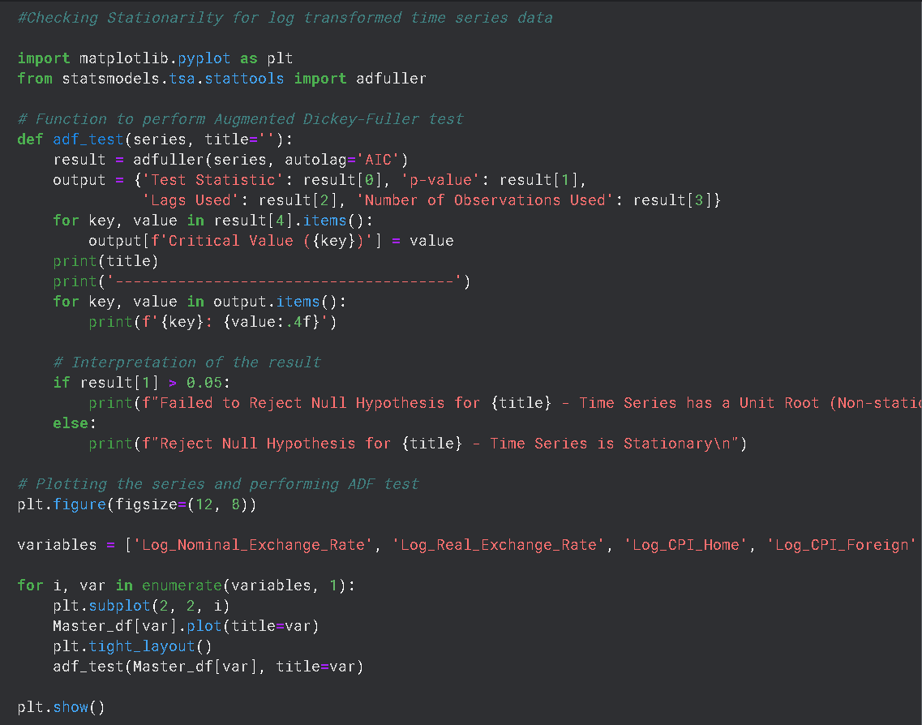
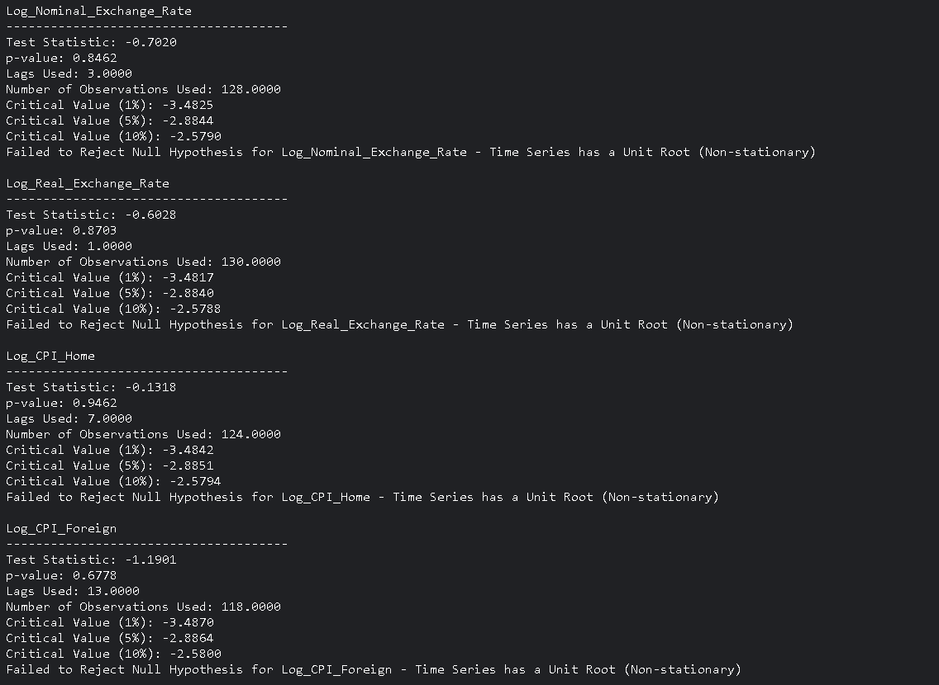
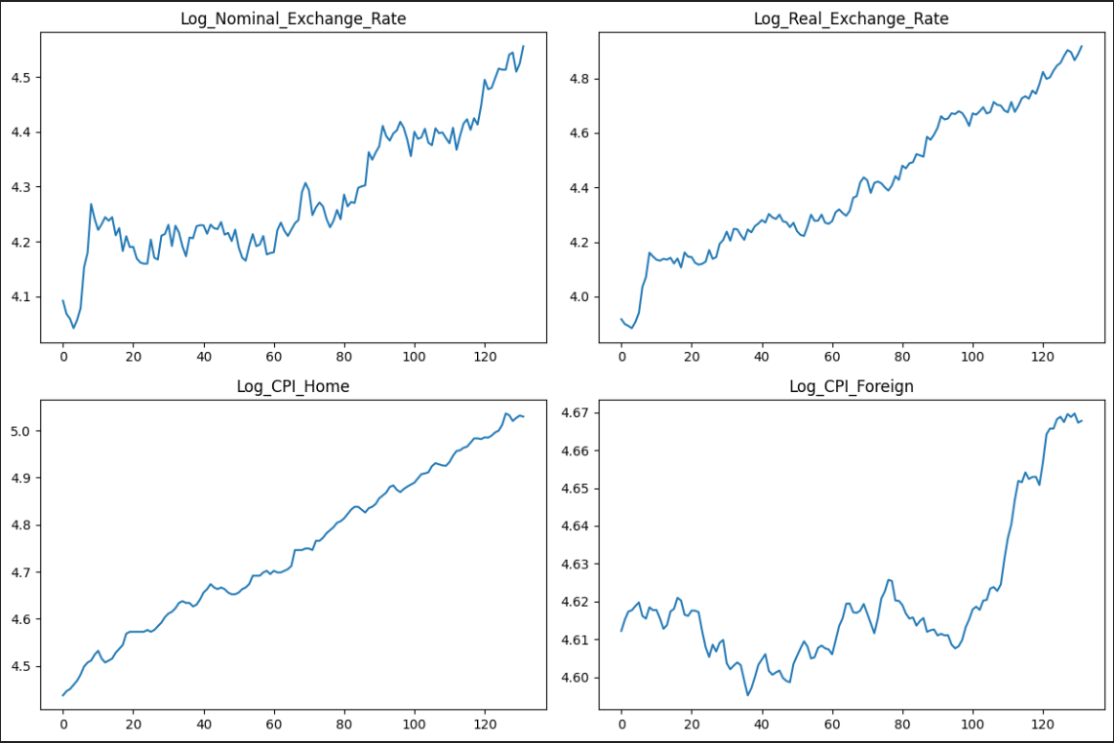

Comments on the test outcomes (ADF test)
The results displayed indicate the output of the Augmented Dickey-Fuller (ADF) test applied to four different log-transformed time series: Log_Nominal_Exchange_Rate, Log_Real_Exchange_Rate, Log_CPI_Home, and Log_CPI_Foreign. For all four-time series, the test statistics are greater than the critical values at the 1%, 5%, and 10% levels, and the p-values are well above the conventional threshold of 0.05. This suggests that we fail to reject the null hypothesis for each series, indicating that each one likely contains a unit root and is non-stationary. The non-stationarity implies that the time series data may have trends or random walks, which can affect the reliability of predictive models if not addressed through differencing or detrending techniques.
After visually examining the plots, all four graphs are clearly showing an upward trend, indicating a consistent increase over time. This is evident as each plot shows a rising trajectory, suggesting that both the nominal and real exchange rates, as well as the CPIs, are increasing in logarithmic terms. Although there are no immediately apparent periodic fluctuations that would suggest seasonality in these plots. The fluctuations appear more irregular and do not follow a consistent pattern that repeats at fixed intervals. Seasonality typically manifests as regular, predictable patterns within a fixed period, like annually or quarterly, which do not seem to be present here.

Phillips-Perron test

The Phillips-Perron (PP) test is another method in time series analysis for testing the presence of a unit root, which is a key indicator of non-stationarity in a time series (Phillips & Perron, 1988). Like the Augmented Dickey-Fuller (ADF) test, the PP test aims to determine whether a time series is stationary or if it exhibits trends or random walks that could impact the validity of statistical analyses. What sets the PP test apart is its robustness to a wide variety of serial correlation and heteroskedasticity in the error terms (Kwiatkowski, Phillips, Schmidt, & Shin, 1992). It achieves this by modifying the test statistics of the Dickey-Fuller test to account for these issues without adding lagged difference terms. This makes the PP test particularly useful in situations where the error terms are suspected to be correlated or exhibit non-constant variance. The outcomes of this test, when combined with a thorough graphical analysis, provide a comprehensive understanding of the time series' properties, informing the appropriate modeling and forecasting techniques to be employed.
*Python code snippet for Phillips-Perron test (With results)
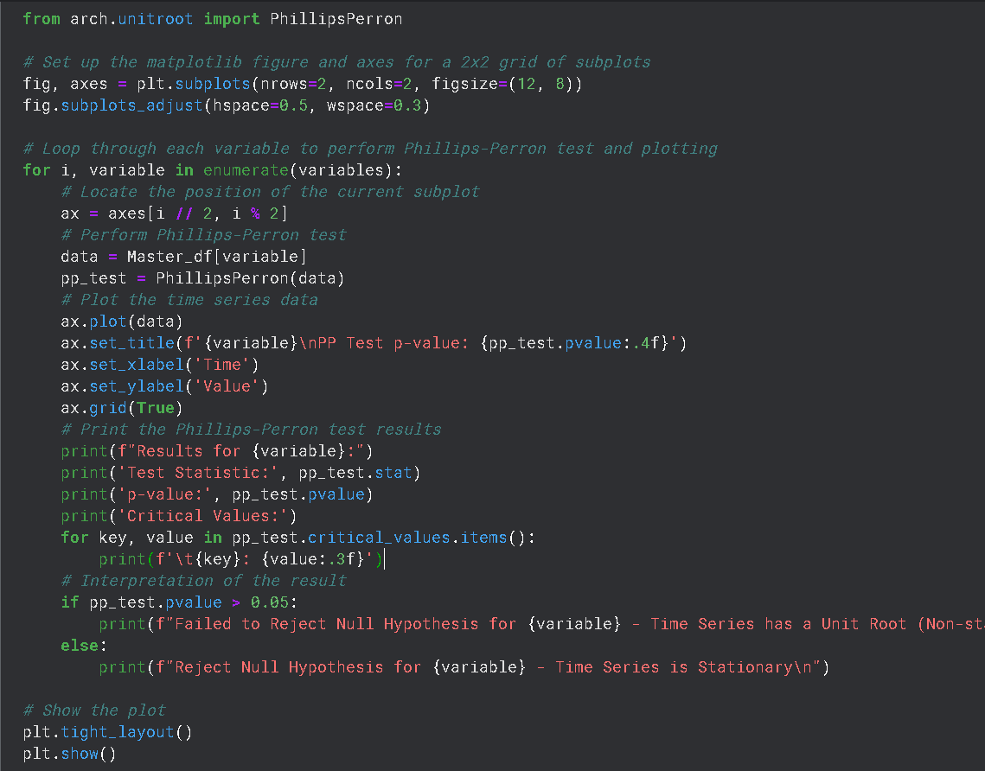
This Python code snippet performs the Phillips-Perron unit root test on a set of time series variables. In the console, the test statistic, p-value, and critical values are printed for each variable, and a conclusion about the stationarity is given based on the p-value: a p-value greater than 0.05 implies failure to reject the null hypothesis, suggesting that the time series is non-stationary, whereas a p-value less than or equal to 0.05 suggests that the time series is stationary. The plots are then displayed with their respective titles and p-values for a visual assessment alongside the statistical test results.

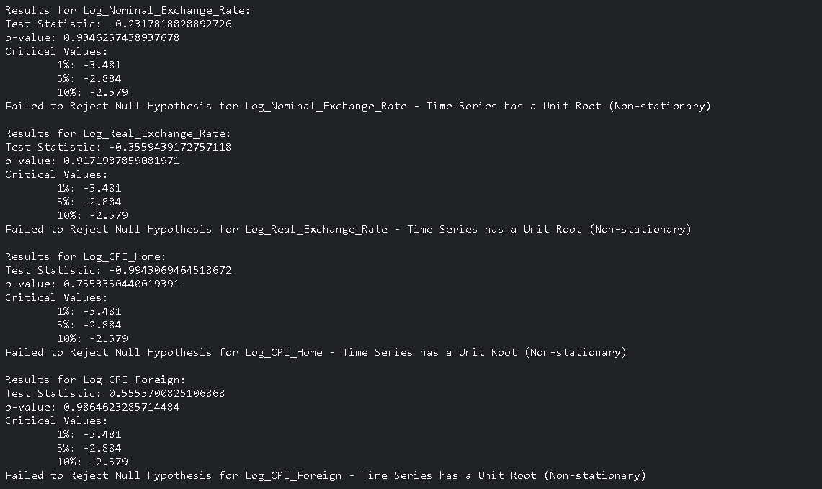
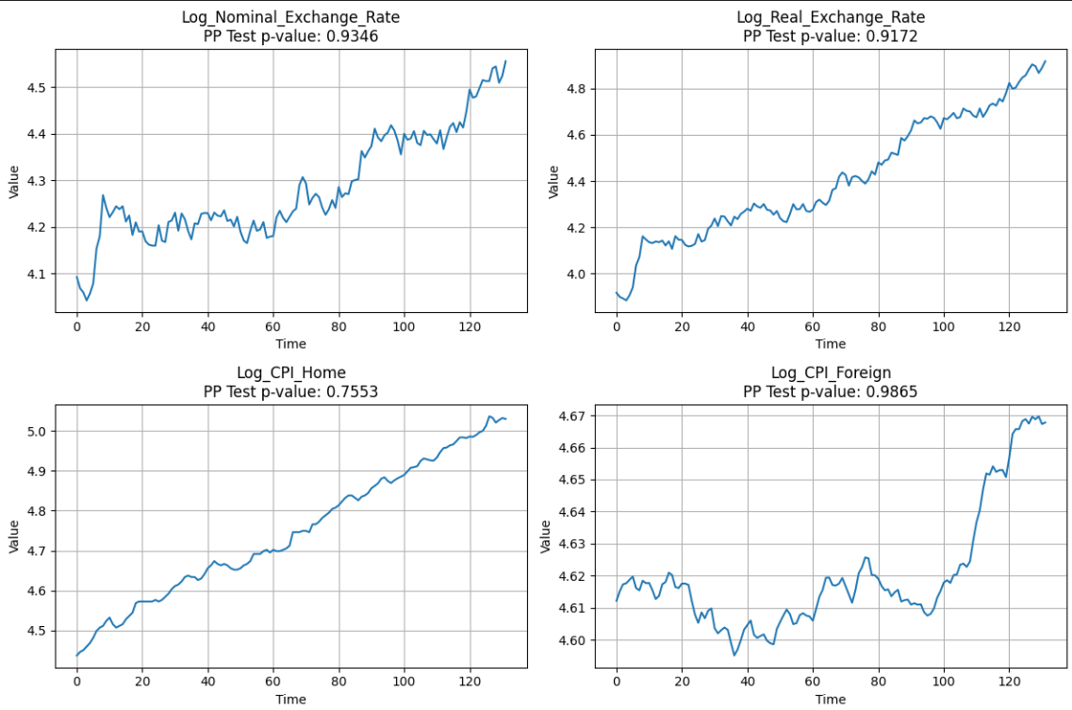

Comments on the test outcomes (Phillips-Perron test)
The results shows that the PP test statistics are above the critical values for the 1%, 5%, and 10% levels, and the p-values are much higher than the standard 0.05 threshold. Consequently, we fail to reject the null hypothesis for each variable, suggesting that all four-time series are non-stationary.
When compared with earlier Augmented Dickey-Fuller (ADF) test results, which also indicated non-stationarity for these time series, we find consistent conclusions across both types of unit root tests. Both tests suggest that the series have a unit root, and no evidence of stationarity is found.

PART E: The Absolute form of Purchasing Power Parity

Purchasing Power Parity (PPP) is a fundamental economic theory that posits that exchange rates between currencies are in equilibrium when their purchasing power is the same in each of the two countries. This absolute form of PPP can be particularly useful when analyzing time series data such as nominal exchange rates, Consumer Price Index (CPI) in both home and foreign countries, and the real exchange rate (Sarno & Taylor, 2002). For instance, the nominal exchange rate between two countries should adjust to the change in the ratio of the CPIs of these countries. In essence, if the domestic CPI increases relative to the foreign CPI, the home currency should depreciate to maintain PPP. Testing for PPP in time series data is crucial for several reasons. It serves as a guide for determining long-term equilibrium exchange rates, informs international investment and pricing strategies, and contributes to understanding inflation dynamics and their global interlinkages (Taylor, 2003).
Testing the absolute form of Purchasing Power Parity (PPP) using cointegration involves examining the relationship between the nominal exchange rate and the price levels (CPI) of two countries. Under absolute PPP, it's expected that the real exchange rate (the nominal exchange rate adjusted by the price levels) will be stationary. However, a more direct approach to testing absolute PPP with cointegration is to examine the relationship between the logarithms of the nominal exchange rate and the price levels. If these variables are cointegrated, it suggests a stable, long-term equilibrium relationship, supporting the idea of absolute PPP.

Engle-Granger Two-Step Method
In our analysis, we performed the Engle-Granger two-step cointegration test, as described by Engle and Granger (1987). This method is designed to test for a long-run equilibrium relationship between two or more non-stationary time series that are integrated of the same order. Initially, an ordinary least squares (OLS) regression is conducted on the variables, followed by testing the residuals from this regression for stationarity using an Augmented Dickey-Fuller (ADF) test, where stationarity of the residuals is indicative of cointegration (Engle & Granger, 1987). The approach taken is central to the analysis of non-stationary time series data, offering insights into the long-term relationships between variables (Banerjee, Dolado, Galbraith, & Hendry, 1993).

*Python code snippet for Regression and to test the Residuals for Stationarity
In the Python code below, we performed a linear regression to model the relationship between the logarithm of the nominal exchange rate and the logarithms of home and foreign Consumer Price Indices (CPIs). Then, used the Augmented Dickey-Fuller (ADF) test on the residuals of this regression to check if they are stationary, helping to determine if there's a cointegrating relationship which implies whether the Absolute Purchasing Power Parity (PPP) holds or not.

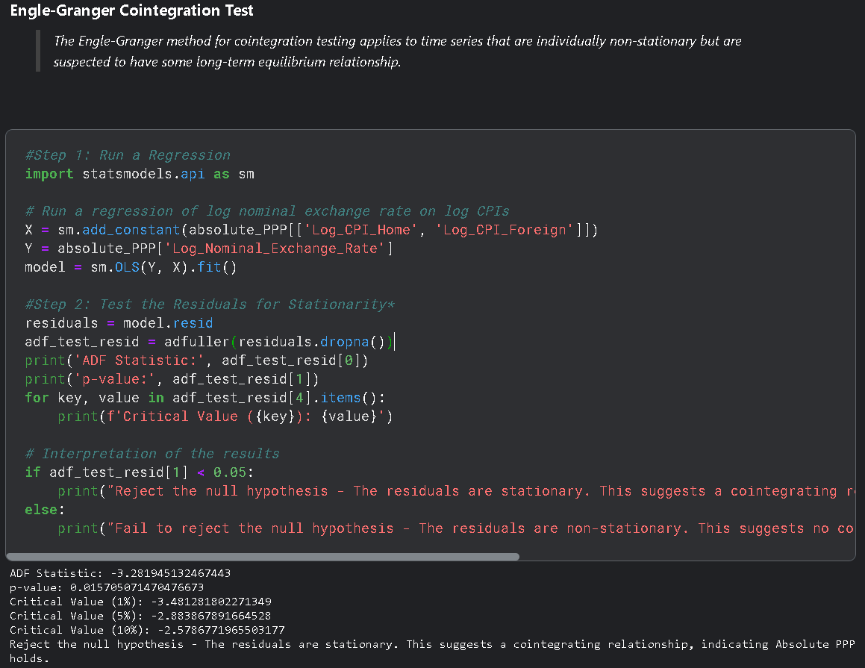

Comments on the test outcomes (Absolute PPP)
The outcome of the Augmented Dickey-Fuller (ADF) test indicates that the residuals from regression are stationary. This conclusion is drawn from the ADF statistic (-3.2819) being more negative than the critical value at the 5% level (-2.8838), and the p-value (0.01570) being less than the typical significance level of 0.05.
Since the null hypothesis of the ADF test is that the series has a unit root (i.e., it is non-stationary), the fact that we can reject this null hypothesis suggests that the residuals are indeed stationary and supports the existence of a cointegrating relationship, implying that the Absolute Purchasing Power Parity (PPP) holds for the data under study. In economic terms, it means that the nominal exchange rate between two countries is stabilized by the ratio of their price levels, as suggested by the theory of Absolute PPP.

PART F: The Relative form of Purchasing Power Parity

Unlike its absolute counterpart, relative PPP doesn’t assert that prices between two countries will be the same when converted at the current exchange rate; rather, it suggests that the rate of change in prices (inflation) in one country will be offset by corresponding changes in the exchange rate and inflation in another country (Rogoff, 1996). For instance, if inflation is higher in the home country than in the foreign country, the home currency is expected to depreciate accordingly. Testing for relative PPP is important because it provides insights into the inflation-exchange rate relationship, which is crucial for international trade, investment decisions, and economic policymaking.
Checking for the relative form of Purchasing Power Parity (PPP) involves comparing changes in exchange rates with changes in price levels between two countries. The relative PPP hypothesis states that the rate of appreciation or depreciation of one country's currency relative to another's should equal the difference in the inflation rates between the two countries.

Regression Analysis
The Relative form of Purchasing Power Parity (PPP) is typically examined through regression analysis by relating the changes in exchange rates to the differences in inflation rates between two countries (Taylor, 1995). This analysis aids in discerning whether the variations in purchasing power of currencies, denoted by inflation differentials, are manifest in the concomitant alterations in the exchange rates, in line with the hypothesis of Relative PPP (Froot & Rogoff, 1995).

*Python code snippet for OLS Regression
First, we calculated annual inflation rates for both home and foreign countries and the percentage change in the nominal exchange rate. It does this by computing the percentage change in the Consumer Price Index (CPI) for each country, which represents the inflation rate, and the percentage change in the Nominal Exchange Rate, respectively. These values are then multiplied by 100 to convert them into percentages, providing a clear year-over-year comparison of inflation and exchange rate movements.
In the second code snippet, we used the “Statsmodels” library to fit a linear regression model. The dependent variable is the change in the exchange rate, and the independent variable is the differential between the home and foreign inflation rates. After adding a constant to the model for the intercept, it fits the model using Ordinary Least Squares (OLS) regression and prints a summary, which includes coefficients, statistics, and diagnostic information useful for understanding the relationship between the exchange rate changes and inflation rate differentials.

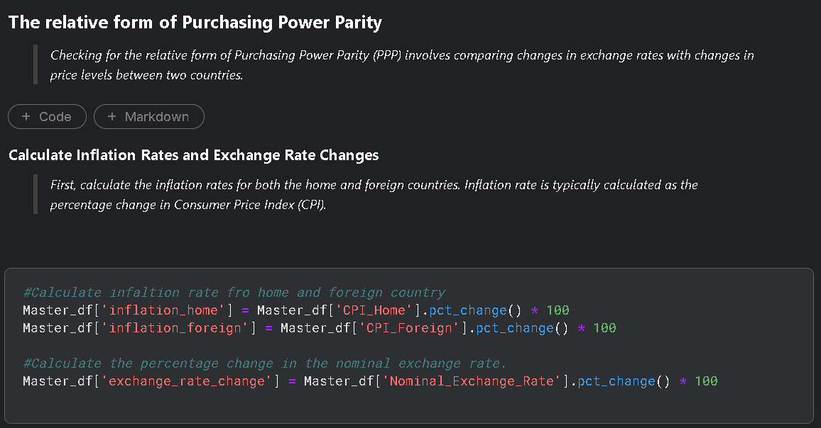

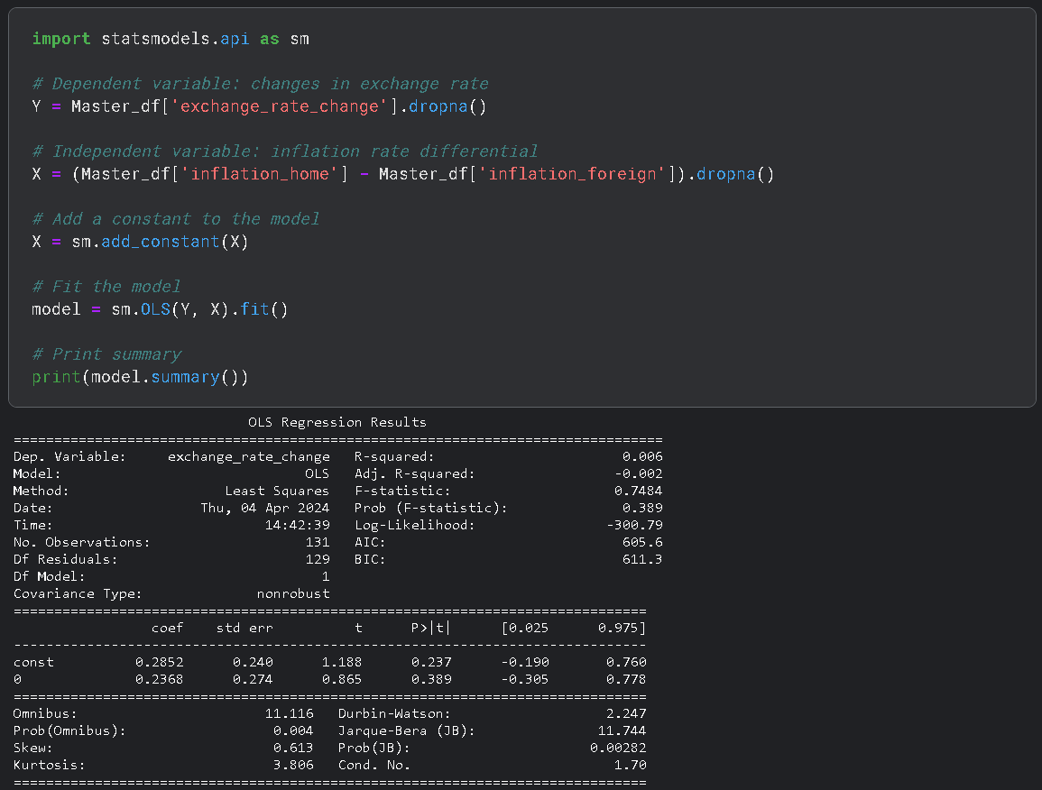

Comments on the test outcomes (Relative PPP)
The regression results testing the Relative Purchasing Power Parity (PPP) indicate a weak connection between exchange rate changes and inflation differentials. With an R-squared value of just 0.006, the model explains a mere 0.6% of the variance in exchange rate changes, suggesting a negligible relationship. Furthermore, the inflation differential's coefficient is not statistically significant, with a p-value well above the standard 0.05 threshold. Similarly, the constant term's coefficient (0.2852) is also not statistically significant, further undermines the model's predictive power. Overall, these findings imply that the Relative PPP hypothesis, which posits that exchange rate changes should mirror inflation rate differences, does not find strong support in the analyzed dataset.

References
Box, G. E. P., Jenkins, G. M., & Reinsel, G. C. (2015). Time series analysis: Forecasting and control. John Wiley & Sons.
Dickey, D. A., & Fuller, W. A. (1979). Distribution of the estimators for autoregressive time series with a unit root. Journal of the American Statistical Association, 74(366a), 427-431. https://www.jstor.org/stable/2286348
Hamilton, J. D. (1994). Time Series Analysis. Princeton University Press.
Enders, W. (2014). Applied econometric time series. John Wiley & Sons.
Said, S. E., & Dickey, D. A. (1984). Testing for unit roots in autoregressive-moving average models of unknown order. Biometrika, 71(3), 599-607. https://www.jstor.org/stable/2336570
Phillips, P. C. B., & Perron, P. (1988). Testing for a unit root in time series regression. Biometrika, 75(2), 335-346. https://www.jstor.org/stable/2336182
Kwiatkowski, D., Phillips, P. C. B., Schmidt, P., & Shin, Y. (1992). Testing the Null Hypothesis of Stationarity against the Alternative of a Unit Root. Journal of Econometrics, 54(1-3), 159-178. https://doi.org/10.1016/0304-4076(92)90104-Y
Hyndman, R. J., & Athanasopoulos, G. (2018). Forecasting: principles and practice. OTexts.
Sarno, L., & Taylor, M. P. (2002). The Economics of Exchange Rates. Cambridge University Press.
Taylor, M. P. (2003). Real Exchange Rates and Purchasing Power Parity: Mean-Reversion in Economic Thought. Applied Economics, 35(5), 557-566. https://www.researchgate.net/publication/24070897_Real_exchange_rates_and_Purchasing_Power_Parity_Mean-reversion_in_economic_thought
Rogoff, K. (1996). The Purchasing Power Parity Debate. Journal of Economic Perspectives, 10(4), 17-45.
Engle, R. F., & Granger, C. W. J. (1987). Co-integration and Error Correction: Representation, Estimation, and Testing. Econometrica, 55(2), 251-276. https://www.jstor.org/stable/1913236
Banerjee, A., Dolado, J. J., Galbraith, J. W., & Hendry, D. (1993). Co-integration, Error Correction, and the Econometric Analysis of Non-Stationary Data. Oxford University Press. https://www.researchgate.net/publication/227467389_Co-Integration_Error_Correction_And_the_Econometric_Analysis_of_Non-Stationary_Data
Froot, K. A., & Rogoff, K. (1995). Perspectives on PPP and long-run real exchange rates. In G. M. Grossman & K. Rogoff (Eds.), Handbook of International Economics (Vol. 3, pp. 1647-1688). Elsevier.
Taylor, M. P. (1995). The economics of exchange rates. Journal of Economic Literature, 33(1), 13-47. https://www.jstor.org/stable/2728909

