The absolute form of Purchasing Power Parity

Purchasing Power Parity (PPP) is a fundamental economic theory that posits that exchange rates between currencies are in equilibrium when their purchasing power is the same in each of the two countries. This absolute form of PPP can be particularly useful when analyzing time series data such as nominal exchange rates, Consumer Price Index (CPI) in both home and foreign countries, and the real exchange rate (Sarno & Taylor, 2002). For instance, the nominal exchange rate between two countries should adjust to the change in the ratio of the CPIs of these countries. In essence, if the domestic CPI increases relative to the foreign CPI, the home currency should depreciate to maintain PPP. Testing for PPP in time series data is crucial for several reasons. It serves as a guide for determining long-term equilibrium exchange rates, informs international investment and pricing strategies, and contributes to understanding inflation dynamics and their global interlinkages (Taylor, 2003). Moreover, PPP is a key concept in macroeconomic models for policy analysis and forecasting. By testing the validity of PPP, economists and policymakers can assess the appropriateness of monetary and fiscal policies and their impact on a country's external balance. Furthermore, as global economies become increasingly interconnected, understanding and testing PPP becomes even more essential for international financial stability and effective economic planning (International Monetary Fund, Various Years).
To proceed with the absolute form of Purchasing Power Parity it is required to confirm that each of the time series (log nominal exchange rate, and both log CPI series for the home and foreign country) are non-stationary in their levels but become stationary after differencing once. Which we have tested using unit root tests like the Augmented Dickey-Fuller (ADF) test and along with that we found that “diff_Log_CPI_Foreign” data is still not stationary even after differencing once. Which means we cannot proceed directly with the Engle-Granger method as Cointegration requires that all involved series are integrated of the same order and must be non-stationary in their levels but stationary in their first differences (i.e., all must be integrated of order one, I(1) (Engle & Granger, 1987). So in this case we excluded the Non-Stationary series as we cannot transform 'diff_Log_CPI_Foreign' to be stationary at I(1), and proceed with the other variables that were properly integrated of order one.

Engle-Granger two-step method
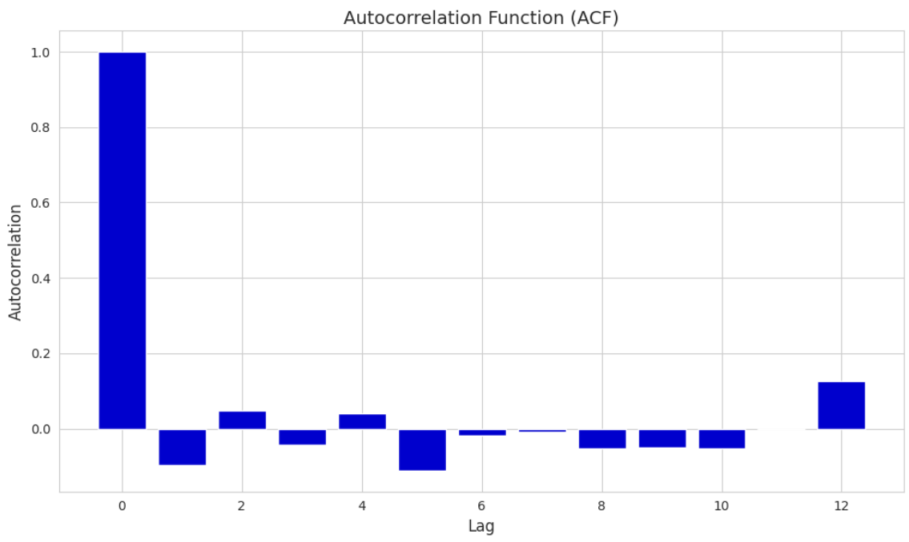
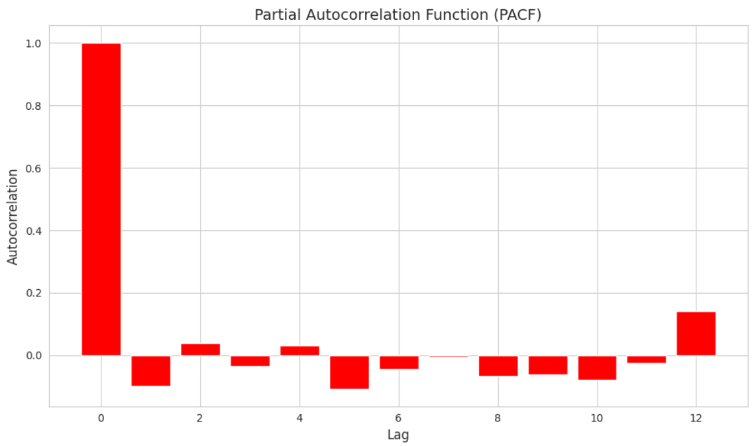

The Partial Autocorrelation Function (PACF) and Autocorrelation Function (ACF) plots provide insights into the potential values of `p` and `q` for an ARIMA model.
Looking at your PACF plot, there is a significant spike at lag 1 followed by insignificant spikes for the subsequent lags. This suggests an AR(1) component, as the partial autocorrelation at lag 1 is above the significance level and cuts off sharply afterward.
In the ACF plot, there are several lags that are significant, but there's no clear cut-off point, which sometimes suggests a mix of AR and MA components. The significant lags at 1, 2, and significantly at 11 could suggest a possible seasonal component, or they may represent an MA process.
Based on these observations, here are five sets of ( (p, d, q) values for ARIMA models that you might start with:
1. ARIMA(1, 0, 0)**: Logical given the PACF plot showing a significant spike at lag 1 with a cutoff after that, suggesting a first-order autoregressive model.
2. **ARIMA(1, 0, 1)**: This model includes both AR and MA components of order 1, which is a balanced approach when both ACF and PACF show significance at lag 1.

3. **ARIMA(1, 0, 2)**: With the ACF plot showing significance at the first few lags, an MA component of order 2 might capture the gradual decay in correlation.

4. **ARIMA(2, 0, 1)**: The PACF plot has a significant effect at lag 1, and possibly some effect at lag 2. This suggests trying a second-order AR component.

5. **ARIMA(1, 0, 11)**: The spike at lag 11 in the ACF may suggest a long MA component. This is less common and may indicate a seasonal pattern, but it's worth trying if you suspect a longer lag structure influences the series.

Each of these models increases in complexity, and it's essential to validate them using both statistical criteria (like AIC and BIC) and diagnostic checks on the residuals to ensure the assumptions of the ARIMA model are met. If the data has a seasonal pattern, then Seasonal ARIMA (SARIMA) models might be more appropriate, which include additional seasonal parameters.

MODELLING WITH NON-STATIONARY DATA
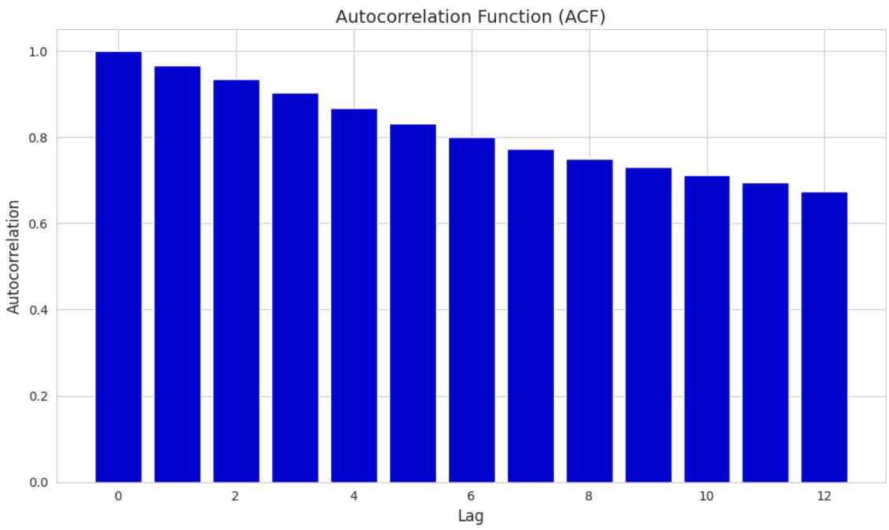

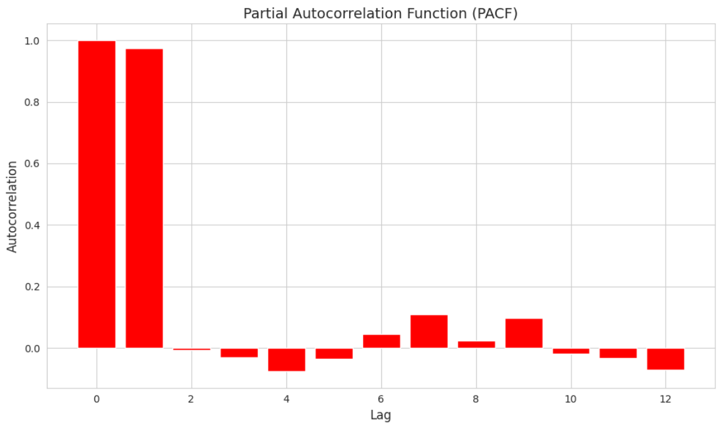
Based on the ACF and PACF plots provided, here is how you might interpret the plots for determining the values of `p` and `q` in an ARIMA(p,1,q) model, considering that your data is non-stationary and requires one level of differencing (d=1):

1. **PACF (Partial Autocorrelation Function)**: The significant spike at lag 1 suggests an AR(1) component is needed. There are no other significant spikes beyond the first lag within the PACF, so higher-order AR terms may not be necessary.

2. **ACF (Autocorrelation Function)**: There is a gradual decay in the ACF plot, which suggests the need for MA terms. However, without additional significant spikes at specific lags, it's less clear-cut what the MA order should be.

Given this information, five potential (p,q) sets for ARIMA(p,1,q) models might be:

1. **ARIMA(1,1,0)**: The spike at lag 1 in the PACF suggests a significant AR(1) component, and no MA component is initially considered.

2. **ARIMA(1,1,1)**: Both the ACF and PACF indicate a significant first lag, which suggests an AR(1) and MA(1) component might be a good starting model.

3. **ARIMA(1,1,2)**: Given the gradual decay in the ACF plot, an MA(2) component may better capture the slowly declining autocorrelation.

4. **ARIMA(2,1,1)**: Even though the PACF does not clearly indicate a second AR term, sometimes adding an extra AR term can capture any autocorrelation not accounted for by the first AR term and the MA component.

5. **ARIMA(1,1,3)**: The ACF shows a more extended lag structure which could suggest that additional MA terms are needed to fully capture the autocorrelation structure.

For all these models, the underlying assumption is that the series becomes stationary after one differencing, thus d=1. It's essential to note that these are initial guesses based on the ACF and PACF plots. The actual best model should be selected based on diagnostic checks and information criteria (like AIC and BIC) after fitting the models. After fitting these models, it's important to look at the residuals to ensure that they are white noise, and to compare model performance using both in-sample fit and out-of-sample forecasts.

STATIONARY DATA MODELLING OUTCOMES:
The table you provided shows the performance metrics for five different ARIMA (AutoRegressive Integrated Moving Average) models applied to your stationary time series data. These models are characterized by their (p, d, q) orders, where 'p' is the number of autoregressive terms, 'd' is the number of differences needed for stationarity, and 'q' is the number of moving average terms. The performance of these models is measured using several metrics: Mean Absolute Error (MAE), Root Mean Squared Error (RMSE), Mean Absolute Percentage Error (MAPE), Akaike Information Criterion (AIC), and Bayesian Information Criterion (BIC). Let's analyze each model based on these metrics:

1. **ARIMA(1, 0, 0)**:
- MAE: 0.019217, RMSE: 0.022220, MAPE: 1.077824, AIC: -455.205391, BIC: -447.272218
- This is the simplest model with only one autoregressive term. It has the lowest AIC and BIC values among all models, which suggests a good balance between model fit and complexity.

2. **ARIMA(1, 0, 1)**:
- MAE: 0.019129, RMSE: 0.022200, MAPE: 1.063070, AIC: -454.824967, BIC: -444.247403
- This model adds a moving average term to the previous model. It slightly improves in MAE, RMSE, and MAPE but has a slightly higher (worse) AIC and BIC.

3. **ARIMA(1, 0, 2)**:
- MAE: 0.019251, RMSE: 0.022365, MAPE: 1.052580, AIC: -453.182918, BIC: -439.960964
- Adding another moving average term doesn't seem to provide significant improvement. In fact, the MAE and RMSE are slightly higher than the first two models, and the AIC and BIC are also higher.

4. **ARIMA(2, 0, 1)**:
- MAE: 0.019191, RMSE: 0.022302, MAPE: 1.050807, AIC: -453.117683, BIC: -439.895728
- This model has two autoregressive terms and one moving average term. It shows a slight improvement in MAPE compared to the first model, but the AIC and BIC values are higher, indicating increased complexity without substantial improvement in model fit.

5. **ARIMA(1, 0, 11)**:
- MAE: 0.020054, RMSE: 0.023968, MAPE: 1.057424, AIC: -444.618310, BIC: -407.596838
- This model, with a high number of moving average terms, shows worse performance in all metrics compared to the other models. Both the error metrics and the information criteria indicate that this model is likely overfitting.

Recommendation: Based on the balance between model complexity and performance, the **ARIMA(1, 0, 0)** model seems to be the best choice. It has the lowest AIC and BIC values, indicating a good balance between fitting the data and not being overly complex. While the MAE, RMSE, and MAPE are not the absolute lowest, they are competitively close to the best values, suggesting that this model is robust and efficient for your data.

NON_STATIONARY DATA MODELLING OUTCOMES:
In this scenario, you have applied five different ARIMA models to a non-stationary Log_Real_Exchange_Rate dataset. Each model's performance is again evaluated using MAE (Mean Absolute Error), RMSE (Root Mean Squared Error), MAPE (Mean Absolute Percentage Error), AIC (Akaike Information Criterion), and BIC (Bayesian Information Criterion). Let's analyze each model:

1. **ARIMA(1, 1, 0)**:
- MAE: 0.097306, RMSE: 0.122435, MAPE: 0.020170, AIC: -449.050885, BIC: -443.762104
- This model has the lowest MAE, RMSE, and MAPE values, and also the best (lowest) AIC and BIC values. This suggests a good fit with minimal complexity.

2. **ARIMA(1, 1, 1)**:
- MAE: 0.097221, RMSE: 0.122368, MAPE: 0.020152, AIC: -447.049445, BIC: -439.116272
- Despite slightly better MAE, RMSE, and MAPE than ARIMA(1, 1, 0), its AIC and BIC values are higher, indicating a more complex model without significant improvement in fit.

3. **ARIMA(1, 1, 2)**:
- MAE: 0.098857, RMSE: 0.123860, MAPE: 0.020494, AIC: -448.162005, BIC: -437.584441
- This model shows a noticeable increase in error metrics (MAE, RMSE, MAPE) and higher complexity as reflected in the AIC and BIC values.

4. **ARIMA(2, 1, 1)**:
- MAE: 0.098951, RMSE: 0.123911, MAPE: 0.020514, AIC: -448.577998, BIC: -438.000434
- Similar to ARIMA(1, 1, 2), this model has higher error metrics and increased complexity, indicating that the addition of extra parameters is not contributing positively.

5. **ARIMA(1, 1, 3)**:
- MAE: 0.098411, RMSE: 0.123427, MAPE: 0.020401, AIC: -445.963083, BIC: -432.741128
- Higher error metrics and the highest complexity among all models suggest that this configuration may be overfitting the data.

**Recommendation**: The **ARIMA(1, 1, 0)** model seems to be the most appropriate for your dataset. It achieves the best balance between fitting the data well (as indicated by the lowest error metrics) and maintaining simplicity (lowest AIC and BIC values), which is crucial for avoiding overfitting and ensuring good generalization.

Comparing best models among stationary and non stationary data

Certainly, let's compare the best models from each of your ARIMA analyses – one using stationary data and the other using non-stationary data.

1. **Best Model for Stationary Data: ARIMA(1, 0, 0)**
- MAE: 0.019217, RMSE: 0.022220, MAPE: 1.077824, AIC: -455.205391, BIC: -447.272218
- Characteristics: Simple model with one autoregressive term, no differences, and no moving average terms.

2. **Best Model for Non-Stationary Data: ARIMA(1, 1, 0)**
- MAE: 0.097306, RMSE: 0.122435, MAPE: 0.020170, AIC: -449.050885, BIC: -443.762104
- Characteristics: Model with one autoregressive term, one differencing, and no moving average terms.

**Comparison and Analysis:**

- **Error Metrics**: The ARIMA(1, 0, 0) model has significantly lower MAE and RMSE values compared to the ARIMA(1, 1, 0) model. This suggests that the model for stationary data is better at predicting values close to the actual numbers. However, MAPE, which is a relative measure, is notably higher in the stationary model, suggesting differences in the scale or nature of the data.

- **Complexity (AIC and BIC)**: Both models have a relatively low complexity, but the ARIMA(1, 0, 0) model has even lower AIC and BIC values. This indicates that it's a more efficient model in terms of the trade-off between goodness of fit and complexity.

- **Data Nature**: The stationary nature of the dataset for the ARIMA(1, 0, 0) model could be a significant reason for its better performance. Stationary data, by definition, has properties like mean and variance that don't change over time, making it easier to model and predict. In contrast, non-stationary data often contains trends and seasonality, which can make accurate modeling more challenging.

**Best Model and Reasons:**

Based on the comparison, the **ARIMA(1, 0, 0)** model used on the stationary data appears to be the best model overall. Its superior performance is likely due to:
- **Lower error metrics (MAE, RMSE)**: Indicates better predictive accuracy.
- **Simplicity (lower AIC and BIC)**: Suggests it captures the necessary patterns in the data without unnecessary complexity.
- **Stationarity of Data**: Stationary data is generally easier to predict due to consistent statistical properties over time.

In conclusion, while the ARIMA(1, 1, 0) model is the best fit for your non-stationary data, the ARIMA(1, 0, 0) model's performance on stationary data is superior. This could be due to the inherent nature of stationary data being more predictable and the simplicity yet effectiveness of the ARIMA(1, 0, 0) model in capturing the necessary dynamics of such data.

References
Sarno, L., & Taylor, M. P. (2002). The Economics of Exchange Rates. Cambridge University Press.
Taylor, M. P. (2003). Real Exchange Rates and Purchasing Power Parity: Mean-Reversion in Economic Thought. Applied Economics, 35(5), 557-566.
International Monetary Fund. (Various Years). IMF Working Papers. [Working Paper Series]. Retrieved from IMF eLibrary: https://www.elibrary.imf.org/
Engle, R. F., & Granger, C. W. J. (1987). Co-integration and Error Correction: Representation, Estimation, and Testing. Econometrica, 55(2), 251-276.

