Little Big World

**Game Description**: The game is about player playing as little human in our normal world. The game aims to stimulate player having to stealthy navigate around houses and overcoming puzzle like obstacle along the way to get to the goal. Even climbing a table’s leg to get a cube of sugar for daily necessity is difficult!

**Game Story**: It is about little human trying to live by every day in a world filled with gigantic animals and human without being caught or eaten.

**Game Platform**: 3D, first person, PC Game.

Game Play Main Idea: Solve puzzle while being stealthy.

Gameplay Mechism: Navigate around in a room as little human and being resourceful and creative in overcoming obstacle to reach goals by utilizing objects found along the way. The catch is that every movement ,every sound made, will potentially alarmed human and being attacked by them.

Game Win and lose condition: Win is to reach designated location/finding certain item set by the game. Lose is when human is alarmed and caught you.  
  
Game Inspiration: The Borrowers Arrietty

illustration (Imagine they are in 3D ):

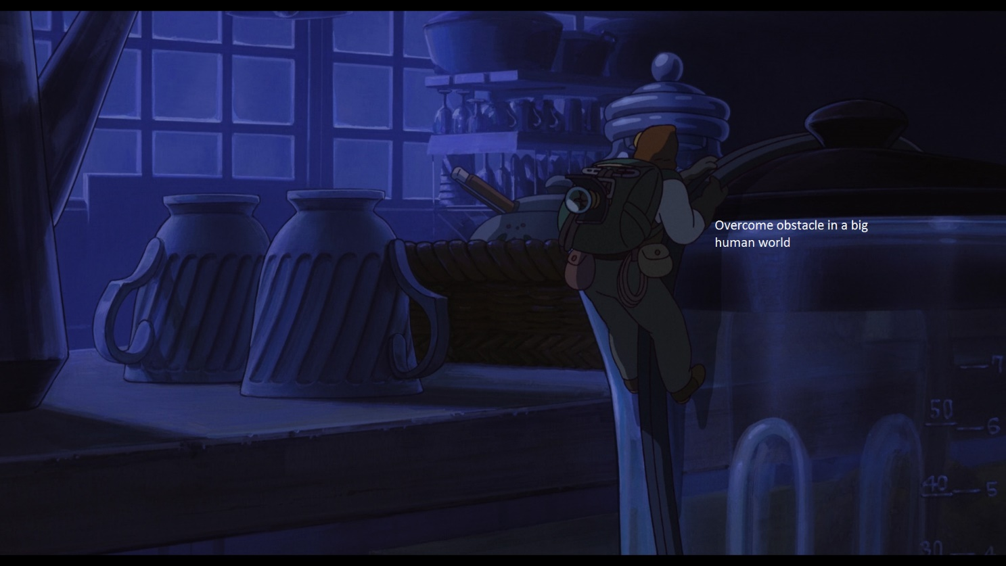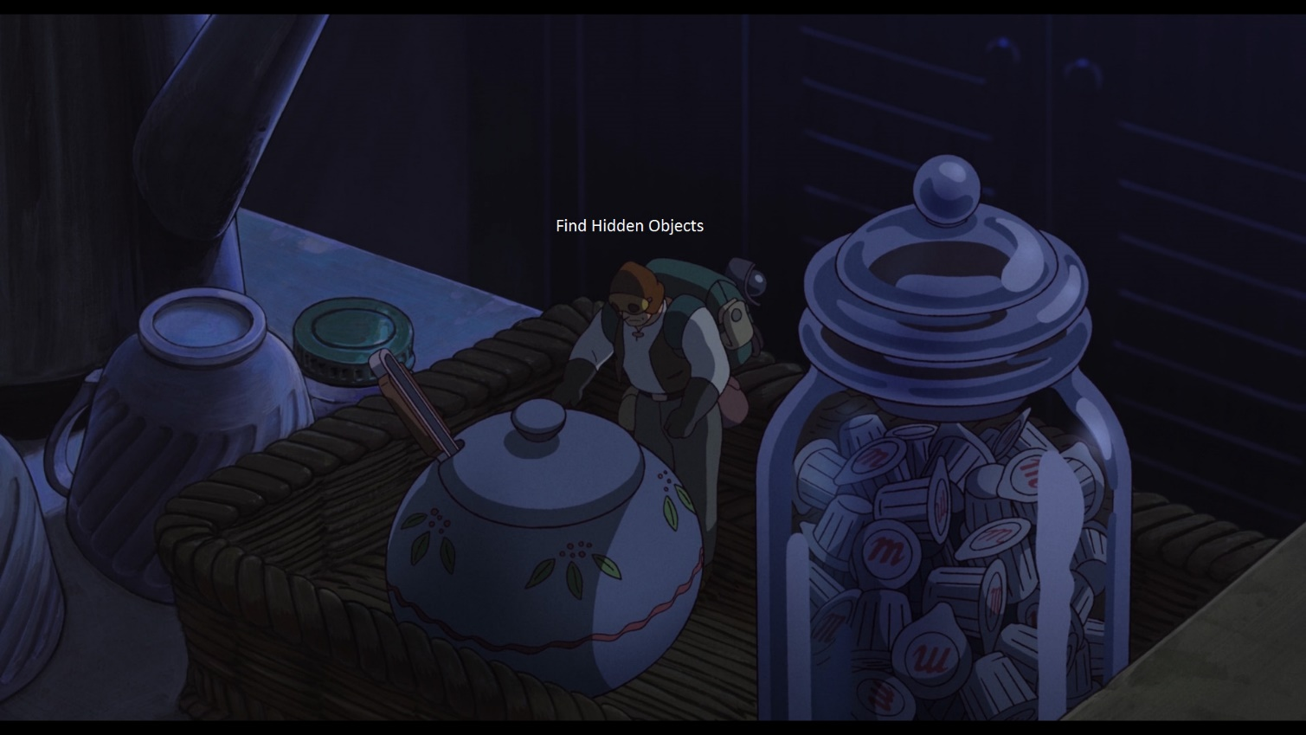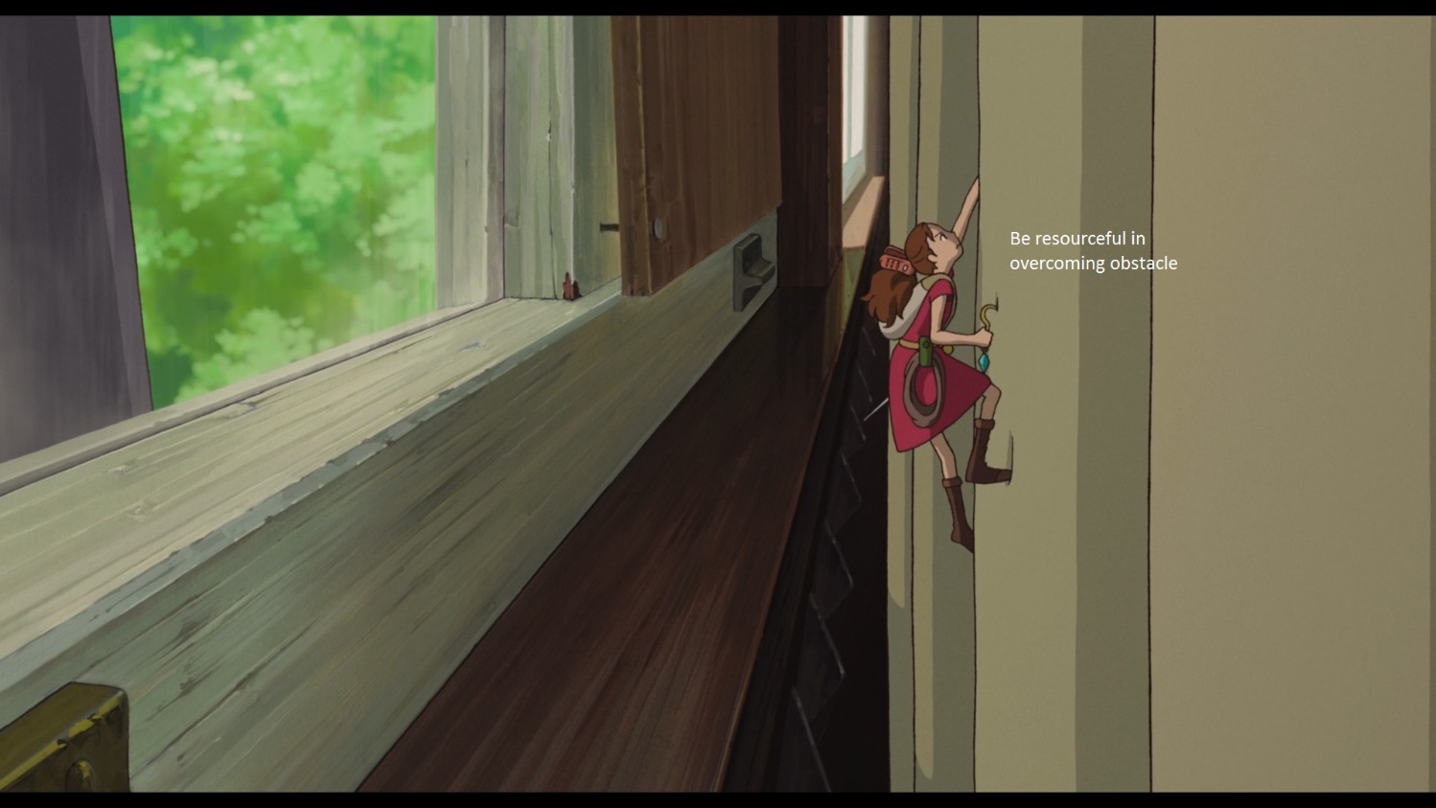

Game Scene mock up:

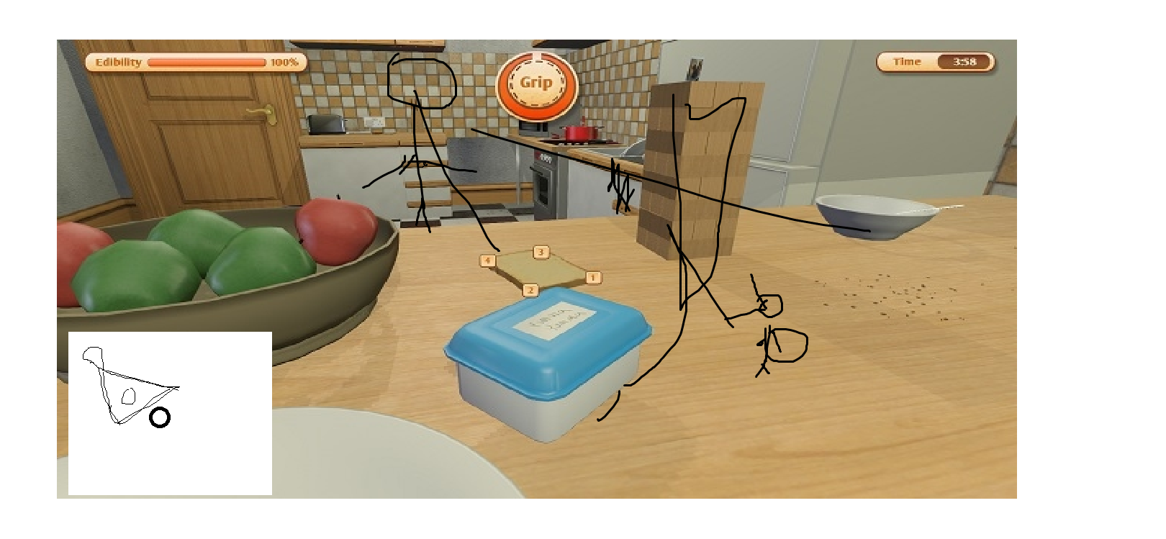

The player is the size of the bread.

MiniMap will be there to help player visualize surround threat

Player is suppose to use item in their inventory to overcome obstactle,like pushing over the tower of block.  
the “Edibility” bar on top will be change to Stealth bar which will rise whenever the giant human get alerted.

*note* it will be 1st person view.

Game Feature:

Inventory system

Crafting system

Stealth System (stealth bar, interactions to influence the bar, e.g. hiding action)

Music and sound

Environment interaction (physics?)

Minimap (show simple map layout, fov of enemy and enemy location)

FSM Ai for enemy

Frustum (FOV) to detect player

Tracking time used to clear stage (point)

(Hidden collectable) Easter eggs

Main menu page

Setting page

Observer mode (?)(Free cam to allow player to look around)

Credit page

Tutorial stage

Collectible page

3 stage (?)

Dialog system(?) (to help explain thing to player)

Undiscussed Possible feature:

-Different control while climbing

-Mini game during lockpicking

Crafted tools:

-grapple

-lockpick

-distract items

Possible puzzle element:

-Traditional platform challenge

-pushing and pulling of object to climb thing

-finding and crafting item.

Stealth mechanism Idea:

Enemy will be alerted when stealth bar drop below 50%. Enemy will come search for player and if spotted,enemy will attack player until player is able to shake enemy away.

Factors for dropping stealth bar

* Movement(running,object collsion,player in wide open space)
* Player in enemy’s fov

Factors for restoring stealth bar

* Hiding using object
* In dark
* Out of enemy’s fov
* Lack of movement

Team members:

Muhd Hazim

Darren low

Pang Kee Yang