For my Olympic sport, I chose fencing as it allowed me to be a lot more creative with the design of my Olympoid, as I only needed to worry about it holding the Epee; one of the blades used in fencing, while still being able to theoretically compete with humans, which was a goal I set myself. Choosing a sport like cycling would mean that I would have had to make my Olympoid more humanoid than I would've liked, as it would have had to be able to sit on a regular bike, whereas a sport like gymnastics would mean that I would be able to make my Olympoid as unique as I liked. This would've made it a lot harder to fit with my goal of my Olympoid being able to compete with humans, as adding too many joints or polygons would make it far for flexible than any Olympic gymnast, but adding too little would make it not able to compete in the sport to an Olympic standard.

For the design of my Olympoid, I first researched fencing (Olympics, 2012) as I wanted to ensure that the sketches I was making and images of robots I was using as research could theoretically fence. My first discovery was that fencing is a very fast sport. This led to the decision that I should keep the design of my Olympoid as simple as possible since I would have to animate a large number of objects otherwise. I also wanted to incorporate the bending of the epee into my design, so I decided for my Olympoid to not have arms. Instead, my Olympoid would have tentacles, as they have the ability to bend in many more directions than arms, as well as more places. Since I decided to ensure that my Olympoid would have tentacles for arms, I then decided to look for animals, as well as other models with tentacles or ones with a similar design to an animal with tentacles. These images below were my key inspiration pieces for the sketches I designed:

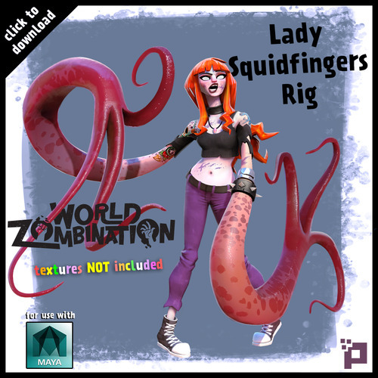

(*EVE*, 2022) (proletariat-inc, 2014)

I wanted my Olympoid to have the simplicity Of EVE, but also be as flexible as Lady Squidfingers. Once I decided this, I began to sketch potential designs for my Olympoid.

During sketching, I found that keeping the tentacles separate from the main body added to the simplicity of my designs, as well as increasing the amount of movability the tentacle would have. If it was floating freely in the air it would be able to rotate in 360 degrees in all axis, so I would be able to animate more complex and unique lunges. Some sketches that incorporate this can be seen below:

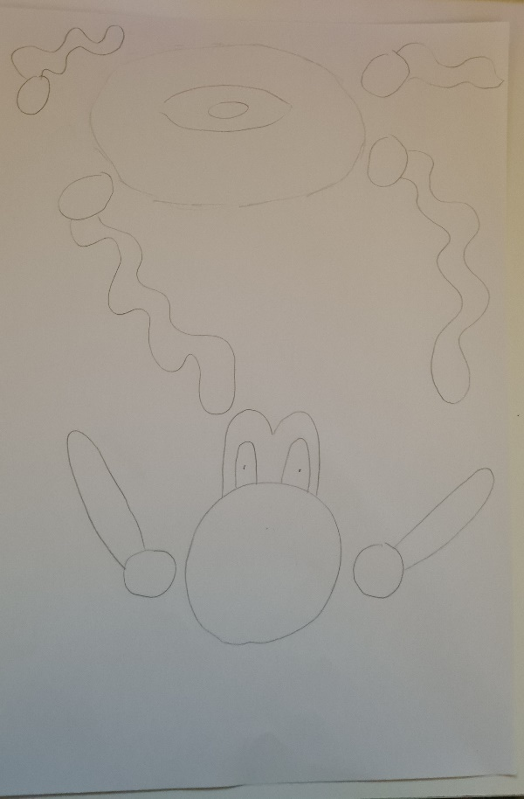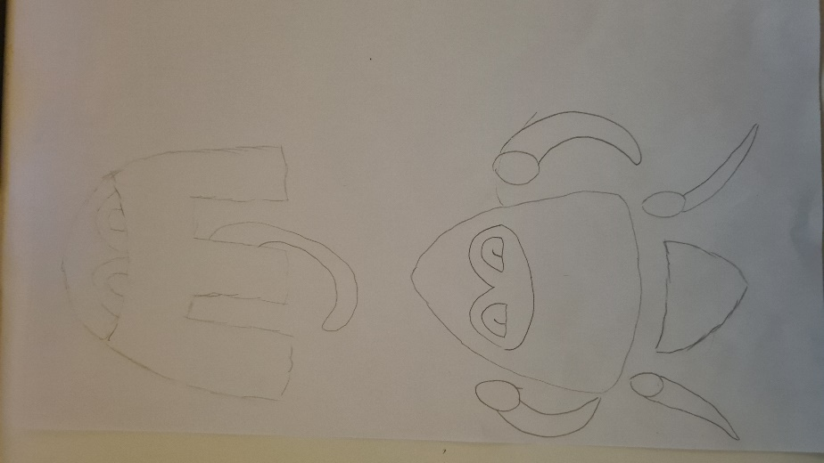

Since I wanted the tentacles of my sketches to be able to rotate in any direction I attached them to spheres, as spheres would easily imply a ball joint. From these designs, I decided to base my Olympoid on the sketch below:

This is because I felt that it was one of the sketches with the most simple design, but also having enough potential features to model and animate.

In order to translate my sketch to Maya I made use of importing image planes, sketching over parts of them with the CV curve tool, and then using the revolve tool to turn a curve into a polygon. However, before I could do this I needed to create images for me to import into Maya. Using the sketch I chose I redrew each section of it at a larger scale, being careful to keep each section of a similar scale to the others. The sketches I used as image planes can be seen below: 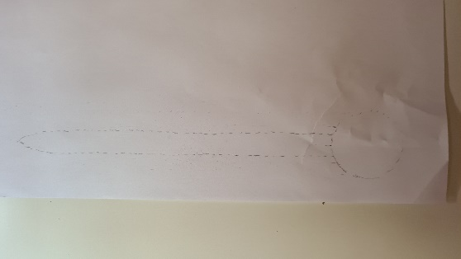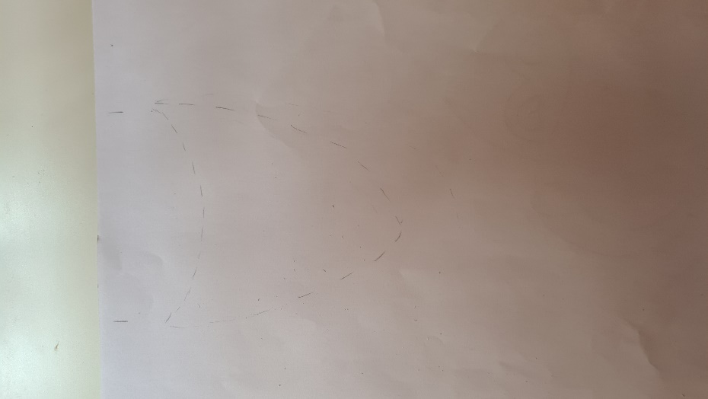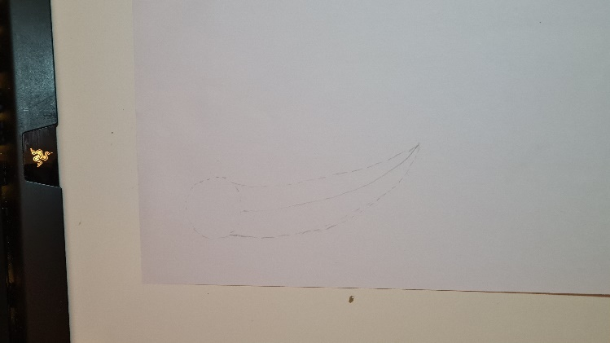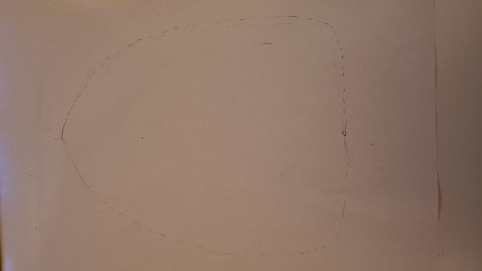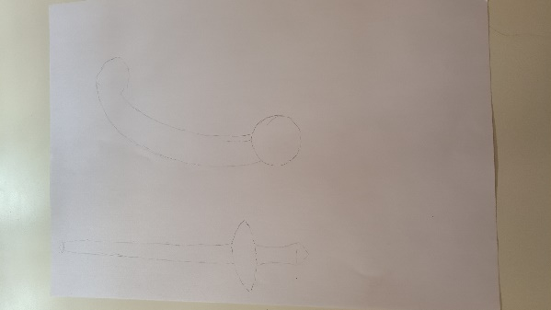

I also decided to model the epee my Olympoid would use this way as well, as it has a cylindrical shape.

I then began to create and rotate the curves I needed in order to create the geometry that would make up my Olympoid. This took a lot of time, as the process was mainly trial and error. My attempt to keep my sketches at a similar scale did not translate well into Maya, and I found that the sketches for the tentacles and epee were far too thick when placed next to the main body. It was at this stage I decided that the two tentacles below the main body of my Olympoid should not be tentacles, but instead have a fixed shape. This was because I felt that during animation if there were too many moving parts, the eye would not focus on the key point of the animation; the movement of the epee. Also, I felt that it would make my Olympoid not fit within the boundaries of my goal, as a human would have a tricky time hitting what are my Olympoid’s equivalent of legs. After positioning the different sections of geometry into their correct places, I finally managed to create a model that I was happy with and able to animate, which can be seen below:

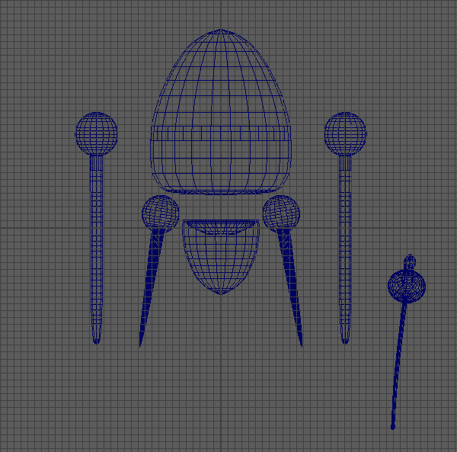

Once I had done this, I then began work on the skeleton. Implementing the skeleton was a fairly simple task, but I wanted to ensure that I had enough joints in each tentacle for them to have enough flexibility. Since this was the most complex task at this point in production, I first created the skeleton for the tentacles. I began by inserting a joint at every vertex along the width of one of the tentacles, I did not do this for both as I could mirror the skeleton later on, however, this resulted in an unintended outcome. The tentacle was too flexible and instead of getting the bend that I wanted, a smooth stretched quadratic curve at the top with a spiral at the bottom of the tentacle, I ended up with the tentacle having a deep, squished quadratic curve. It was possible to get the curve I wanted with the current skeleton, but it would take a lot of time to create it. Therefore, I decided to remake the skeleton, with joints spread out at a greater distance at the top of the tentacle, where it connects to the ball joint, compared to the bottom. This made it a lot easier to bend the tentacle into the shape I wanted. I used a similar technique when modelling the epee, but instead of lowering the distance between joints at the epee tip, I shortened the distance about 3 quarters of the way down the length of the blade. Creating the joints for the other parts of my Olympoid was a much simpler task. I made sure that each section had one joint that could move individually, but also move with the main body. To do this I parented the joints to the main body after creating each one, as if I had created them as parents of the main body joint one by one they would have lost the ability to move by themselves. Once I had ensured that each joint was in the correct position, I attached it to the geometry it corresponded to. I also made use of the MEL select -hi command so that I could quickly select each joint of the tentacles and epee. A wireframe of my Olympoid connected to its skeleton can be seen below:

I then began to animate my Olympoid. I wanted my Olympoid to: Pick up the epee, and have its tentacle wrap around the handle; get into an En garde position; quickly move forward and attempt to hit its opponent, but miss; retreat back and taunt its opponent; block some incoming attacks; counterattack and hit its opponent; then move into a victory pose. Before I began animating this, I watched a few more reference videos (THNKR, 2012) (Vox, 2016) (Red Bull, 2016) in order to replicate a proper En garde position and lunge with my Olympoid. I mainly focused on how the tentacles acting as arms reached these positions, as I would be able to perform a lot of movement with them. Once I had an idea of the position that the tentacles should end up in I began animating.

In order to attach the epee to the right tentacle, I created a parent constraint between the epee and tentacle which was set to 1 once the tentacle had wrapped around it. I also made use of the select -hi MEL command again as it allowed me to set a keyframe for all joints in a tentacle or the epee, rather than assigning each joint a keyframe individually. During animating, I tried to mainly make use of the Anticipation Principle of the Disney Animation Principles, as it was the easiest to implement. I made sure that the tentacles at the bottom half of the main body swung backwards or forward just before the whole model moved backwards or forwards. I also made sure that they moved beyond the position of the main body once it had stopped moving, in order to keep an illusion of momentum in my Olympoid. I also made sure the epee bent a tiny amount as the main body was moving as well, otherwise it would make the extreme bends of it when it collides with the Olympoid’s opponent unnatural. During the taunt section of the animation, I wanted the Olympoid to rotate the end its the tentacle holding the eppe about a circle, causing the epee’s blade to rotate about a larger circle, which is a typical fencing move. However, since the joints of the skeletons that would move are both attached to a parent joint I was unable to create a motion path for the joints to follow. This meant that I had to manually move the joints around a circle, which resulted in that part of the animation not being as smooth as I would’ve liked.

Once I had finished animating my Olympoid I began to add textures to it. I applied Maya’s Standard Surface Material to each component of my Olympoid. It was at this point I thought about how I could create a link between the Olympoid with the Olympics and a specific country that would compete. I decided to represent the flag of a country on the main body of my Olympoid since it is the largest component, and since I had 5 other components of the Olympoid’s body, represent the Olympic Rings on the other sections. I chose my Olympoid to represent Austria, as due to the position of polygons on the main body it was very easy to wrap a rectangle around the middle part. I then made sure that the material on the epee was a lot more metallic than the other materials as it would be made of metal, and I wanted it to reflect light differently compared to the other materials so that a viewer's eye would more easily follow it. The final textured model of my Olympoid can be seen below:

Then, I began to light the scene around my Olympoid. I started by looking for HDRi images which could be used on an Arnold SkyDome light. An image of An Olympic stadium would have been ideal, but unfortunately, I could not find one. However, I came across A HDRi (Majboroda, 2022) of a gym with a long strip of fabric running down the middle, which could act as a fencing strip. Once I had scaled down the SkyDome and placed a camera in a suitable position I began to render my animation.

Overall, I believe that given more time, and under different circumstances, I would have been able to add much more detail to the animation of my Olympoid, as well as the model. I could have kept the low level of detail I aimed for by adding more components to my Olympoid but making them large and stand out, for example, adding eyes to the top half of the main body or making the ball joints less smooth by adding bolts or screws. However, despite this, I did manage to mimic the fast-paced sport that fencing is. My Olympoid quickly makes lunges, jabs and blocks and doesn’t leave a large amount of time between its next action. During the moments when the fencing match would be fast-paced, my Olympoid is constantly moving every part of its body. I would also have liked to make a few adjustments to the taunt section of the animation by making them smoother and more menacing, by introducing a quick jab with the epee or setting more keyframes during the rotation of the epee.

References:

*EVE* (2022) *Pixar Wiki*. Available at: https://pixar.fandom.com/wiki/EVE (Accessed: 5 May 2022).

Majboroda, S. (2022) *Gym 01 HDRI • Poly Haven*, *Poly Haven*. Available at: https://polyhaven.com/a/gym_01 (Accessed: 5 May 2022).

Olympics (2012) *Aron Szilagyi Szilagyi Wins Fencing Sabre Gold - London 2012 Olympics*. Available at: https://www.youtube.com/watch?v=nGearEu2PlU (Accessed: 5 May 2022).

proletariat-inc (2014) ‘Lady Squidfingers Character Rig’, *Proletariat Inc.*, May. Available at: https://proletariat-inc.tumblr.com/post/87109151907/lady-squidfingers-character-rig (Accessed: 5 May 2022).

Red Bull (2016) *The Physics and Speed of Fencing*. Available at: https://www.youtube.com/watch?v=ezoZfZK75zA (Accessed: 6 May 2022).

THNKR (2012) *How To Fence: The Basics of Fencing, Taught by Olympians*. Available at: https://www.youtube.com/watch?v=a8IdfA5fXJs (Accessed: 6 May 2022).

Vox (2016) *Fencing, explained*. Available at: https://www.youtube.com/watch?v=kTw05gC2T9Y (Accessed: 6 May 2022).