Meta-analysis plans
March 28 2025
- Checking if sd of t1, t2, t3,t4 if too lagreif not, no need to compute effect size/time interval
Development of Narcissism Across the Life Span: A Meta-Analytic Review of Longitudinal Studies (Orth et al., 2024, p.9)
- the within-study variance of d:
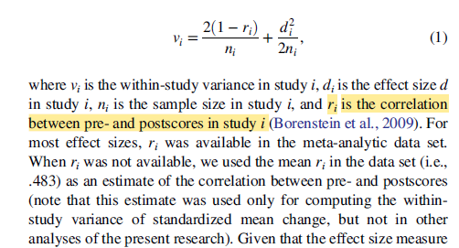

Borenstein, M., Hedges, L. V., Higgins, J. P. T., & Rothstein, H. R. (2009). Introduction to meta-analysis. Wiley.
- Chapter 4: Effect Sizes Based on Means (p.29). The formular is not the same as the formula (1) in Orth et al (2024)
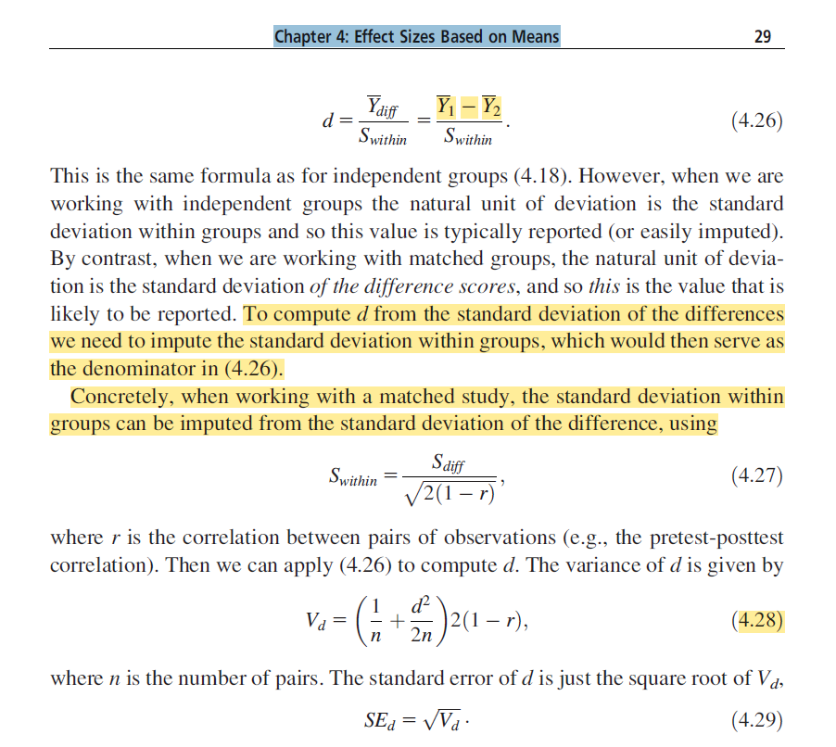

Viechtbauer (2019): An Introduction to Longitudinal Meta-Analysis in R with the metafor Package
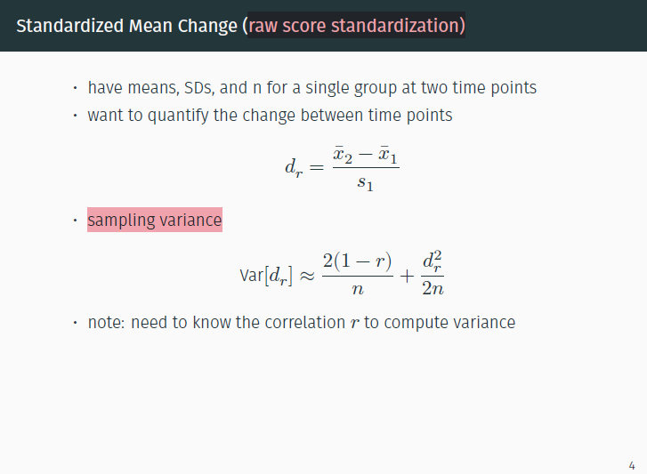

Development of Narcissism Across the Life Span: A Meta-Analytic Review of Longitudinal Studies (Orth et al., 2024, p.6)
- Effect size/ time interval is not necessary
  - Orth et al (2021): Development of Domain-Specific Self-Evaluations: A Meta-Analysis of Longitudinal Studies: did not convert effect size/time interval
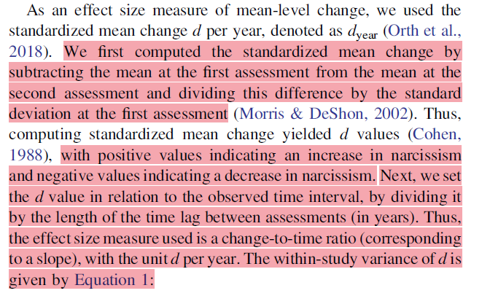
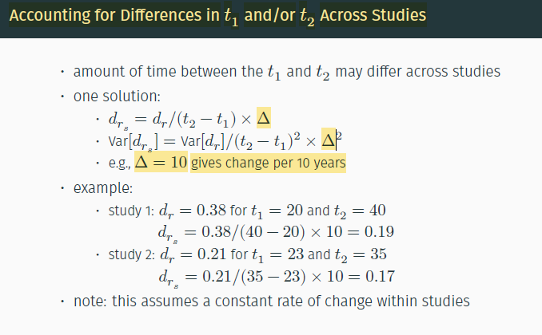
dat <- transform(dat, es_d = (outm2-outm1)/outsd1)# the mean differences between T2-T1
dat <- transform(dat, es_dyear = es_d/timelag) #amount time between T1 and T2 might differ across studies

- Effect size/ time interval is not necessary
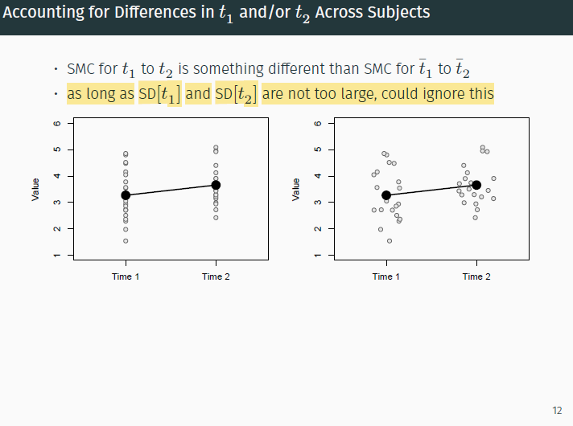

Meta-analysis questions
- Computing the standardized mean-level change:
- The “SMCR” in the escalc function is based on equation 13 in Becker (1998). Orth et al (2024) use this equation wo write the R code. The source of computing sample variance and the standardized mean-level change is from :
https://www.metafor-project.org/doku.php/analyses:morris2008
- Becker, B. J. (1988). Synthesizing standardized mean-change measures. British Journal of Mathematical and Statistical Psychology, 41(2), 257–278.
- Morris, S. B. (2008). Estimating effect sizes from pretest-posttest-control group designs. Organizational Research Methods, 11(2), 364–386.
- The standardized mean-level change: (Mean_post-Mean_pre)/standard deviation_pre
  - Morris, S. B. (2000). Distribution of the standardized mean change effect size for meta‐analysis on repeated measures. British Journal of Mathematical and Statistical Psychology, 53(1), 17-29.
------------------------------------------------------forest plots-------------------------------------------------------------
- A graphical representation of the effect size for each study
- Question: Fitting a long list of studies in Metafor Forestplot to make it readable
https://stackoverflow.com/questions/75076670/fitting-a-long-list-of-studies-in-metafor-forestplot-to-make-it-readable
https://stats.stackexchange.com/questions/460277/alternative-visualisation-to-forest-plot-for-large-dataset-of-effect-sizes-in-r
https://stackoverflow.com/questions/48858734/how-can-i-split-a-long-forest-plot-when-meta-analyzing-with-the-metafor-package

-----------------------------------------------funnel plots (publication bias)------------------------------------------------
- When there is no publication bias, the data points in such a plot should form a roughly symmetrical, upside-down funnel
- Egger’s Regression Test (the function is regtest)

------------------------------------------------------metafor package----------------------------------------------------------
- rma.mv: Function to fit meta-analytic multivariate/multilevel fixed- and random/mixed-effects models with or without moderators via linear (mixed-effects) models.
- rma: Function to fit meta-analytic equal-, fixed-, and random-effects models and (mixed-effects) meta-regression models using a linear (mixed-effects) model framework
- robu: is used to meta-regression models using robust variance estimation (RVE) methods. robu can be used to estimate correlated and hierarchical effects models using the original (Hedges, Tipton and Johnson, 2010) and small-sample corrected (Tipton, 2013) RVE methods.
-----------------------------------------------------------model---------------------------------------------------------------
Code from Development of narcissism –Orth et al (2024)
Line 191: rma.mv(yi=es_dyear, V=v_dyear, random = ~ 1 | sampid/caseid, data=dat.agentic)
- random = ~ 1 | sampid/caseid nested random effects structurecasei is nested with sampid
Line 206: res <- rma.mv(yi=es_dyear, V=v_dyear, random = ~ 1 | sampid/caseid, data=dat.agentic, mods = cbind(agem1ic1)) Adds a moderator variable to the model: agem1ic1, which is a centered and scaled version of age at time 1.
Line 55-60:
dat <- transform(dat, yob = t1year-agem1)
dat <- transform(dat, agem1ic1 = (agem1i-23.13)/10)## the mean of agem1 (the first time point of age) is 23.13 mean age at beginning of interval on which effect size is based - the mean of agem1
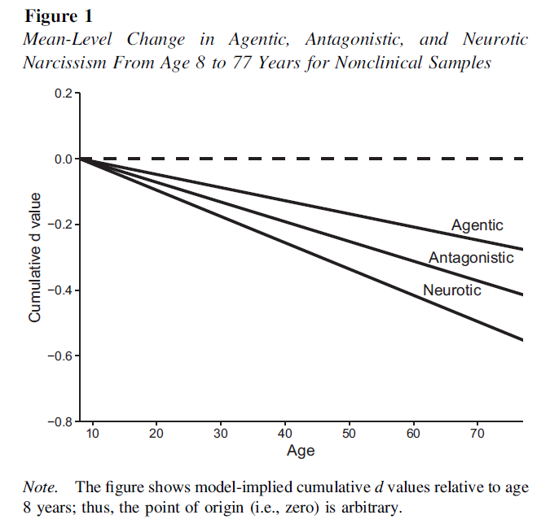

dat <- transform(dat, agem1ic2 = agem1ic1^2)
dat <- transform(dat, agem1ic3 = agem1ic1^3)
dat <- transform(dat, timelagc = timelag-11.42)
dat <- transform(dat, agem2i = agem1i+timelag) )## the mean of timelagc (time lag between assessments) is 11.41

Age effect
Line 206-212
res <- rma.mv(yi=es_dyear, V=v_dyear, random = ~ 1 | sampid/caseid, data=dat.agentic, mods = cbind(agem1ic1))cbind means : can combine multiple moderators
print(res, digits=4) agem1ic1 is significant

res <- rma.mv(yi=es_dyear, V=v_dyear, random = ~ 1 | sampid/caseid, data=dat.agentic, mods = cbind(agem1ic1, agem1ic2)) combine two moderators: age and square of age
print(res, digits=4) agem1ic1, agem1ic2 are not significant

res <- rma.mv(yi=es_dyear, V=v_dyear, random = ~ 1 | sampid/caseid, data=dat.agentic, mods = cbind(agem1ic1, agem1ic2, agem1ic3)) combine three moderatos: age, square of age, ..--> agem1ic1, agem1ic2, agem1ic3 are not significant

---------------------------------------------------------Publication bias------------------------------------------------------
Code from Development of narcissism –Orth et al (2024): they tried rma and rma.mv functions
- Line 337: res <- rma(yi=es_dyear, vi=v_dyear, data=dat.agentic)rma function
- Random-Effects Model (k = 96; tau^2 estimator: REML)

- tau^2 (estimated amount of total heterogeneity): 0.011 (SE = 0.002)
- tau (square root of estimated tau^2 value): 0.105
- I^2 (total heterogeneity / total variability): 99.28%
- H^2 (total variability / sampling variability): 138.52

- Test for Heterogeneity:
- Q(df = 95) = 938.421, p-val < .001

- Model Results:

- estimate se zval pval ci.lb ci.ub
- -0.016 0.012 -1.304 0.192 -0.040 0.008

- ---
- Signif. codes: 0 ‘***’ 0.001 ‘**’ 0.01 ‘*’ 0.05 ‘.’ 0.1 ‘ ’ 1

- Line 340: res <- rma.mv(yi=es_dyear, V=v_dyear, random = ~ 1 | sampid/caseid, data=dat.agentic, mods = cbind(pubstatus))rma.mv function with a nested structure

ultivariate Meta-Analysis Model (k = 96; method: REML)

Variance Components:

estim sqrt nlvls fixed factor
sigma^2.1 0.001 0.028 45 no sampid
sigma^2.2 0.010 0.102 96 no sampid/caseid

Test for Residual Heterogeneity:
QE(df = 94) = 855.239, p-val < .001

Test of Moderators (coefficient 2):
QM(df = 1) = 0.574, p-val = 0.449

Model Results:

estimate se zval pval ci.lb ci.ub
intrcpt 0.015 0.041 0.376 0.707 -0.065 0.095
pubstatus -0.020 0.027 -0.758 0.449 -0.072 0.032

---
Signif. codes: 0 ‘***’ 0.001 ‘**’ 0.01 ‘*’ 0.05 ‘.’ 0.1 ‘ ’ 1
--------------------------------------------test non-linear regression models-----------------------------------
Line 564: nls <- nls(corrdis~a+(1-a)*exp(-b*timelag), data=dat.agentic, start=list(a=0.5, b=1.0), trace = TRUE) corrdis is a test-retest correlation

-------------------------------------------drawing a plot of mean-level change--------------------------------
Line 253: res <- rma.mv(yi=es_dyear, V=v_dyear, random = ~ 1 | sampid/caseid, data=dat.agentic.nonclin)slope is -0.004
sum(dat.agentic.nonclin.es_dyear.sample$n)34119 (what is that?)
Multivariate Meta-Analysis Model (k = 80; method: REML)

Variance Components:

estim sqrt nlvls fixed factor
sigma^2.1 0.000 0.000 38 no sampid
sigma^2.2 0.010 0.098 80 no sampid/caseid

Test for Heterogeneity:
Q(df = 79) = 850.831, p-val < .001

Model Results:

estimate se zval pval ci.lb ci.ub
-0.004 0.013 -0.299 0.765 -0.028 0.021

---
Signif. codes: 0 ‘***’ 0.001 ‘**’ 0.01 ‘*’ 0.05 ‘.’ 0.1 ‘ ’ 1
Line 257: res <- rma.mv(yi=es_dyear, V=v_dyear, random = ~ 1 | sampid/caseid, data=dat.antagonistic.nonclin)slope -0.006
Multivariate Meta-Analysis Model (k = 27; method: REML)

Variance Components:

estim sqrt nlvls fixed factor
sigma^2.1 0.000 0.000 12 no sampid
sigma^2.2 0.003 0.052 27 no sampid/caseid

Test for Heterogeneity:
Q(df = 26) = 373.543, p-val < .001

Model Results:

estimate se zval pval ci.lb ci.ub
-0.006 0.011 -0.489 0.625 -0.028 0.017

---
Signif. codes: 0 ‘***’ 0.001 ‘**’ 0.01 ‘*’ 0.05 ‘.’ 0.1 ‘ ’ 1

Line 262: res <- rma.mv(yi=es_dyear, V=v_dyear, random = ~ 1 | sampid/caseid, data=dat.neurotic.nonclin)slope -0.008; intercept is -0.008 (res$b)

ultivariate Meta-Analysis Model (k = 17; method: REML)

Variance Components:

estim sqrt nlvls fixed factor
sigma^2.1 0.000 0.000 6 no sampid
sigma^2.2 0.004 0.066 17 no sampid/caseid

Test for Heterogeneity:
Q(df = 16) = 376.885, p-val < .001

Model Results:

estimate se zval pval ci.lb ci.ub
-0.008 0.017 -0.508 0.611 -0.041 0.024

---
Signif. codes: 0 ‘***’ 0.001 ‘**’ 0.01 ‘*’ 0.05 ‘.’ 0.1 ‘ ’ 1

Line 265 min(dat.nonclin.es_dyear$agem1i) mean age at beginning of interval on which effect size is basedthe minimal age is 8.86
Line 266 max(dat.nonclin.es_dyear$agem2i)the next time point: Line 60 dat <- transform(dat, agem2i = agem1i+timelag) the maximal age is 77
Line 267: dat.mlchange <- data.frame(x = c(8, 77))

Ggplot for mean-level change

ggplot(dat.mlchange, aes(x, y)) + labs(x = "Age", y = "Cumulative d value") +
scale_x_continuous(breaks = seq(10, 70, 10), lim = c(8, 77), expand = c(0,0)) +
scale_y_continuous(breaks = seq(-0.8, 0.2, 0.2), lim = c(-0.8, 0.2), expand = c(0,0)) +
geom_hline(yintercept= 0, linetype="dashed", color = "black", linewidth = 1) +
geom_abline(intercept= -0.004*-8, slope = -0.004, linetype="solid", color = "black", linewidth = 1) +
geom_abline(intercept= -0.006*-8, slope = -0.006, linetype="solid", color = "black", linewidth = 1) +
geom_abline(intercept= -0.008*-8, slope = -0.008, linetype="solid", color = "black", linewidth = 1) +
theme(panel.grid.major = element_blank(), panel.grid.minor = element_blank(), panel.background = element_blank(),
axis.line = element_line(colour = "black")) +
annotate("text", x=70, y=-0.2, label="Agentic") +
annotate("text", x=69, y=-0.3, label="Antagonistic") +
annotate("text", x=66, y=-0.4, label="Neurotic")
ggsave(file="fig1.eps", width=5, height=3.75)

