1. About hand-in format
2. You should have only a .zip file on E3
3. The .zip file looks like below.

Notice the file name format is <student ID>.zip and DO NOT put files in a folder.

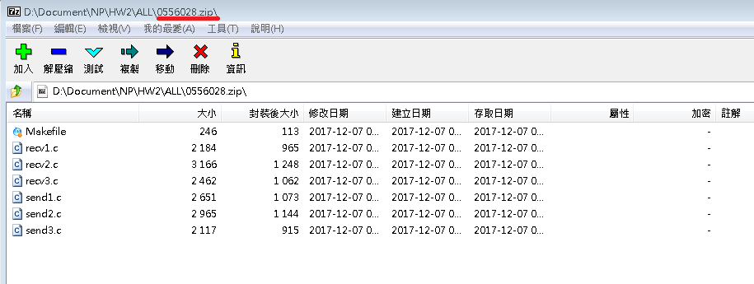

1. Unzip the file at directory ALL/ for example, we get sth like below

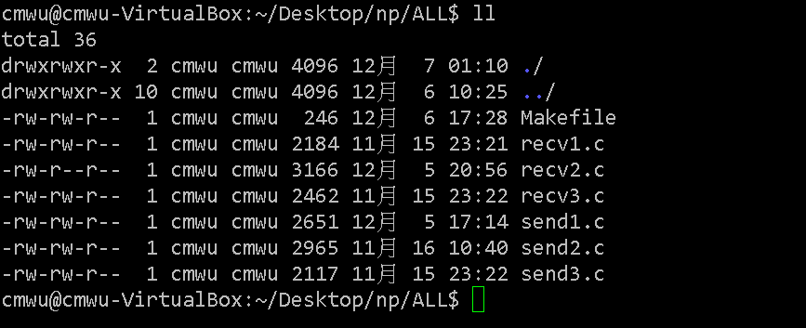

1. After make

Notice the execution file names should be THE SAME AS below.

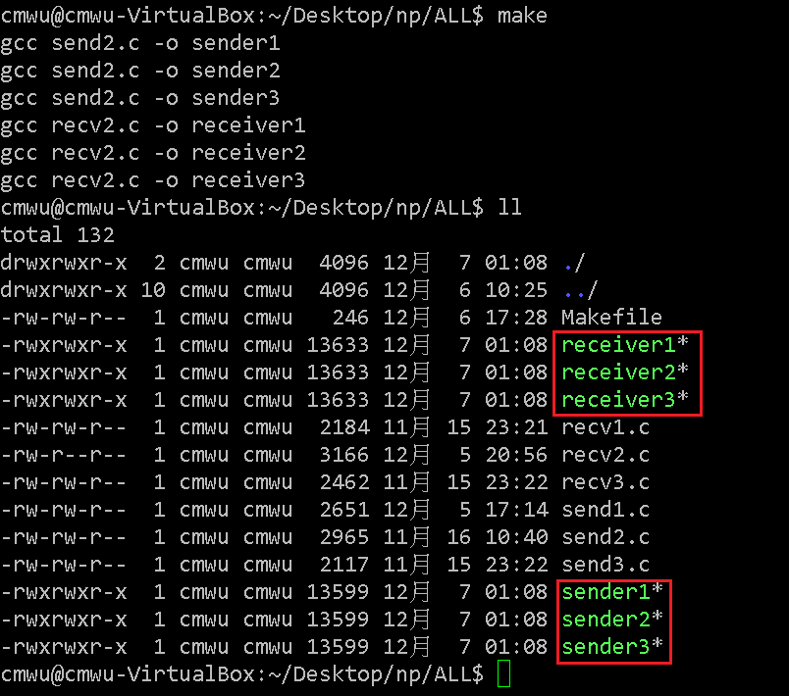

1. About sender/receiver & Makefile format
2. For sender programs, its usage is like below



1. For receiver programs, its usage is like below

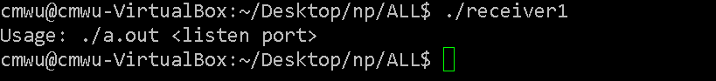

1. For Makefile, it should have at least two function:
2. make

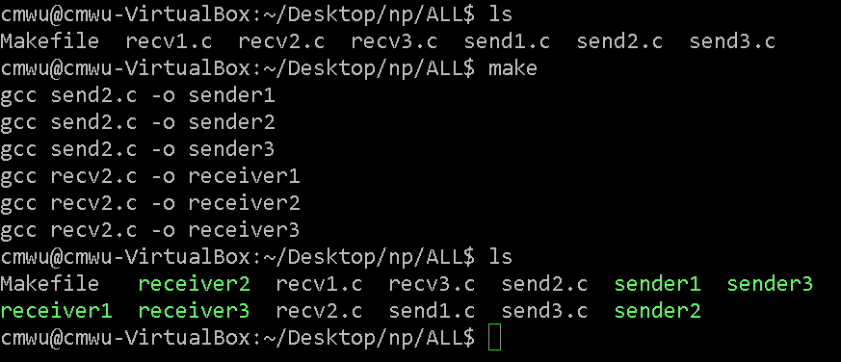

1. make clean

You don’t need to remove the test files if exist.

