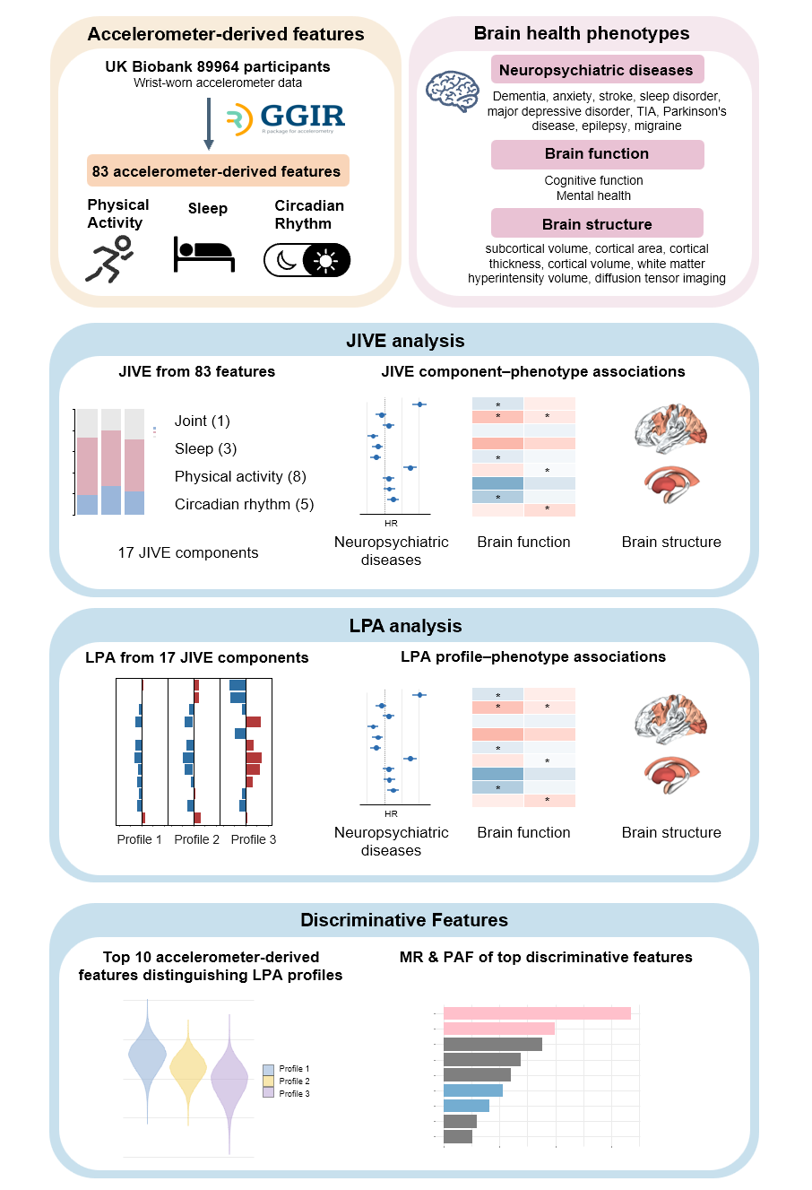

Utilizing the wristband accelerometer data of approximately 90,000 subjects in the UK Biobank to deeply explore the characteristics of individuals' Physical Activity, Sleep and Circadian Rhythm. The core objective of the research is to quantify how these daily behavioral characteristics reflect or predict complex brain health phenotypes, including neuropsychiatric disorders, cognitive functions, and changes in brain structure. 83 features were integrated into 17 principal components to distinguish the common variations and independent variations among behaviors through the Joint and Individual Variation Explained (JIVE) method

library(tidyverse)
library(data.table)
library(corrplot)
library(r.jive)

# Read GGIR files
sleep <- read_csv("your path", show_col_types = FALSE)
pa <- read_csv("your path", show_col_types = FALSE)
circadian <- read_csv("your path", show_col_types = FALSE)

# keep eid + all numeric features; drop all-NA and constant columns
prep_domain <- function(df, domain_name, eid_col = "eid") {
if (!eid_col %in% names(df)) {
stop("Missing column '", eid_col, "' in ", domain_name, " file.")
}

# Keep eid + numeric columns only
out <- df %>%
dplyr::select(all_of(eid_col), where(is.numeric))

# Drop columns that are all NA (except eid)
keep1 <- vapply(out, function(x) !all(is.na(x)), logical(1))
out <- out[, keep1, drop = FALSE]

# Drop constant columns (sd==0 or only one unique finite value), except eid
num_cols <- setdiff(names(out), eid_col)
if (length(num_cols) > 0) {
is_const <- vapply(out[, num_cols, drop = FALSE], function(x) {
x <- x[is.finite(x)]
length(unique(x)) <= 1
}, logical(1))

if (any(is_const)) {
out <- out %>% dplyr::select(-all_of(names(is_const)[is_const]))
}
}

# Basic logging
cat(domain_name, ": n=", nrow(out), ", p(numeric features)=", ncol(out) - 1, "\n")
out
}

sleepDomain <- prep_domain(sleep, "Sleep")
paDomain <- prep_domain(pa, "Physical Activity")
circadianDomain <- prep_domain(circadian, "Circadian Rhythm")

# Correlation plots (optional)
plot_corr_safe <- function(domain_df, title = "", max_vars = 40) {
X <- domain_df %>% dplyr::select(-eid)
if (ncol(X) < 2) {
message("Skip corrplot (too few numeric vars): ", title)
return(invisible(NULL))
}
if (ncol(X) > max_vars) {
message(title, " has ", ncol(X), " vars; plotting first ", max_vars, " only.")
X <- X[, 1:max_vars, drop = FALSE]
}
corM <- cor(X, use = "pairwise.complete.obs")
corrplot(
corM,
method = "color",
type = "lower",
tl.col = "black",
tl.srt = 45,
addCoef.col = "black",
number.cex = 0.6,
col = colorRampPalette(c("blue", "white", "red"))(200)
)
}

plot_corr_safe(sleepDomain, "Sleep domain", max_vars = 40)
plot_corr_safe(paDomain, "PA domain", max_vars = 40)
plot_corr_safe(circadianDomain, "Circadian domain", max_vars = 40)

# Prepare data for JIVE
domainName <- c("Sleep", "Physical Activity", "Circadian Rhythm")

# Merge all domains by eid
jiveData <- sleepDomain %>%
inner_join(paDomain, by = "eid") %>%
inner_join(circadianDomain, by = "eid")

# Remove rows with ANY missing values
jiveData_complete <- jiveData %>% drop_na()

# Extract eid for later use
jive.filenames <- jiveData_complete$eid
cat("Complete-case N =", nrow(jiveData_complete), "\n")

# Build JIVE input list: matrices (features x participants)
sleep_vars <- setdiff(names(sleepDomain), "eid")
pa_vars <- setdiff(names(paDomain), "eid")
cr_vars <- setdiff(names(circadianDomain), "eid")

jive.data <- list(
# Sleep domain
jiveData_complete %>%
dplyr::select(all_of(sleep_vars)) %>%
as.matrix() %>%
t(),

# PA domain
jiveData_complete %>%
dplyr::select(all_of(pa_vars)) %>%
as.matrix() %>%
t(),

# Circadian domain
jiveData_complete %>%
dplyr::select(all_of(cr_vars)) %>%
as.matrix() %>%
t()
)

names(jive.data) <- domainName

# Sanity check
cat("JIVE input dims:\n")
for (k in seq_along(jive.data)) {
cat(" - ", names(jive.data)[k], ": ",
nrow(jive.data[[k]]), "features x",
ncol(jive.data[[k]]), "participants\n", sep = "")
}

# Store feature names for each domain
jive.data.rownames <- list(
colnames(sleepDomain)[-1],
colnames(paDomain)[-1],
colnames(circadianDomain)[-1]
)

# Name the list elements
names(jive.data) <- domainName

# Check dimensions
for (k in 1:3) {
cat(domainName[k], ":", dim(jive.data[[k]]), "\n")
}

# Global transformation function from Kang et al.
global.transform <- function(L0) {
z <- matrix(0, nrow(L0), ncol(L0))

for (i in 1:ncol(L0)) {
F <- ecdf(L0[, i])
u <- F(L0[, i])
z[, i] <- qnorm(u)
}

z[is.infinite(z)] = max(z[!is.infinite(z)], na.rm = TRUE) + 1
colnames(z) <- colnames(L0)
return(z)
}

# Apply global normalization to each domain
jive.data.norm <- jive.data
for (k in 1:3) {
jive.data.norm[[k]] <- t(global.transform(t(jive.data.norm[[k]])))
cat(domainName[k], ":", dim(jive.data.norm[[k]]), "\n")
}

# Run JIVE with automatic rank selection
set.seed(20250601)
res <- jive(jive.data.norm,
scale = TRUE,
center = TRUE
)

# View results
summary(res)

# Variance explained plot
showVarExplained(res, col = c("#999999", "#E69F00", "#56B4E9"))

# Heatmap visualization
plot(res, type = "heat")

# Compute JIVE scores
J_Est <- jive.predict(jive.data.norm, res)

joint <- J_Est$joint.scores
rownames(joint) <- paste0("JScore_Joint_", seq_len(nrow(joint)))

indiv_list <- vector("list", 3)
for (k in 1:3) {
temp <- J_Est$indiv.scores[[k]]
dn <- gsub("\\s+", "", domainName[k])
rownames(temp) <- paste0("JScore_", dn, "_", seq_len(nrow(temp)))
indiv_list[[k]] <- temp
}

all_scores <- rbind(joint, do.call(rbind, indiv_list))

Jscore_df <- data.frame(
eid = jive.filenames,
t(all_scores),
check.names = FALSE
)

# Save scores
write.csv(Jscore_df, file = "jive_predScore.csv", row.names = FALSE)

# PCA plots
showPCA(res, n_joint = 2, Colors = 'purple')
showPCA(
res,
n_joint = 1,
n_indiv = c(1, 1, 1),
Colors = 'purple'
)

# Save JIVE decomposition
jive.joint <- NULL
jive.ind <- NULL

for (k in 1:3) {
temp <- cbind(
jive.data.rownames[[k]],
domainName[k],
"J",
res$joint[[k]]
)
jive.joint <- rbind(jive.joint, temp)

temp2 <- cbind(
jive.data.rownames[[k]],
domainName[k],
"A",
res$individual[[k]]
)
jive.ind <- rbind(jive.ind, temp2)
}

jive.out <- rbind(jive.joint, jive.ind)
colnames(jive.out) <- c("feature", "domain", "jive", jive.filenames)

write.csv(jive.out,
file = "jive_Decomposition.csv",
row.names = FALSE)

