Run app_gui_fun.py

Click run in circle

### Mouse mode:

|  |  |
| --- | --- |
|  | 1. (double click) |
|  | Move mouse |
|  | Change mode |
|  | click |
|  | Scroll down |
|  | Scroll up |
|  | None |
|  | Previous page |

### Keyboard(Youtube) mode:

|  |  |
| --- | --- |
|  | Fast forward |
|  | Clockwise:  Speed up  Counter clockwise:  Slow down |
|  | Change mode |
|  | Stop/play |
|  | Music up |
|  | Music down |
|  | Rewind |
|  | subtitle |

### Rest mode:

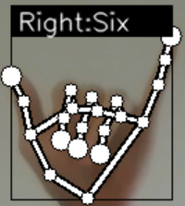

You only can use this gesture to change mode