Features and Features Selection

We have extracted 20 stylometric features from the dataset as well as content-based features. Due to the large size of the dataset (278841 samples) we produced a lot of features with the content-based method. We have chosen the word based n-gram model to extract features using CountVectorizer. This method results in 1000 new columns of features. We have chosen 1000 as our value since larger values exceed memory limits. The features contain words that are most commonly used and their counts. If a word appears in the string then the value in the column is 1 otherwise it remains 0. Since not all of the 1000 features will be of importance, we have employed a ExtraTreesClassifier method of feature selection. ExtraTreesClassifier fits a randomized number of decision trees to the dataset, predictions are made by averaging the prediction of the decision trees for regression or using majority voting for classification.

To perform feature selection, after running the ExtraTreesClassifier we have used SelectFromModel library from sklearn which selects features based on importance weights. After feature selection we are left with a new dataframe of 278841 rows and 332 columns (278841, 332). A major difference from 1000 features. Feature selection helps in selecting the most important features for training our models and speeding up the process by getting rid of unnecessary features.

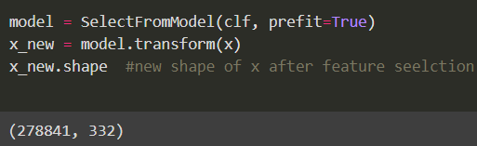Figure 1: Feature selection result

Model Training

Logistic Regression

The first model we have used is Logistic Regression. For logistic regression, we have set the max_iter parameter to 7600, a random large number, as on smaller numbers, it was reaching the max iterations limit. The accuracy score of this model is around 63%.

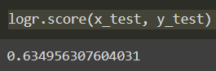Figure 2: Logistic Regression accuracy score
We have also plotted a confusion matrix for further confirmation of accuracy and understanding of the performance.

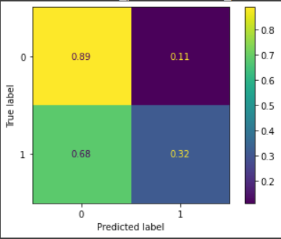Figure 3: Logistic Regression Confusion Matrix
Looking at the confusion matrix, we can see that we have most accuracy in predicting male (0) gender correctly, while the female (1) is mostly incorrectly labeled as male. The male is not incorrectly predicted very much.

Random Forest Classifier

The second model employed is the Random Forest Classifier. An initial observation showed that Random Forest took a much longer time to train than Logistic Regression, the reason for this is most likely that Random Forest is more complex as it has to build a large number of trees and this requires additional computing power as well. Random Forest has provided a close result to Logistic Regression of 66%. We have also plotted the confusion matrix for this model for more clarity.

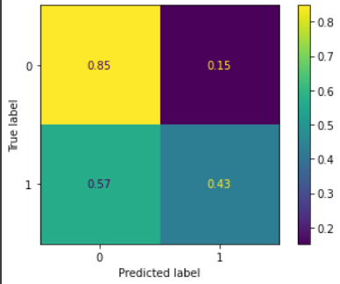Figure 4: Random Forest Confusion Matrix

The confusion matrix shows us that similar to logistic regression, the male gender is predicted more accurately than the female gender. Although there are less incorrect predictions for the female gender than Logistic Regression. However, since the accuracies of both models are close the confusion matrices also look similar.

To further improve the performance, we could use tf idf vectorization as it is faster.

