**How does the average digital humanities person look like?**

**Something to ask bio-informatics and open science**

library (EBImage)

#Define working directory

setwd("/Users/tobiasblanke/Downloads/DDH-images")

filenames <- Sys.glob(file.path(getwd(), "*.jpg"))

#Define list of images

images_list <- lapply(filenames, readImage)

names(images_list) <- basename(filenames)

#Calculate average image

ImageAvg <- Reduce("+", images_list) / length(images_list)

display(ImageAvg)

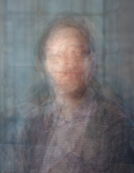

**What does the average digital humanities like to wear?**

h <- dim(ImageAvg)[1]

w <- dim(ImageAvg)[2]

m <- matrix(ImageAvg, h*w)

pca <- prcomp(m)

summary(pca)

Importance of components:

PC1 PC2 PC3

Standard deviation 0.1986 0.05514 0.007713

Proportion of Variance 0.9272 0.07145 0.001400

Cumulative Proportion 0.9272 0.99860 1.000000

extractColors <- function(x) rgb(x[1], x[2], x[3])

(colors <- apply(abs(pca$rotation), 2, extractColors))

pie(pca$sdev, col = colors, labels = colors)

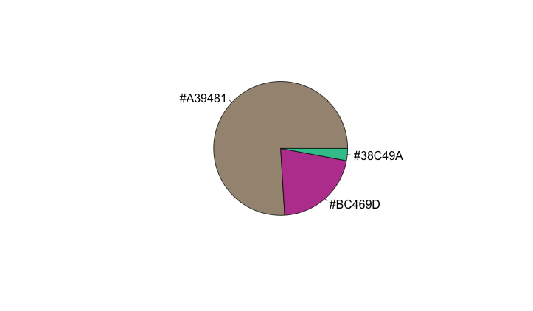

#PCA 1:

image(matrix(pca$x[, 1], h), col = gray.colors(100))

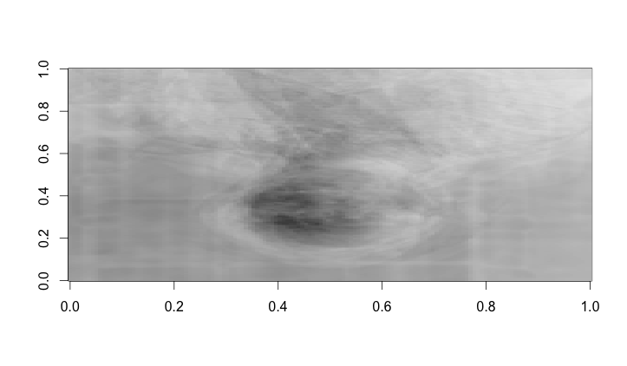

**#PCA 2:**

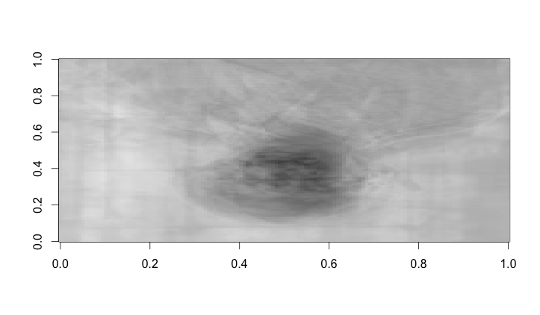

**Having fun with the Microsoft Oxford Image API**

<http://www.r-bloggers.com/analyzing-twitter-faces-in-r-with-microsoft-project-oxford/>

dataframeFromJSON <- function(l) {

l1 <- lapply(l, function(x) {

x[sapply(x, is.null)] <- NA

unlist(x)

})

keys <- unique(unlist(lapply(l1, names)))

l2 <- lapply(l1, '[', keys)

l3 <- lapply(l2, setNames, keys)

res <- data.frame(do.call(rbind, l3))

return(res)

}

**library(httr)**

**key <- "2304d1bf83184a198a90add8ad5a6b21"**

**mybody <- upload_file("/Users/tobiasblanke/Downloads/DDH-images/AverageImage/pjimage.jpg")**

**faceURL <-** [**https://api.projectoxford.ai/face/v1.0/detect?returnFaceId=true&returnFaceAttributes=gender**](https://api.projectoxford.ai/face/v1.0/detect?returnFaceId=true&returnFaceAttributes=gender)

**faceResponse <- POST(**

**url = faceURL,**

**content_type('application/octet-stream'), add_headers(.headers = c('Ocp-Apim-Subscription-Key' = key)),**

**body = mybody,**

**encode = 'multipart'**

**)**

**df_gender <- dataframeFromJSON(content(faceResponse))**

|  |  |  |  |  |  |  |
| --- | --- | --- | --- | --- | --- | --- |
|  | **faceId** | **faceRectangle.top** | **faceRectangle.left** | **faceRectangle.width** | **faceRectangle.height** | **faceAttributes.gender** |
| **1** | 207637fa-4020-47dd-9a75-ac964dcc1712 | 473 | 101 | 122 | 122 | male |
| **2** | 18b3952b-efb2-48b0-aa4b-1676f66990d4 | 481 | 1064 | 98 | 98 | female |
| **3** | 2af704c7-e7c8-40a0-863f-617383028e3d | 69 | 430 | 96 | 96 | male |
| **4** | 9e5ced23-79be-4b89-a8d1-a1290e57cff6 | 101 | 747 | 96 | 96 | male |
| **5** | 058367ca-0871-4327-8d56-c6165afa870b | 442 | 745 | 94 | 94 | female |
| **6** | 5cf422c8-9d6a-4a52-8808-b4710a4e1289 | 100 | 1084 | 92 | 92 | male |
| **7** | af7d7fed-47d3-4559-91bb-456f436f8ee6 | 112 | 107 | 86 | 86 | male |
| **8** | eafbb42a-a758-4f9e-b1a3-baf5c8594bb6 | 482 | 450 | 85 | 85 | male |