AI Job Search and Career Agent
Stage 2 Report: AI-Assisted Implementation
EECS3311 | Zarak Khan, York University | 222046965 | November 2026
Repository: https://github.com/zarakkhancs/AI-Job-Search-and-Career-Agent

1. Overview and status
The AI Job Search and Career Agent helps a job seeker manage a search end to end: extract and match skills, tailor application documents, track applications through a pipeline, get deadline alerts, practise interviews and review analytics. Stage 2 implements the Stage 1 design (12 features, F01 to F12) in Java with AI tools used throughout development, as the course requires.

Architecture as built
- Backend: Java 25, Maven, package com.careeragent. All business logic lives in services shared by the CLI and the HTTP API through one AppContext.
- CLI: Command pattern (CommandRegistry plus one class per command), run with the backend jar or exec:java.
- HTTP API: Javalin REST layer (package com.careeragent.api) on port 7070 with consistent error mapping (400 bad input, 404 not found, 409 invalid state, 502 AI failure).
- GUI: Next.js, React and Tailwind in frontend/, calling the API through a /api rewrite. Pages: dashboard (deadlines, alerts), resume, jobs, skills, tailor, pipeline (with analytics), bullets, prep, interview and agent.
- AI: Gemini API behind an LLMClient interface (GeminiClient for production, MockLLMClient for tests). The key is read from a gitignored local .env; .env.example documents the variables.

Status summary (as of November 7, 2026)
230 automated JUnit tests pass (mvn test). Tests use MockLLMClient and Javalin test tools, so they are deterministic and need no API key.
- All 12 features are implemented with a GUI page and CLI access. F03 and F04 reach the CLI through the agent and export commands.
- F01 reads skills from a PDF or pasted resume text; it does not extract work experience.
- F02 imports job postings from a URL or pasted text. Some sites block automatic downloads, so pasting the text is the fallback.

How to run
- Copy .env.example to .env and add the Gemini API key and model name (LLM_MODEL).
- Backend: cd backend; mvn test; then mvn -q exec:java "-Dexec.mainClass=com.careeragent.Main" "-Dexec.args=serve" starts the API. Without the serve argument it starts the CLI.
- GUI: cd frontend; npm install; npm run dev, then open http://localhost:3000.

2. Feature-to-implementation mapping
Feature names follow the Stage 1 design document. Class names are in package com.careeragent.
Feature | Status | Implementation | CLI | GUI / API
F01 Resume Import & Parsing | Done | ResumeImportService, PdfTextExtractor (Apache PDFBox), ParsedResume, SkillExtractor, SourceVerifier. Reads the text of a PDF (or pasted text), extracts skills with the AI, and verifies each skill against the resume text. Work experience is not extracted. | resume | GUI /resume  POST /api/resumes (PDF upload or text)  POST /api/extract
F02 Job Posting Ingestion | Done | JobIngestionService, PageFetcher, HttpPageFetcher, HtmlText, JobPosting. Imports a posting from a URL or pasted text and cleans it to plain text. Only http and https links are allowed and local or private addresses are refused. Deterministic, no AI. | job | GUI /jobs  /api/jobs
F03 Skill Gap & Match | Done | JobMatcher with MatchingStrategy (KeywordOverlapStrategy, LlmMatchingStrategy), MatchResult, MatchJobTool. | agent (match_job tool) | GUI /skills  POST /api/match
F04 Tailored Cover Letter | Done | TailoredDocumentService, TailoredDocument, TailorDocumentTool. Generates summary and cover letter, then flags job skills not backed by the resume. | agent, export | GUI /tailor  POST /api/documents/tailor
F05 Pipeline State Management | Done | JobApplication, ApplicationState with SavedState, AppliedState, InterviewState, OfferState, RejectedState; ApplicationService; InvalidTransitionException. | track | GUI /pipeline  /api/applications, /{id}/move
F06 Deadline Tracking & Alerts | Done | Deadline, DeadlineScheduler, AlertService, AlertObserver, ConsoleAlertObserver, AlertSource (scheduler vs user alerts). | alerts | GUI dashboard /  /api/deadlines, /api/alerts
F07 Interview Prep Sheet | Done | PrepSheetService, PrepSheet, PrepSheetPromptFactory, PrepSheetTool. | prep | GUI /prep  POST /api/prep
F08 Bullet Point Optimizer | Done | BulletOptimizerService, BulletResult, BulletVersion (lists unsupported figures), BulletPromptFactory, OptimizeBulletTool. | bullet | GUI /bullets  POST /api/bullets/optimize
F09 Analytics Dashboard | Done | MetricsService, DashboardMetrics: counts per stage and interview, offer and rejection rates. Fully deterministic. | stats | GUI /pipeline (analytics panel)  GET /api/analytics
F10 Application Package Exporter | Done | ExportService, ExportFile, ExportCommand. Bundles summary, cover letter and resume into one text file, with a review warning for flagged skills. | export | GUI /tailor (Export button)  POST /api/export
F11 Career Agent Assistant | Done | AgentController, Planner, PlanStep, Tool, ToolRegistry. Five registered tools: extract skills, match job, tailor documents, optimize bullet, prep sheet. | agent | GUI /agent  POST /api/agent/ask
F12 Mock Interview Practice | Done | MockInterviewService, InterviewSession, InterviewQuestion, AnswerFeedback, InterviewSummary. Sessions are kept in memory; answers are checked for skill claims missing from the resume. | interview | GUI /interview  /api/interview/start, /{id}, /{id}/answer, /{id}/finish

Additional features beyond Stage 1
- SourceVerifier: deterministic check that every skill the AI extracts actually appears in the source text; rejected skills are reported separately.
- Factual checks on AI output: flagged skills on tailored documents, flagged claims on mock interview answers, and unsupported figures on optimized bullets. These address the Stage 1 feedback to keep factual-source checks.
- LLMClient abstraction with GeminiClient (retry with backoff, readable error messages) and MockLLMClient for tests.
- One-time retry in skill extraction when the model returns no JSON array.
- Javalin REST layer and AppContext so the GUI and CLI share one set of services.

3. Design patterns
Pattern | Package | Classes | Role
State | pipeline | ApplicationState, SavedState, AppliedState, InterviewState, OfferState, RejectedState, JobApplication | Each stage decides which transitions are legal; illegal moves raise InvalidTransitionException (HTTP 409).
Strategy | matching | MatchingStrategy, KeywordOverlapStrategy, LlmMatchingStrategy, JobMatcher | Match scoring algorithm is swappable (deterministic keyword overlap or LLM-based).
Observer | alerts | AlertService (subject), AlertObserver, ConsoleAlertObserver, DeadlineScheduler, AlertSource | Alerts are published to subscribers. AlertSource keeps scheduler-generated alerts distinct from user alerts.
Command | cli | Command, CommandRegistry (invoker), HelpCommand, AskCommand, AgentCommand, AlertsCommand, TrackCommand, StatsCommand, BulletCommand, PrepCommand, ExportCommand | Each CLI action is an object registered by name and dispatched from typed input.
Factory Method | prompts | PromptFactory, BulletPromptFactory, PrepSheetPromptFactory, Prompt, BulletOptimizerPrompt, PrepSheetPrompt | Each factory builds the right prompt object for its feature.
Facade | agent | AgentController over Planner and ToolRegistry | One entry point (handle) for the CLI and API; hides planning and tool dispatch.

Figures 1 to 6 on the following pages show the implemented classes for each pattern. The UMLet source files are in stage2/diagrams/umlet/ in the repository.

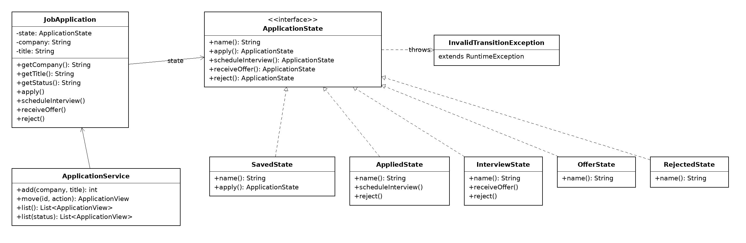
Figure 1. State pattern: application pipeline (package pipeline).
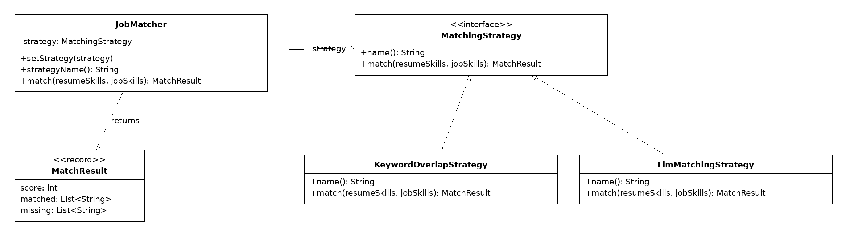
Figure 2. Strategy pattern: job matching (package matching).
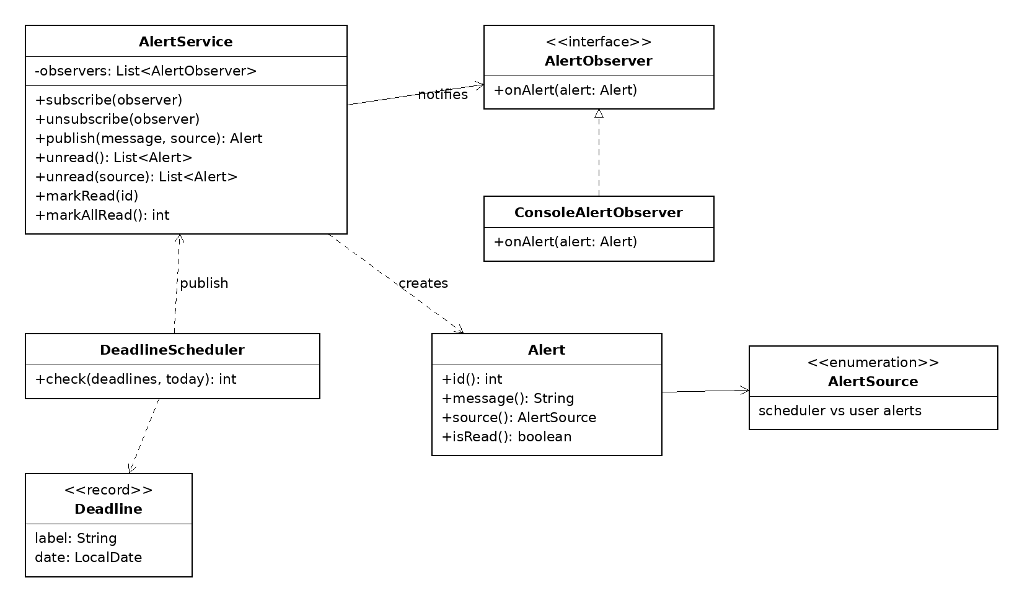
Figure 3. Observer pattern: deadline alerts (package alerts).
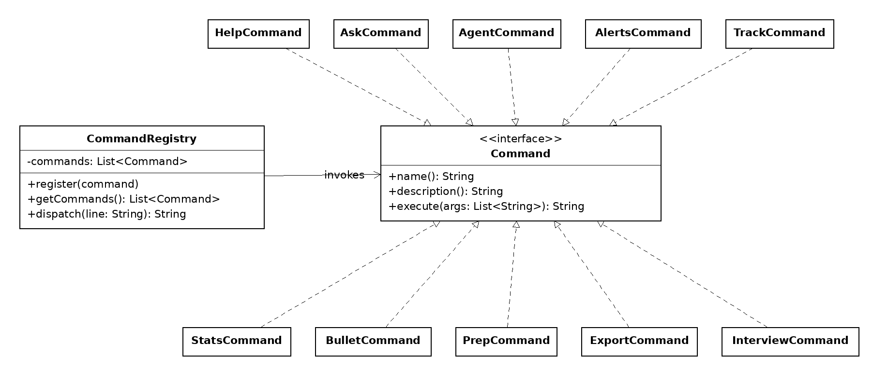
Figure 4. Command pattern: CLI commands (package cli).
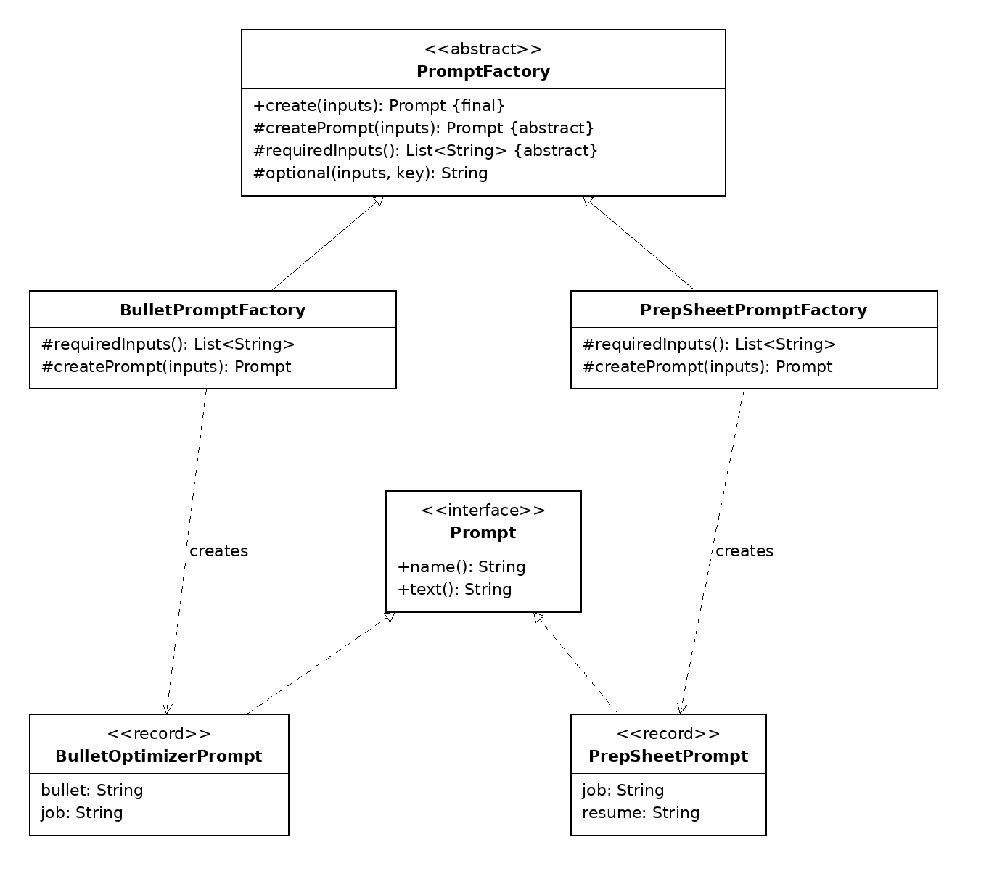
Figure 5. Factory Method pattern: prompt factories (package prompts).
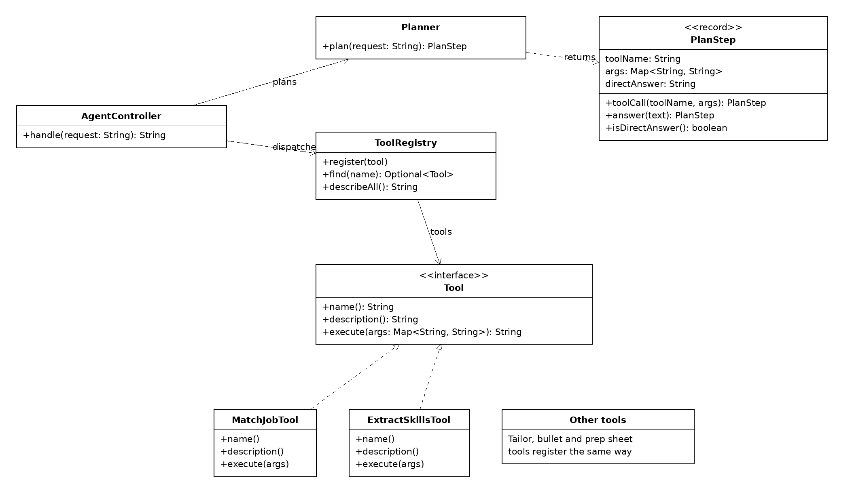
Figure 6. Facade: agent controller over the planner and tool registry (package agent).

4. Changes from Stage 1 and rationale
Area | Stage 1 | Stage 2 as built | Rationale
LLM model | Gemini 3.1 Pro | gemini-3.5-flash-lite, set through LLM_MODEL in the local .env | Live testing returned HTTP 429 on the 3.1 Pro preview and 503 on Gemini 3.8 Flash. Only flash-lite responded reliably.
Persistence | PostgreSQL | In memory: applications, alerts, deadlines and interview sessions live in the running backend | All twelve features were prioritized over adding a database, so data is kept in memory and resets when the backend restarts.
AI reliability | Not specified | Retry with backoff in GeminiClient; one retry in skill extraction | The flash-lite model sometimes times out or returns non-JSON output.
CLI structure | CommandInvoker | CommandRegistry plus one Command class per action | Same Command pattern; a registry keyed by command name is simpler to extend and to test.
F10 output | Downloadable document | Plain text package (.txt) with a review warning on top | Deterministic, needs no document library, and the warning about unsupported skills stays visible in the file.
Factual check | Source checks on generated text | Skill-level checks (skills, claimed skills in answers, figures in bullets) | Skills and figures can be verified deterministically against the resume. Employers and degrees are not checked (limitation).
Alert window | Within 48 hours | Scheduler configured with a 7-day window | Most calendars and planning are done weekly, so a 7-day window gives a week of notice.
F01 scope | Skills and experience from a PDF | Skills only, from a PDF or pasted text | Applicant tracking systems (ATS) scan resumes mainly for skills and keywords, so skills are the most useful data to extract, and they can be verified against the resume text. Experience entries are not extracted (limitation).

5. AI tools log

How AI was used
- Development: Claude in a chat workflow generated Java and TypeScript code as PowerShell scripts that create files and make anchored edits. Each change was followed by mvn test and a manual check in the browser or CLI before committing.
- Design: Gemini was used to draft the Stage 1 design document; Claude later revised the architecture and diagrams.
- Runtime: the Gemini API (gemini-3.5-flash-lite) powers skill extraction, tailored documents, bullet optimization, prep sheets, mock interview and agent planning.
- Human review: AI output was reviewed and corrected. For example, scripts that edited existing files were checked against the real code, and a wrong first attempt was reset with git before a correct version was applied.

Tool | Used for | Plan | Usage (tokens) | Cost
Claude (claude.ai chat) | Code generation, debugging, Stage 1 revision, this report | Free plan, in use since Oct 26, 2026 | Not shown by the chat interface; long working sessions from Oct 26 to Nov 9 | $0
Gemini (Pro subscription) | Stage 1 design drafting | Pro plan free through a student plan; renewed, about 13 months in total | Not shown by the chat interface | $0
Gemini API (gemini-3.5-flash-lite) | Runtime AI features and live testing | Free tier | AI Studio usage page (28-day view): requests in the tens per day, peaking at about 43 in one day. It also shows a few 429 and 503 errors. | $0
Token counts are not shown by the chat tools, so their usage is described instead of counted. The Gemini API figures come from the Google AI Studio usage page.

6. Weekly commit summary
Each commit links to its page in the public repository. The course requires at least 5 meaningful code commits in each weekly window.
Window | Commits | Focus
Window 1: Oct 20 to 26 | 5 | Backend skeleton, configuration, LLM adapter, State-based pipeline, Command-based CLI
Window 2: Oct 27 to Nov 2 | 7 | Agent core, skill extraction, Strategy matching, Observer alerts, application tracking, Gemini retry
Window 3: Nov 3 to 9 | 19 | REST API, tailored documents, mock interview, Next.js GUI, analytics, bullets and prep, exporter, interview CLI and agent page, UML diagrams, resume and job import, demo videos

Window 1 (Oct 20 to 26)
# | Commit | Date | Message
1 | c0d1436 | 2026-10-26 17:23 | Add Maven backend skeleton, .env.example and secrets gitignore
2 | 4e5f716 | 2026-10-26 17:37 | Add AppConfig loader with .env parsing, env override and tests
3 | 952152a | 2026-10-26 21:36 | Add LLMClient interface, GeminiClient adapter, MockLLMClient and tests
4 | 8105e6f | 2026-10-26 21:38 | Add JobApplication pipeline with State pattern and transition tests
5 | eb4749b | 2026-10-26 21:44 | Add CLI with Command pattern: registry, help and ask commands, with tests

Window 2 (Oct 27 to Nov 2)
# | Commit | Date | Message
1 | 89da763 | 2026-10-29 14:28 | Add agent core: Tool interface, ToolRegistry, Planner and AgentController with tests
2 | 83c5e56 | 2026-10-29 14:30 | Add skill extraction with source verification and extract_skills agent tool
3 | 8b3d343 | 2026-10-29 14:31 | Add job matching with Strategy pattern, JobMatcher and match_job agent tool
4 | 0087064 | 2026-10-29 14:33 | Add alerts with Observer pattern, scheduler vs user alert sources, and CLI alerts command
5 | 951d78e | 2026-10-29 14:39 | Wire agent into CLI: agent command, extract_skills and match_job tools, alert observer
6 | 2bbafcc | 2026-10-29 14:58 | Add application tracking service and CLI track command using State pattern
7 | bd97f2a | 2026-11-02 19:08 | Add retry with backoff and readable API errors to GeminiClient, with tests

Window 3 (Nov 3 to 9)
# | Commit | Date | Message
1 | 724ffd7 | 2026-11-03 20:46 | Add Javalin HTTP server skeleton and shared AppContext
2 | a81f85e | 2026-11-03 20:50 | Add REST endpoints for applications, alerts, matching and agent
3 | bbf6454 | 2026-11-03 21:05 | Add skill extraction and deadline endpoints to REST API with tests
4 | e3346b1 | 2026-11-03 21:14 | Add tailored document generation with factual source check
5 | 96d4fec | 2026-11-04 15:53 | Add mock interview service, REST endpoints, and tests
6 | 797af78 | 2026-11-05 00:55 | Add Next.js GUI skeleton: deadlines, alerts, skill extraction
7 | da3a2cb | 2026-11-05 02:32 | Add tailored documents page with factual-check warning
8 | a6edbda | 2026-11-05 14:15 | Retry skill extraction once when the model returns no JSON array, with tests
9 | 05b9b1d | 2026-11-05 14:34 | Add skills match, tailored documents and mock interview pages; fix Tailwind PostCSS setup
10 | bd36e30 | 2026-11-05 22:55 | Add F09 analytics: MetricsService, DashboardMetrics, /api/analytics and CLI stats command, with tests
11 | 6093bd5 | 2026-11-05 22:56 | Add pipeline GUI page with application tracking and analytics dashboard
12 | cfe178f | 2026-11-06 12:59 | Add F08 bullet optimizer and F07 prep sheet with Factory Method prompt factories, API, CLI and agent tools
13 | c4fe438 | 2026-11-06 12:59 | Add bullet optimizer and prep sheet GUI pages
14 | 6358598 | 2026-11-07 00:07 | Add F10 application package exporter: ExportService, export CLI command and /api/export, with tests
15 | 0215b83 | 2026-11-07 16:05 | Add export package button to the tailor page
16 | ef0edcb | 2026-11-08 03:38 | Add interview CLI command for F12 and career agent GUI page for F11
17 | b2b9b05 | 2026-11-08 04:07 | Add Stage 2 UML class diagrams (UMLet) for the implemented patterns
18 | 4037191 | 2026-11-08 15:12 | Add F01 resume PDF import and F02 job posting ingestion with API, CLI, GUI and nav links
19 | 0f78a83 | 2026-11-09 16:26 | Add Stage 2 demo videos

Verification
Commits were counted from the repository history with git log, one command per window, for example:
git log --since="2026-11-03 00:00" --until="2026-11-10 00:00" --reverse --pretty=format:"%H|%ad|%s"
The counts are 5, 7 and 19, so every window meets the minimum of 5. The test suite (230 tests) passes at the latest commit.

7. Demo video index
Each feature has a video showing both the GUI and the CLI, with timestamps for where each part starts. The videos are in the folder stage2/videos/ of the repository. F04 and F10 share one video.
Feature | Video | GUI starts | CLI starts
F01 Resume Import & Parsing | stage2/videos/F01-resume-import.mp4 | 0:00 | 0:25
F02 Job Posting Ingestion | stage2/videos/F02-job-ingestion.mp4 | 0:00 | 0:37
F03 Skill Gap & Match Analysis | stage2/videos/F03-skill-match.mp4 | 0:00 | 0:42
F04 Tailored Cover Letter | stage2/videos/F04-F10-cover-letter-and-export.mp4 | 0:00 | 0:58
F05 Pipeline State Management | stage2/videos/F05-pipeline.mp4 | 0:00 | 0:53
F06 Deadline Tracking & Alerts | stage2/videos/F06-deadlines-alerts.mp4 | 0:00 | 0:36
F07 Interview Prep Sheet | stage2/videos/F07-prep-sheet.mp4 | 0:00 | 0:27
F08 Bullet Point Optimizer | stage2/videos/F08-bullet-optimizer.mp4 | 0:00 | 0:30
F09 Analytics Dashboard | stage2/videos/F09-analytics.mp4 | 0:00 | 0:30
F10 Application Package Exporter | stage2/videos/F04-F10-cover-letter-and-export.mp4 | 0:00 | 0:58
F11 Career Agent Assistant | stage2/videos/F11-career-agent.mp4 | 0:00 | 0:24
F12 Mock Interview Practice | stage2/videos/F12-mock-interview.mp4 | 0:00 | 1:11

