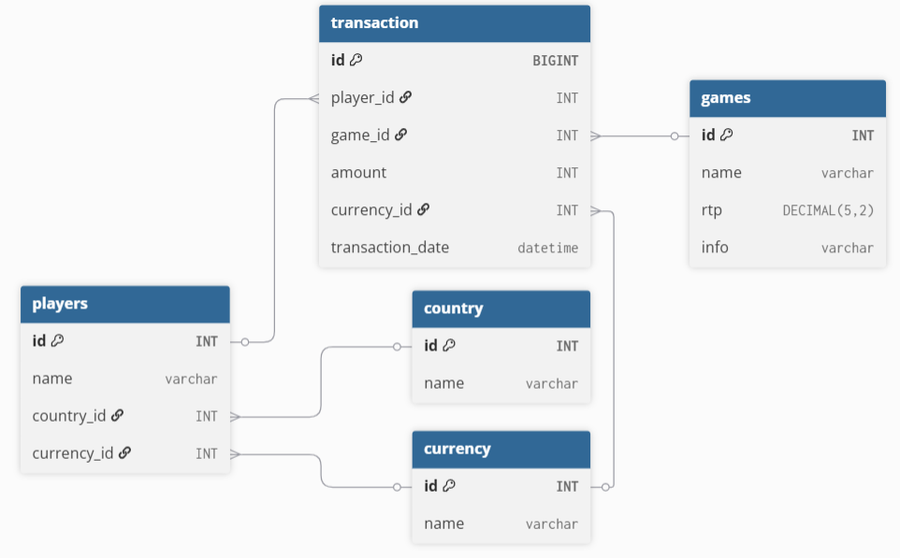

Main structural problems:
- Redundant / conflicting balance storage
We have:
- players.balance
- balance table (id, value)
- transaction.credit / debit
Problem:
We are storing the same concept in multiple places.
This leads to inconsistency (balance mismatch) , unclear source of truth and difficult debugging

- Transaction table design is not clean
We have:
- credit INT
- debit INT
Problem:
redundant fields, forces NULL logic, harder aggregation
Better:
Use a single field amount INT (+/-)
The transaction table becomes the source of truth.
Balance is SUM(amount) and NOT stored manually (or only cached).
- currency_id duplicated in multiple places
We have:
- players.currency_id
- transaction.currency_id
Problem:
- currency should usually be in transaction only
- player should have default currency only if needed

- balance_id in multiple tables is unclear
We have:
- players.balance_id
- transaction.balance_id
Problem:
- unclear meaning
- violates normalization principles
- usually unnecessary in transactional systems

- countries table relationship unclear
We have in players → countries_id
- could be many-to-many in real world (but we imagine in this case 1 to n)

- games table design
We have:
- rtp INT
Issues:
- rtp usually decimal (e.g. 96.5%), not INT

Top 3 most played games (number of bets):
SELECT g.id, g.name, COUNT(t.id) AS total_bets
FROM games g
JOIN transaction t ON t.games_id = g.id
GROUP BY g.id, g.name
ORDER BY total_bets DESC
LIMIT 3;

If this query is requested a lot, how to optimize?
Indexing (first step):
CREATE INDEX idx_transaction_game_id ON transaction(games_id);
Improves GROUP BY + JOIN speed
Materialized view (BEST SIMPLE SOLUTION):
CREATE MATERIALIZED VIEW game_bet_stats AS
SELECT games_id, COUNT(*) AS total_bets
FROM transaction
GROUP BY games_id;
And then:
SELECT *
FROM game_bet_stats
ORDER BY total_bets DESC
LIMIT 3;
Very fast reads but needs refresh strategy:
REFRESH MATERIALIZED VIEW game_bet_stats;
Pre-aggregated counter table (real-time systems)
By having another table:
game_stats:
game_id | total_bets
Update on every insert:
- increment counter
- avoid full scan
Redis caching (high traffic systems)
Cache result:
top_games → [cached result]
Refresh every X seconds.
Partitioning (very large data)
Partition transaction table by:
- transaction_date
- game_id

Key concerns in large-scale databases
1. Performance
slow queries, full table scans, missing indexes
Fix: indexing strategy, query optimization, partitioning
2. Concurrency
Multiple writes at same time: race conditions, double spending, lost updates
Fix: transactions, row-level locks, optimistic locking
3. Scalability
When data grows: 10M → 1B rows
Fix: Sharding, read replicas, partitioning
4. Data consistency
Problems: balance mismatch, partial updates
Fix: ACID transactions, single source of truth (transactions table)
- Storage bloat
Transaction tables grow forever.
Fix: archiving old data, cold storage (S3 / warehouse)
6. Backup & disaster recovery
Risks: data loss, corruption
Fix: WAL logs, automated backups, point-in-time recovery
7. Observability
You need visibility into: slow queries, lock contention, DB load
Fix: query logs, metrics (Prometheus), tracing
8. Security
SQL injection, unauthorized access
Fix: parameterized queries, roles & permissions, encryption at rest
9. Data modeling mistakes
Like the given schema: duplicated balance fields, unclear relations
Fix: Normalization, clear ownership of data

