HW 1
Team member: Catherine Chen, Dylan Pan, Hsiao-Chi Chen, Jackie Zhang, Zara Nip

Macro asset returns

Q1. Annualized Geometric Mean Total Returns Since 2000

We compute annualized geometric mean total returns for seven macro asset classes using monthly data since 2000, or from the earliest available date for each series. The assets include U.S. 10-year government bonds, European 10-year government bonds, U.S. equity, European equity, U.S. high-yield credit, European high-yield credit, and global commodities.

Whenever possible, we use cash instruments or total return indices. For U.S. equity, we use the S&P 500 Total Return Index, which includes reinvested dividends. For European equity, we use EZU as a proxy for euro-area developed-market equities. For high-yield credit and commodities, we use ETF proxies because long historical cash total return series are not freely available. Specifically, we use HYG for U.S. high-yield credit, EXHA.DE for European high-yield credit, and DBC for global commodities. For government bonds, we approximate monthly total returns from yield data using a constant-maturity bond return formula that combines income and capital gains or losses from yield changes. U.S. 10-year bond yields are taken from the FRED DGS10 series, and European 10-year government bond yields are proxied by the German 10-year Bund yield.

We then compute the annualized geometric mean return as the compounded average of monthly total returns. This measure captures long-run investment performance and accounts for volatility drag.

Our results show that U.S. equity has the highest annualized geometric mean return in the sample, at 8.39%. U.S. high-yield credit follows at 4.92%, while European equity earns 4.75%. U.S. 10-year bonds and European 10-year bonds deliver 3.60% and 2.96%, respectively. Commodities return 2.14%, and European high-yield credit has the lowest value at 0.46%.

Several patterns stand out. First, U.S. equity clearly outperforms all other asset classes over the sample, suggesting that it was the strongest long-run return generator among the assets considered. Second, European equity performs materially worse than U.S. equity, though it still exceeds the returns on both government bond series. Third, both bond series generate positive but moderate returns, with U.S. bonds outperforming European bonds. Fourth, U.S. high-yield credit earns a return above sovereign bonds but below equities, which is consistent with its position between fixed income and equity in the risk-return spectrum. Finally, commodities and European high-yield credit show relatively weak long-run performance in this sample.
Table: Annualized Mean Return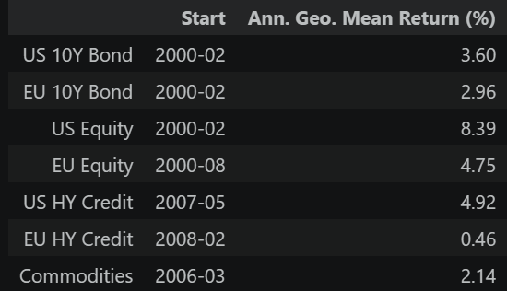
These results should be interpreted with some caution because the sample periods are not identical across assets. The bond series begins in 2000, but the commodity series begins in 2006, U.S. high-yield credit begins in 2007, and European high-yield credit begins in 2008. In addition, several series are represented by ETF proxies rather than underlying cash indices, so the measured returns may reflect fund expenses and tracking differences. Even so, the results provide a useful summary of realized long-run performance across major macro asset classes.
Table: Data Source and Coverage
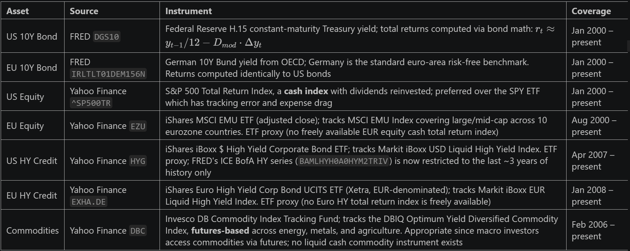

Q2 Annualized Volatility of Returns

We next compute the annualized volatility of monthly total returns for the same seven asset classes. For each series, annualized volatility is calculated as the standard deviation of monthly returns multiplied by the square root of 12.

The results show clear differences in risk across asset classes. European equity has the highest annualized volatility in the sample, at 21.06%, followed by commodities at 18.54% and U.S. equity at 15.19%. U.S. high-yield credit has volatility of 10.28%, while U.S. 10-year bonds and European 10-year bonds are much less volatile at 7.60% and 5.09%, respectively. European high-yield credit has the lowest reported volatility, at 3.73%.
Table: Risk and Return Summary
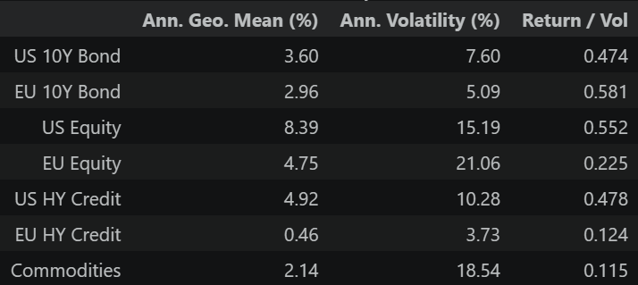
Several patterns stand out. First, equities are substantially more volatile than government bonds, which is consistent with the fact that bond returns are supported by contractual cash flows and generally experience smaller price fluctuations than stocks. Second, commodities exhibit very high volatility but relatively low average returns, making them one of the weakest assets on a risk-adjusted basis in this sample. Third, U.S. high-yield credit lies between sovereign bonds and equities in terms of volatility, which is consistent with its hybrid nature as a risky fixed-income asset exposed to both credit risk and macroeconomic conditions.

A notable result is that European 10-year bonds have the highest return-to-volatility ratio in the sample, slightly above U.S. equity. This reflects the unusually favorable bond environment over much of the sample period, especially the long decline in European yields, which generated capital gains in addition to carry while keeping measured volatility relatively low. U.S. equity still has the highest absolute return, but its volatility is also much higher.

The low reported volatility of European high-yield credit should be interpreted cautiously. Although its standard deviation is small, its annualized geometric mean return is also extremely low. This suggests that low volatility alone does not imply attractive performance. In addition, standard deviation may understate the true risk of high-yield credit because it does not fully capture downside tail risk, default risk, or large drawdowns during crisis periods.

As in Q1, cross-asset comparisons should be interpreted carefully because the sample windows differ across series. U.S. and European bond data begin in 2000, but commodities begin in 2006, U.S. high-yield credit in 2007, and European high-yield credit in 2008. Because these later-starting series do not cover the full post-2000 period, their volatility and return-to-volatility measures are not perfectly comparable to those of the longer series.

Q3. Decomposition of U.S. Equity and Bond Returns into Carry and Price Returns

We next decompose the returns on U.S. 10-year government bonds and U.S. equity into carry and price components. The goal is to distinguish the portion of total return that comes from income from the portion that comes from capital gains or losses.

For U.S. 10-year bonds, we use the same constant-maturity return approximation as in Q1. Under this framework, monthly bond returns can be written as the sum of two terms: carry, given by the previous month’s yield divided by 12, and price return, given by minus modified duration times the change in yield. This decomposition is natural for bonds because coupon income and capital gains from interest rate movements are conceptually distinct.

For U.S. equity, we define carry as income from dividends and price return as capital appreciation of the price index. Operationally, we approximate the income component as the difference between the total return series and the price return series of the S&P 500. In other words, equity carry is the dividend return, while the price component reflects changes in the underlying equity index level.
Table: US 10Y Bond and US Equity Comparison
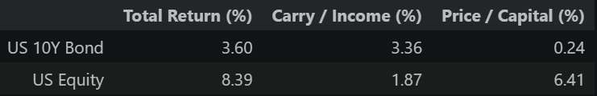
The results show a sharp contrast between bonds and equities. For U.S. 10-year bonds, the annualized total return is 3.60%, of which 3.36% comes from carry and only 0.24% comes from price appreciation. This indicates that most of the long-run return on bonds in our sample comes from income rather than capital gains. By contrast, for U.S. equity, the annualized total return is 8.39%, of which only 1.87% comes from carry and 6.41% comes from price appreciation. Thus, the majority of equity return comes from capital gains, while dividends account for a much smaller share.

This difference is economically intuitive. Bond investors receive a large portion of expected return from contractual income, and price gains mainly arise when yields fall. Equity investors, in contrast, rely much more on growth in firm value and rising stock prices, while dividend income plays a secondary role. In our sample, this distinction is very clear: bond returns are mostly carry-driven, whereas equity returns are mostly price-driven.

We are not asked to perform the same decomposition for high-yield credit for two main reasons. First, a clean carry-price split is much harder to construct using available total return or ETF data, since we generally do not observe the constituent-level coupon and pricing information needed to isolate pure income from price effects. Second, and more importantly, carry in high-yield credit is not comparable to carry in government bonds. The extra yield on high-yield bonds compensates investors not only for income but also for expected default losses, downgrade risk, illiquidity, and credit spread risk. As a result, labeling the full coupon or yield as “carry” would overstate the stable income component and understate the embedded credit risk. For this reason, the carry-price decomposition is much cleaner and more meaningful for Treasury bonds and equities than for high-yield credit.

Q4 Volatility of Income and Capital Returns

We next compute the volatility of the income and capital components for U.S. 10-year bonds and U.S. equity. As in Q2, annualized volatility is calculated as the standard deviation of monthly returns multiplied by the square root of 12. We also report the correlation between the carry component and the price component for each asset.

The results show that for both asset classes, nearly all return volatility comes from the price component rather than the income component. For U.S. 10-year bonds, total volatility is 7.60%. Carry volatility is only 0.37%, while price volatility is 7.54%. This means that the coupon-accrual component is very stable over time, whereas fluctuations in yields generate almost all of the variation in bond returns through duration effects. In other words, bond return risk is driven primarily by capital gains and losses arising from interest rate movements.

A similar pattern appears for U.S. equity, but even more strongly. Total equity volatility is 15.19%. Carry volatility is only 0.19%, while price volatility is 15.18%, essentially identical to total volatility. This shows that dividend income is extremely stable relative to stock price movements. Almost all of the risk in equity returns comes from capital appreciation and depreciation rather than from changes in dividend yield.

The correlation between carry and price returns is small and positive for both assets. For U.S. bonds, the correlation is 0.144, and for U.S. equity, it is 0.043. These values are close to zero, especially for equity, which suggests that income and capital returns are largely separate components. The main conclusion is therefore clear: carry is the stable part of return, while price return is the volatile part. This holds for both bonds and equities, even though the economic source of carry differs across the two assets.
Table: Volatility Decomposition of US 10Y Bond and US Equity
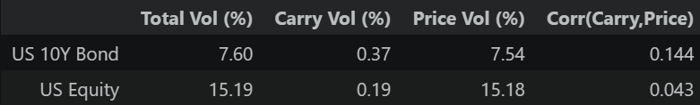
Taken together with Q3, these results highlight an important distinction. Carry explains a large share of average bond returns but very little of bond volatility. Likewise, dividends explain only a modest share of average equity returns and almost none of equity volatility. In both markets, long-run return decomposition and volatility decomposition tell different stories: income matters for average return, but price changes dominate risk.

Asset allocation v. security selection

Q5. Asset Allocation versus Security Selection

We next consider whether it is more valuable to be correct in asset allocation across asset classes or in security selection within asset classes, assuming we can only be right about one of the two. Our conclusion is that asset allocation is more important, especially over longer horizons.

To justify this quantitatively, we compare the cross-sectional dispersion of returns across the seven asset classes in our sample on a common time period. We compute the average cross-sectional standard deviation of cumulative returns across asset classes over different horizons. The results are 2.97% at the 1-month horizon, 12.53% at the 12-month horizon, 24.11% at the 36-month horizon, and 39.85% at the 60-month horizon.

These numbers show that differences across asset classes grow substantially as the investment horizon lengthens. At short horizons, the return gap between asset classes is noticeable but modest. Over one year, the gap becomes much larger, and over three to five years it becomes economically dominant. This means that being allocated to the right asset class can generate very large performance differences over time.

By contrast, return differences from security selection within an asset class are typically less persistent over long horizons. In the equity market, cross-stock dispersion can be large at a point in time, but stock-specific outperformance is harder to sustain because idiosyncratic returns are more mean-reverting and competition among investors is intense. A successful security selector may add alpha, but the magnitude of that alpha is usually smaller and less persistent than the return differences generated by being in the right asset class.

Therefore, if we can only be correct in one dimension, we would rather be correct in asset allocation than in security selection. This is especially true over medium- to long-term horizons, such as three years or more. Over very short horizons, security selection may matter more because stock-specific news, momentum, and idiosyncratic shocks can temporarily dominate. However, as the horizon extends, broad differences across asset classes compound, and asset allocation becomes the more important driver of outcomes.

Q6. Implications for a CIO

Given the result in Q5, the main implication for a CIO is that a multi-asset fund should devote more resources to asset allocation than to security selection. If cross-asset return differences widen materially with horizon, then the largest gains from research and portfolio construction are likely to come from getting the broad allocation right rather than from trying to add small amounts of alpha within each asset class.

In practice, this means that a CIO should invest more heavily in top-down macro research, regime analysis, and dynamic portfolio construction. Understanding the business cycle, inflation trends, monetary policy, and valuation across major asset classes is likely to have a larger impact on long-run portfolio performance than marginal improvements in bottom-up security picking. Similarly, building the systems and risk frameworks needed to adjust exposures across equities, bonds, credit, and commodities should generate greater payoff than expanding security-level research alone.

At the same time, this conclusion depends on the type of fund. For a multi-asset macro fund, asset allocation should be the primary source of active value added. For a fund that is already restricted to a single asset class, such as a dedicated equity or credit fund, security selection naturally becomes more important because cross-asset allocation is no longer available as a decision margin. In that case, the CIO must focus on security selection within the permitted universe.

There is also an important institutional consideration. Some investors, such as pension funds or endowments, operate under relatively fixed strategic allocation mandates. In those settings, the CIO may have limited flexibility to make large allocation shifts, so security selection becomes relatively more important in practice. Even so, the broader lesson remains that when a CIO has freedom to allocate across asset classes, that decision is likely to be the more powerful driver of long-run performance.

Mini-project question

Q7. Investing in HY credit

We aim to assess whether US HY credit is truly a desirable asset for a typical macro investor. In previous sections, results suggest that HY might be an attractive asset based on return and volatility. However, this analysis may be incomplete if it relies solely on these two metrics. A more appropriate evaluation requires examining the true sources of risk, how HY behaves within a broader portfolio, and whether its apparent attractiveness persists once we account for time variation, market structure, and implementation constraints.

- Correct measure of risk
Volatility alone cannot fully explain the true risk of US HY credit. While HY exhibits a moderate annualized volatility of 10.28%, its maximum drawdown reaches −30.24%, which is close to that of U.S. 10-year bonds (−27.29%). This highlights the importance of considering downside risk measures in addition to standard deviation. Moreover, HY displays substantial excess kurtosis (7.60), indicating fat tails and exposure to rare but severe losses, consistent with the nature of credit events, which tend to generate abrupt and significant drawdowns. Although the sample shows slightly positive skewness (+0.296), this is likely driven by the strong post-2009 credit recovery; structurally, HY returns are expected to exhibit negative skewness, as spread widening tends to occur rapidly during crises while recoveries are more gradual. Importantly, HY spreads (OAS) compensate investors not only for expected default losses but also for credit risk and liquidity risk, implying that the observed returns are a premium for bearing systematic downside risk. Overall, a proper assessment of HY risk must incorporate drawdowns, tail behavior, and credit spread dynamics, rather than relying solely on volatility.
Table: HY vs Equity vs Bond – Full Risk Profile
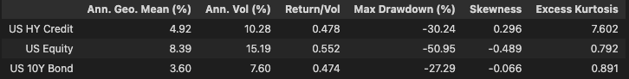

(b) HY as a combination of bonds and equity
HY credit behaves largely as a hybrid of equity and government bonds rather than as a distinct asset class. Regression results show that 55.6% of HY return variation can be explained by equity and bond returns, with an equity beta of 0.493 and a bond beta of 0.154. This implies that much of HY exposure can be replicated through a dynamic allocation to equities and bonds, often with greater flexibility and liquidity. As a result, the marginal diversification benefit of adding HY to a macro portfolio is limited.

(c) Time variation in exposures
The relationship between HY and other asset classes is highly time-varying. Rolling regressions show that equity beta ranges from 0.135 to 0.816 and tends to increase during crises, while bond beta can become negative in risk-off environments. This means that HY behaves like equity precisely when equity risk is most severe, reducing its effectiveness as a diversifier. The attractiveness of HY is therefore conditional on the macro environment and credit cycle.

Figure: Rolling 24-Month Equity and Bond Exposures of US HY Credit
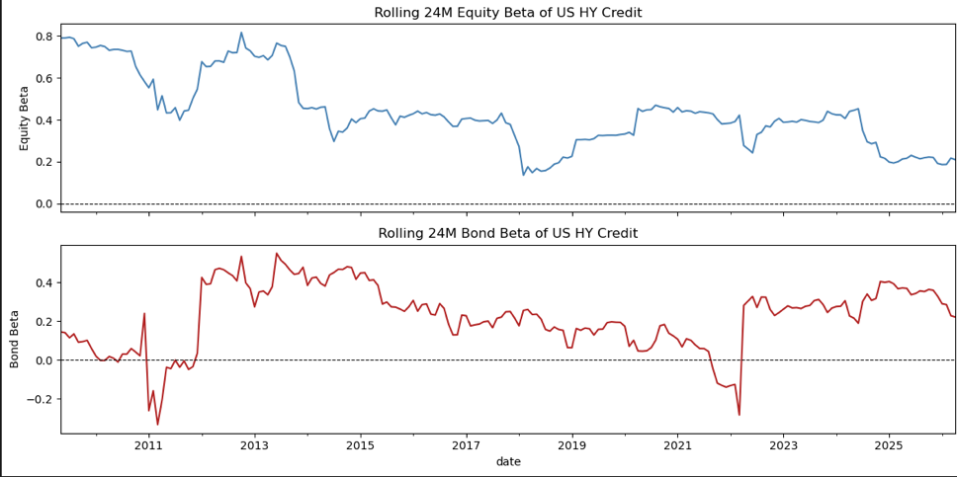

(d) Practical investment constraints
Several constraints may limit the ability to invest in HY credit. Many institutional investors, such as pension funds and insurers, face restrictions on holding sub-investment-grade assets. In addition, the HY market is relatively illiquid, especially during periods of stress when bid-ask spreads widen and forced selling amplifies losses. These factors make implementation more difficult and increase the realized risk of holding HY.

(e) HY as a risk premium strategy
Being long U.S. high-yield (HY) credit is best viewed as a risk premium harvesting strategy, similar to equity risk premia or carry trades. Investors earn steady income from credit spreads in normal market conditions, but this carry is compensation for bearing systematic downside risk, particularly during periods of economic stress when spreads widen sharply. As a result, HY exhibits a payoff profile characterized by frequent small gains and occasional large losses, leading to fat-tailed return distributions. Like other risk premia strategies, HY performance is driven primarily by exposure to broad macro factors rather than idiosyncratic alpha, and its attractiveness depends on timing and the level of spreads. Consequently, HY should be understood as a cyclical, risk-dependent source of return rather than a consistently diversifying asset.

(f) Implications for investor behavior
Investor behavior in HY credit is strongly shaped by institutional constraints and market structure. Constrained investors, such as those limited to investment-grade assets, are structurally excluded from HY, which may help sustain a persistent risk premium as compensation for bearing credit risk. In contrast, unconstrained investors, particularly macro hedge funds, often access the HY premium through CDS indices (e.g., CDX HY, iTraxx Crossover) rather than cash bonds, benefiting from better liquidity, easier hedging, and lower funding frictions. At the same time, HY is a widely followed carry trade, leading to crowding risk: capital tends to flow in during benign periods when spreads are tight, and sentiment reversals can trigger sharp, systemic unwinds, as seen in episodes such as Q4 2018 and March 2020.

Overall, while US HY credit appears attractive based on average returns and volatility, this is misleading for a macro investor. HY returns primarily reflect compensation for systematic credit and macro risk, with a payoff profile similar to a risk premium strategy—steady carry in normal times but significant losses in stress periods. It behaves largely as a hybrid of equity and bond exposures, with correlations that increase during downturns, limiting diversification benefits. In addition, its attractiveness is time-varying, depends on spread levels, and is affected by liquidity constraints and crowding. Therefore, HY is not a uniquely desirable standalone asset, but a cyclical, timing-dependent exposure that should be used selectively rather than as a core allocation.

