kint_test

2022-03-15

**per capita consumption**: This is the basic bechmarking model utilzing the default, uninformed priors

Model Summery

summary(per_cap_consumption_Bayesmodel)

## Family: gaussian   
## Links: mu = identity; sigma = identity   
## Formula: consumption_asinh | weights(samp_wgt) ~ cost_deviation + treat_any + treat_GK + consumption_asinh_R1 + Lhh_wealth_asinh + Lvill_eligible_ratio + (1 | block) + (1 | vid)   
## Data: per_cap_consumption_data (Number of observations: 1750)   
## Draws: 4 chains, each with iter = 2000; warmup = 1000; thin = 1;  
## total post-warmup draws = 4000  
##   
## Group-Level Effects:   
## ~block (Number of levels: 22)   
## Estimate Est.Error l-95% CI u-95% CI Rhat Bulk_ESS Tail_ESS  
## sd(Intercept) 0.27 0.06 0.17 0.39 1.00 1397 2021  
##   
## ~vid (Number of levels: 248)   
## Estimate Est.Error l-95% CI u-95% CI Rhat Bulk_ESS Tail_ESS  
## sd(Intercept) 0.38 0.03 0.33 0.44 1.00 1931 2534  
##   
## Population-Level Effects:   
## Estimate Est.Error l-95% CI u-95% CI Rhat Bulk_ESS  
## Intercept 8.52 0.19 8.16 8.89 1.00 3533  
## cost_deviation 0.00 0.00 0.00 0.00 1.00 2814  
## treat_any 0.11 0.08 -0.06 0.27 1.00 2121  
## treat_GK -0.13 0.08 -0.30 0.03 1.00 2005  
## consumption_asinh_R1 0.18 0.01 0.16 0.21 1.00 7235  
## Lhh_wealth_asinh 0.02 0.00 0.01 0.03 1.00 8408  
## Lvill_eligible_ratio 0.16 0.34 -0.50 0.83 1.00 1748  
## Tail_ESS  
## Intercept 2753  
## cost_deviation 2818  
## treat_any 2844  
## treat_GK 2553  
## consumption_asinh_R1 3135  
## Lhh_wealth_asinh 2906  
## Lvill_eligible_ratio 2304  
##   
## Family Specific Parameters:   
## Estimate Est.Error l-95% CI u-95% CI Rhat Bulk_ESS Tail_ESS  
## sigma 1.16 0.01 1.14 1.19 1.00 7158 2934  
##   
## Draws were sampled using sampling(NUTS). For each parameter, Bulk_ESS  
## and Tail_ESS are effective sample size measures, and Rhat is the potential  
## scale reduction factor on split chains (at convergence, Rhat = 1).

Prior summery - how informative are priors

prior_summary(per_cap_consumption_Bayesmodel)

## prior class coef group resp dpar nlpar  
## (flat) b   
## (flat) b consumption_asinh_R1   
## (flat) b cost_deviation   
## (flat) b Lhh_wealth_asinh   
## (flat) b Lvill_eligible_ratio   
## (flat) b treat_any   
## (flat) b treat_GK   
## student_t(3, 10.7, 2.5) Intercept   
## student_t(3, 0, 2.5) sd   
## student_t(3, 0, 2.5) sd block   
## student_t(3, 0, 2.5) sd Intercept block   
## student_t(3, 0, 2.5) sd vid   
## student_t(3, 0, 2.5) sd Intercept vid   
## student_t(3, 0, 2.5) sigma   
## bound source  
## default  
## (vectorized)  
## (vectorized)  
## (vectorized)  
## (vectorized)  
## (vectorized)  
## (vectorized)  
## default  
## default  
## (vectorized)  
## (vectorized)  
## (vectorized)  
## (vectorized)  
## default

check_prior(per_cap_consumption_Bayesmodel)

## Warning: Some priors could not be simulated.

## Parameter Prior_Quality  
## 1 b_Intercept uninformative  
## 2 b_cost_deviation not determinable  
## 3 b_treat_any not determinable  
## 4 b_treat_GK not determinable  
## 5 b_consumption_asinh_R1 not determinable  
## 6 b_Lhh_wealth_asinh not determinable  
## 7 b_Lvill_eligible_ratio not determinable

Diagnostics

# trace diagnostic plot  
mcmc_trace(per_cap_consumption_Bayesmodel, n_warmup = 0,  
 pars = c("b_Intercept", "b_cost_deviation", "b_treat_any",   
 "b_treat_GK", "b_consumption_asinh_R1", "b_Lhh_wealth_asinh",  
 "b_Lvill_eligible_ratio", "sd_block__Intercept",   
 "sd_vid__Intercept", "sigma"))

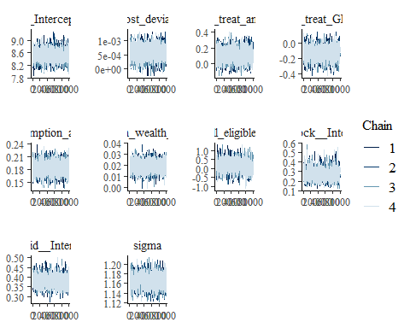

ggsave("table_2_diagnostics\\per_cap_consumption_trace.png", plot = last_plot(), width = 12, height = 5)  
  
  
#density diagnostic plot  
mcmc_dens(per_cap_consumption_Bayesmodel,  
 pars = c("b_Intercept", "b_cost_deviation", "b_treat_any",   
 "b_treat_GK", "b_consumption_asinh_R1", "b_Lhh_wealth_asinh",  
 "b_Lvill_eligible_ratio", "sd_block__Intercept",   
 "sd_vid__Intercept", "sigma"))

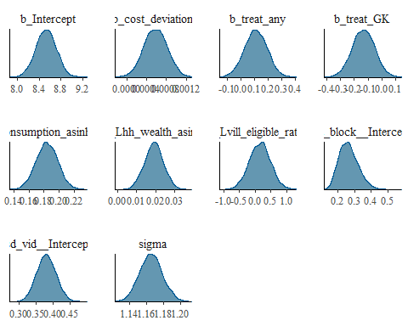

ggsave("table_2_diagnostics\\per_cap_consumption_dens.png", plot = last_plot(), width = 12, height = 5)  
  
mcmc_dens_overlay(per_cap_consumption_Bayesmodel,  
 pars = c("b_Intercept", "b_cost_deviation", "b_treat_any",   
 "b_treat_GK", "b_consumption_asinh_R1", "b_Lhh_wealth_asinh",  
 "b_Lvill_eligible_ratio", "sd_block__Intercept",   
 "sd_vid__Intercept", "sigma"))

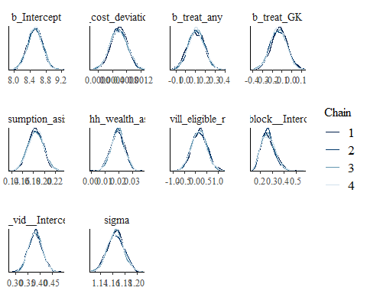

ggsave("table_2_diagnostics\\per_cap_consumption_overlay.png", plot = last_plot(), width = 12, height = 5)  
  
  
#acf (auto-correlation) diagnostic plot  
mcmc_acf(per_cap_consumption_Bayesmodel,  
 pars = c("b_Intercept", "b_cost_deviation", "b_treat_any",   
 "b_treat_GK", "b_consumption_asinh_R1", "b_Lhh_wealth_asinh",  
 "b_Lvill_eligible_ratio", "sd_block__Intercept",   
 "sd_vid__Intercept", "sigma"))

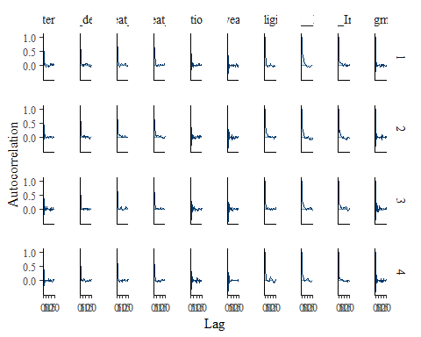

ggsave("table_2_diagnostics\\per_cap_consumption_acf.png", plot = last_plot(), width = 12, height = 5)

posterior predictive checks

pp_check(per_cap_consumption_Bayesmodel, nsamples = 100)

## Warning: Argument 'nsamples' is deprecated. Please use argument 'ndraws'  
## instead.

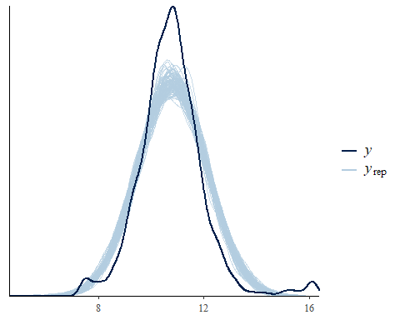

pp_check(per_cap_consumption_Bayesmodel, nsamples = 10, type = 'error_scatter_avg', alpha = .1)

## Warning: Argument 'nsamples' is deprecated. Please use argument 'ndraws'  
## instead.

