Table 2 - Dietary Diversity

2022-03-15

Load the **Dietary Diversity** variables

**Dietary Diversity:** This is the basic bechmarking model utilizing the default, uninformed priors

dietary_diversity_Bayesmodel <-   
 brm(formula = dietarydiversity | weights(samp_wgt) ~   
 cost_deviation + treat_any + treat_GK +   
 dietarydiversity_R1 + Lhh_wealth_asinh + Lvill_eligible_ratio + Lsavingsstock_asinh3 +   
 Lconsumpti_x_Ldietarydi + Lconsumpti_x_Lproductiv + Ldietarydi_x_Lassetscon +   
 (1 | vid) + (1 | block),  
 data = dietary_diversity_data,  
 family = gaussian("identity"),  
 seed = 1272022,  
 warmup = 1000,  
 iter = 2000,  
 thin = 1,  
 control = list(adapt_delta = .95, max_treedepth = 10),  
 #backend = "cmdstanr",  
 cores = 4, #overrides default 1 core  
 #threads = 3,need to get cmdstanr package working here  
 save_pars = save_pars(all = TRUE), # potentially allows for more post-processing functionality  
 file = "uninformed_prior_outcomes\\dietary_diversity_Bayes")

Model Summary

summary(dietary_diversity_Bayesmodel)

## Family: gaussian   
## Links: mu = identity; sigma = identity   
## Formula: dietarydiversity | weights(samp_wgt) ~ cost_deviation + treat_any + treat_GK + dietarydiversity_R1 + Lhh_wealth_asinh + Lvill_eligible_ratio + Lsavingsstock_asinh3 + Lconsumpti_x_Ldietarydi + Lconsumpti_x_Lproductiv + Ldietarydi_x_Lassetscon + (1 | vid) + (1 | block)   
## Data: dietary_diversity_data (Number of observations: 1751)   
## Draws: 4 chains, each with iter = 2000; warmup = 1000; thin = 1;  
## total post-warmup draws = 4000  
##   
## Group-Level Effects:   
## ~block (Number of levels: 22)   
## Estimate Est.Error l-95% CI u-95% CI Rhat Bulk_ESS Tail_ESS  
## sd(Intercept) 0.30 0.08 0.16 0.48 1.01 962 1425  
##   
## ~vid (Number of levels: 248)   
## Estimate Est.Error l-95% CI u-95% CI Rhat Bulk_ESS Tail_ESS  
## sd(Intercept) 0.55 0.04 0.47 0.64 1.01 1469 2187  
##   
## Population-Level Effects:   
## Estimate Est.Error l-95% CI u-95% CI Rhat Bulk_ESS  
## Intercept 3.19 0.22 2.75 3.62 1.00 2472  
## cost_deviation 0.00 0.00 0.00 0.00 1.00 2392  
## treat_any 0.26 0.12 0.02 0.48 1.00 1556  
## treat_GK -0.03 0.12 -0.27 0.21 1.00 1837  
## dietarydiversity_R1 -0.12 0.07 -0.26 0.02 1.00 2694  
## Lhh_wealth_asinh 0.01 0.01 -0.00 0.03 1.00 6416  
## Lvill_eligible_ratio -0.57 0.45 -1.44 0.32 1.00 1509  
## Lsavingsstock_asinh3 0.00 0.00 0.00 0.00 1.00 4307  
## Lconsumpti_x_Ldietarydi 0.01 0.01 0.00 0.03 1.00 2640  
## Lconsumpti_x_Lproductiv 0.01 0.00 0.00 0.01 1.00 3204  
## Ldietarydi_x_Lassetscon 0.01 0.00 0.01 0.01 1.00 5973  
## Tail_ESS  
## Intercept 2787  
## cost_deviation 2866  
## treat_any 2521  
## treat_GK 2760  
## dietarydiversity_R1 2588  
## Lhh_wealth_asinh 3066  
## Lvill_eligible_ratio 2411  
## Lsavingsstock_asinh3 3074  
## Lconsumpti_x_Ldietarydi 2727  
## Lconsumpti_x_Lproductiv 3584  
## Ldietarydi_x_Lassetscon 3365  
##   
## Family Specific Parameters:   
## Estimate Est.Error l-95% CI u-95% CI Rhat Bulk_ESS Tail_ESS  
## sigma 1.58 0.02 1.55 1.62 1.00 5245 2491  
##   
## Draws were sampled using sampling(NUTS). For each parameter, Bulk_ESS  
## and Tail_ESS are effective sample size measures, and Rhat is the potential  
## scale reduction factor on split chains (at convergence, Rhat = 1).

Prior summery - how informative are priors

prior_summary(dietary_diversity_Bayesmodel)

## prior class coef group resp dpar nlpar  
## (flat) b   
## (flat) b cost_deviation   
## (flat) b dietarydiversity_R1   
## (flat) b Lconsumpti_x_Ldietarydi   
## (flat) b Lconsumpti_x_Lproductiv   
## (flat) b Ldietarydi_x_Lassetscon   
## (flat) b Lhh_wealth_asinh   
## (flat) b Lsavingsstock_asinh3   
## (flat) b Lvill_eligible_ratio   
## (flat) b treat_any   
## (flat) b treat_GK   
## student_t(3, 5, 2.5) Intercept   
## student_t(3, 0, 2.5) sd   
## student_t(3, 0, 2.5) sd block   
## student_t(3, 0, 2.5) sd Intercept block   
## student_t(3, 0, 2.5) sd vid   
## student_t(3, 0, 2.5) sd Intercept vid   
## student_t(3, 0, 2.5) sigma   
## bound source  
## default  
## (vectorized)  
## (vectorized)  
## (vectorized)  
## (vectorized)  
## (vectorized)  
## (vectorized)  
## (vectorized)  
## (vectorized)  
## (vectorized)  
## (vectorized)  
## default  
## default  
## (vectorized)  
## (vectorized)  
## (vectorized)  
## (vectorized)  
## default

check_prior(dietary_diversity_Bayesmodel)

## Warning: Some priors could not be simulated.

## Parameter Prior_Quality  
## 1 b_Intercept uninformative  
## 2 b_cost_deviation not determinable  
## 3 b_treat_any not determinable  
## 4 b_treat_GK not determinable  
## 5 b_dietarydiversity_R1 not determinable  
## 6 b_Lhh_wealth_asinh not determinable  
## 7 b_Lvill_eligible_ratio not determinable  
## 8 b_Lsavingsstock_asinh3 not determinable  
## 9 b_Lconsumpti_x_Ldietarydi not determinable  
## 10 b_Lconsumpti_x_Lproductiv not determinable  
## 11 b_Ldietarydi_x_Lassetscon not determinable

Diagnostics

# trace diagnostic plot  
mcmc_trace(dietary_diversity_Bayesmodel, n_warmup = 0,  
 pars = c("b_Intercept", "b_cost_deviation", "b_treat_any",   
 "b_treat_GK", "b_dietarydiversity_R1", "b_Lhh_wealth_asinh",  
 "b_Lvill_eligible_ratio", "b_Lsavingsstock_asinh3",  
 "b_Lconsumpti_x_Ldietarydi", "b_Lconsumpti_x_Lproductiv",   
 "b_Ldietarydi_x_Lassetscon", "sd_block__Intercept",   
 "sd_vid__Intercept", "sigma"))

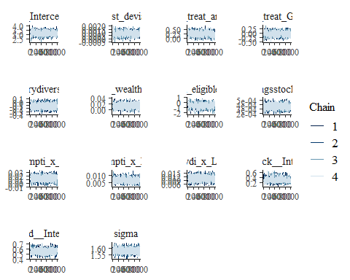

ggsave("table_2_diagnostics\\dietary_div_trace.png", plot = last_plot(), width = 12, height = 5)  
  
#density diagnostic plot  
mcmc_dens(dietary_diversity_Bayesmodel,  
 pars = c("b_Intercept", "b_cost_deviation", "b_treat_any",   
 "b_treat_GK", "b_dietarydiversity_R1", "b_Lhh_wealth_asinh",  
 "b_Lvill_eligible_ratio", "b_Lsavingsstock_asinh3",  
 "b_Lconsumpti_x_Ldietarydi", "b_Lconsumpti_x_Lproductiv",   
 "b_Ldietarydi_x_Lassetscon", "sd_block__Intercept",   
 "sd_vid__Intercept", "sigma"))

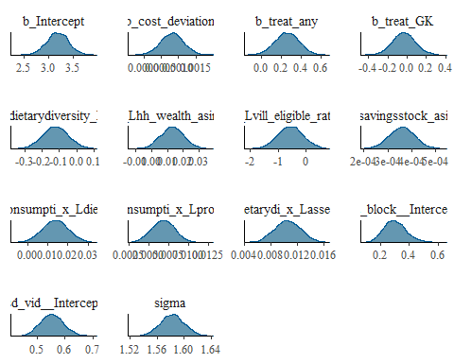

ggsave("table_2_diagnostics\\dietary_div_dens.png", plot = last_plot(), width = 12, height = 5)  
  
mcmc_dens_overlay(dietary_diversity_Bayesmodel,  
 pars = c("b_Intercept", "b_cost_deviation", "b_treat_any",   
 "b_treat_GK", "b_dietarydiversity_R1", "b_Lhh_wealth_asinh",  
 "b_Lvill_eligible_ratio", "b_Lsavingsstock_asinh3",  
 "b_Lconsumpti_x_Ldietarydi", "b_Lconsumpti_x_Lproductiv",   
 "b_Ldietarydi_x_Lassetscon", "sd_block__Intercept",   
 "sd_vid__Intercept", "sigma"))

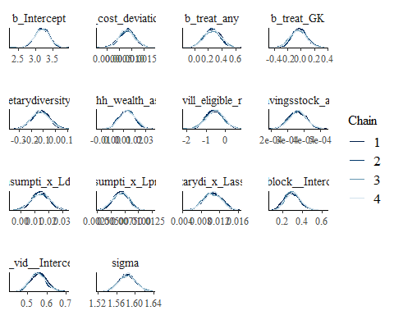

ggsave("table_2_diagnostics\\dietary_div_overlay.png", plot = last_plot(), width = 12, height = 5)  
  
  
#acf (auto-correlation) diagnostic plot  
mcmc_acf(dietary_diversity_Bayesmodel,  
 pars = c("b_Intercept", "b_cost_deviation", "b_treat_any",   
 "b_treat_GK", "b_dietarydiversity_R1", "b_Lhh_wealth_asinh",  
 "b_Lvill_eligible_ratio", "b_Lsavingsstock_asinh3",  
 "b_Lconsumpti_x_Ldietarydi", "b_Lconsumpti_x_Lproductiv",   
 "b_Ldietarydi_x_Lassetscon", "sd_block__Intercept",   
 "sd_vid__Intercept", "sigma"))

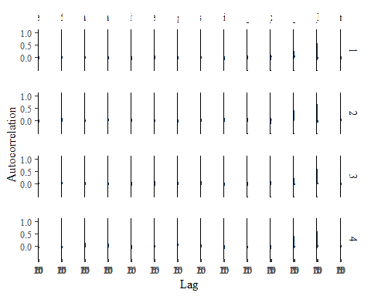

ggsave("table_2_diagnostics\\dietary_div_acf.png", plot = last_plot(), width = 12, height = 5)

posterior predictive checks

pp_check(dietary_diversity_Bayesmodel, nsamples = 100)

## Warning: Argument 'nsamples' is deprecated. Please use argument 'ndraws'  
## instead.

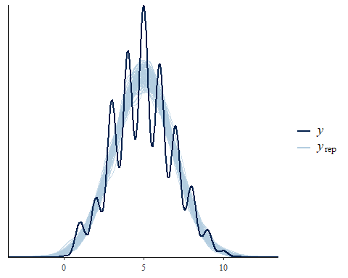

pp_check(dietary_diversity_Bayesmodel, nsamples = 10, type = 'error_scatter_avg', alpha = .1)

## Warning: Argument 'nsamples' is deprecated. Please use argument 'ndraws'  
## instead.

